March 1, 2026 2nd Sunday in Lent 11 AM

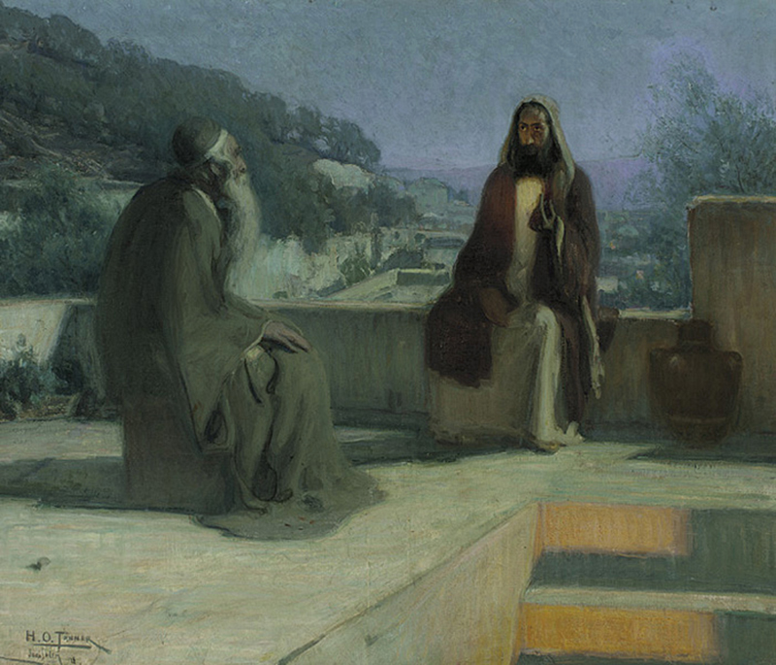
Tanner, Henry Ossawa, 1859-1937. Nicodemus, 1899
from Art in the Christian Tradition, a project of the Vanderbilt Divinity Library, Nashville, TN.

PRELUDE “Prelude in G Minor” J.S. Bach

WELCOME

CALL TO WORSHIP

HYMN #618 “O Love, How Deep, How Broad, How High”

1 O love, how deep, how broad, how high, beyond all thought and fantasy,
that God, the Son of God, should take our mortal form for mortals' sake.

2 For us baptized, for us he bore his holy fast and hungered sore;
for us temptations sharp he knew, for us, the tempter overthrew.

3 For us by wickedness betrayed, for us, in crown of thorns arrayed,
he bore the shameful cross and death; for us gave up his dying breath.

4 For us he rose from death again; for us he went on high to reign;
for us he sent the Spirit here to guide, to strengthen, and to cheer.

5 All glory to our Lord and God, for love so deep, so high, so broad:
the Trinity whom we adore forever and forevermore.

CALL TO CONFESSION

ASSURANCE OF GOD’S LOVE

RESPONSE: HYMN #581 “Gloria Patri”
Glory be the Father, and to the Son and to the Holy Ghost,
As it was in the beginning, is now, and ever shall be,
World without end. Amen. Amen.

PEACE
Let there be peace on earth.
And let it begin with me.
The peace of Christ be with you.
And also with you.

RESPONSIVE READING Psalm 121 (NRSVUE)
I lift up my eyes to the hills—from where will my help come?
My help comes from the Lord, who made heaven and earth.

He will not let your foot be moved; he who keeps you will not slumber.
He who keeps Israel will neither slumber nor sleep.

The Lord is your keeper; the Lord is your shade at your right hand.
The sun shall not strike you by day nor the moon by night.

The Lord will keep you from all evil; he will keep your life.
The Lord will keep your going out and your coming in
from this time on and forevermore.

FIRST READING Genesis 12:1-4a (NRSVUE)
¹ Now the Lord said to Abram, “Go from your country and your kindred and your father’s house to the land that I will show you. ² I will make of you a great nation, and I will bless you and make your name great, so that you will be a blessing. ³ I will bless those who bless you, and the one who curses you I will curse, and in you all the families of the earth shall be blessed.” ⁴ So Abram went, as the Lord had told him, and Lot went with him.

CHILDREN’S SERMON

SECOND READING John 3:1-17 (NRSVUE)
¹ Now there was a Pharisee named Nicodemus, a leader of the Jews. ² He came to Jesus by night and said to him, “Rabbi, we know that you are a teacher who has come from God, for no one can do these signs that you do unless God is with that person.” ³ Jesus answered him, “Very truly, I tell you, no one can see the kingdom of God without being born from above.” ⁴ Nicodemus said to him, “How can anyone be born after having grown old? Can one enter a second time into the mother’s womb and be born?” ⁵ Jesus answered, “Very truly, I tell you, no one can enter the kingdom of God without being born of water and Spirit. ⁶ What is born of the flesh is flesh, and what is born of the Spirit is spirit. ⁷ Do not be astonished that I said to you, ‘You must be born from above.’ ⁸ The wind blows where it chooses, and you hear the sound of it, but you do not know where it comes from or where it goes. So it is with everyone who is born of the Spirit.” ⁹ Nicodemus said to him, “How can these things be?” ¹⁰ Jesus answered him, “Are you the teacher of Israel, and yet you do not understand these things?
¹¹ “Very truly, I tell you, we speak of what we know and testify to what we have seen, yet you do not receive our testimony. ¹² If I have told you about earthly things and you do not believe, how can you believe if I tell you about heavenly things? ¹³ No one has ascended into heaven except the one who descended from heaven, the Son of Man. ¹⁴ And just as Moses lifted up the serpent in the wilderness, so must the Son of Man be lifted up, ¹⁵ that whoever believes in him may have eternal life.
¹⁶ “For God so loved the world that he gave his only Son, so that everyone who believes in him may not perish but may have eternal life.
¹⁷ “Indeed, God did not send the Son into the world to condemn the world but in order that the world might be saved through him.

SERMON “God’s New Creation” Jeff Courter

HYMN #774 “There Is Now a New Creation”

- There is now a new creation through the grace of Jesus Christ,
Peace and reconciliation with the God of endless life.

- Call the lost and found together; tell the news to everyone;
Now the past is gone forever and a new life has begun.

- Wrap the prodigal in welcome; run to greet the wayward child.
All is finished and forgiven; let us know be reconciled.

- Come and join the celebration; come and join this happy feast;
Jesus makes an invitation to the greatest and the least.

- There is now a new creation through the grace of Jesus Christ.
Sing, with thanks and adoration, to the God of endless life!

PROFESSION OF FAITH THE NICENE CREED
I Believe in God the Father Almighty, Maker of heaven and earth; and in Jesus Christ, His Only Son, our Lord, who was conceived by the Holy Spirit, born of the Virgin Mary, suffered under Pontius Pilate, was crucified, dead, and buried. He descended into hell; the third day He rose again from the dead. He ascended into heaven, and sitteth at the right hand of God the Father Almighty, from thence He shall come to judge the quick and the dead.
I believe in the Holy Spirit, the holy catholic church, the communion of saints, the forgiveness of sins, the resurrection of the body, and the life everlasting. Amen.

PRAYERS OF THE PEOPLE

OFFERING/OFFERTORY “Your name and renown O Lord, John White
are the desire of our hearts.”

OFFERING SONG #606 Doxology
Praise God, from whom all blessings flow,
Praise God, all creatures here below,
Praise God above, ye heavenly host,
Praise Father, Son and Holy Ghost. Amen.

PRAYER OF DEDICATION

INVITATION TO THE TABLE

GREAT PRAYER OF THANKSGIVING

The Lord be with you.
And also with you.
Lift up your hearts.
We lift them to the Lord.
Let us give thanks to the Lord our God.
It is right to give our thanks and praise.

It is truly right and our greatest joy to give you thanks and praise, O Lord our God,
creator and ruler of the universe.
You established your people to be a light for the nations, and called us to walk in your paths and follow your ways.
Even now, you are coming to bring justice and peace to the world.
You have been our shepherd and savior in every generation.
Though we turned away from you, you were always faithful.

In the fullness of time, you sent your only Son to be our Immanuel.
Therefore we praise you, joining our voices with choirs of angels with prophets,
apostles, and martyrs, and with all the faithful of every time and place who forever
sing to the glory of your name:
Holy, holy, holy Lord, God of power and might, heaven and earth are full of
your glory. Hosanna in the highest. Blessed is he who comes in the name of
the Lord. Hosanna in the highest.

You are holy, O God of majesty. Out of your great love for the world, you sent
Jesus, not to condemn, but to save, so that everyone who believes in him might not
perish, but have eternal life, born again from above by water and the Spirit.
In Christ Jesus, you drew near to us for our salvation, teaching us to live in faith and to seek the good of all.
Through his dying and rising, you brought life to the world.
In Jesus Christ, born of Mary, you fulfilled your promise, long-awaited by prophets, and spoken in the scriptures.
By his resurrection from the dead, we receive life everlasting.
Remembering your gracious acts in Jesus Christ, we take from your creation this bread and this wine and joyfully celebrate his dying and rising, as we await the day of his coming.
With thanksgiving, we offer our very selves to you to be a living and holy sacrifice, dedicated to your service.

Great is the mystery of faith:
Christ has died, Christ is risen, Christ will come again.

Gracious God, pour out your Holy Spirit upon us and upon these your gifts of bread and wine, that the bread we break and the cup we bless may be the communion of the body and blood of Christ.
By your Spirit, unite us with Christ and with your church in all the world.
Keep us faithful and alert for the hour of Christ’s coming.
Let us live honorably as children of truth and light, so that we may eat and drink together in your eternal realm.

Fill us with wisdom and understanding, knowledge and power, and grant that we may live in harmony with one another as we await the coming of the kingdom of heaven.
Help us to grow in faith and love, as your people in Christ.
Strengthen our hearts and teach us patience as we watch and pray for the coming of the Lord.
Give hope and strength to those who call upon your name.
Feed us with the bread of life and fill us with the spirit of joy so that we may share your grace and peace with all the world.
Through Christ, with Christ, in Christ, in the unity of the Holy Spirit, all glory and honor are yours, almighty God, now and forever. Amen.

THE LORD’S PRAYER

WORDS OF INSTITUTION

COMMUNION OF THE PEOPLE “Lamb of God” W.A. Mozart

ANNOUNCEMENTS

CLOSING HYMN #264 “At the Name of Jesus”

1 At the name of Jesus every knee shall bow, every tongue confess him
King of glory now; 'tis the Father's pleasure we should call him Lord,
who from the beginning was the mighty Word.

2 Humbled for a season to receive a name from the lips of sinners
unto whom he came, faithfully he bore it spotless to the last,
brought it back victorious, when from death he passed;

3 Bore it up triumphant, with its human light, through all ranks of creatures,
to the central height, to the throne of Godhead, to the Father's breast,
filled it with the glory of that perfect rest.

4 Christians, this Lord Jesus shall return again, with his Father's glory
o'er the earth to reign; for all wreaths of empire meet upon his brow,
and our hearts confess him King of glory now.

BENEDICTION

POSTLUDE “Fugue in C Minor” (Op.90 No. 13) C. Geissler

UPCOMING CALENDAR

ADULT BIBLE STUDY – Sunday 10:00 AM – we are currently reading Delivered into Covenant (Pivotal Moments in the Book of Exodus) by Walter Brueggemann
If you are interested, please contact David in the office.

WEDNESDAY, MARCH 4th – Lenten Study, 7:00 PM on Zoom
We are continuing our Lenten study by reading Pastor Brian Zahnd's book, The Wood Between the Worlds:A Poetic Theology of the Cross (InterVarsity Press, 2024) until Holy Week. We have copies of the book available who are in the study - if you want a copy, please contact the office or stop by and get a copy.

REMINDER: We are still looking for volunteers for worship readers and/or juice/coffee hour. There is a 3-month sign-up sheet posted just outside the office.
If you have any questions, please contact the Office.

First Presbyterian Church of Forest Hills
70-35 112th St., Forest Hills, NY 11375 presbyfh.org
David Barnett, Admin.718-268-4036 Jeff Courter, Pastor,
FirstPresFHNY@gmail.com; rev.jeffrey.courter@gmail.com
Rafael Reyes-Quiroz, Clerk of Session Hannah Lin, Guest Organist

Please note: we now have a public WiFi for the church, though it may only be available in the church hall for now. Name: CHURCH GUEST Password: welcome1

For offerings/donations:

- Use Zelle to make Online donations from your bank account. Use this phone number to transfer to the church:
929-418-0958 (please note: this is a new number)
- Make checks payable to First Presbyterian Church of Forest Hills and mail check to the church office
- Go to our church website: presbyfh.org and click on the “Give Now” icon to set up a donation; or click on the qr code above
- Set up a “Bill pay” from your bank.
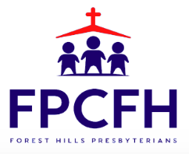

Building a Community of Faith, Hope, and Love
PresbyFH.org

