September 27, 2026 18th Sunday after Pentecost 11 AM

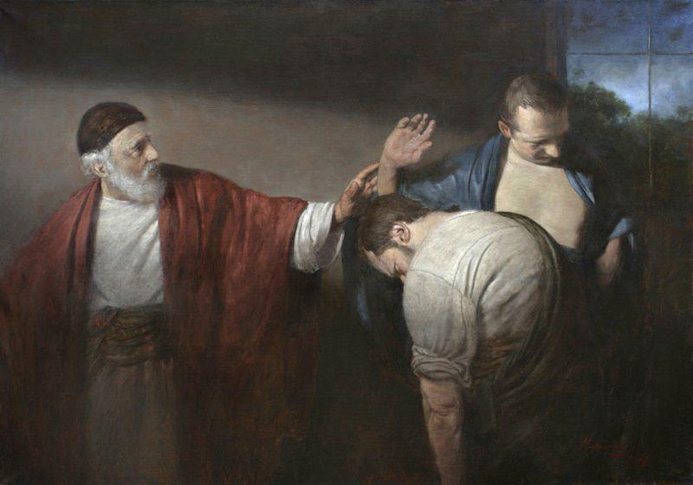
Mironov, Andreĭ (Andreĭ Nikolaevich), 1975-. Parable of the Two Sons, (2013)
from Art in the Christian Tradition, a project of the Vanderbilt University Divinity Library, Nashville, TN.

PRELUDE

WELCOME

MINUTE FOR MISSION

CALL TO WORSHIP

HYMN #700 “I’m Gonna Live So God Can Use Me”

1 I'm gonna live so God can use me anywhere, Lord, anytime!
I'm gonna live so God can use me anywhere, Lord, anytime!

2 I'm gonna work so God can use me anywhere, Lord, anytime!
I'm gonna work so God can use me anywhere, Lord, anytime!

3 I'm gonna pray so God can use me anywhere, Lord, anytime!
I'm gonna pray so God can use me anywhere, Lord, anytime!

4 I'm gonna sing so God can use me anywhere, Lord, anytime!
I'm gonna sing so God can use me anywhere, Lord, anytime!

CALL TO CONFESSION

PRAYER OF CONFESSION

ASSURANCE OF GOD’S LOVE

RESPONSE: HYMN #582 “Glory to God”
1 Glory to God, whose goodness shines on me,
and to the Son, whose grace has pardoned me,
and to the Spirit, whose love has set me free.
As it was in the beginning, is now and ever shall be. Amen.

2 World without end, without end. Amen.
World without end, without end. Amen
World without end, without end. Amen.
As it was in the beginning, is now and ever shall be. Amen.

PEACE
Let there be peace on earth.
And let it begin with me.
The peace of Christ be with you.
And also with you.

RESPONSIVE READING Psalm 25:1-9 (NRSVUE)
To you, O Lord, I lift up my soul.
O my God, in you I trust; do not let me be put to shame;
do not let my enemies exult over me.
Do not let those who wait for you be put to shame;
let them be ashamed who are wantonly treacherous.
Make me to know your ways, O Lord; teach me your paths.
Lead me in your truth and teach me, for you are the God of my salvation;
for you I wait all day long.
Be mindful of your mercy, O Lord, and of your steadfast love,
for they have been from of old.
Do not remember the sins of my youth or my transgressions;
according to your steadfast love remember me,
for the sake of your goodness, O Lord!
Good and upright is the Lord; therefore he instructs sinners in the way.
He leads the humble in what is right and teaches the humble his way.

FIRST READING Ezekiel 18:1-4,25-32
¹ The word of the Lord came to me: ² What do you mean by repeating this proverb concerning the land of Israel, “The parents have eaten sour grapes, and the children’s teeth are set on edge”? ³ As I live, says the Lord God, this proverb shall no more be used by you in Israel. ⁴ Know that all lives are mine; the life of the parent as well as the life of the child is mine: it is only the person who sins who shall die.

²⁵ Yet you say, “The way of the Lord is unfair.” Hear now, O house of Israel: Is my way unfair? Is it not your ways that are unfair? ²⁶ When the righteous turn away from their righteousness and commit iniquity, they shall die for it; for the iniquity that they have committed, they shall die. ²⁷ Again, when the wicked turn away from the wickedness they have committed and do what is lawful and right, they shall save their life. ²⁸ Because they considered and turned away from all the transgressions that they had committed, they shall surely live; they shall not die. ²⁹ Yet the house of Israel says, “The way of the Lord is unfair.” O house of Israel, are my ways unfair? Is it not your ways that are unfair?

³⁰ Therefore I will judge you, O house of Israel, all of you according to your ways, says the Lord God. Repent and turn from all your transgressions; otherwise iniquity will be your ruin. ³¹ Cast away from you all the transgressions that you have committed against me, and get yourselves a new heart and a new spirit! Why will you die, O house of Israel? ³² For I have no pleasure in the death of anyone, says the Lord God. Turn, then, and live.

CHILDREN’S SERMON

SECOND READING Matthew 21:23-32 (NRSVUE)
²³ When he entered the temple, the chief priests and the elders of the people came to him as he was teaching and said, “By what authority are you doing these things, and who gave you this authority?” ²⁴ Jesus said to them, “I will also ask you one question; if you tell me the answer, then I will also tell you by what authority I do these things. ²⁵ Did the baptism of John come from heaven, or was it of human origin?” And they argued with one another, “If we say, ‘From heaven,’ he will say to us, ‘Why, then, did you not believe him?’ ²⁶ But if we say, ‘Of human origin,’ we are afraid of the crowd, for all regard John as a prophet.” ²⁷ So they answered Jesus, “We do not know.” And he said to them, “Neither will I tell you by what authority I am doing these things.

²⁸ “What do you think? A man had two sons; he went to the first and said, ‘Son, go and work in the vineyard today.’ ²⁹ He answered, ‘I will not,’ but later he changed his mind and went. ³⁰ The father went to the second and said the same, and he answered, ‘I go, sir,’ but he did not go. ³¹ Which of the two did the will of his father?” They said, “The first.” Jesus said to them, “Truly I tell you, the tax collectors and the prostitutes are going into the kingdom of God ahead of you. ³² For John came to you in the way of righteousness, and you did not believe him, but the tax collectors and the prostitutes believed him, and even after you saw it you did not change your minds and believe him.

SERMON “Doing Repentance” Jeff Courter

HYMN #727 “Will You Let Me Be Your Servant” (The Servant Song)

1 Will you let me be your servant, let me be as Christ to you?
Pray that I may have the grace to let you be my servant, too.

2 We are pilgrims on a journey; we’re together on the road.
We are here to help each other walk the mile and bear the load.

3 I will hold the Christ-light for you in the nighttime of your fear.
I will hold my hand out to you, speak the peace you long to hear.

4 I will weep when you are weeping; when you laugh I’ll laugh with you.
I will share your joy and sorrow till we’ve seen this journey through.

5 When we sing to God in heaven, we sall find such harmony,
Born of all we’ve known together of Christ’s love and agony.

6 Will you let me be your servant, let me be as Christ to you?
Pray that I may have the grace to let you be my servant, too.

PROFESSION OF FAITH THE APOSTLES’ CREED
I Believe in God the Father Almighty, Maker of heaven and earth; and in Jesus Christ, His Only Son, our Lord, who was conceived by the Holy Spirit, born of the Virgin Mary, suffered under Pontius Pilate, was crucified, dead, and buried. He descended into hell; the third day He rose again from the dead. He ascended into heaven, and sitteth at the right hand of God the Father Almighty, from thence He shall come to judge the quick and the dead.
I believe in the Holy Spirit, the holy catholic church, the communion of saints, the forgiveness of sins, the resurrection of the body, and the life everlasting. Amen.

PRAYERS OF THE PEOPLE

OFFERING/OFFERTORY

OFFERING SONG #328 “Praise God, All You Nations” (DaNase)
Praise God, all you nations. People of God, sing praise!
Praise God, all you nations. People of God, sing praise:
God’s love is great and endures forever.
Praise God, all you nations. People of God, sing praise!

PRAYER OF DEDICATION/ THE LORD’S PRAYER

ANNOUNCEMENTS

CLOSING HYMN #702 “Christ Be Beside Me”

1 Christ be beside me; Christ be before me; Christ be behind me, King of my heart.
Christ be within me; Christ be below me; Christ be above me, never to part.

2 Christ on my right hand, Christ on my left hand, Christ all around me, shield in the
strife. Christ in my sleeping, Christ in my sitting, Christ in my rising, Light of my
life.

3 Christ be in all hearts thinking about me; Christ be on all tongues telling of me.
Christ be the vision in eyes that see me; In ears that hear me, Christ ever be.

BENEDICTION

POSTLUDE
___________________________________________________________________

UPCOMING CALENDAR

WORLD COMMUNION OFFERING - September 6 - October 4, 2026
All of God's people gather around the Table to celebrate the life, death and resurrection of Jesus Christ. Part of the atonement that happens around this Table is reconciliation, which is the focus of the World Communion Offering. Experience the grace that comes from reconciling all peoples from all nations around the corner and around the globe through the ministry of this offering.
(Formally Peace and Global Witness)

REMINDER – Please keep in mind that the worship is now at 11:00 AM through the Fall and Winter; Sunday School and Adult Bible Study starts at 10:00 AM.

REMINDER: We are still looking for volunteers for worship readers and/or juice/coffee hour. There is a 3-month sign-up sheet posted just outside the office.
If you have any questions, please contact the Office.

First Presbyterian Church of Forest Hills
70-35 112th St., Forest Hills, NY 11375 presbyfh.org
David Barnett, Admin.718-268-4036 Jeff Courter, Pastor,
FirstPresFHNY@gmail.com; rev.jeffrey.courter@gmail.com
Rafael Reyes-Quiroz, Clerk of Session

Please note: we now have a public WiFi for the church, though it may only be available in the church hall for now.
Name: CHURCH GUEST
Password: welcome1

For offerings/donations:

- Use Zelle to make Online donations from your bank account. Use this phone number to transfer to the church:
929-418-0958 (please note: this is a new number)
- Make checks payable to First Presbyterian Church of Forest Hills and mail check to the church office
- Go to our church website: presbyfh.org and click on the “Give Now” icon to set up a donation; or click on the QR code above
- The web address of your donation form has now been changed to: https://secure.myvanco.com/L-ZBFD
- Set up a “Bill pay” from your bank.

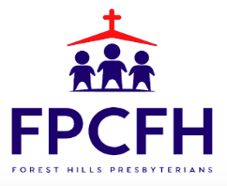

Building a Community of Faith, Hope, and Love
PresbyFH.org

