May 5, 2024 6th Sunday of Easter 11 AM

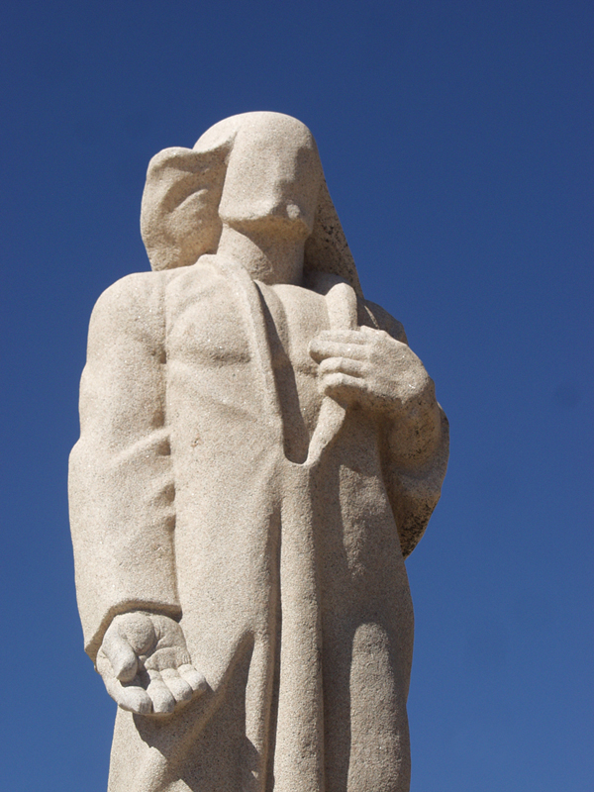
Love one another as I have loved you - Sculpture by Noël Bonardi, 1984
from Art in the Christian Tradition, a project of the Vanderbilt Divinity Library, Nashville, TN.

PRELUDE Prelude and Fugue in F Major Bach

WELCOME

CALL TO WORSHIP

HYMN #110 “Love Has Come”

1 Love has come; a light in the darkness! Love shines forth in the Bethlehem skies.
See, all heaven has come to proclaim it; hear how their song of joy arises:
Love! Love! Born unto you, a Savior! Love! Love! Glory to God on high.

2 Love is born! Come share in the wonder. Love is God now asleep in the hay.
See the glow in the eyes of His mother; what is the name her heart is saying?
Love! Love! Love is the name she whispers. Love! Love! Jesus, Emmanuel.

3 Love has come and never will leave us! Love is life everlasting and free.
Love is Jesus within and among us; Love is the peace our hearts are seeking.
Love! Love! Love is the gift of Christmas. Love! Love! Praise to You, God on high!

CALL TO CONFESSION

PRAYER OF CONFESSION

ASSURANCE OF GOD’S LOVE

RESPONSE: HYMN #581 “Gloria Patri”
Glory be the Father, and to the Son and to the Holy Ghost,
As it was in the beginning, is now, and ever shall be,
World without end. Amen. Amen.

PEACE
Let there be peace on earth.
And let it begin with me.
The peace of Christ be with you.
And also with you.

RESPONSIVE READING Psalm 101 (NRSVUE)
I will sing of loyalty and of justice; to you, O Lord, I will sing.
I will study the way that is blameless. When shall I attain it?
I will walk with integrity of heart within my house;
I will not set before my eyes anything that is base.
I hate the work of those who fall away; it shall not cling to me.
Perverseness of heart shall be far from me; I will know nothing of evil.
One who secretly slanders a neighbor I will destroy.
A haughty look and an arrogant heart I will not tolerate.
I will look with favor on the faithful in the land, so that they may live with me;
whoever walks in the way that is blameless shall minister to me.
No one who practices deceit shall remain in my house;
no one who utters lies shall continue in my presence.
Morning by morning I will destroy all the wicked in the land,
cutting off all evildoers from the city of the Lord.

FIRST READING 1 John 5:1-6 (NRSVUE)
¹ Everyone who believes that Jesus is the Christ has been born of God, and everyone who loves the parent loves the child. ² By this we know that we love the children of God, when we love God and obey his commandments. ³ For the love of God is this, that we obey his commandments. And his commandments are not burdensome, ⁴ for whatever is born of God conquers the world. And this is the victory that conquers the world, our faith. ⁵ Who is it who conquers the world but the one who believes that Jesus is the Son of God?

⁶ This is the one who came by water and blood, Jesus Christ, not with the water only but with the water and the blood. And the Spirit is the one that testifies, for the Spirit is the truth.

SECOND READING John 15:9-17 (NRSVUE)
⁹ As the Father has loved me, so I have loved you; abide in my love. ¹⁰ If you keep my commandments, you will abide in my love, just as I have kept my Father’s commandments and abide in his love. ¹¹ I have said these things to you so that my joy may be in you and that your joy may be complete.

¹² “This is my commandment, that you love one another as I have loved you. ¹³ No one has greater love than this, to lay down one’s life for one’s friends. ¹⁴ You are my friends if you do what I command you. ¹⁵ I do not call you servants any longer, because the servant does not know what the master is doing, but I have called you friends, because I have made known to you everything that I have heard from my Father. ¹⁶ You did not choose me, but I chose you. And I appointed you to go and bear fruit, fruit that will last, so that the Father will give you whatever you ask him in my name. ¹⁷ I am giving you these commands so that you may love one another.

SERMON “Heaven on Earth” Rev. Jeff Courter

HYMN #693 “Though I May Speak”

1 Though I may speak with bravest fire, and have the gift to all inspire,
and have not love, my words are vain, as sounding brass, and hopeless gain.

2 Though I may give all I possess, and striving so my love profess,
but not be given by love within, the profit soon turns strangely thin.

3 Come, Spirit, come, our hearts control; our spirits long to be made whole.
Let inward love guide every deed; by this we worship, and are freed.

PROFESSION OF FAITH THE NICENE CREED
We believe in one God, the Father, the Almighty, maker of heaven and earth, of all that is, seen and unseen. We believe in one Lord, Jesus Christ, the only Son of God, eternally begotten of the Father, God from God, Light from Light, true God from true God, begotten, not made, of one Being with the Father; through him all things were made. For us and for our salvation he came down from heaven, was incarnate of the Holy Spirit and the Virgin Mary and became truly human. For our sake he was crucified under Pontius Pilate; he suffered death and was buried. On the third day he rose again in accordance with the Scriptures; he ascended into heaven and is seated at the right hand of the Father. He will come again in glory to judge the living and the dead, and his kingdom will have no end. We believe in the Holy Spirit, the Lord, the giver of life, who proceeds from the Father and the Son, who with the Father and the Son is worshiped and glorified, who has spoken through the prophets. We believe in one holy catholic and apostolic Church. We acknowledge one baptism for the forgiveness of sins. We look for the resurrection of the dead, and the life of the world to come. Amen.

PRAYERS OF THE PEOPLE

OFFERING/OFFERTORY Prayer Freni

OFFERING SONG #606 Doxology
Praise God, from whom all blessings flow,
Praise God, all creatures here below,
Praise God above, ye heavenly host,
Praise Father, Son and Holy Ghost. Amen.
PRAYER OF DEDICATION

PRAYER OF GREAT THANKSGIVING
The Lord be with you.
And also with you.
Lift up your hearts.
We lift them to the Lord.
Let us give thanks to the Lord our God.
It is right to give our thanks and praise.
It is truly right and our greatest joy to give you thanks and praise, O Lord our God, creator and ruler of the universe.
You made a covenant with our ancestor Abraham, promising to make of him a great nation, and a blessing to all the families of the earth. (Gen. 12:1-4a)
Therefore we praise you, joining our voices with choirs of angels with prophets, apostles, and martyrs, and with all the faithful of every time and place who forever sing to the glory of your name:
Holy, holy, holy Lord, God of power and might, heaven and earth are full of your glory. Hosanna in the highest. Blessed is he who comes in the name of the Lord. Hosanna in the highest.
You are holy, O God of majesty. Out of your great love for the world, you sent Jesus, not to condemn, but to save, so that everyone who believes in him might not perish, but have eternal life, born again from above by water and the Spirit.
Remembering your gracious acts in Jesus Christ, we take from your creation this bread and this wine and joyfully celebrate his dying and rising, as we await the day of his coming.
With thanksgiving, we offer our very selves to you to be a living and holy sacrifice, dedicated to your service.
Great is the mystery of faith:
Christ has died, Christ is risen, Christ will come again.
Gracious God, pour out your Holy Spirit upon us and upon these your gifts of bread and wine, that the bread we break and the cup we bless may be the communion of the body and blood of Christ.
By your Spirit, make us one with Christ and one with your church in all the world. By faith, make us children of Abraham, justified by the righteousness and grace of Christ, so that we may share the blessings of your covenant people.
Through Christ, with Christ, in Christ, in the unity of the Holy Spirit, all glory and honor are yours, almighty God, now and forever. Amen.

THE LORD’S PRAYER

SACRAMENTS OF THE LORD’S SUPPER

ANNOUNCEMENTS

CLOSING HYMN #833 “O Love That Will Not Let Me Go”

1 O Love that wilt not let me go, I rest my weary soul in thee;
I give thee back the life I owe, that in thine ocean depths its flow
may richer, fuller be.

2 O Light that followest all my way, I yield my flickering torch to thee;
my heart restores its borrowed ray, that in thy sunshine’s blaze its day
may brighter, fairer be.

3 O Joy that seekest me through pain, I cannot close my heart to thee;
I trace the rainbow through the rain, and feel the promise is not vain
that morn shall tearless be.

4 O Cross that liftest up my head, I dare not ask to fly from thee;
I lay in dust life’s glory dead, and from the ground there blossoms red
life that shall endless be.

BENEDICTION

POSTLUDE Fugue Couperin
_________________________________________________________________________________________________________

UPCOMING CALENDAR

MONDAY, 7:00 PM – Meditation & Prayer Group in the church sanctuary. No Zoom.

SUNDAY, 10:00 AM – Bible Study in Room 7. We are studying the book of James, and will finish by end May.

SUNDAY, MAY 19 – Pentecost Sunday. Wear red! Celebration of Pastor’s graduation from New York Theological Seminary (Doctor of Ministry)

SUNDAY, MAY 26 – Picnic! Memorial Day, after service

June through August – Summer Hours: Worship will begin at 10:00 AM.

REMINDER: We are still looking for volunteers for worship readers and/or juice/coffee hour. There is a 3-month sign-up sheet posted just outside the office, and we would appreciate your help as we have been transitioning back to in-worship service. If you have any questions, please contact the Office.

First Presbyterian Church of Forest Hills
70-35 112th St., Forest Hills, NY 11375 presbyfh.org
David Barnett, Admin.718-268-4036 Jeff Courter, Pastor,
FirstPresFHNY@gmail.com; rev.jeffrey.courter@gmail.com
‘Cil Brewer, Clerk of Session David Yurick, Organist

For offerings/donations:
- Use Zelle to make Online donations from your bank account. Use this phone number to transfer to the church: 929-418-0958 (please note: this is a new number)
- Make checks payable to First Presbyterian Church of Forest Hills and mail check to the church office
- Go to our church website: presbyfh.org and click on the “Give Now” icon to set up a donation; or click on the qr code above
- Set up a “Bill pay” from your bank

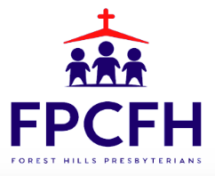

Building a Community of Faith, Hope, and Love

