August 23, 2026 13th Sunday after Pentecost 11 AM

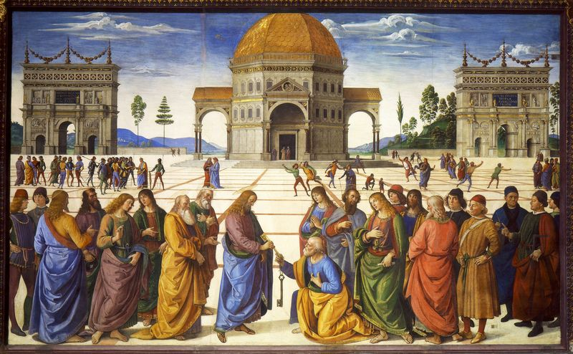
Perugino, approximately 1450-1523. Christ gives the keys of the kingdom to Peter, detail, from Art in the Christian Tradition, a project of the Vanderbilt University Divinity Library, Nashville, TN.

PRELUDE

WELCOME

CALL TO WORSHIP

HYMN #311 “Here, O Lord, Your Servants Gather”

- Here, O Lord, your servants gather, hand we link with hand;
looking toward our Savior’s cross, joined in love we stand.
As we seek the realm of God, we unite to pray:
Jesus, Savior, guide our steps, for you are the Way.

- Many are the tongues we speak, scattered are the lands,
Yet our hearts are one in God, one in love’s demands.
While in darkness hope appears, calling age and youth:
Jesus, teacher, dwell with us, for You are the Truth.

- Nature’s secrets open wide, changes never cease;
where, O where, can weary souls find the source of peace?
Unto all those sore distressed, torn by endless strife:
Jesus, healer, bring your balm, For You are the Life.

- Grant, O God, an age renewed, filled with deathless love;
help us as we work and pray; send us from above
Truth and courage, faith and power needed in our strife:
Jesus, Savior, be our Way, Be our Truth, our Life.

CALL TO CONFESSION

PRAYER OF CONFESSION

ASSURANCE OF GOD’S LOVE

RESPONSE: HYMN #582 “Glory to God”
1 Glory to God, whose goodness shines on me,
and to the Son, whose grace has pardoned me,
and to the Spirit, whose love has set me free.
As it was in the beginning, is now and ever shall be. Amen.

2 World without end, without end. Amen.
World without end, without end. Amen
World without end, without end. Amen.
As it was in the beginning, is now and ever shall be. Amen.
PEACE
Let there be peace on earth.
And let it begin with me.
The peace of Christ be with you.
And also with you.

RESPONSIVE READING Psalm 138 (NRSVUE)
I give you thanks, O Lord, with my whole heart;
before the gods I sing your praise;
I bow down toward your holy temple and give thanks to your name for your
steadfast love and your faithfulness, for you have exalted your name and
your word above everything.
On the day I called, you answered me; you increased my strength of soul.
All the kings of the earth shall praise you, O Lord,
for they have heard the words of your mouth.
They shall sing of the ways of the Lord, for great is the glory of the Lord.
For though the Lord is high, he regards the lowly,
but the haughty he perceives from far away.
Though I walk in the midst of trouble, you preserve me against the wrath of my
enemies; you stretch out your hand, and your right hand delivers me.
The Lord will fulfill his purpose for me; your steadfast love, O Lord,
endures forever. Do not forsake the work of your hands.

FIRST READING Isaiah 51:1-6 (NRSVUE)
¹ Listen to me, you who pursue righteousness, you who seek the Lord. Look to the rock from which you were hewn and to the quarry from which you were dug. ² Look to Abraham your father and to Sarah, who bore you, for he was but one when I called him, but I blessed him and made him many. ³ For the Lord will comfort Zion; he will comfort all her waste places and will make her wilderness like Eden,
her desert like the garden of the Lord; joy and gladness will be found in her, thanksgiving and the voice of song. ⁴ Listen to me, my people, and give heed to me, my nation, for a teaching will go out from me and my justice for a light to the peoples. ⁵ I will bring near my deliverance swiftly; my salvation has gone out, and my arms will rule the peoples; the coastlands wait for me, and for my arm they hope. ⁶ Lift up your eyes to the heavens and look at the earth beneath, for the heavens will vanish like smoke, the earth will wear out like a garment, and those who live on it will die like gnats, but my salvation will be forever, and my deliverance will never be ended.

CHILDREN’S SERMON

SECOND READING Matthew 16:13-20 (NRSVUE)
¹³ Now when Jesus came into the district of Caesarea Philippi, he asked his disciples, “Who do people say that the Son of Man is?” ¹⁴ And they said, “Some say John the Baptist but others Elijah and still others Jeremiah or one of the prophets.” ¹⁵ He said to them, “But who do you say that I am?” ¹⁶ Simon Peter answered, “You are the Messiah, the Son of the living God.” ¹⁷ And Jesus answered him, “Blessed are you, Simon son of Jonah! For flesh and blood has not revealed this to you but my Father in heaven. ¹⁸ And I tell you, you are Peter, and on this rock I will build my church, and the gates of Hades will not prevail against it. ¹⁹ I will give you the keys of the kingdom of heaven, and whatever you bind on earth will be bound in heaven, and whatever you loose on earth will be loosed in heaven.” ²⁰ Then he sternly ordered the disciples not to tell anyone that he was the Messiah.

SERMON “The Kingdom of Heaven” Jeff Courter

HYMN #319 “Shout to the North”

1 Men of faith rise up and sing Of the great and glorious King.
You are strong when you feel weak; In your brokenness complete.
Chorus Shout to the north and the south; Sing to the east and the west.
Jesus is Savior to all, Lord of heaven and earth.

2 Rise up women of the truth. Stand and sing to broken hearts
Who can know the healing power of our awesome King of love.
Chorus Shout to the north and the south; Sing to the east and the west.
Jesus is Savior to all, Lord of heaven and earth.

Bridge We've been through fire; we've been through rain;
We've been refined by the power of His name.
We've fallen deeper in love with You. You've burned the truth on our lips.
Chorus Shout to the north and the south; Sing to the east and the west.
Jesus is Savior to all, Lord of heaven and earth.

3 Rise up church with broken wings; fill this place with songs again
of our God who reigns on high; by God’s grace again we'll fly.
Chorus Shout to the north and the south; Sing to the east and the west.
Jesus is Savior to all, Lord of heaven and earth.

PROFESSION OF FAITH THE APOSTLES’ CREED
I Believe in God the Father Almighty, Maker of heaven and earth; and in Jesus Christ, His Only Son, our Lord, who was conceived by the Holy Spirit, born of the Virgin Mary, suffered under Pontius Pilate, was crucified, dead, and buried. He descended into hell; the third day He rose again from the dead. He ascended into heaven, and sitteth at the right hand of God the Father Almighty, from thence He shall come to judge the quick and the dead.
I believe in the Holy Spirit, the holy catholic church, the communion of saints, the forgiveness of sins, the resurrection of the body, and the life everlasting. Amen.

PRAYERS OF THE PEOPLE

OFFERING/OFFERTORY

OFFERING SONG #328 “Praise God, All You Nations” (DaNase)
Praise God, all you nations. People of God, sing praise!
Praise God, all you nations. People of God, sing praise:
God’s love is great and endures forever.
Praise God, all you nations. People of God, sing praise!

PRAYER OF DEDICATION/THE LORD’S PRAYER

ANNOUNCEMENTS

CLOSING HYMN #295 “Go to the World!”

- Go to the world! Go into all the earth.
Go preach the cross where Christ renews life's worth,
baptizing as the sign of our rebirth.
Alleluia! Alleluia!

- Go to the world! Go into every place.
Go live the word of God's redeeming grace.
Go seek God's presence in each time and space.
Alleluia! Alleluia!

- Go to the world! Go struggle, bless and pray;
the nights of tears give way to joyous day.
As servant church, you follow Christ's own way.
Alleluia! Alleluia!

- Go to the world! Go as the ones I send,
for I am with you till the age shall end,
when all the hosts of glory cry "Amen!"
Alleluia! Alleluia!

BENEDICTION

POSTLUDE
___________________________________________________________________

UPCOMING CALENDAR

WORLD COMMUNION OFFERING - September 6 - October 4, 2026
All of God's people gather around the Table to celebrate the life, death and resurrection of Jesus Christ. Part of the atonement that happens around this Table is reconciliation, which is the focus of the World Communion Offering. Experience the grace that comes from reconciling all peoples from all nations around the corner and around the globe through the ministry of this offering.
(Formally Peace and Global Witness)

REMINDER – Please keep in mind that worship is now at 10:00 AM for the Summer months ending last Sunday of August.

REMINDER: We are still looking for volunteers for worship readers and/or juice/coffee hour. There is a 3-month sign-up sheet posted just outside the office.
If you have any questions, please contact the Office.

First Presbyterian Church of Forest Hills
70-35 112th St., Forest Hills, NY 11375 presbyfh.org
David Barnett, Admin.718-268-4036 Jeff Courter, Pastor,
FirstPresFHNY@gmail.com; rev.jeffrey.courter@gmail.com
Rafael Reyes-Quiroz, Clerk of Session

Please note: we now have a public WiFi for the church, though it may only be available in the church hall for now.
Name: CHURCH GUEST
Password: welcome1

For offerings/donations:

- Use Zelle to make Online donations from your bank account. Use this phone number to transfer to the church:
929-418-0958 (please note: this is a new number)
- Make checks payable to First Presbyterian Church of Forest Hills and mail check to the church office
- Go to our church website: presbyfh.org and click on the “Give Now” icon to set up a donation; or click on the QR code above
- The web address of your donation form has now been changed to: https://secure.myvanco.com/L-ZBFD
- Set up a “Bill pay” from your bank.

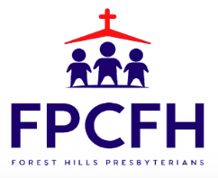

Building a Community of Faith, Hope, and Love
PresbyFH.org

