June 7, 2026 2nd Sunday after Pentecost 11 AM
PRIDE month

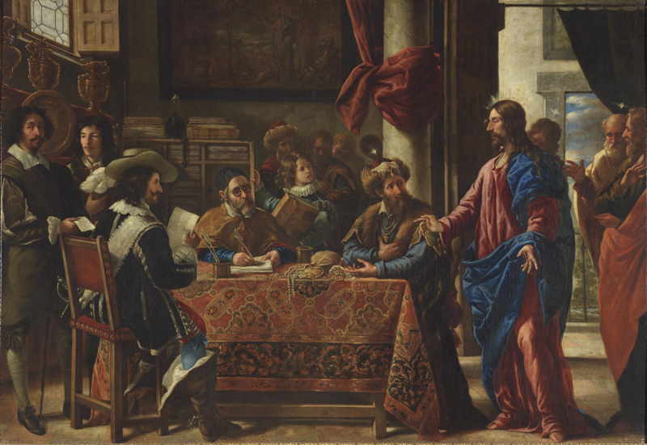
Pareja, Juan de, 1606-1670. Vocation of Saint Matthew,(1661)
from Art in the Christian Tradition, a project of the Vanderbilt Divinity Library, Nashville, TN.

PRELUDE “Overture” G.F. Handel
“Let justice and judgment be the preparation of Thy seat;
Let mercy and faithfulness go before Thy face.”

WELCOME

CALL TO WORSHIP

HYMN #149 “All Hail to God’s Anointed”

1 All hail to God’s anointed, great David’s greater Son!
All hail, in time appointed, your reign on earth begun!
You come to break oppression, to set the captive free,
to take away transgression and rule in equity.

2 You come with rescue speedy to those who suffer wrong,
to help the poor and needy and bid the weak be strong;
to give them songs for sighing, their darkness turn to light,
whose souls, condemned and dying, are precious in your sight.

3 You shall come down like showers upon the fruitful earth;
love, joy, and hope, like flowers, spring in your path to birth.
Before you on the mountains shall peace, the herald, go,
and righteousness in fountains from hill to valley flow.

4 All rulers bow before you, and gold and incense bring.
All nations shall adore you; your praise all people sing.
To you shall prayer unceasing and daily vows ascend.
Your rule is still increasing; your rule is without end.

CALL TO CONFESSION

PRAYER OF CONFESSION

ASSURANCE OF GOD’S LOVE

RESPONSE: HYMN #581 “Gloria Patri”
Glory be the Father, and to the Son and to the Holy Ghost,
As it was in the beginning, is now, and ever shall be,
World without end. Amen. Amen.

PEACE
Let there be peace on earth.
And let it begin with me.
The peace of Christ be with you.
And also with you.
RESPONSIVE READING Psalm 50:7-15 (NRSVUE)
“Hear, O my people, and I will speak, O Israel, I will testify against you.
I am God, your God.
Not for your sacrifices do I rebuke you;
your burnt offerings are continually before me.
I will not accept a bull from your house or goats from your folds.
For every wild animal of the forest is mine, the cattle on a thousand hills.
I know all the birds of the air, and all that moves in the field is mine.
“If I were hungry, I would not tell you, for the world and all that is in it is mine.
Do I eat the flesh of bulls or drink the blood of goats?
Offer to God a sacrifice of thanksgiving, and pay your vows to the Most High.
Call on me in the day of trouble; I will deliver you, and you shall glorify me.”

FIRST READING Hosea 5:15-6:6 (NRSVUE)
¹⁵ I will return again to my place until they acknowledge their guilt and seek my face. In their distress they will beg my favor:

¹ “Come, let us return to the Lord, for it is he who has torn, and he will heal us;
he has struck down, and he will bind us up. ² After two days he will revive us;
on the third day he will raise us up, that we may live before him. ³ Let us know, let us press on to know the Lord; his appearing is as sure as the dawn; he will come to us like the showers, like the spring rains that water the earth.” Impenitence of Israel and Judah ⁴ What shall I do with you, O Ephraim? What shall I do with you, O Judah? Your love is like a morning cloud, like the dew that goes away early.
⁵ Therefore I have hewn them by the prophets; I have killed them by the words of my mouth, and my judgment goes forth as the light. ⁶ For I desire steadfast love and not sacrifice, the knowledge of God rather than burnt offerings.

SECOND READING Matthew 9:9-13,18-26 (NRSVUE)
⁹ As Jesus was walking along, he saw a man called Matthew sitting at the tax-collection station, and he said to him, “Follow me.” And he got up and followed him.
¹⁰ And as he sat at dinner in the house, many tax collectors and sinners came and were sitting with Jesus and his disciples. ¹¹ When the Pharisees saw this, they said to his disciples, “Why does your teacher eat with tax collectors and sinners?” ¹² But when he heard this, he said, “Those who are well have no need of a physician, but those who are sick. ¹³ Go and learn what this means, ‘I desire mercy, not sacrifice.’ For I have not come to call the righteous but sinners.”

¹⁸ While he was saying these things to them, suddenly a leader came in and knelt before him, saying, “My daughter has just died, but come and lay your hand on her, and she will live.” ¹⁹ And Jesus got up and followed him, with his disciples. ²⁰ Then suddenly a woman who had been suffering from a flow of blood for twelve years came up behind him and touched the fringe of his cloak, ²¹ for she was saying to herself, “If I only touch his cloak, I will be made well.” ²² Jesus turned, and seeing her he said, “Take heart, daughter; your faith has made you well.” And the woman was made well from that moment. ²³ When Jesus came to the leader’s house and saw the flute players and the crowd making a commotion, ²⁴ he said, “Go away, for the girl is not dead but sleeping.” And they laughed at him. ²⁵ But when the crowd had been put outside, he went in and took her by the hand, and the girl got up. ²⁶ And the report of this spread through all of that district.

SERMON ‘Cil Brewer

HYMN # 720 “Jesus Calls Us”

1 Jesus calls us: o'er the tumult of our life's wild, restless sea;
day by day his sweet voice soundeth saying, "Christian, follow me."

2 Jesus calls us from the worship of the vain world's golden store,
from each idol that would keep us, saying, "Christian, love me more."

3 In our joys and in our sorrows, days of toil and hours of ease,
still he calls, in cares and pleasures, "Christian, love me more than these."

4 Jesus calls us: by thy mercies, Savior, may we hear thy call,
give our hearts to thy obedience, serve and love thee best of all.

PROFESSION OF FAITH THE APOSTLES CREED
I Believe in God the Father Almighty, Maker of heaven and earth; and in Jesus Christ, His Only Son, our Lord, who was conceived by the Holy Spirit, born of the Virgin Mary, suffered under Pontius Pilate, was crucified, dead, and buried. He descended into hell; the third day He rose again from the dead. He ascended into heaven, and sitteth at the right hand of God the Father Almighty, from thence He shall come to judge the quick and the dead.
I believe in the Holy Spirit, the holy catholic church, the communion of saints,
the forgiveness of sins, the resurrection of the body, and the life everlasting.

PRAYERS OF THE PEOPLE

OFFERING/OFFERTORY “Evocation” Gilber M. Martin
“The risen Lord reinstates Peter. “Do you truly love Me more than these?”

OFFERING SONG #606 Doxology
Praise God, from whom all blessings flow,
Praise God, all creatures here below,
Praise God above, ye heavenly host,
Praise Father, Son and Holy Ghost. Amen.

PRAYER OF DEDICATION/THE LORD’S PRAYER

ANNOUNCEMENTS

HYMN # 546 “Lord, Dismiss Us with Your Blessing”

1 Lord, dismiss us with your blessing; fill our hearts with joy and peace;
let us each, your love possessing, triumph in redeeming grace.
O refresh us, O refresh us, traveling through this wilderness.

2 Thanks we give and adoration for your gospel's joyful sound;
may the fruits of your salvation in our hearts and lives abound.
Ever faithful, ever faithful to your truth may we be found.

3 Savior, when your love shall call us, from our struggling pilgrim way,
let no fear of death appall us, glad your summons to obey.
May we ever, may we ever reign with you in endless day.
BENEDICTION

POSTLUDE “Devotional Suite” C. Talmadge

UPCOMING CALENDAR

TODAY, JUNE 7th – JACKSON HEIGHTS PRIDE PARADE, 12:00 NOON – Please note that the Sacrament of Communion has been moved to Sunday, June 14th. The Pastor is not here as he is marching in the parade.

WEDNESDAY, 7:00 PM - we have started our book discussion group on the book The Cost of Discipleship by Dietrich Bonhoeffer. We will be on Zoom at 7:00 PM.

SUNDAY, JUNE 21st, Father’s Day - Starting on this date, worship will move to 10:00 AM for the Summer months ending last Sunday of August.

REMINDER: We are still looking for volunteers for worship readers and/or juice/coffee hour. There is a 3-month sign-up sheet posted just outside the office.
If you have any questions, please contact the Office.

First Presbyterian Church of Forest Hills
70-35 112th St., Forest Hills, NY 11375 presbyfh.org
David Barnett, Admin.718-268-4036 Jeff Courter, Pastor,
FirstPresFHNY@gmail.com; rev.jeffrey.courter@gmail.com
Rafael Reyes-Quiroz, Clerk of Session Hannah Lin, Guest Organist

Please note: we now have a public WiFi for the church, though it may only be available in the church hall for now.
Name: CHURCH GUEST
Password: welcome1

For offerings/donations:

- Use Zelle to make Online donations from your bank account. Use this phone number to transfer to the church:
929-418-0958 (please note: this is a new number)
- Make checks payable to First Presbyterian Church of Forest Hills and mail check to the church office
- Go to our church website: presbyfh.org and click on the “Give Now” icon to set up a donation; or click on the qr code above
- The web address of your donation form has now been changed to: https://secure.myvanco.com/L-ZBFD
- Set up a “Bill pay” from your bank.

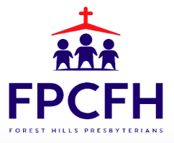

Building a Community of Faith, Hope, and Love
PresbyFH.org

