October 18, 2026 21st Sunday after Pentecost 11 AM
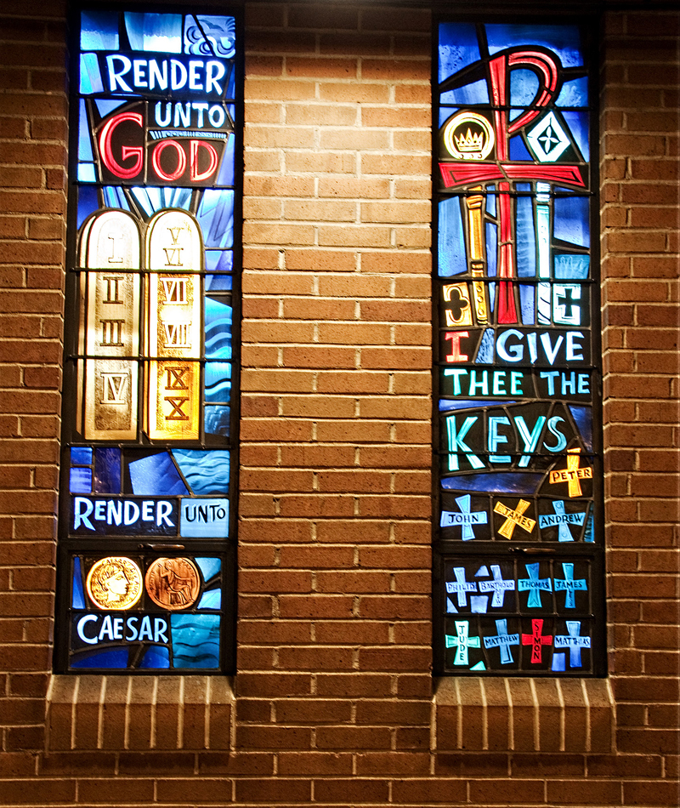
. Rambusch Company. Render unto God, 1962,
from Art in the Christian Tradition, a project of the Vanderbilt University Divinity Library, Nashville, TN.

PRELUDE “Concerto Opus 4, No.6, B♭ Major, 2nd & 3rd Mvt.” G.F. Handel

WELCOME

CALL TO WORSHIP

HYMN #307 “God of Grace and God of Glory”

1 God of grace and God of glory, on thy people pour thy power;
crown thine ancient church's story; bring its bud to glorious flower.
Grant us wisdom, grant us courage, for the facing of this hour,
for the facing of this hour.

2 Lo! the hosts of evil round us scorn thy Christ, assail his ways!
From the fears that long have bound us free our hearts to faith and praise.
Grant us wisdom, grant us courage, for the living of these days,
for the living of these days.

3 Cure thy children's warring madness; bend our pride to thy control;
shame our wanton, selfish gladness, rich in things and poor in soul.
Grant us wisdom, grant us courage, lest we miss thy kingdom's goal,
lest we miss thy kingdom's goal.

4 Save us from weak resignation to the evils we deplore.
Let the gift of thy salvation be our glory evermore.
Grant us wisdom, grant us courage, serving thee whom we adore,
serving thee whom we adore.

CALL TO CONFESSION

PRAYER OF CONFESSION

ASSURANCE OF GOD’S LOVE

RESPONSE: HYMN #581 “Gloria Patri”
Glory be the Father, and to the Son and to the Holy Ghost,
As it was in the beginning, is now, and ever shall be,
World without end. Amen. Amen

PEACE
Let there be peace on earth.
And let it begin with me.
The peace of Christ be with you.
And also with you.
RESPONSIVE READING Psalm 96:1-9 (NRSVUE)
O sing to the Lord a new song; sing to the Lord, all the earth.
Sing to the Lord; bless his name; tell of his salvation from day to day.
Declare his glory among the nations, his marvelous works among all the peoples.
For great is the Lord and greatly to be praised;
he is to be revered above all gods.
For all the gods of the peoples are idols, but the Lord made the heavens.
Honor and majesty are before him; strength and beauty are in his sanctuary.
Ascribe to the Lord, O families of the peoples,
scribe to the Lord glory and strength.
Ascribe to the Lord the glory due his name;
bring an offering, and come into his courts.
Worship the Lord in holy splendor; tremble before him, all the earth.

FIRST READING Isaiah 45:1-7 (NRSVUE)
¹ Thus says the Lord to his anointed, to Cyrus, whose right hand I have grasped
to subdue nations before him and to strip kings of their robes, to open doors before him — and the gates shall not be closed: ² I will go before you and level the mountains; I will break in pieces the doors of bronze and cut through the bars of iron; ³ I will give you the treasures of darkness and riches hidden in secret places,
so that you may know that it is I, the Lord, the God of Israel, who call you by your name. ⁴ For the sake of my servant Jacob and Israel my chosen, I call you by your name; I give you a title, though you do not know me. ⁵ I am the Lord, and there is no other; besides me there is no god. I arm you, though you do not know me,
⁶ so that they may know, from the rising of the sun and from the west, that there is no one besides me; I am the Lord, and there is no other. ⁷ I form light and create darkness, I make weal and create woe; I the Lord do all these things.

SECOND READING Matthew 22:15-22 (NRSVUE)
¹⁵ Then the Pharisees went and plotted to entrap him in what he said. ¹⁶ So they sent their disciples to him, along with the Herodians, saying, “Teacher, we know that you are sincere, and teach the way of God in accordance with truth, and show deference to no one, for you do not regard people with partiality. ¹⁷ Tell us, then, what you think. Is it lawful to pay taxes to Caesar or not?” ¹⁸ But Jesus, aware of their malice, said, “Why are you putting me to the test, you hypocrites? ¹⁹ Show me the coin used for the tax.” And they brought him a denarius. ²⁰ Then he said to them, “Whose head is this and whose title?” ²¹ They answered, “Caesar’s.” Then he said to them, “Give therefore to Caesar the things that are Caesar’s and to God the things that are God’s.” ²² When they heard this, they were amazed, and they left him and went away.

SERMON “God’s Currency” Jeff Courter

HYMN#697 (V-1,3,4) “Take My Life”

1 Take my life and let it be consecrated, Lord, to thee;
take my moments and my days; let them flow in ceaseless praise;
let them flow in ceaseless praise.
3 Take my voice and let me sing always, only, for my King;
take my lips and let them be filled with messages from thee,
filled with messages from thee.
4 Take my silver and my gold; not a mite would I withhold;
take my intellect and use every power as thou shalt choose,
every power as thou shalt choose.

PROFESSION OF FAITH THE APOSTLES’ CREED
I Believe in God the Father Almighty, Maker of heaven and earth; and in Jesus Christ, His Only Son, our Lord, who was conceived by the Holy Spirit, born of the Virgin Mary, suffered under Pontius Pilate, was crucified, dead, and buried. He descended into hell; the third day He rose again from the dead. He ascended into heaven, and sitteth at the right hand of God the Father Almighty, from thence He shall come to judge the quick and the dead.
I believe in the Holy Spirit, the holy catholic church, the communion of saints, the forgiveness of sins, the resurrection of the body, and the life everlasting. Amen.

PRAYERS OF THE PEOPLE

OFFERING/OFFERTORY Chorale on “Deck Thyself with Gladness” J.S. Bach
(BWV. 634)
OFFERING SONG #606 Doxology
Praise God, from whom all blessings flow,
Praise God, all creatures here below,
Praise God above, ye heavenly host,
Praise Father, Son and Holy Ghost. Amen.

PRAYER OF DEDICATION/THE LORD’S PRAYER

ANNOUNCEMENTS

CLOSING HYMN #541 “God Be with You Till We Meet Again”
1 God be with you till we meet again; loving counsels guide, uphold you,
with a shepherd's care enfold you: God be with you till we meet again.
2 God be with you till we meet again; unseen wings protecting hide you,
daily manna still provide you: God be with you till we meet again.
3 God be with you till we meet again; when life's perils thick confound you,
put unfailing arms around you: God be with you till we meet again.
4 God be with you till we meet again; keep love's banner floating o'er you;
smite death's threatening wave before you: God be with you till we meet again.

BENEDICTION

POSTLUDE Duet Movement – Flute 8’ 2’ & Horn 8’ Thomas Thorley
___________________________________________________________________

UPCOMING CALENDAR

TODAY - we will be part of Commonpoint's "Longest Table" get-together after our worship service. We will gather and dine with other organizations and faiths in a potluck event. Click the link below to find out more and to register:
https://www.commonpoint.org/event/the-longest-table (You must be registered to attend!)

WEDNESDAY, OCT. 21st – 7:00 PM - We will be starting another mid-week book discussion next week: C.S. Lewis' The Screwtape Letters at 7:00 PM Wednesday evenings on Zoom. We have copies of the book in the church office for those interested in reading and participating in the discussion.

SATURDAY, OCTOBER 24th - We will March to the Polls from VoteFest in MacDonald Park! October 24 is the first day for early voting, and our Outreach and Engagement Committee will represent our congregation as we gather and walk to vote early in the upcoming general election. Stay tuned for more details - this upcoming vote is an important one! (November 3 is Election Day.) As the VoteFest flyer says, "Democracy is a team sport!"

OCTOBER 31st - Halloween is on a Saturday this year, and we will have a party for the kids in the church hall! We are looking for volunteers - please contact Lois DeLong or the church office to volunteer.

SUNDAY, NOVEMBER 8th - we will have a discussion about Medicare, Medicaid and health insurance for seniors. This will be a presentation after worship in the church hall - mark your calendars and invite anyone who you think would be interested. Stay tuned for more details and a flyer.

REMINDER – Please keep in mind that the worship is now at 11:00 AM through the Fall and Winter; Sunday School and Adult Bible Study starts at 10:00 AM.

REMINDER: We are still looking for volunteers for worship readers and/or juice/coffee hour. There is a 3-month sign-up sheet posted just outside the office.
If you have any questions, please contact the Office.
First Presbyterian Church of Forest Hills
70-35 112th St., Forest Hills, NY 11375 presbyfh.org
David Barnett, Admin.718-268-4036 Jeff Courter, Pastor,
FirstPresFHNY@gmail.com; rev.jeffrey.courter@gmail.com
Rafael Reyes-Quiroz, Clerk of Session Hannah Lin, Guest Organist

Please note: we now have a public WiFi for the church, though it may only be available in the church hall for now.
Name: CHURCH GUEST
Password: welcome1

For offerings/donations:

- Use Zelle to make Online donations from your bank account. Use this phone number to transfer to the church:
929-418-0958 (please note: this is a new number)
- Make checks payable to First Presbyterian Church of Forest Hills and mail check to the church office
- Go to our church website: presbyfh.org and click on the “Give Now” icon to set up a donation; or click on the QR code above
- The web address of your donation form has now been changed to: https://secure.myvanco.com/L-ZBFD
- Set up a “Bill pay” from your bank.



Building a Community of Faith, Hope, and Love
PresbyFH.org

