May 17, 2026 7th Sunday of Easter/ 11 AM
Ascension of the Lord

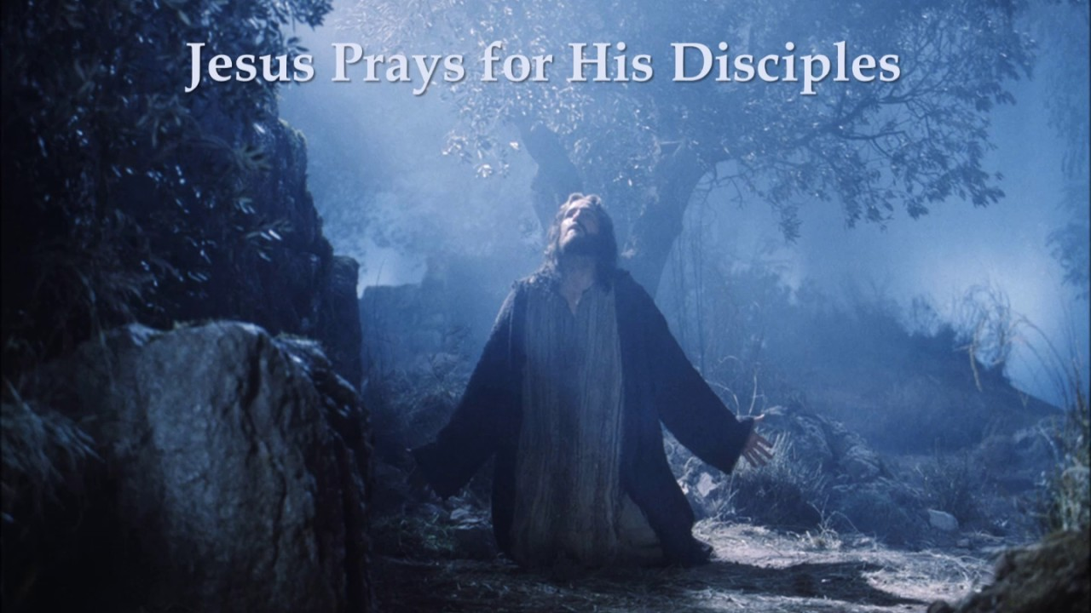
John 17 – follow-Jesus

PRELUDE “Chorale in D Major” Cesar Franck

WELCOME

CALL TO WORSHIP

HYMN #260 (vv. 1, 2) “Alleluia! Sing to Jesus”

1 Alleluia! Sing to Jesus; his the scepter, his the throne;
Alleluia! his the triumph, his the victory alone!
Hark! The songs of peaceful Zion thunder like a mighty flood:
"Jesus out of every nation has redeemed us by his blood."

2 Alleluia! Not as orphans are we left in sorrow now;
Alleluia! he is near us; faith believes nor questions how.
Though the cloud from sight received him, when the forty days were o'er,
shall our hearts forget his promise: "I am with you evermore"?

CALL TO CONFESSION

PRAYER OF CONFESSION

ASSURANCE OF GOD’S LOVE

RESPONSE: HYMN #581 “Gloria Patri”
Glory be the Father, and to the Son and to the Holy Ghost,
As it was in the beginning, is now, and ever shall be,
World without end. Amen. Amen.

PEACE
Let there be peace on earth.
And let it begin with me.
The peace of Christ be with you.
And also with you.

RESPONSIVE READING Psalm 21:1-7 (NRSVUE)
In your strength the king rejoices, O Lord, and in your help how greatly he exults!
You have given him his heart’s desire
and have not withheld the request of his lips. Selah
For you meet him with rich blessings; you set a crown of fine gold on his head.
He asked you for life; you gave it to him—length of days forever and ever.
His glory is great through your help; splendor and majesty you bestow on him.
You bestow on him blessings forever;
you make him glad with the joy of your presence.
For the king trusts in the Lord,
and through the steadfast love of the Most High he shall not be moved.

FIRST READING Acts 1:6-14 (NRSVUE)
⁶ So when they had come together, they asked him, “Lord, is this the time when you will restore the kingdom to Israel?” ⁷ He replied, “It is not for you to know the times or periods that the Father has set by his own authority. ⁸ But you will receive power when the Holy Spirit has come upon you, and you will be my witnesses in Jerusalem, in all Judea and Samaria, and to the ends of the earth.” ⁹ When he had said this, as they were watching, he was lifted up, and a cloud took him out of their sight. ¹⁰ While he was going and they were gazing up toward heaven, suddenly two men in white robes stood by them. ¹¹ They said, “Men of Galilee, why do you stand looking up toward heaven? This Jesus, who has been taken up from you into heaven, will come in the same way as you saw him go into heaven.”
¹² Then they returned to Jerusalem from the mount called Olivet, which is near Jerusalem, a Sabbath day’s journey away. ¹³ When they had entered the city, they went to the room upstairs where they were staying: Peter, and John, and James, and Andrew, Philip and Thomas, Bartholomew and Matthew, James son of Alphaeus, and Simon the Zealot, and Judas son of James. ¹⁴ All these were constantly devoting themselves to prayer, together with certain women, including Mary the mother of Jesus, as well as his brothers.

CHILDREN’S SERMON

SECOND READING John 17:1-11 (NRSVUE)
¹ After Jesus had spoken these words, he looked up to heaven and said, “Father, the hour has come; glorify your Son so that the Son may glorify you, ² since you have given him authority over all people, to give eternal life to all whom you have given him. ³ And this is eternal life, that they may know you, the only true God, and Jesus Christ, whom you have sent. ⁴ I glorified you on earth by finishing the work that you gave me to do. ⁵ So now, Father, glorify me in your own presence with the glory that I had in your presence before the world existed.
⁶ “I have made your name known to those whom you gave me from the world. They were yours, and you gave them to me, and they have kept your word. ⁷ Now they know that everything you have given me is from you, ⁸ for the words that you gave to me I have given to them, and they have received them and know in truth that I came from you, and they have believed that you sent me. ⁹ I am asking on their behalf; I am not asking on behalf of the world but on behalf of those whom you gave me, because they are yours. ¹⁰ All mine are yours, and yours are mine, and I have been glorified in them. ¹¹ And now I am no longer in the world, but they are in the world, and I am coming to you. Holy Father, protect them in your name that you have given me, so that they may be one, as we are one.

GUEST SPEAKER “Life Questions” Dr. Rikki Asher

HYMN #346 (vv. 1,2) “For the Healing of the Nations”

1 For the healing of the nations, Lord, we pray with one accord;
for a just and equal sharing of the things that earth affords;
to a life of love in action help us rise and pledge our word.

2 Lead us forward into freedom; from despair your world release,
that, redeemed from war and hatred, all may come and go in peace.
Show us how through care and goodness fear will die and hope increase.

PROFESSION OF FAITH THE APOSTLES’ CREED
I Believe in God the Father Almighty, Maker of heaven and earth; and in Jesus Christ, His Only Son, our Lord, who was conceived by the Holy Spirit, born of the Virgin Mary, suffered under Pontius Pilate, was crucified, dead, and buried. He descended into hell; the third day He rose again from the dead. He ascended into heaven, and sitteth at the right hand of God the Father Almighty, from thence He shall come to judge the quick and the dead. I believe in the Holy Spirit, the holy catholic church, the communion of saints, the forgiveness of sins, the resurrection of the body, and the life everlasting. Amen.
PRAYERS OF THE PEOPLE

OFFERING/OFFERTORY “Here Am I, Send Me” Van D. Thompson

OFFERING SONG #606 Doxology
Praise God, from whom all blessings flow,
Praise God, all creatures here below,
Praise God above, ye heavenly host,
Praise Father, Son and Holy Ghost. Amen.

PRAYER OF DEDICATION/THE LORD’S PRAYER

ANNOUNCEMENTS

CLOSING HYMN #737 (vv. 1, 2) “Lord Jesus, You Shall Be My Song”

1 Lord Jesus, you shall be my song as I journey;
I'll tell everybody about you wherever I go:
you alone are our life and our peace and our love.
Lord Jesus, you shall be my song as I journey.

2 Lord Jesus, I'll praise you as long as I journey;
May all of my joy be a faithful reflection of you.
May the earth and the sea and the sky join my song.
Lord Jesus, I'll praise you as long as I journey.

BENEDICTION

POSTLUDE “Grand Jeu” Pierre Du Mage
(Reed Chorus of the Organ) (1674-1751)

UPCOMING CALENDAR

Our Guest Speaker today is Dr. Rikki Asher, who has been practicing Buddhism since 1978. She is an artist and a yoga teacher who tends to combine these talents as much as possible.

SUNDAY, ADULT BIBLE STUDY – 10:00 AM – We are finishing up the Bible book of Ephesians, and then we will take a break for the Summer until resuming in the Fall.

SUNDAY, May 24 – Pentecost Sunday/Memorial Day Sunday Picnic
Wear something red for Pentecost Sunday! Stay after for the picnic!

REMINDER: We are still looking for volunteers for worship readers and/or juice/coffee hour. There is a 3-month sign-up sheet posted just outside the office.
If you have any questions, please contact the Office.

First Presbyterian Church of Forest Hills
70-35 112th St., Forest Hills, NY 11375 presbyfh.org
David Barnett, Admin.718-268-4036 Jeff Courter, Pastor,
FirstPresFHNY@gmail.com; rev.jeffrey.courter@gmail.com
Nadina Grants, Clerk of Session Hannah Lin, Guest Organist

Please note: we now have a public WiFi for the church, though it may only be available in the church hall for now.
Name: CHURCH GUEST
Password: welcome1

For offerings/donations:

- Use Zelle to make Online donations from your bank account. Use this phone number to transfer to the church:
929-418-0958 (please note: this is a new number)
- Make checks payable to First Presbyterian Church of Forest Hills and mail check to the church office
- Go to our church website: presbyfh.org and click on the “Give Now” icon to set up a donation; or click on the qr code above
- The web address of your donation form has now been changed to: https://secure.myvanco.com/L-ZBFD
- Set up a “Bill pay” from your bank.



Building a Community of Faith, Hope, and Love
PresbyFH.org

