ANNUAL REPORT 2025
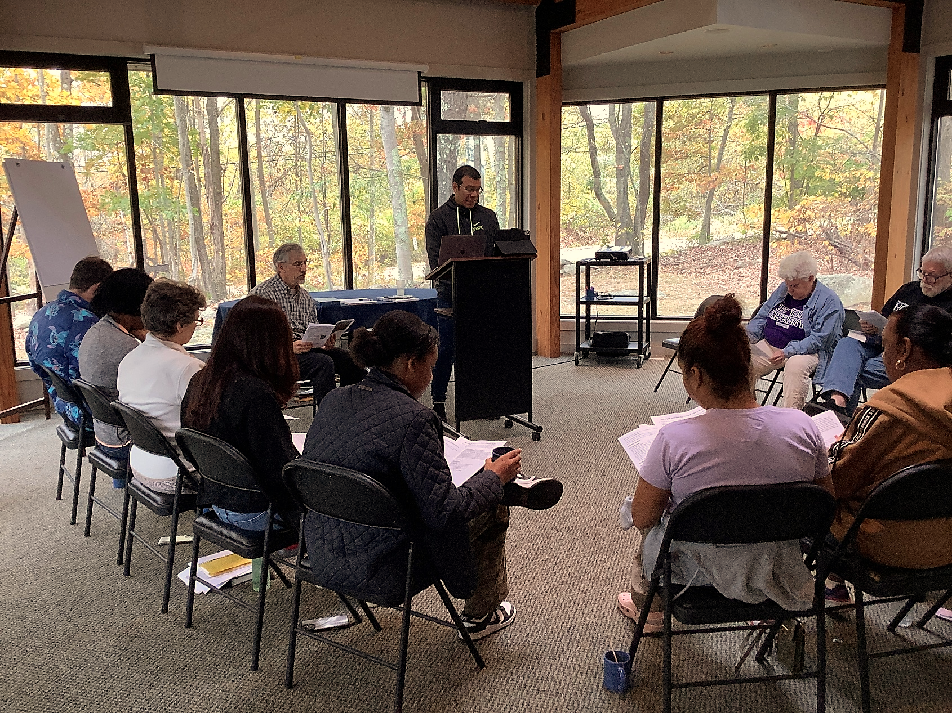

First Presbyterian Church of Forest Hills
70-35 112th Street, Forest Hills, NY 11375
Phone: 1 (718) 268-4036 Websit e: www.presbyfh.org
E-mail: FirstPresFHNY@gmail.com Jeffrey Courter, Pastor – E-mail: Rev.Jeff.Courter@gmail.com

Reports for the Year 2025

ANNUAL MEETING OF THE CONGREGATION

SUNDAY, January 25, 2026 (virtual/online)
The Mission of the First Presbyterian Church of Forest Hills is to welcome all people into our diverse family of Christian faith and fellowship within the larger body of the Presbyterian Church, USA. We strive to experience and celebrate God's presence in worship and daily living, and to deepen our faith and commitment to Jesus Christ. We share the love of Christ by reaching out to those in need within our church, across our communities, and throughout the world. By word and deed, we endeavor to proclaim the message of God's love and the Gospel of Jesus Christ our Lord and Savior.

Table of Contents

Pg. 2 Agenda

Pg. 3 Reports of the Session
2024 Annual Meeting of the Congregation and Corporation Minutes

Pg. 8 Report of the Pastor

Pg. 15 Report from Clerk of Session

Pg. 16 Spiritual Formation Committee Report

Pg. 17 Outreach & Engagement Committee Report

Pg. 22 Stewardship Report

Pg. 22 Personnel & Administration Committee Report

Pg. 23 Building and Grounds Committee Report

Pg. Report of the Deacons - N/A

Pg. 25 State of the Congregation Report

Pg. 26 Report of the Nominating Committee

END OF REPORT:

Financial Report for year ending 2025

Morgan Stanley Investments Report

Budget Projection 2026

ANNUAL MEETINGS OF THE CONGREGATION
January 25, 2026

Moderator ......................................,......,.....................................................................Rev. Dr. Jeff Courter
Clerk of Session………………………………………………………………………………………..…….Nadina Grants

Call to Order, Quorum, Prayer.
Invitation to non-members to rights of the floor without vote Approval of the Agenda and Reports as Printed
Necrology Report
Approval of Minutes (Page 3)

Report of the Session……………………………………………………………………..Clerk of Session

Report of the Deacons N/A

Report of the Nominating Committee……………………………………………………………….
Session vacancies to be filled Nominations from the floor Election
Deacons' vacancies to be filled Nominations from the floor
Election

Election of Pastor Nominating Committee

Closing Prayer
Adjournment

ANNUAL CONGREGATION MEETING MINUTES
OF THE FIRST PRESBYTERIAN CHURCH OF FOREST HILLS
February 2, 2025

The meeting was called to order at 12:26 p.m. It was held both in-person and online. There were 17 members present in-person and 9 people online for a total of 26 members present to declare a quorum.

The meeting was opened with prayer by Pastor Jeff Courter at 12:25 pm.

A motion was made and approved to accept the 2024 Annual Meeting Agenda and 2024 Annual Meeting and Corporation Minutes.

Report of the Pastor:

Let the record reflect Pastor Jeff as the Designated Pastor and not Interim Pastor.
Pastor Jeff has been our Interim and Designated Pastor for 5 years with his contract up for renewal this summer. He deferred the congregation to his Pastor’s Report but expressed his best thing he love to do as Pastor was to spend time with us and he extended an open invitation to spend time with him.

Clerk of Session Report:

Report was reviewed and a motion was made and approved to accept the report.

Committee Reports: Chairs were invited to highlight or add to their submitted written reports. Each report was reviewed, discussed, voted on and approved separately. The reports approved were:

The Spiritual Formation and Education Committees:

Nadina Grants noted the Online studies held where “Little Prince,” Season’s Greetings” along with others.

Karen Wood noted more children were needed for Sunday School.

Outreach and Engagement Committee:

Lois highlighted the brainstorming sessions held. The 3 areas the committee focused on were Civil Engagement, Arts and Health. She expressed there were mixed results but they will continue to move forward on the 3 areas. She thanked the committee members and David Barnett for their efforts to get work accomplished. The committee is seeking additional volunteers and Pastor noted more participation is needed and urged us to get involved. He suggested we do something sacrificial and support the church’s events.

Personnel Committee:

Andy’s Quality Cleaning was used for janitorial services. The IRS returned $27,327.00 in taxes collected during COVID. The church received $1,000.00 from the Borough President’s Office. The Presbytery raised the minimum compensation for ministers to 3.5%. Session approved the raise for Pastor Jeff. Vernon Griffith was replaced with ESB Consulting.

Buildings and Grounds Committee:

Milton deferred to his report.

Deacon’s Report:

Charlie deferred to his report.

State of the Congregation:
Necrology: In 2024, we lost longtime church member Carmen Serra and music director and organist, David Yurick, who served our church for over fifty years.
Membership: As noted in the Clerk of Session report, as of December 31, 2025, the membership roll of the church stands at 93 members.

Stewardship Report: There were 19 pledges as of January 21, 2025 totaling $43,180.00.
Report of the Nominating Committee: Irene and Rafi reported more volunteers are needed.

Session  Rotating off 2025 | 2026 | 2027
Nadina Grants | N/A | N/A
Karen Wood
Leon Collier
 | Milton Balram | Lois Anne DeLong
 | Bruno Razafindrakoto | Rafael Reyes-Quiroz
 | Luis Gallego

Deacons  Rotating off 2025 | 2026 | 2027
N/A | Charlie Potter | ‘Cil Brewer
 | Dawn Simmonds

Lois agreed to remain on Session with the remaining members remaining the same. ‘Cil agreed to serve on Deacons for 3 years. There was an invitation to nominate members from the floor and online to serve as Elders and Deacons with none being made.

Session voted to reduce the minimum number of Elders required by the Bi-Laws to 6 members.

A motion to close the nominations was made and acceptance of the slate as presented was made and approved.

Nominating Committee:

‘Cil from the Deacons, Rafi as the Elder and Ingrid. A motion to close the nominations was made and approved.

With the business of the 2025 Annual Congregation Meeting completed, it was adjourned at 12:53 p.m. and closed with prayer by Pastor Jeff.

ANNUAL MEETING OF THE CORPORATION OF
THE FIRST PRESBYTERY CHURCH OF FOREST HILLS

The Annual Meeting of the Corporation of the First Presbyterian Church of Forest Hills was immediately called to order following the adjournment of the Annual Congregational Meeting.

Pastor Jeff reported on the pending trip and fall lawsuit noting the insurance company is handling it and reminded the congregation it is a confidential matter and should not be discussed.

There is a Session Team exploring options for the church building noting nothing has been decided. The congregation will be invited to a meeting this year to express their views. Pastor asked for prayer for the Session Team seeking guidance and wisdom on what is the best way forward for God’s building.

The Annual Financial Report:

Highlighted stocks were up and down, Morgan Stanley was doing a great job and has been the church’s financial advisor over 2 decades. Dividend income 53%, $140,000 was withdrawn to support operational expenses and will likely be the same this year. We have a deficit budget but fortunately, our portfolio earnings were more than we withdrew and pledges were up. The pastor’s salary is the largest expense followed by the building expenses.

It was noted the report was not showing the money going out, aim for an actual accounting to show the money coming in and where it is coming from. Budget vs what the congregation gives for special donations. ESB will correct the data and discrepancies in the category labels.

Donating online:

The church does not get the information to provide statements. The donor receives an email about the donation but the Presbytery Foundation deposits the donations without specifying who donated.

Projected Budget Reviewed:

The budget was approved by Session and shared with the congregation for informational purposes. $155,092.00 was collected with $175,327.00 spent for a $20,000 shortfall. It does not reflect the $140,000.00 withdrawn from our investment account. This year, we are estimating $165,000.00 for 2025 with $223,000.00 spent and will probably withdraw from the investment account.

Facility use income was $42,320.00. Pastor noted the congregation is very generous and must be commended for it.
Per Capita: every member pays $45.00 per year to support the Presbytery.

Salary for Pastor: the Study Leave money helped pay for Pastor Jeff’s doctorate degree.

Capital Projects: $4500.00 to service the driveway.

The $1,000.00 for the Sunday School was not allocated in the budget.

Total Benevolence donated was $12,400.00. Missions/missionaries were not included in the special offering. Will use the carry over funds this year.

A motion to receive the report from Session was made and approved.

A motion to adjourn the Business of the Congregation at 1:16 pm was made and approve led in prayer by Pastor Jeff.
Respectfully submitted,
‘Cil Brewer, Clerk of Session

Pastor’s Report to the Congregation
for Annual Meeting January 2026
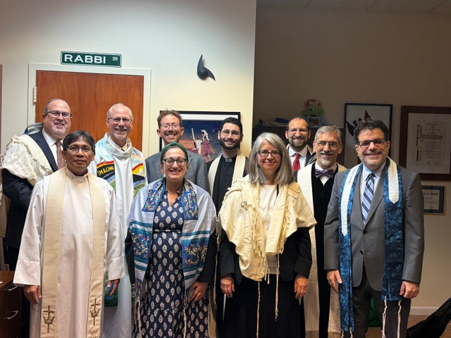
Photo from Forest Hills Interfaith Thanksgiving 2025

Dear Church Family –
2025 was a challenging year for America and the world. Last year saw a rise in authoritarianism here and abroad, as well as an increase in global violence.
Israel continued killing thousands of Palestinians in Gaza. Russia continued to kill thousands in Ukraine. Civil war erupted in Sudan, killing thousands there. Here at home, thousands of immigrants were deported, and too many died in detention centers. If we were looking for signs of the end of the age, as Mark 13:8 warns of “wars and rumors of wars,” we would perhaps now anticipate “the Son of Man coming in clouds with great power and glory.” (Mark 13:26)
Sadly, Jesus has not yet returned, so it remains with us to prepare the way of the Kingdom he promised to build. We do this by resisting what is evil and doing what is good – as the Apostle Paul told us, this is how we overcome evil itself. (See Romans 12:21)
There are those who do not want to mix politics with spiritual affairs. This is understandable. No one wants to go to a worship service to engage in a political debate. However, Christian churches are now being divided over political party affiliations and rhetoric, so “being political” has become unavoidable. God has given us values to live by, and we must stand for them. And the highest value God has given us in Christ is love.
“This is my commandment, that you love one another as I have loved you.” (John 15:12) We are commanded to love: love our neighbors, love our sisters and brothers in Christ, and even love our enemies. As Paul tells us, “Love is the fulfillment of the law.” (Romans 13:10)
So rather than lament how much destruction of our norms we have seen in the last year, I will write about what our denomination has done, as well as what we as a congregation have done. There are plenty of media sources available to see what happened in our political arena.

PC(USA) Developments in 2025

(This article was written using Microsoft Copilot before editing)
The year 2025 was a season of significant movement and faithful discernment across the Presbyterian Church (U.S.A.). As congregations like ours continued to serve our communities with compassion and courage, the denomination as a whole undertook major steps to strengthen its witness, clarify its identity, and prepare for the future.

Strengthening Our Shared Witness: The Unified Agency
In September 2025, the Unification Commission approved the organizational structure for the new PC(USA) Unified Agency, marking the most substantial restructuring in decades. This new model brings together previously separate agencies into a more integrated, collaborative system designed to support congregations, mission partners, and ministries with greater clarity and coherence.
The Unified Agency is organized around four major areas of ministry, including Denominational Life & Witness, which holds the shared identity and voice of the church.

Context for Change: Mission and Sustainability
The restructuring also comes in the wake of the closure of Presbyterian World Mission earlier in 2025, a difficult decision shaped by declining giving and changing approaches to global mission. While 54 mission workers were laid off, partnerships and global engagement continue through other channels. This moment underscored the need for a more sustainable, integrated denominational structure — one of the driving forces behind the Unified Agency.

Honest Patriotism & Public Witness
A November 2025 chapel service at the national offices highlighted the PC(USA)’s ongoing commitment to honest patriotism and its clear rejection of white Christian nationalism. Drawing on General Assembly statements and historical lessons, the denomination continues to equip congregations for faithful civic engagement rooted in justice, humility, and truth.

Pursuing Peace
The 2025 Peace & Global Witness Offering encouraged congregations to “Pursue What Makes for Peace,” strengthening local and global peacemaking efforts and reinforcing the PC(USA)’s long-standing commitment to nonviolence and justice.
The Peace & Global Witness Offering will not continue under its current name in 2026. As part of the denomination-wide restructuring of Special Offerings approved by the 226th General Assembly (2024), the PC(USA) is reducing the number of offerings from four to three beginning in January 2026. In this transition, the Peace & Global Witness Offering is being renamed and reshaped into the new World Communion Offering, while the Pentecost Offering concludes after 2025.
Although the name is changing, the core commitments of the Peace & Global Witness Offering remain firmly in place. The new World Communion Offering continues to support ministries of peacemaking, reconciliation, global witness, and justice-oriented engagement at the congregational, mid-council, and denominational levels. The familiar 25/25/50 distribution model is preserved, ensuring that local congregations and presbyteries retain meaningful participation in shaping peace and justice ministries.

What This Means for Our Congregation
For a multicultural, immigrant-serving congregation like ours, these developments offer both encouragement and opportunity. The Unified Agency promises clearer denominational support, more integrated resources, and a stronger shared identity. The themes of justice, peace, and honest public witness resonate deeply with our mission and the lived realities of our members.
As we look ahead, we remain connected to a denomination that is actively discerning how to serve Christ’s mission with integrity, courage, and compassion. We give thanks for the ways God continues to shape the PC(USA) — and for the ways our congregation participates in that unfolding story.

Church Highlights for Our Congregation in 2025
Our Sunday attendance rebounded slightly in 2025, returning to levels of 2015 and 2016. We saw young children join our worship services, and the pastor had a Children’s Sermon each Sunday to hold their attention.
In October we began a Confirmation Class which now has three young adults who are learning about the Christian faith! This class meets with the pastor each Sunday at 10:00 AM in the church hall parlor. Olivia Hernandez is assisting with adult leadership. The class will continue until Easter this year.
Here is a timeline for activities we had last year:

Highlights of 2025
January
- Rev. Dr. Mary Newburn-Williams, Transitional Leader of the Presbytery of NYC, preaches on MLK Sunday

February
- Annual Meeting
- Session elects Nadina Grants to return as Clerk of Session, John Biswas remains on as Treasurer, ‘Cil Brewer returns as Deacon
March
- Ash Wednesday imposition of ashes by subway with St. Lukes Episcopal Church
- Online Lenten Study
April
- Benefit concert – Beata Moon for Partners in Health
- Songfest at Forest View Nursing Home
- Maundy Thursday service and Good Friday service with Church in the Garden
- Community Easter egg hunt
May
- Concert – Medina Clarinet
- Memorial Day Sunday community picnic
June
- Queens Pride Parade
- League of Women Voters presentation
- Matthew Black in concert
- Funeral for Ruth Stanton
- Pastor voted to continue as designated pastor for an additional 2 years
July
- Independence Day Picnic
August
- Labor Day Sunday picnic
September
- Sunday School begins
- Sunday Bible study on Exodus (with book by Walter Brueggeman)
- Memorial for Marilyn Haas
October
- Church Retreat at Holmes Camp
- New Members Class
- International Dinner at Newtown Presbyterian Church
November
- Advent study – The First Advent in Palestine (book)
- Senior Resource Fair
- Interfaith Thanksgiving Service at Reform Temple of Forest Hills
December
- Singing at Forest View
- Community Christmas/Holiday Party
In 2025 we lost two long-time members whose lives were celebrated on All Saints Sunday.
Community Organizing
Last year saw our church become involved with community organizing. We were asked to help by hosting events and planning sessions with the following organizations:
Let’s Talk Democracy
This organization, founded in 2015, presented lectures to people in the community about civic engagement, voting rights, and how to make change happen. This non-partizan group held several meetings during weeknights in our sanctuary from May to November.
Queens Says No Kings
People from Let’s Talk Democracy wanted to find ways to protest the Trump Administration’s overreach with deportation policies and ICE tactics. Two marches were organized with help from the pastor last year, going from MacDonald Park to Queens Borough Hall.
Central Queens Mutual Aid
Separately from Let’s Talk Democracy and Queens Says No Kings, several members of the Forest Hills community started a mutual aid group to assist neighbors in and around Forest Hills, modeling themselves after mutual aid groups in Astoria and South Queens. This group decided to help stock our food pantry and has coordinated keeping it full.
Forest Hills Indivisible
This group came from Queens Says No Kings and is associated with the national Indivisible organization. This activist group is focused on protesting civil rights violations in America.
While these organizations have not led to an increase in attendance in our worship services, they have contributed money to the church’s operating fund and have given food to the community. They have also increased the visibility of our church.
Community Facilities Use
Several organizations continue to use our church hall weekly for their programs:
- New York Chess Academy
- Startline After-School Program
- FoHi Theater Improv
- Gamblers Anonymous
These groups pay for use of the church hall. (There are some other smaller organizations which occasionally use our facilities as well, often at a reduced rate.) We consider them our partners in building community within the neighborhood.
Church Facilities
Church technology continues to play a major part in the ministry of this church, as seen by the number of online Bible studies and our ongoing livestreaming of worship. Last year we purchased two cameras to improve the quality of our online videos.
Last year we had insurance-related expenses as well. We covered the cracks in our driveway with blacktop and installed new emergency exit lights. Both of these projects were required to keep our insurance in place.
We painted the exterior wood around the sanctuary and the rear wall. We have been blessed to have buildings which have not required major repair expenses yet, but we must budget for potential larger repairs as our facilities age.
Development Plans
Over the past two years the Session has been discussing potential development projects for the church property. There have been multiple discussions with real estate professionals, lawyers, consultants and city planners to determine options available.
The session voted to move forward with some developer to be determined, rather than leaving the existing facilities as they are. The consensus is that the sanctuary building should be preserved mostly as it is, but the church hall and manse would likely be torn down for space for a larger building. With the need for apartments in NYC, building a multi-story building for both a community center (and congregational use) along with new apartments seems the best approach at this time.
The cost of maintaining the aging church hall, the poor space layout and lack of handicap access, along with new developments being built nearby make this decision almost necessary. Having a new source of revenue can also help finance the mission and ministry of the congregation for decades to come.

Designated Pastor
In June of last year I was renewed for another two years as full-time Designated Pastor for this congregation. At the end of the two-year period, I will be 70 years old and will begin to take Social Security pension payments. This may have some impact on my ministry in 2027, as my financial situation will be enhanced.
Much depends on the membership and finances of the congregation, which is why I am currently a Designated Pastor rather than installed full-time. If finances and membership decline, the congregation may want to offer a part-time position rather than full-time.
At age 73, PCUSA ministers must begin taking retirement payments. (Barna Research states that most Protestant pastors retire between ages 65 to 72). Many “retired” pastors continue in some form of ministry part-time, often as pulpit supply. While there is no requirement to retire at age 73, the PCUSA Benefit Plan requires that ministers vested in the plan begin retirement pay at that age.
I will say I love the work of ministry and will continue to do it in some form until I leave this life, whether paid or unpaid, part-time or full-time. It is an honor and privilege to represent the Lord Jesus Christ in the ministry of word and sacrament. However, age catches up to everyone at some point in our lives.
The future health and ongoing ministry of this congregation will eventually fall on the shoulders of younger, more able ministers. At some point, this church will need to look for newer faces to lead. Until then, I will continue as best I am able, “to exercise ministry with energy, intelligence, imagination, and love; to be governed by the church’s polity; to abide by its discipline; and to serve the people with compassion, faithfulness, and integrity,” as the PCUSA’s vows of ordination bind me to do.

This report is the longest I have submitted in my tenure as your pastor for the annual report. Last year was a consequential year in the life of our nation and the PCUSA. This does not require a long report from me, but I want to keep you, the members of this congregation, informed about where we are as a church. Where we go from here is in God’s hands, and God has brought us along to this point together.
Let us continue to work and pray together to build on last year and make this year even better. With God’s help it is possible!

Yours in Christian service,
Rev. Dr. Jeff Courter

Report from the Clerk of Session

Necrology:
Elder Ruth Stanton died on June 7, 2025
Deacon Marilyn Haas died on September 2, 2025
Both had been longtime members of our church and we miss them.

Sacraments:
We continued to celebrate the Lord's Supper on the first Sunday of each month.

Baptism:
None this year.

Attendance:
On many Sundays, in-person attendance has increased in the past year. Also, our worship service continues to be streamlined (YouTube and Zoom). New equipment has been purchased in order to enhance the technical aspects of our services.

Session Meetings:
With the exception of August and December, the Session had met every month in person as well as online. We also communicated via e-mails as needed.

Renewal of our Pastor's Contract:
On June 19, 2025 the congregation voted and approved the renewal of a two-year term for Rev. Dr. Jeffrey Courter to serve as our designated pastor.

New Members:
After the completion of a membership class held by our pastor, Diana Paley and Olivia Hernandez expressed their desire to become members of our church.

Church Building and Property:
Throughout the year, our Session continued to explore various proposals regarding the development of the church property.

Deacons:
The Session would like to thank our Deacons 'Cil Brewer, Charlie Potter, and Dawn Simmons for their faithfulness and dedication by serving our congregation throughout the year.

On a personal note, it has been my joy and honor to be part of a wonderful Session as well as serving as your Clerk of Session.

Gratefully submitted,
Nadina Grants, Clerk of Session

Spiritual Formation Committee

Throughout the year, with only short interruptions, we had Bible/Spiritual book studies.
On Sunday mornings, before our worship services, David Barnett led the Adult Bible study.
We read and discussed the following:
1 and 2 Thessalonians with guidance from N.T. Wright's book.
Richard Rohr's "Wondrous Encounters; Scripture for Lent"
"Delivered into Covenant; Pivotal Moments in the Book of Exodus" by Walter Brueggemann.
8-10 people participated on most Sundays.
Special thanks to David for his excellent preparations for those studies and his interesting thoughts guiding our group.

Mid-Week Bible Studies
Our mid-week Bible studies have been in the evenings and online only and were led by our pastor Rev. Dr. Jeffrey Courter.
We started the year reading Richard Rohr with John Feister's book: "Jesus Plan for a New World- the Sermon on the Mount"
Our next study was based on the book by Philip Yancey "The Jesus I Never Knew".
During Advent, we read Dr. Kelly Nikondeha's book "The First Advent in Palestine".
Conducting these studies online made it possible for people living outside NY, like Ellen Taylor, to participate.
We are grateful to our Pastor for leading us in those discussions by creating room for new insights and joy in learning from each other.

Church Retreat at Holmes Presbyterian Camp
This Fall, about 15 people participated in a weekend retreat at Holmes.
Our theme for this time together concentrated on defining and implementing new ways to care for one another in a practical and tangible manner. We thank our pastor for his leadership and insights.

Our Lord Jesus tells us: "This is my commandment, that you love one another as I have loved you." John 15, verse 12

Thankfully,
Nadina Grants

Sunday School
The Sunday School continues with very few children, and Pat Young Collier and Karen Wood are the teachers. Pat teaches the early elementary children and Karen teaches the
upper elementary children. The curriculum used is published by David C Cook.

Respectfully submitted,
Karen Wood

2025 Report of the Outreach and Engagement Committee

"If you pour yourself out for the hungry and satisfy the desire of the afflicted, then shall your light rise in the darkness and your gloom be as the noonday.”
--Isaiah 58:10

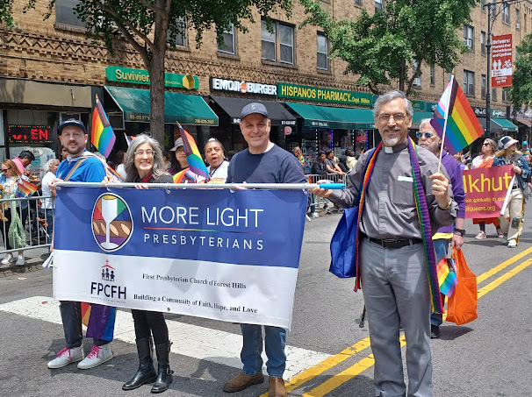

Showing up for Queens Pride: Pastor Jeff, Steve Harte, Tanessa Cabe-Harte, Shelly Courter, David Barnett and an honorary church representative, Benjamin Meade, June 2025, Jackson Heights, NY. Also present that day were Sandra Huang, Linda Tsang, and Yvette Jong and friends. Photo: Lois Anne DeLong

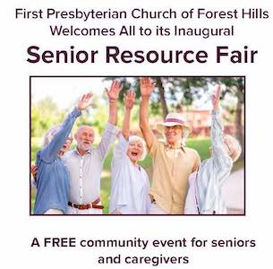
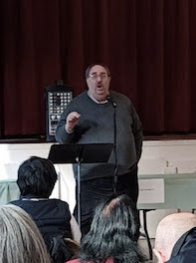
Another year of providing aid and comfort to New York City and the world has now entered the record books. In 2025, OEC reached out to a new demographic in our community—seniors and those who care for them. Our first Senior Resource Fair, held October 16, drew about 40 very attentive participants who were really hungry to know more about health insurance, guardianship, and many other issues connected to growing older. We plan to continue providing this knowledge in the coming year through a series of after worship talks. Given the valuable contacts made through this event—including individuals from the New York City Department for the Aging and representatives of the Ridgewood Savings Bank—we feel like we are in a good position to identify and share this information going forward. Stay tuned for future announcements.
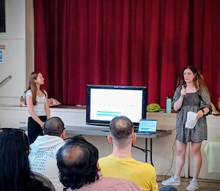
The rest of our 2025 programs continued to address a three-pronged emphasis the committee established a year or two ago. In establishing new programs, we look to educate, inform, or entertain with a focus on health, civics, and the arts. While the Senior Resource Fair ticked off the health box, we were able to sponsor two programs that fulfilled the civics category. Representatives from the League of Women Voters came to the church to discuss ranked choice voting on June 8, while on September 25, we sponsored the Freedom to Read event for the third year. In a time that has seen 22,810 books removed from school libraries over the past five years (according to PEN America), the latter event is a great reminder that our First Amendment is worth defending. As always, thanks to our team member Yvette Jong for organizing and promoting this program.
The only category lacking in our trio of programming goals was arts outreach. We did not sponsor a concert this year or any other type of artistic initiative. We plan on making this a priority in the year ahead.
While we thank a number of individuals at the end of this report, we choose to acknowledge upfront a special gift from an anonymous donor as it directly enabled us to be especially generous with our overseas mission partners. This individual donated $3,200.00 to the work of our committee, which made it possible to stretch our giving well beyond the limitations of our set budget. In a year when our overseas partners found themselves struggling to replace the support of the PCUSA, this was a very special gesture indeed. The same donor has already extended an even larger gift for 2026 and our appreciation for this support of the outreach work of this church knows no bounds.
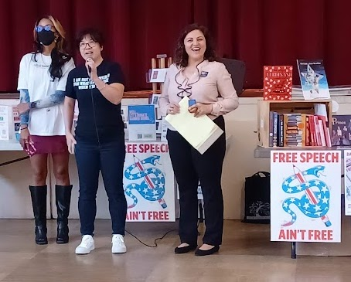
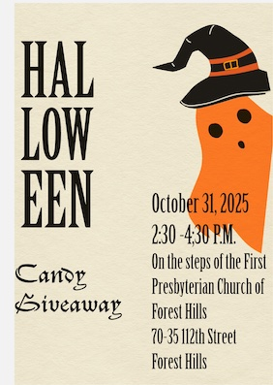
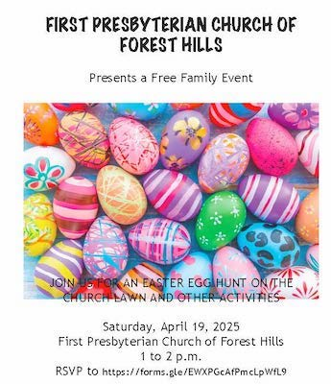
Some other highlights of our year included:

- We held a Flea Market fundraiser on March 22 for World Central Kitchens in support of their work with those who lost their homes to the L.A. Wildfires. The church raised $202.00 from sales of donated merchandise at this event, which was then matched by the committee. An additional donation from Herndon and Mindy Lackey meant we could forward a total of $654.00 to WCK. Again, thanks to Yvette for organizing this event.
• We made two visits to the Forest View Nursing Home in April and December.
• We held two family events: an outdoor egg hunt on April 19, and a Candy Giveaway on
Halloween day. The egg hunt drew about 40 plus children over the course of an hour. We
had a good-sized group of volunteers (8) turn out to help us oversee both outdoor and inside
events. Everything ran quite smoothly and everyone had a good time,
• We provided funding for the purchase of an AED device for the church.
• We drafted and mailed out a survey to groups that had previously rented our church hall to
Determine how we can better market our space. Unfortunately, we received only a handful of
responses, so we should consider re-sending it. The survey is still a work in progress so feel
free to add comments or make suggestions. The link is at https://docs.google.com/forms/d/e/1FAIpQLSfyBM364aiV3bCmF5WUbpUuqEwuKPYB9USG8gULRph hxI003A/viewform
• Beyond our designated local and overseas partners, the committee provided additional
donations to help people in Gaza, victims of flooding victims in different parts of the USA,
and those hurt by an earthquake in Myanmar earlier this year. Also, we gave a stipend of
$300.00 to South Bronx Mutual Aid, a grassroots volunteer organization providing food,
clothing, personal care items, housing, and legal support.
• We made the holidays bright by collecting toys and other holiday gifts for the children and
Families served by Hour Children. And, we made back to school time easier for parents by
not only donating to Forestdale’s backpack campaign, but by also sending them some extra
backpacks and spare school supplies we had left over from an older campaign.
• We once again marched in the Queens Pride parade, this time with a nice complement of
about eight marchers. One of my friends, Benjamin Meade, who I met through our former
Mission Partners at Not So Churchy, also joined us.
• We raised $1,281.00 for PCUSA’s One Great Hour of Sharing campaign, and $886.50
for its Peace and Global Witness campaign (this total is with our local designated funds
removed). Again, we thank the congregation for their embrace of these two denomination-
wide offerings.

Our 2025 Local Mission Partners
We made no changes in our roster of local mission partners either last year or moving into this year. We feel our current roster serves a good cross-section of needs within the community. In 2025, each partner initially received $770.00 (except for More Light Presbyterians, which received $800 as this amount included our annual dues). However, since we funded fewer local programs this year, we had sufficient money left over to send out second donations to Stacy’s Pantry and Drama Club at the end of the year. We also gave Forestdale $600.00 towards its toy drive in December. If you would like to learn more about any of these organizations—including ways you can volunteer—feel free to contact me.

For 2026, we will also be giving a small stipend of $200.00 to the Word Up Community Bookshop in Washington Heights to support their children’s literacy program. We previously dealt with this store during Covid, when they were accepting and directing donations for a food pantry run by South Bronx Mutual Aid.

International Mission Partners

Perhaps our biggest challenge in 2025 was figuring out how to be of continued assistance to our long-time mission partners once the PCUSA let them go earlier this year. Through the grace of God, all have found alternative funding through other agencies. Mark Hare and Jenny Bent, our partners in Costa Rica, reached out to Mark’s home presbytery—The Presbytery of Scioto Valley in Central and Southern Ohio—who agreed to take on support of the work for the immediate future. Meanwhile, Jim McGill is now in the service of the Reformed Church of America. His work in Niger, ensuring access to clean water, sanitation facilities and hygiene promotion, can continue to receive money through their auspices. Given the political situation in Niger, however, Jim will be pursuing similar work at a new location in Africa. We remain in touch and hope to have more to report in the months ahead.
Lastly, the Turks have put together a support network that will allow them to continue their work under the auspices of the FJKM (Church of Jesus Christ in Madagascar). They have set up a mechanism for receiving donations through The Partners Fund, a 501-C3 organization started by members of First Presbyterian Church in Orlando.

Last year, with the help of a donation, we were able to send $1,385.50 to Mark and Jenny, $1,445.50 to Jim McGill, and $1,604.00 to the Turks. As of now, the committee plans to continue our support of all three mission teams, and this year, we plan to send $1,133.33 to each of our partners out of Session designated funds, or $1,633.33 once we add in a portion of the anonymous designated gift mentioned above. (Our plan is divide this donation in thirds to support local programming, overseas missionary personnel, and emergency response.)

Please lift up these individuals in prayer and support as they pursue the mission placed upon their hearts.

For the sixth year in a row, we also provided a stipend to Mamisoa Rakotomalala, a seminary student from Madagascar who is working on her Ph.D. at Graduate Theological Union in Berkeley, CA. Because of health issues, completing her degree has been a bit of a struggle. However, we recognize the importance of her work, and will continue to assist her in these efforts.

This year, we have also budgeted a small stipend of $200.00 for Living Waters for the World. This initiative of the PCUSA seeks to provide the knowledge and the tools needed to ensure small rural communities around the world have access to clean drinking water and improved sanitation.

Giving Thanks
In addition to the generosity mentioned above, we know our programs have benefited from the open hands and wallets of this congregation. Many thanks to all of you and I hope we can count on your support in the year ahead.

I would also like to give a big thank you to the members of this committee who continue to share their perspectives, energy, and commitment to this team. A special shout-out to Linda Tsang who has been a very capable overseer of our disbursements and our financial records, and new member Diana Paley. Welcome aboard, Diana. We look forward to hearing your ideas as we move forward.

Rev. Jeffrey Courter continues to be a reliable source of information, advice, and support. And, David Barnett, through his work as our church administrator, remains an invaluable contributor to all we do.

Lastly, as always, thanks again to all of you.

Respectfully submitted,
Lois Anne DeLong

for The Outreach and Engagement Committee
Members: Tanessa Cabe-Harte, Sandra Huang, Yvette Jong, Linda Tsang

Stewardship

In December we received 25 pledges for a total of $54,643.00.

Personnel and Admin Committee Report

In 2025 the church continued its contracts with Andy's Quality Cleaning for janitorial services and with Handyman Landscaping for outdoor lawn maintenance. Both companies have continued their services with no increase in their fees, for which we are grateful.

Last year we purchased two Opcon AI-enhanced cameras for recording and livestreaming our worship services. The cost for the cameras and related equipment was $4800. Bruno Razafindrakoto has learned how to configure and use the cameras. James Potter has been working with Bruno as technical support for the cameras and Zoom, for which he is paid a small stipend by the church. Both Bruno and James have been outstanding and have added substantial improvement to the quality of our online worship.

Startline Academy, the New York Chess Academy, Gamblers Anonymous and FoHi Improv continue to rent space in the church hall. The Ghana Presbyterian Church and the Thai Community Church continue to rent the sanctuary for Sunday worship. Total facilities use receipts are included in both the budget and the financial report for 2025.

Last year we again received a grant for $1000 from the Office of the Borough President of Queens, Donovan Richards.

ESB Consulting of Forest Hills handled our accounting services. This year’s financial report was created by them.

John Biswas remained on as treasurer last year, even while he relocated to London, England. We are grateful for his continuing support!

This concludes the committee's report.

Buildings and Grounds Committee Report

SANCTUARY:
Work description:
Contractor: Peter Aviles (646)-533-9982
  - Painting the following:
- Wood around the bell tower and all window sills, the gable in front of 112th Street and doors, the exterior of the North sanctuary wall.
- Payment made on 8/21/25 COST: $ 5700.00
  - Paint exterior around stained glass windows in sanctuary and reattach fallen gutters
- Payment made on 11/21/25 COST: $ 300.00
  - (a) Clean leaders and gutters/scuppers, leaves from dry[well adjacent to the flat roof near the garden.
(b) Replace 1 piece of window glass-pane on church hall.
(c) Glue rubber moulding to wall room #7
(d) Roof flashing on cracks found on church hall roof exterior above all entrance
(e) 4 screens to cover scuppers
- Payment made on 11/7/25 COST: $ 1500.00
4. Repair north back wall of sanctuary – exterior and interior
- Payment made on 8/14/25 COST: $ 3975.00
5. Fabricate wood slats/bell tower of sanctuary
- Payment made on 8/14/25 COST: $ 350.00

6. Arista Air Conditioning LLC – Tel.#: 718-706-4429
Replace fuses in the split system; took the fuses out of the unti not working and replace the
blown fuses on each of the other two systems that were not working. Need to order
controller suses and any control board in air handling.
- Payment made on 7/25/25 COST: $ 547.00

7. FERNANDEZ HEATING AND MECHANIC CORP.
Boiler repair - Payment made on 2/18/25 COST: $ 350.00

8. Russo Electric Inc. Tel#: 718-846-5576
Replace/add EXIT lights in church and church hall
1st Floor Replace 4 EXIT lights and add 1 EXIT light
2nd Floor Replace 2 EXIT lights and add 1 EXIT light
- Payment made on 12/19/25 COST: $1900.00

Andy’s Cleaning Services (janitorial):
Cleaning of the church facilities and surrounding areas
Garbage separation and disposal (10 months) COST: $14,527.50

Handyman Landscaping, 87027 133rd Street, Richmond Hill, NY 11418
Mowing grass, raking leaves, cleaning up and removing debris, pruning (seasonal)
COST: $ 9350.00

RECAP OF AMOUNT SPENT FOR 2025

CONTRACTOR/PERSONNEL PAYMENT AMOUNT
Peter Aviles $11,825.00
Arista Air Conditioning $ 547.00
Fernandez Heating $ 350.00
Russo Electrical $ 1,900.00
Andy’s Cleaning $14,527.00
Handyman Landscaping $ 9,350.00

TOTAL $38,499.00

Respectfully Submitted,
Milton Balram

STATE OF THE CONGREGATION

Membership as of December 31, 2024..................................….…..…93
Additions  By Profession 0  By Certificate 0  By Reaffirmation 0  Total Additions 0 | Losses  By Certificate 0  By Death 2  By Other 0  Total Losses 0

Active Membership as of December 31, 2025 .................................... 91

Adult Baptisms: 0

Children (with birthdates) – 0

New Members: 0

OTHER STATISTICS
BAPTISMS FOR THE YEAR 2025 CHURCH SCHOOL: 5
Children 0 Total Students - 3
Adult 0 Teachers - 2
Total Baptisms 2
Marriages for the Year 2025: 0
Number of Persons Received on Profession of Faith up to Age Eighteen: 0

CHURCH OFFICERS Men Women Total
Elders 5 3 8
Deacons 1 2 3

Average Attendance in 2025 was 35. (Monthly averages include in person and online):
January 40 July 30
February 35 August 30
March 35 September 30
April 35 October 30
May 35 November 40
June 35 December 45

Report of the Nominating Committee

Dear members and friends of the First Presbyterian Church of Forest Hills –
The following names are presented for serving as church officers:

Elders:
Class of 2026: Milton Balram, Bruno Razafindrakoto, Luis Gallego.
Class of 2027: Lois Anne DeLong, Rafael Reyes-Quiroz
Class of 2028: Karen Wood
Elders rotating off session: Nadina Grants, Leon Collier.

Deacons:
Class of 2026: Charlie Potter, Dawn Simmons
Class of 2027: ‘Cil Brewer

Thank you to all whose service has ended and for those whose is beginning.

Respectfully submitted,
‘Cil Brewer, Nominating Committee Chair (Rafael Reyes-Quiroz, Ingrid Anthony)

Here is the list of current members of the boards:
SESSION
Rotating off 2025 | 2026 | 2027 |  | 2028
Nadina Grants | Milton Balram | Rafael Reyes-Quiroz |  | Karen Wood
Leon Collier | Luis Gallego | Lois Anne DeLong
Karen Wood | Bruno Razafindrakoto

DEACONS
Rotating off 2024 | 2026 | 2027 | 2028
 | Charlie Potter | ‘Cil Brewer
 | Dawn Simmonds

The committee reminds the congregation that it must elect three members (who will not be
serving on Session or Deacons) to join one member of Session and the Deacons on the 2026 Congregational Nominating Committee. When elected, their names should be written
below, so that everyone remembers who they are:

(1) ______________, (2) _______________, and (3) ________________.

