December 7, 2025 2nd Sunday of Advent 11 AM

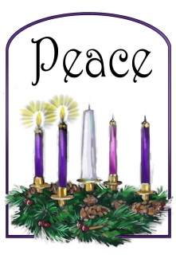
Second Sunday of Advent – Clip Art Library

PRELUDE “Do not tarry, Happy Shepherds J.S. Bach
Hurry, hurry before you’re too late, Hurry to see the
Wonderful holy child….go, the Joy is too wonderful find
Approval for this beautry, go, find the joy for heart and mind”
(German translated to English by Nadina Grants)
from Christmas Oratorio, BWV. 248, #15

WELCOME

MINUTE FOR STEWARDSHIP

CALL TO WORSHIP

HYMN #85 (vv. 1,2) “Light One Candle to Watch for Messiah”

- Light one candle to watch for Messiah; let the light banish darkness.
He shall bring salvation to Israel, God fulfills the promise

- Light two candles to watch for Messiah: let the light banish darkness.
He shall feed the flock like a shepherd, gently lead them homeward.

LIGHTING OF THE ADVENT CANDLE
(One Candle - An advent liturgy by Rev. Karen Ware Jackson)

Light one candle for hope. (light first candle)
Because the world is broken and the wait is long, but hope just won’t let go.
Hope holds space for all our longings lingers on the edge of harsh reality like the dawn gently awakening the sky.
“Keep awake,” she whispers, “for the world is being made new.”
So we light one candle, because it only takes one: Christ with us.

Light one candle for peace. (light second candle)
Because the world is broken and the wait is long,
but we refuse to be frozen by fear.
Peace comes in fits and starts- a deep breath a courageous truth a humble heart. “Prepare the way,” she whispers, “for the Lord comes to make the broken whole.” So we light one candle, because it only takes one: Christ with us

OPENING PRAYER

HYMN #88 (vv 1,6,7) “O Come, O Come Emmanuel”

1 O come, O come, Emmanuel, and ransom captive Israel,
that mourns in lonely exile here until the Son of God appear.
Refrain: Rejoice! Rejoice! Emmanuel shall come to thee, O Israel.

6 O come, thou Dayspring, come and cheer our spirits by thine advent here;
disperse the gloomy clouds of night, and death’s dark shadows put to flight. Refrain: Rejoice! Rejoice! Emmanuel shall come to thee, O Israel.

7 O come, Desire of nations, bind all peoples in one heart and mind;
bid envy, strife, and discord cease; fill the whole world with heaven’s peace. Refrain: Rejoice! Rejoice! Emmanuel shall come to thee, O Israel.

CALL TO CONFESSION

PRAYER OF CONFESSION

ASSURANCE OF GOD’S LOVE

RESPONSE: HYMN #581 “Gloria Patri”
Glory be to the Father, and to the Son, and to the Holy Ghost;
as it was in the beginning, is now, and ever shall be, world without end.
Amen, amen.

PEACE
Let there be peace on earth.
And let it begin with me.
The peace of Christ be with you.
And also with you.

RESPONSIVE READING Psalm 72:1-7,18-19 (NRSVUE)
Give the king your justice, O God, and your righteousness to a king’s son.
May he judge your people with righteousness and your poor with justice.
May the mountains yield prosperity for the people,
and the hills, in righteousness.
May he defend the cause of the poor of the people,
give deliverance to the needy, and crush the oppressor.
May he live[a] while the sun endures
and as long as the moon, throughout all generations.
May he be like rain that falls on the mown grass,
like showers that water the earth.
In his days may righteousness flourish
and peace abound, until the moon is no more.
Blessed be the Lord, the God of Israel, who alone does wondrous things.
Blessed be his glorious name forever; may his glory fill the whole earth.
Amen and Amen.

SPECIAL MUSIC “And my spirit has rejoiced in God, my Saviour” J.S. Bach
(from Magnificat #2) sung by Miangaly Razafindrakoto

FIRST READING Isaiah 11:1-10 (NRSVUE)
¹ A shoot shall come out from the stump of Jesse, and a branch shall grow out of his roots. ² The spirit of the Lord shall rest on him, the spirit of wisdom and understanding, the spirit of counsel and might, the spirit of knowledge and the fear of the Lord. ³ His delight shall be in the fear of the Lord. He shall not judge by what his eyes see or decide by what his ears hear, ⁴ but with righteousness he shall judge for the poor and decide with equity for the oppressed of the earth; he shall strike the earth with the rod of his mouth, and with the breath of his lips he shall kill the wicked. ⁵ Righteousness shall be the belt around his waist and faithfulness the belt around his loins. ⁶ The wolf shall live with the lamb; the leopard shall lie down with the kid; the calf and the lion will feed together, and a little child shall lead them.
⁷ The cow and the bear shall graze; their young shall lie down together; and the lion shall eat straw like the ox. ⁸ The nursing child shall play over the hole of the asp,
and the weaned child shall put its hand on the adder’s den. ⁹ They will not hurt or destroy on all my holy mountain, for the earth will be full of the knowledge of the Lord as the waters cover the sea. ¹⁰ On that day the root of Jesse shall stand as a signal to the peoples; the nations shall inquire of him, and his dwelling shall be glorious.

CHILDREN’S SERMON

SECOND READING Matthew 3:1-12 (NRSVUE)
¹ In those days John the Baptist appeared in the wilderness of Judea, proclaiming, ² “Repent, for the kingdom of heaven has come near.” ³ This is the one of whom the prophet Isaiah spoke when he said,
“The voice of one crying out in the wilderness:
‘Prepare the way of the Lord; make his paths straight.’ ”
⁴ Now John wore clothing of camel’s hair with a leather belt around his waist, and his food was locusts and wild honey. ⁵ Then Jerusalem and all Judea and all the region around the Jordan were going out to him, ⁶ and they were baptized by him in the River Jordan, confessing their sins.
⁷ But when he saw many of the Pharisees and Sadducees coming for his baptism, he said to them, “You brood of vipers! Who warned you to flee from the coming wrath? ⁸ Therefore, bear fruit worthy of repentance, ⁹ and do not presume to say to yourselves, ‘We have Abraham as our ancestor,’ for I tell you, God is able from these stones to raise up children to Abraham. ¹⁰ Even now the ax is lying at the root of the trees; therefore every tree that does not bear good fruit will be cut down and thrown into the fire.
¹¹ “I baptize you with water for repentance, but the one who is coming after me is more powerful than I, and I am not worthy to carry his sandals. He will baptize you with the Holy Spirit and fire. ¹² His winnowing fork is in his hand, and he will clear his threshing floor and will gather his wheat into the granary, but the chaff he will burn with unquenchable fire.”

SERMON “Fruit of the Spirit’s Baptism” Jeff Courter

HYMN #82 “Come, Thou Long-Expected Jesus”

1 Come, thou long-expected Jesus, born to set thy people free;
from our fears and sins release us; let us find our rest in thee.
Israel’s strength and consolation, hope of all the earth thou art;
dear desire of every nation, joy of every longing heart.

2 Born thy people to deliver, born a child and yet a king,
born to reign in us forever, now thy gracious kingdom bring.
By thine own eternal Spirit rule in all our hearts alone;
by thine all-sufficient merit raise us to thy glorious throne.

PROFESSION OF FAITH THE NICENE CREED
We believe in one God, the Father, the Almighty, maker of heaven and earth, of all that is, seen and unseen. We believe in one Lord, Jesus Christ, the only Son of God, eternally begotten of the Father, God from God, Light from Light, true God from true God, begotten, not made, of one Being with the Father; through him all things were made. For us and for our salvation he came down from heaven, was incarnate of the Holy Spirit and the Virgin Mary and became truly human. For our sake he was crucified under Pontius Pilate; he suffered death and was buried. On the third day he rose again in accordance with the Scriptures; he ascended into heaven and is seated at the right hand of the Father. He will come again in glory to judge the living and the dead, and his kingdom will have no end. We believe in the Holy Spirit, the Lord, the giver of life, who proceeds from the Father and the Son, who with the Father and the Son is worshiped and glorified, who has spoken through the prophets. We believe in one holy catholic and apostolic Church. We acknowledge one baptism for the forgiveness of sins. We look for the resurrection of the dead, and the life of the world to come. Amen.

PRAYERS OF THE PEOPLE

OFFERING/OFFERTORY “The Heaven and earth and seas adore!
The heart of Judah, Thy delight, in one defensive band unite.”
(from Judas Macabaeus Oratorio #23) George Handel

OFFERING SONG #606 Doxology
Praise God, from whom all blessings flow,
Praise God, all creatures here below,
Praise God above, ye heavenly host,
Praise Father, Son and Holy Ghost. Amen.

PRAYER OF DEDICATION

DEDICATION OF PLEDGES

November 8, 2011: Submitted by the Rev. Teri Peterson, Ridgefield Crystal Lake Presbyterian Church, Crystal Lake IL. A prayer of dedication, used for Stewardship Sunday / parable of the talents.

One: Creator of all, the earth is yours, the world and all who live in it.
All: You have entrusted us with gifts—time, talent, energy, money—
and asked us to use them to build your kingdom.
With thanks and praise we respond to your call.
One: We bring these gifts you have given,
returning your generosity, paying it forward.
All: We offer ourselves, our lives, our hopes and fears, our dollars and our hours. We commit ourselves to work for your world, to love and serve wherever you call.
One: We ask your blessing on this, your church,
as we seek to follow you with heart, mind, and soul.
All: Bless also these gifts, our investment in your future,
that they may multiply in faith, hope, and love. Amen.

SACRAMENT OF THE LORD’S SUPPER

PRAYER OF GREAT THANKSGIVING
The Lord be with you. And also with you.
Lift up your hearts. We lift them to the Lord.
Let us give thanks to the Lord our God.
It is right to give our thanks and praise.
Blessed are you, O Lord our God:
The heavens tremble and the mountains quake at your presence.
Although we have forsaken you, you have never forgotten us:
you are the potter and we are the clay, the work of your hand.
Therefore we praise you, joining the song
of the universal church and the heavenly choir:
Holy, holy, holy Lord, God of power and might, heaven and earth are full of your glory. Hosanna in the highest. Blessed is he who comes in the name of the Lord. Hosanna in the highest.
Blessed is Jesus Christ, our Savior:
Christ Jesus is our grace and peace, the Word that we proclaim,
the source of all our strength, and the giver of every good gift.
In Christ’s body, we have received fellowship with you, our God.
Remembering your goodness and grace,
we offer ourselves to you with gratitude
as we share this joyful feast.
Great is the mystery of faith:
Christ has died, Christ is risen, Christ will come again.
Pour out your Holy Spirit upon us and upon this bread and cup;
make us one in the body and blood of Jesus Christ our Lord.
Keep us awake until the hour of Christ’s coming,
when the sun and moon and stars will fall from heaven
and you will gather up the faithful from the ends of the earth.
Through the Lord Jesus Christ, in the unity of the Spirit, we bless you,
God of glory, now and forever. Amen.

THE LORD’S PRAYER

COMMUNION OF THE PEOPLE “Jesu, Grant Me This I Pray” C.H. Kitson

ANNOUNCEMENTS

CLOSING HYMN #110 “Love Has Come”

1 Love has come; a light in the darkness! Love shines forth in the Bethlehem skies.
See, all heaven has come to proclaim it; hear how their song of joy arises:
Love! Love! Born unto you, a Savior! Love! Love! Glory to God on high.

2 Love is born! Come share in the wonder. Love is God now asleep in the hay.
See the glow in the eyes of His mother; what is the name her heart is saying?
Love! Love! Love is the name she whispers. Love! Love! Jesus, Emmanuel.

3 Love has come and never will leave us! Love is life everlasting and free.
Love is Jesus within and among us; Love is the peace our hearts are seeking.
Love! Love! Love is the gift of Christmas. Love! Love! Praise to You, God on high!

BENEDICTION

POSTLUDE “We Worship God Alone” G. Handel
(Judas Maccabaeus Oratorio #49B)

Religious leaders bear living witness to faith expressed at Nicaea 1700 years ago
In an historic commemoration of the 1700th anniversary of the First Ecumenical Council, faith leaders gathered in Nicaea—modern-day Iznik, Türkiye – on 28 November to mark the 1700th anniversary of the First Ecumenical Council in the history of the church.
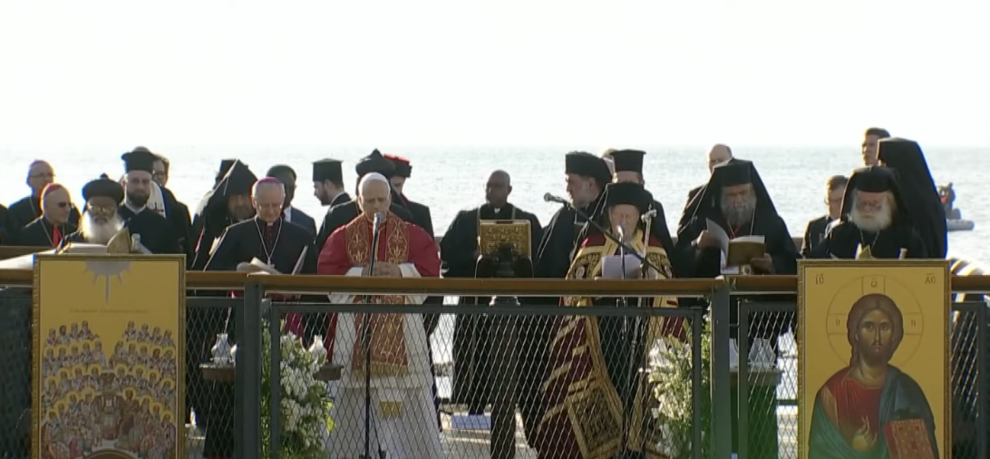
Photo: Vatican News 28 November 2025

World Council of Churches (WCC) general secretary Rev. Prof. Dr Jerry Pillay joined His All Holiness Patriarch Bartholomew and Pope Leo XIV for an ecumenical prayer service.

His All Holiness Patriarch Bartholomew noted the hope expressed through the sacred commemoration even in world with upheavals, difficulties, and divisions.

“We are here to bear living witness to the same faith expressed by the fathers of Nicaea,” he said. “We return to this wellspring of the Christian faith in order to move forward. The power of this place does not reside in what passes away but in what endures forever.”

Pillay shared a Gospel reading from John 17, which includes a passage with a prayer from Jesus that is oft-cited in the World Council of Churches: “That they all shall be one, just as you, my Father, are in me, and I am in you.”
Delivering a message, Pope Leo XIV acknowledged that we live in a time marked by may tragic signs yet we are linked by a profound bond.

“In this way, we are all invited to overcome the scandal of the divisions that unfortunately still exist, to nurture the desire for unity for which the Lord Jesus prayed and gave his life,” said Pope Leo. “Today, the whole of humanity afflicted by violence and conflict is crying out for reconciliation.”

His All Holiness Patriarch Bartholomew and Pope Leo XIV signed a Joint Declaration giving thanks for the fraternal meeting 1700 years ago and in the present.

“We are convinced that the commemoration of this significant anniversary can inspire new and courageous steps on the path towards unity,” reads the declaration. “The goal of Christian unity includes the objective of contributing in a fundamental and life-giving manner to peace among all peoples.”

The declaration encourages the whole of humanity to knit together.

“While we are deeply alarmed by the current international situation, we do not lose hope,” the declaration reads. “God will not abandon humanity.”

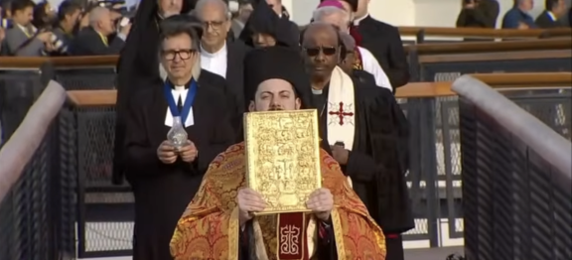
Photo: Vatican News

UPCOMING CALENDAR

TODAY - We are dedicating our pledges for next year. Please be sure to fill out your pledge cards!

TODAY - SONGFEST at FORESTVIEW – we will bring the gift of holiday music to the residents of Forest View Nursing and Rehab Center after worship. We will rehearse after coffee hour and walk to Forest View to sing – please join us!

WEDNESDAY, DEC. 10th, 7:00 PM ZOOM – ADVENT STUDY – we are using Dr. Kelley Nikondeha's recent book, The First Advent in Palestine. This book will explore the theme of incarnation through the lens of Luke and Matthew's gospels. Please see David in the office.

ADULT BIBLE STUDY – We are taking a short break till after the holidays, then start Part 2 of the study of Exodus in January. Books for this study will be ordered, and we’ll let you know when they’ve arrived.

SUNDAY, DEC. 21 – HOLIDAY PARTY! We will have our annual Christmas party after our worship service in the church hall. Mark your calendars!

REMINDER: We are still looking for volunteers for worship readers and/or juice/coffee hour. There is a 3-month sign-up sheet posted just outside the office.
If you have any questions, please contact the Office.

First Presbyterian Church of Forest Hills
70-35 112th St., Forest Hills, NY 11375 presbyfh.org
David Barnett, Admin.718-268-4036 Jeff Courter, Pastor,
FirstPresFHNY@gmail.com; rev.jeffrey.courter@gmail.com
Nadina Grants, Clerk of Session Hannah Lin, Guest Organist

Please note: we now have a public WiFi for the church, though it may only be available in the church hall for now.
Name: CHURCH GUEST
Password: welcome1

For offerings/donations:

- Use Zelle to make Online donations from your bank account. Use this phone number to transfer to the church:
929-418-0958 (please note: this is a new number)
- Make checks payable to First Presbyterian Church of Forest Hills and mail check to the church office
- Go to our church website: presbyfh.org and click on the “Give Now” icon to set up a donation; or click on the qr code above
- Set up a “Bill pay” from your bank.

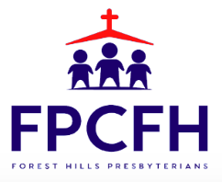

Building a Community of Faith, Hope, and Love
PresbyFH.org

