August 2, 2026 10th Sunday after Pentecost 11 AM

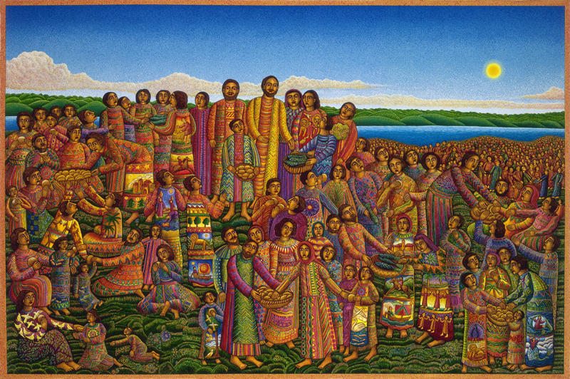
Swanson, John August. Loaves and Fishes, (2003)
from Art in the Christian Tradition, a project of the Vanderbilt Divinity Library, Nashville, TN.

PRELUDE “Praise the Lord with the Sounding of Cornet & Flute” Henry Heron

WELCOME

CALL TO WORSHIP
This is the day that the Lord has made; let us rejoice and give thanks for it!

OPENING PRAYER
Loving and mighty God, bless us here with your presence and lead us in our worship we pray. By your Spirit unite us with you and one another, that our worship may be an acceptable offering to you. This we pray in the name of Jesus Christ. Amen.
HYMN #460 “Break Thou the Bread of Life”

1 Break thou the bread of life, dear Lord, to me,
as thou didst break the loaves beside the sea.
Beyond the sacred page I seek thee, Lord.
My spirit pants for thee, O living Word!

2 Bless thou the truth, dear Lord, now unto me,
as thou didst bless the bread by Galilee.
Then shall all bondage cease, all fetters fall.
And I shall find my peace, my all in all.

CALL TO CONFESSION
If we say that we have no sin, we deceive ourselves, and the truth is not in us. If we confess our sins, he who is faithful and just will forgive us. (1 John 1:8-9)

In confidence as God’s children, let us confess our sins to God, ourselves and one another.

PRAYER OF CONFESSION
Most merciful God, we confess that we have sinned against you by what we have done, and by what we have left undone. We have not loved you with our whole heart or our neighbors as ourselves. We humbly repent. For the sake of your Son, Jesus Christ, have mercy on us; that we may delight in your will, and walk in your ways. Amen.

ASSURANCE OF GOD’S LOVE
One: What we have hoped for is true. What we cannot see has been made known. God’s forgiveness is certain and sure. In the name of Jesus Christ, you are forgiven!
All: Thanks be to God!

RESPONSE: HYMN #581 “Gloria Patri”
Glory be the Father, and to the Son and to the Holy Ghost,
As it was in the beginning, is now, and ever shall be,
World without end. Amen. Amen.

PEACE
Let there be peace on earth.
And let it begin with me.
The peace of Christ be with you.
And also with you.

RESPONSIVE READING Psalm 145:8-9,14-21 (NRSVUE)
The Lord is gracious and merciful,
slow to anger and abounding in steadfast love.
The Lord is good to all, and his compassion is over all that he has made.

The Lord upholds all who are falling and raises up all who are bowed down.
The eyes of all look to you, and you give them their food in due season.
You open your hand, satisfying the desire of every living thing.
The Lord is just in all his ways and kind in all his doings.
The Lord is near to all who call on him, to all who call on him in truth.
He fulfills the desire of all who fear him;
he also hears their cry and saves them.
The Lord watches over all who love him, but all the wicked he will destroy.
My mouth will speak the praise of the Lord,
and all flesh will bless his holy name forever and ever.

FIRST READING Isaiah 55:1-5 (NRSVUE)
¹ Hear, everyone who thirsts; come to the waters; and you who have no money, come, buy and eat! Come, buy wine and milk without money and without price. ² Why do you spend your money for that which is not bread and your earnings for that which does not satisfy? Listen carefully to me, and eat what is good, and delight yourselves in rich food. ³ Incline your ear, and come to me; listen, so that you may live. I will make with you an everlasting covenant, my steadfast, sure love for David. ⁴ See, I made him a witness to the peoples, a leader and commander for the peoples. ⁵ Now you shall call nations that you do not know, and nations that do not know you shall run to you, because of the Lord your God, the Holy One of Israel, for he has glorified you.

SECOND READING Matthew 14:13-21 (NRSVUE)
¹³ Now when Jesus heard this, he withdrew from there in a boat to a deserted place by himself. But when the crowds heard it, they followed him on foot from the towns. ¹⁴ When he went ashore, he saw a great crowd, and he had compassion for them and cured their sick. ¹⁵ When it was evening, the disciples came to him and said, “This is a deserted place, and the hour is now late; send the crowds away so that they may go into the villages and buy food for themselves.” ¹⁶ Jesus said to them, “They need not go away; you give them something to eat.” ¹⁷ They replied, “We have nothing here but five loaves and two fish.” ¹⁸ And he said, “Bring them here to me.” ¹⁹ Then he ordered the crowds to sit down on the grass. Taking the five loaves and the two fish, he looked up to heaven and blessed and broke the loaves and gave them to the disciples, and the disciples gave them to the crowds. ²⁰ And all ate and were filled, and they took up what was left over of the broken pieces, twelve baskets full. ²¹ And those who ate were about five thousand men, besides women and children.

SERMON Elder Nadina Grants

HYMN #343 (vv. 1, 2, 5, 6) “Where Cross the Crowded Ways of Life”

1 Where cross the crowded ways of life,
where sound the cries of race and clan,
above the noise of selfish strife,
we hear your voice, O Son of Man.

2 In haunts of wretchedness and need,
on shadowed thresholds fraught with fears,
from paths where hide the lures of greed,
we catch the vision of your tears.

5 O Master, from the mountainside,
make haste to heal these hearts of pain;
among these restless throngs abide;
O tread the city's streets again;

6 Till all the world shall learn your love,
and follow where your feet have trod;
till glorious from your heaven above
shall come the city of our God.

PROFESSION OF FAITH THE APOSTLES’ CREED
I Believe in God the Father Almighty, Maker of heaven and earth; and in Jesus Christ, His Only Son, our Lord, who was conceived by the Holy Spirit, born of the Virgin Mary, suffered under Pontius Pilate, was crucified, dead, and buried. He descended into hell; the third day He rose again from the dead. He ascended into heaven, and sitteth at the right hand of God the Father Almighty, from thence He shall come to judge the quick and the dead.
I believe in the Holy Spirit, the holy catholic church, the communion of saints, the forgiveness of sins, the resurrection of the body, and the life everlasting. Amen.

PRAYERS OF THE PEOPLE

OFFERING/OFFERTORY
Do good, be rich in good works, generous, and ready to share,
thus storing up for yourselves the treasure of a good foundation for the future, so that you may take hold of the life that really is life. (1 Tim. 6:17-19)

OFFERTORY Chorale on “Teach Us, Our Father, to Mean the Words We Say,
and From the Inmost Hearts to Pray” Thomas Merritt

OFFERING SONG #606 Doxology
Praise God, from whom all blessings flow,
Praise God, all creatures here below,
Praise God above, ye heavenly host,
Praise Father, Son and Holy Ghost. Amen.

PRAYER OF DEDICATION/THE LORD’S PRAYER

ANNOUNCEMENTS
CLOSING HYMN #366 “Love Divine, All Loves Excelling”

1 Love divine, all loves excelling, Joy of heaven, to earth come down,
fix in us thy humble dwelling; all thy faithful mercies crown.
Jesus, thou art all compassion; pure, unbounded love thou art;
visit us with thy salvation; enter every trembling heart.

2 Breathe, O breathe thy loving Spirit into every troubled breast;
let us all in thee inherit; let us find the promised rest.
Take away the love of sinning; Alpha and Omega be;
end of faith, as its beginning, set our hearts at liberty.

3 Come, Almighty, to deliver; let us all thy life receive;
suddenly return, and never, nevermore thy temples leave.
Thee we would be always blessing, serve thee as thy hosts above,
pray, and praise thee without ceasing, glory in thy perfect love.

4 Finish then thy new creation; pure and spotless let us be;
let us see thy great salvation perfectly restored in thee:
changed from glory into glory, till in heaven we take our place,
till we cast our crowns before thee, lost in wonder, love, and praise.

BENEDICTION
Go in peace, to love and serve the Lord.

POSTLUDE “Fugue in E Minor” John Stanley
___________________________________________________________________

UPCOMING CALENDAR

WEDNESDAY, 7:00 PM - Book Discussion Group on the book The Cost of Discipleship by Dietrich Bonhoeffer. We will be on the church Zoom at 7:00 PM.

REMINDER – Please keep in mind that worship is now at 10:00 AM for the Summer months ending last Sunday of August.

REMINDER: We are still looking for volunteers for worship readers and/or juice/coffee hour. There is a 3-month sign-up sheet posted just outside the office.
If you have any questions, please contact the Office.

First Presbyterian Church of Forest Hills
70-35 112th St., Forest Hills, NY 11375 presbyfh.org
David Barnett, Admin.718-268-4036 Jeff Courter, Pastor,
FirstPresFHNY@gmail.com; rev.jeffrey.courter@gmail.com
Rafael Reyes-Quiroz, Clerk of Session Hannah Lin, Guest Organist

Please note: we now have a public WiFi for the church, though it may only be available in the church hall for now.
Name: CHURCH GUEST
Password: welcome1

For offerings/donations:

- Use Zelle to make Online donations from your bank account. Use this phone number to transfer to the church:
929-418-0958 (please note: this is a new number)
- Make checks payable to First Presbyterian Church of Forest Hills and mail check to the church office
- Go to our church website: presbyfh.org and click on the “Give Now” icon to set up a donation; or click on the QR code above
- The web address of your donation form has now been changed to: https://secure.myvanco.com/L-ZBFD
- Set up a “Bill pay” from your bank.

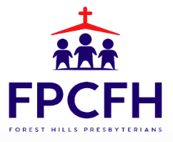

Building a Community of Faith, Hope, and Love
PresbyFH.org

