February 15, 2026 Transfiguration of the Lord 11 AM
Black History Month
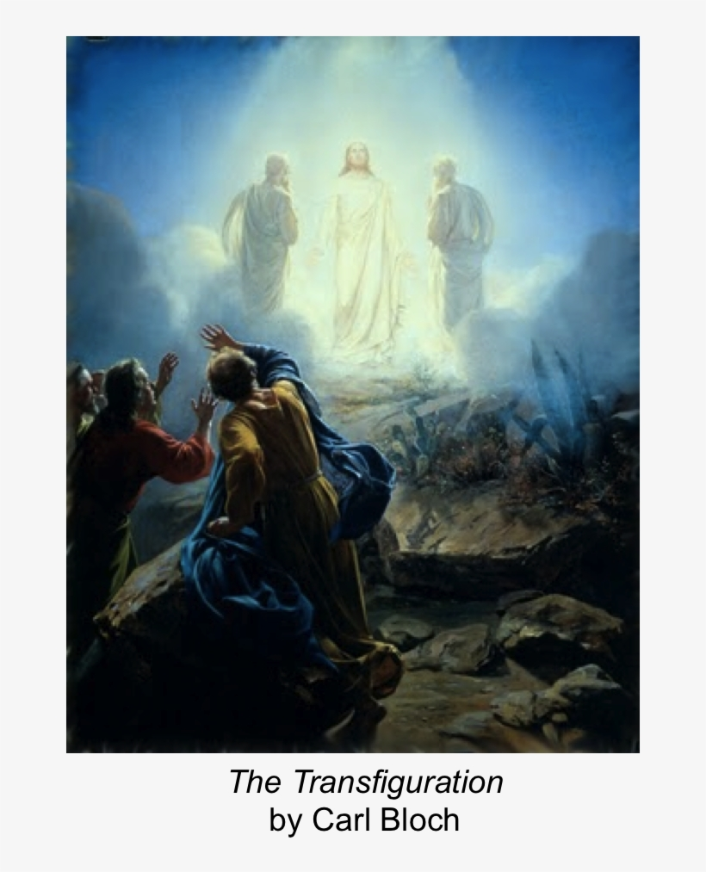

PRELUDE Chorale Prelude – “God our Father, dwell within make us J.S. Bach
free from all our sin. Keep us from the devil free; let us in faith abiding,
look over to they guiding, and grant a blessed ending.”

WELCOME

CALL TO WORSHIP

HYMN #193 (vv. 1, 2, 5) “Jesus, Take Us to the Mountain”

1. Jesus, take us to the mountain where, with Peter, James and John,
we are dazzled by your glory, light as blinding as the sun.
There prepare us for the night by the vision of that sight.

2. What do you want us to see there, That your close companions saw?
Your divinity revealed there fills us with the selfsame awe.
Clothed in flesh like ours you go, matched to meet our deadliest foe.

5. We who have beheld your glory, risen and ascended Lord,
cannot help but tell the story, all that we have seen and heard;
say with Peter, James, and John: "You are God's beloved Son!"

CALL TO CONFESSION

ASSURANCE OF GOD’S LOVE

RESPONSE: HYMN #581 “Gloria Patri”
Glory be the Father, and to the Son and to the Holy Ghost,
As it was in the beginning, is now, and ever shall be,
World without end. Amen. Amen.

PEACE
Let there be peace on earth.
And let it begin with me.
The peace of Christ be with you.
And also with you.

RESPONSIVE READING Psalm 2 (NRSVUE)
Why do the nations conspire and the peoples plot in vain?
The kings of the earth set themselves, and the rulers take counsel together,
against the Lord and his anointed, saying,
“Let us burst their bonds apart and cast their cords from us.”
He who sits in the heavens laughs; the Lord has them in derision.
Then he will speak to them in his wrath and terrify them in his fury, saying,
“I have set my king on Zion, my holy hill.”
I will tell of the decree of the Lord: He said to me, “You are my son;
today I have begotten you.
Ask of me, and I will make the nations your heritage
and the ends of the earth your possession.
You shall break them with a rod of iron
and dash them in pieces like a potter’s vessel.”
Now therefore, O kings, be wise; be warned, O rulers of the earth.
Serve the Lord with fear; with trembling
kiss his feet, or he will be angry, and you will perish in the way,
for his wrath is quickly kindled. Happy are all who take refuge in him.

FIRST READING Exodus 24:12-18 (NRSVUE)
¹² The Lord said to Moses, “Come up to me on the mountain and wait there; I will give you the tablets of stone, with the law and the commandment, which I have written for their instruction.” ¹³ So Moses set out with his assistant Joshua, and Moses went up onto the mountain of God. ¹⁴ To the elders he had said, “Wait here for us, until we come back to you. Look, Aaron and Hur are with you; whoever has a dispute may go to them.”

¹⁵ Then Moses went up on the mountain, and the cloud covered the mountain. ¹⁶ The glory of the Lord settled on Mount Sinai, and the cloud covered it for six days; on the seventh day he called to Moses out of the cloud. ¹⁷ Now the appearance of the glory of the Lord was like a devouring fire on the top of the mountain in the sight of the Israelites. ¹⁸ Moses entered the cloud and went up on the mountain. Moses was on the mountain for forty days and forty nights.

CHILDREN’S SERMON

SECOND READING Matthew 17:1-9 (NRSVUE)
¹ Six days later, Jesus took with him Peter and James and his brother John and led them up a high mountain, by themselves. ² And he was transfigured before them, and his face shone like the sun, and his clothes became bright as light. ³ Suddenly there appeared to them Moses and Elijah, talking with him. ⁴ Then Peter said to Jesus, “Lord, it is good for us to be here; if you wish, I will set up three tents here, one for you, one for Moses, and one for Elijah.” ⁵ While he was still speaking, suddenly a bright cloud overshadowed them, and a voice from the cloud said, “This is my Son, the Beloved; with him I am well pleased; listen to him!” ⁶ When the disciples heard this, they fell to the ground and were overcome by fear. ⁷ But Jesus came and touched them, saying, “Get up and do not be afraid.” ⁸ And when they raised their eyes, they saw no one except Jesus himself alone.

⁹ As they were coming down the mountain, Jesus ordered them, “Tell no one about the vision until after the Son of Man has been raised from the dead.”

SERMON “Revelation” Jeff Courter

PROFESSION OF FAITH THE APOSTLES CREED
I Believe in God the Father Almighty, Maker of heaven and earth; and in Jesus Christ, His Only Son, our Lord, who was conceived by the Holy Spirit, born of the Virgin Mary, suffered under Pontius Pilate, was crucified, dead, and buried. He descended into hell; the third day He rose again from the dead. He ascended into heaven, and sitteth at the right hand of God the Father Almighty, from thence He shall come to judge the quick and the dead.
I believe in the Holy Spirit, the holy catholic church, the communion of saints,
the forgiveness of sins, the resurrection of the body, and the life everlasting.

HYMN #189 (vv. 1, 4, 5) “O Wondrous Sight, O Vision Fair”

1 O wondrous sight, O vision fair of glory that the church shall share,
which Christ upon the mountain shows, where brighter than the sun he glows!

4 With shining face and bright array Christ deigns to manifest today
what glory shall be theirs above who joy in God with perfect love.

5 And faithful hearts are raised on high by this great vision's mystery,
for which in joyful strains we raise the voice of prayer, the hymn of praise.

PRAYERS OF THE PEOPLE

OFFERING/OFFERTORY “Flute & Horn Movement” Thomas Thorley

OFFERING SONG #606 Doxology
Praise God, from whom all blessings flow,
Praise God, all creatures here below,
Praise God above, ye heavenly host,
Praise Father, Son and Holy Ghost. Amen.

PRAYER OF DEDICATION/THE LORD’S PRAYER

ANNOUNCEMENTS

CLOSING HYMN #267 “Come, Christians, Join to Sing”

1 Come, Christians, join to sing: Alleluia! Amen!
Loud praise to Christ our King: Alleluia! Amen!
Let all, with heart and voice, before his throne rejoice;
praise is his gracious choice: Alleluia! Amen!

2 Come, lift your hearts on high: Alleluia! Amen!
Let praises fill the sky: Alleluia! Amen!
He is our guide and friend; to us he'll condescend;
his love shall never end: Alleluia! Amen!

3 Praise yet our Christ again: Alleluia! Amen!
Life shall not end the strain: Alleluia! Amen!
On heaven's blissful shore his goodness we'll adore,
singing forevermore: Alleluia! Amen!

BENEDICTION

POSTLUDE “A Safe Stronghold Our God Is Still” George Boehm

UPCOMING CALENDAR

ADULT BIBLE STUDY – Sunday 10:00 AM – we are currently starting Delivered into Covenant (Pivotal Moments in the Book of Exodus) by Walter Brueggemann
If you are interested, please contact David in the office.

WEDNESDAY, FEBRUARY 18TH – ASH WEDNESDAY
Lent is the season of the church year which leads up to Easter. It begins with Ash Wednesday, which will be this week. The church will open the sanctuary doors from 6:00 PM to 6:30 PM for anyone who wants to receive ashes on their forehead as a sign of earnest repentance and renewed commitment to the faith.

We will have a Lenten book discussion beginning on Ash Wednesday as well - at 7:00 on Zoom! We will be reading Pastor Brian Zahnd's book, The Wood Between the Worlds:A Poetic Theology of the Cross (InterVarsity Press, 2024) until Holy Week. (The book is 199 pages long, so we will not be able to discuss all of it in detail. For most weeks we will read 3 chapters [about 30 pages] and discuss them broadly. We have copies of the book available - if you want a copy, please contact the office or stop by and get a copy.

REMINDER: We are still looking for volunteers for worship readers and/or juice/coffee hour. There is a 3-month sign-up sheet posted just outside the office.
If you have any questions, please contact the Office.

First Presbyterian Church of Forest Hills
70-35 112th St., Forest Hills, NY 11375 presbyfh.org
David Barnett, Admin.718-268-4036 Jeff Courter, Pastor,
FirstPresFHNY@gmail.com; rev.jeffrey.courter@gmail.com
Nadina Grants, Clerk of Session Hannah Lin, Guest Organist

Please note: we now have a public WiFi for the church, though it may only be available in the church hall for now.
Name: CHURCH GUEST
Password: welcome1

For offerings/donations:

- Use Zelle to make Online donations from your bank account. Use this phone number to transfer to the church:
929-418-0958 (please note: this is a new number)
- Make checks payable to First Presbyterian Church of Forest Hills and mail check to the church office
- Go to our church website: presbyfh.org and click on the “Give Now” icon to set up a donation; or click on the qr code above
- Set up a “Bill pay” from your bank.



Building a Community of Faith, Hope, and Love
PresbyFH.org

