April 19, 2026 3rd Sunday of Easter 11 AM

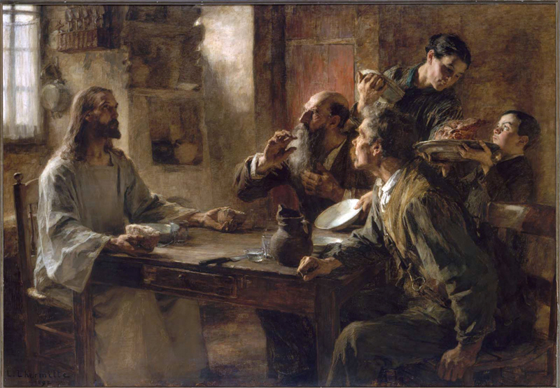
Lhermitte, Léon Augustin, 1844-1925. Friend of the Humble (Supper at Emmaus), 1892
from Art in the Christian Tradition, a project of the Vanderbilt Divinity Library, Nashville, TN.

PRELUDE “I, I am He that comforteth. Be not afraid, be not afraid, for I am thy God; I’ll strengthen thee! Say, who art thou? That Thou art afraid of a man that shall die; and forgettest the Lord thy Maker, who hath stretched for the heavens, and laid the earth’s foundations, say who art thou? I’m that comforteth; be not afraid, for I, thy God will strengthen thee.” Felix Mendelssohn
(from Elijah Oratorio, 2nd part No. 21)

WELCOME

CALL TO WORSHIP

HYMN #460 “Break Thou the Bread of Life”

1 Break thou the bread of life, dear Lord, to me,
as thou didst break the loaves beside the sea.
Beyond the sacred page I seek thee, Lord.
My spirit pants for thee, O living Word!

2 Bless thou the truth, dear Lord, now unto me,
as thou didst bless the bread by Galilee.
Then shall all bondage cease, all fetters fall.
And I shall find my peace, my all in all.

CALL TO CONFESSION

PRAYER OF CONFESSION

ASSURANCE OF GOD’S LOVE

RESPONSE: HYMN #581 “Gloria Patri”
Glory be the Father, and to the Son and to the Holy Ghost,
As it was in the beginning, is now, and ever shall be,
World without end. Amen. Amen.

PEACE
Let there be peace on earth.
And let it begin with me.
The peace of Christ be with you.
And also with you.

RESPONSIVE READING Psalm 34:1-10 (NRSVUE)
I will bless the Lord at all times; his praise shall continually be in my mouth.
My soul makes its boast in the Lord; let the humble hear and be glad.
O magnify the Lord with me, and let us exalt his name together.
I sought the Lord, and he answered me and delivered me from all my fears.
Look to him, and be radiant, so your faces shall never be ashamed.
This poor soul cried and was heard by the Lord
and was saved from every trouble.
The angel of the Lord encamps around those who fear him and delivers them.
O taste and see that the Lord is good;
happy are those who take refuge in him.
O fear the Lord, you his holy ones, for those who fear him have no want.
The young lions suffer want and hunger,
but those who seek the Lord lack no good thing.

FIRST READING Acts 2:38-47 (NRSVUE)
³⁸ Peter said to them, “Repent and be baptized every one of you in the name of Jesus Christ so that your sins may be forgiven, and you will receive the gift of the Holy Spirit. ³⁹ For the promise is for you, for your children, and for all who are far away, everyone whom the Lord our God calls to him.” ⁴⁰ And he testified with many other arguments and exhorted them, saying, “Save yourselves from this corrupt generation.” ⁴¹ So those who welcomed his message were baptized, and that day about three thousand persons were added. ⁴² They devoted themselves to the apostles’ teaching and fellowship, to the breaking of bread and the prayers.

⁴³ Awe came upon everyone because many wonders and signs were being done through the apostles. ⁴⁴ All who believed were together and had all things in common; ⁴⁵ they would sell their possessions and goods and distribute the proceeds to all, as any had need. ⁴⁶ Day by day, as they spent much time together in the temple, they broke bread at home and ate their food with glad and generous hearts, ⁴⁷ praising God and having the goodwill of all the people. And day by day the Lord added to their number those who were being saved.

CHILDREN’S SERMON

SECOND READING Luke 24:13-35 (NRSVUE)
¹³ Now on that same day two of them were going to a village called Emmaus, about seven miles from Jerusalem, ¹⁴ and talking with each other about all these things that had happened. ¹⁵ While they were talking and discussing, Jesus himself came near and went with them, ¹⁶ but their eyes were kept from recognizing him. ¹⁷ And he said to them, “What are you discussing with each other while you walk along?” They stood still, looking sad. ¹⁸ Then one of them, whose name was Cleopas, answered him, “Are you the only stranger in Jerusalem who does not know the things that have taken place there in these days?” ¹⁹ He asked them, “What things?” They replied, “The things about Jesus of Nazareth, who was a prophet mighty in deed and word before God and all the people, ²⁰ and how our chief priests and leaders handed him over to be condemned to death and crucified him. ²¹ But we had hoped that he was the one to redeem Israel. Yes, and besides all this, it is now the third day since these things took place. ²² Moreover, some women of our group astounded us. They were at the tomb early this morning, ²³ and when they did not find his body there they came back and told us that they had indeed seen a vision of angels who said that he was alive. ²⁴ Some of those who were with us went to the tomb and found it just as the women had said, but they did not see him.” ²⁵ Then he said to them, “Oh, how foolish you are and how slow of heart to believe all that the prophets have declared! ²⁶ Was it not necessary that the Messiah should suffer these things and then enter into his glory?” ²⁷ Then beginning with Moses and all the prophets, he interpreted to them the things about himself in all the scriptures.

²⁸ As they came near the village to which they were going, he walked ahead as if he were going on. ²⁹ But they urged him strongly, saying, “Stay with us, because it is almost evening and the day is now nearly over.” So he went in to stay with them. ³⁰ When he was at the table with them, he took bread, blessed and broke it, and gave it to them. ³¹ Then their eyes were opened, and they recognized him, and he vanished from their sight. ³² They said to each other, “Were not our hearts burning within us while he was talking to us on the road, while he was opening the scriptures to us?” ³³ That same hour they got up and returned to Jerusalem, and they found the eleven and their companions gathered together. ³⁴ They were saying, “The Lord has risen indeed, and he has appeared to Simon!” ³⁵ Then they told what had happened on the road and how he had been made known to them in the breaking of the bread.

SERMON “Bread of Life” Jeff Courter

HYMN #522 (vv. 1,2,4) “I Am the Bread of Life”

- “I am the Bread of Life. You who come to Me shall not hunger;
and who believe in Me shall not thirst. No one can come to Me
unless the Father beckons.”

[Refrain]: “And I will raise you up, and I will raise you up,
and I will raise you up on the last day.”

2. “The bread that I will give is My flesh for the life of the world,
and if you eat of this Bread, you shall live forever; you shall live forever!”
[Refrain]
4. “I am the Resurrection; I am the Life.
If you believe in Me, even though you die, you shall live forever.
[Refrain]

PROFESSION OF FAITH THE APOSTLES CREED
I Believe in God the Father Almighty, Maker of heaven and earth; and in Jesus Christ, His Only Son, our Lord, who was conceived by the Holy Spirit, born of the Virgin Mary, suffered under Pontius Pilate, was crucified, dead, and buried. He descended into hell; the third day He rose again from the dead. He ascended into heaven, and sitteth at the right hand of God the Father Almighty, from thence He shall come to judge the quick and the dead.
I believe in the Holy Spirit, the holy catholic church, the communion of saints,
the forgiveness of sins, the resurrection of the body, and the life everlasting.

PRAYERS OF THE PEOPLE

OFFERING/OFFERTORY “Hear the Truth and Keep Thy Way” Edward Broughton

OFFERING SONG #606 Doxology
Praise God, from whom all blessings flow,
Praise God, all creatures here below,
Praise God above, ye heavenly host,
Praise Father, Son and Holy Ghost. Amen.

PRAYER OF DEDICATION/THE LORD’S PRAYER
ANNOUNCEMENTS

HYMN #515 (vv. 1,2,5) “I Come with Joy”

1 I come with joy, a child of God, forgiven, loved, and free,
the life of Jesus to recall, in love laid down for me, in love laid down for me.

2 I come with Christians far and near to find, as all are fed,
the new community of love in Christ’s communion bread,
in Christ’s communion bread.

5 Together met, together bound by all that God has done,
we’ll go with joy, to give the world the love that makes us one,
the love that makes us one.

BENEDICTION

POSTLUDE “An Air for the Trumpet” G. Philipp Telemann

UPCOMING CALENDAR

TODAY, APRIL 19th , 12:30 PM – EMBRACING COMPASSION. Please come join
us in the church hall to hear Dr. Rikki Asher! (see flyer)

ACROSS-THE-STREET BOOK CLUB – TUES., APRIL 21st, 7:30 PM – we will meet online to discuss the book, The Traitors Circle: The True Story of a Secret Resistance Network in Nazi Germany―and the Spy Who Betrayed Them – Berlin's Elite Defying Tyranny in 1943, by Jonathan Freedland

SUNDAY, APRIL 26^{th,} 1:00 PM – Please come join us to help decorate and fill special treat bags for moms being helped by Safe Horizons. The bags will be distributed by Safe Horizons to their clients before Mother’s Day. (see flyer)

SUNDAY, ADULT BIBLE STUDY – 10:00 AM – We are studying the Bible book of Ephesians in case you would like to join us. There are only six chapters in the book, so that we will be finished by end May/early June. If you are interested, please see David in the office.

REMINDER: We are still looking for volunteers for worship readers and/or juice/coffee hour. There is a 3-month sign-up sheet posted just outside the office.
If you have any questions, please contact the Office.

First Presbyterian Church of Forest Hills
70-35 112th St., Forest Hills, NY 11375 presbyfh.org
David Barnett, Admin.718-268-4036 Jeff Courter, Pastor,
FirstPresFHNY@gmail.com; rev.jeffrey.courter@gmail.com
Nadina Grants, Clerk of Session Hannah Lin, Guest Organist

Please note: we now have a public WiFi for the church, though it may only be available in the church hall for now.
Name: CHURCH GUEST
Password: welcome1

For offerings/donations:

- Use Zelle to make Online donations from your bank account. Use this phone number to transfer to the church:
929-418-0958 (please note: this is a new number)
- Make checks payable to First Presbyterian Church of Forest Hills and mail check to the church office
- Go to our church website: presbyfh.org and click on the “Give Now” icon to set up a donation; or click on the qr code above
- The web address of your donation form has now been changed to: https://secure.myvanco.com/L-ZBFD
- Set up a “Bill pay” from your bank.

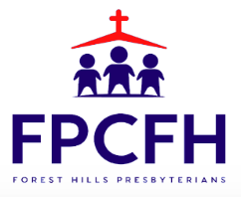

Building a Community of Faith, Hope, and Love
PresbyFH.org

