April 14, 2024 3rd Sunday of Easter 11 AM

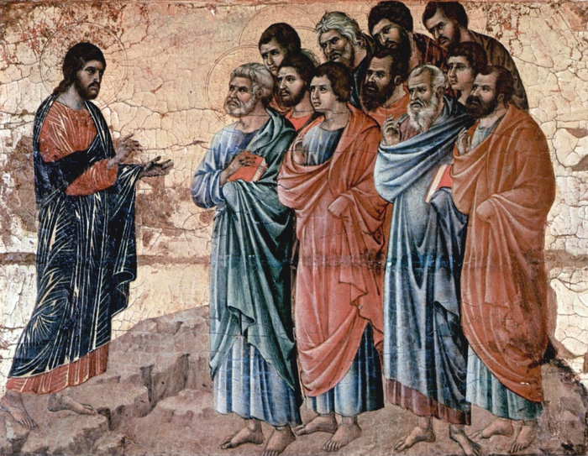
Duccio, di Buoninsegna, -1319?. Christ Appears to the Disciples on the Mountain in Galilee, from Art in the Christian Tradition, a project of the Vanderbilt Divinity Library, Nashville, TN.

PRELUDE “My Heart Ever Faithful” J.S. Bach

WELCOME

CALL TO WORSHIP

HYMN #4 “Holy God, We Praise Your Name”

1 Holy God, we praise your name; Lord of all, we bow before you.
All on earth your scepter claim; all in heaven above adore you.
Infinite your vast domain, everlasting is your reign.

2 Hark! The glad celestial hymn angel choirs above are raising;
cherubim and seraphim, in unceasing chorus praising,
fill the heavens with sweet accord: “Holy, holy, holy Lord!”

3 All apostles join the strain as your sacred name they hallow;
prophets swell the glad refrain, and the blessed martyrs follow,
and from morn to set of sun, through the church the song goes on.

4 Holy Father, Holy Son, Holy Spirit: three we name you,
while in essence only one; undivided God we claim you,
and adoring, bend the knee while we own the mystery.

CALL TO CONFESSION

PRAYER OF CONFESSION

ASSURANCE OF GOD’S LOVE

RESPONSE: HYMN #581 “Gloria Patri”
Glory be the Father, and to the Son and to the Holy Ghost,
As it was in the beginning, is now, and ever shall be,
World without end. Amen. Amen.

PEACE
Let there be peace on earth.
And let it begin with me.
The peace of Christ be with you.
And also with you.

RESPONSIVE READING Psalm 40:1-5 (NRSVUE)
I waited patiently for the Lord; he inclined to me and heard my cry.
He drew me up from the desolate pit, out of the miry bog,
and set my feet upon a rock, making my steps secure.
He put a new song in my mouth, a song of praise to our God.
Many will see and fear and put their trust in the Lord.
Happy are those who make the Lord their trust,
who do not turn to the proud, to those who go astray after false gods.
You have multiplied, O Lord my God, your wondrous deeds and your thoughts
toward us; none can compare with you. Were I to proclaim and tell of them,
they would be more than can be counted.

FIRST READING Isaiah 6:1-9 (NRSVUE)
¹ In the year that King Uzziah died, I saw the Lord sitting on a throne, high and lofty, and the hem of his robe filled the temple. ² Seraphs were in attendance above him; each had six wings: with two they covered their faces, and with two they covered their feet, and with two they flew. ³ And one called to another and said,
“Holy, holy, holy is the Lord of hosts; the whole earth is full of his glory.”
⁴ The pivots on the thresholds shook at the voices of those who called, and the house filled with smoke. ⁵ And I said, “Woe is me! I am lost, for I am a man of unclean lips, and I live among a people of unclean lips, yet my eyes have seen the King, the Lord of hosts!” ⁶ Then one of the seraphs flew to me, holding a live coal that had been taken from the altar with a pair of tongs. ⁷ The seraph touched my mouth with it and said, “Now that this has touched your lips, your guilt has departed and your sin is blotted out.” ⁸ Then I heard the voice of the Lord saying, “Whom shall I send, and who will go for us?” And I said, “Here am I; send me!” ⁹ And he said, “Go and say to this people: ‘Keep listening, but do not comprehend;
keep looking, but do not understand.’

SECOND READING Luke 24:36b-48 (NRSVUE)
³⁶ Jesus himself stood among them (His disciples) and said to them, “Peace be with you.” ³⁷ They were startled and terrified and thought that they were seeing a ghost. ³⁸ He said to them, “Why are you frightened, and why do doubts arise in your hearts? ³⁹ Look at my hands and my feet; see that it is I myself. Touch me and see, for a ghost does not have flesh and bones as you see that I have.” ⁴⁰ And when he had said this, he showed them his hands and his feet. ⁴¹ Yet for all their joy they were still disbelieving and wondering, and he said to them, “Have you anything here to eat?” ⁴² They gave him a piece of broiled fish, ⁴³ and he took it and ate in their presence.

⁴⁴ Then he said to them, “These are my words that I spoke to you while I was still with you—that everything written about me in the law of Moses, the prophets, and the psalms must be fulfilled.” ⁴⁵ Then he opened their minds to understand the scriptures, ⁴⁶ and he said to them, “Thus it is written, that the Messiah is to suffer and to rise from the dead on the third day ⁴⁷ and that repentance and forgiveness of sins is to be proclaimed in his name to all nations, beginning from Jerusalem. ⁴⁸ You are witnesses of these things.

SERMON “Witnesses” Jeff Courter

HYMN #248 “Christ Is Risen! Shout Hosanna!”

1 Christ is risen! Shout Hosanna! Celebrate this day of days!
Christ is risen! Hush in wonder: all creation is amazed.
In the desert all-surrounding, see, a spreading tree has grown.
Healing leaves of grace abounding bring a taste of love unknown.

2 Christ is risen! Raise your spirits from the caverns of despair.
Walk with gladness in the morning. See what love can do and dare.
Drink the wine of resurrection, not a servant, but a friend.
Jesus is our strong companion. Joy and peace shall never end.

3 Christ is risen! Earth and heaven nevermore shall be the same.
Break the bread of new creation where the world is still in pain.
Tell its grim, demonic chorus: "Christ is risen! Get you gone!"
God the First and Last is with us. Sing Hosanna everyone!

PROFESSION OF FAITH THE APOSTLES CREED
I Believe in God the Father Almighty, Maker of heaven and earth; and in Jesus Christ, His Only Son, our Lord, who was conceived by the Holy Spirit, born of the Virgin Mary, suffered under Pontius Pilate, was crucified, dead, and buried. He descended into hell; the third day He rose again from the dead. He ascended into heaven, and sitteth at the right hand of God the Father Almighty, from thence He shall come to judge the quick and the dead.
I believe in the Holy Spirit, the holy catholic church, the communion of saints, the forgiveness of sins, the resurrection of the body, and the life everlasting. Amen.

PRAYERS OF THE PEOPLE

OFFERING/OFFERTORY “Praise and Thanks Be to Thee, O Lord” Fr. Lambillote

OFFERING SONG #606 Doxology
Praise God, from whom all blessings flow,
Praise God, all creatures here below,
Praise God above, ye heavenly host,
Praise Father, Son and Holy Ghost. Amen.

PRAYER OF DEDICATION/THE LORD’S PRAYER

ANNOUNCEMENTS

CLOSING HYMN #69 “Here I Am, Lord”

- I, the Lord of sea and sky, I have heard my people cry.
All who dwell in dark and sin My hand will save.
I, who made the stars of night, I will make their darkness bright.
Who will bear my light to them? Whom shall I send?
Refrain: Here I am, Lord. Is it I, Lord? I have heard you calling in the night.
I will go, Lord, if you lead me. I will hold your people in my heart.

2. I, the Lord of snow and rain, I have borne my people's pain.
I have wept for love of them. They turn away.
I will break their hearts of stone, give them hearts for love alone.
I will speak my word to them. Whom shall I send?
Refrain: Here I am, Lord. Is it I, Lord? I have heard you calling in the night.
I will go, Lord, if you lead me. I will hold your people in my heart.

3. I, the Lord of wind and flame, I will tend the poor and lame.
I will set a feast for them. My hand will save.
Finest bread I will provide til their hearts be satisfied.
I will give my life to them. Whom shall I send?
Refrain: Here I am, Lord. Is it I, Lord? I have heard you calling in the night.
I will go, Lord, if you lead me. I will hold your people in my heart.

BENEDICTION

POSTLUDE “Easter Jubilance” L.N. Porter
_________________________________________________________________________________________________________

UPCOMING CALENDAR

MONDAY, 7:00 PM – Meditation & Prayer Group in the church sanctuary. No Zoom.

SUNDAY, 10:00 AM – Bible Study in Room 7. We are studying the book of James, and will finish by end May or first Sunday of June.

REMINDER: We are still looking for volunteers for worship readers and/or juice/coffee hour. There is a 3-month sign-up sheet posted just outside the office, and we would appreciate your help as we have been transitioning back to in-worship service. If you have any questions, please contact the Office.

First Presbyterian Church of Forest Hills
70-35 112th St., Forest Hills, NY 11375 presbyfh.org
David Barnett, Admin.718-268-4036 Jeff Courter, Pastor,
FirstPresFHNY@gmail.com; rev.jeffrey.courter@gmail.com
‘Cil Brewer, Clerk of Session Hannah Lin, Organist

For offerings/donations:
- Use Zelle to make Online donations from your bank account. Use this phone number to transfer to the church: 929-418-0958 (please note: this is a new number)
- Make checks payable to First Presbyterian Church of Forest Hills and mail check to the church office
- Go to our church website: presbyfh.org and click on the “Give Now” icon to set up a donation; or click on the qr code above
- Set up a “Bill pay” from your bank

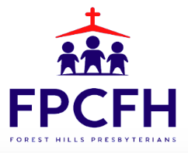

Building a Community of Faith, Hope, and Love

