May 31, 2026 Trinity Sunday 11 AM

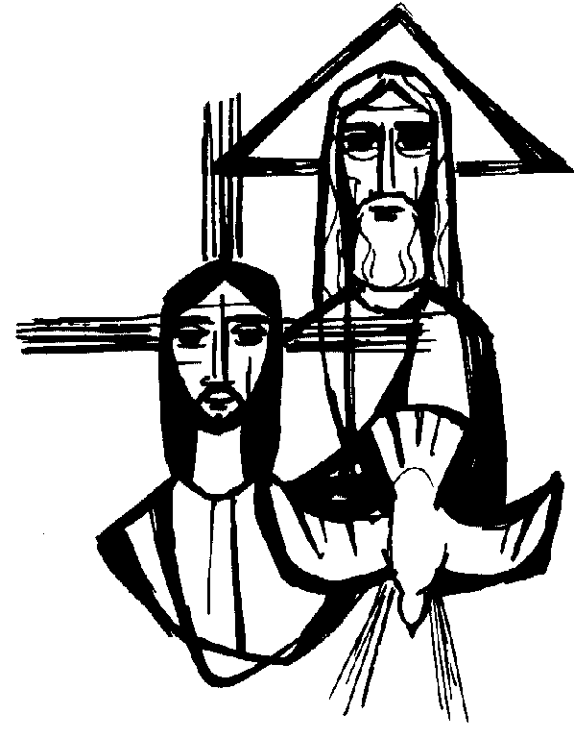
Clipart Library

PRELUDE

WELCOME

CALL TO WORSHIP

HYMN#370 “This Is My Father’s World”

1 This is my Father's world, and to my listening ears
all nature sings, and round me rings the music of the spheres.
This is my Father's world; I rest me in the thought
of rocks and trees, of skies and seas, his hand the wonders wrought.
2 This is my Father's world. O, let me ne'er forget
that though the wrong seems oft so strong, God is the ruler yet.
This is my Father's world. The battle is not done:
Jesus who died shall be satisfied, and earth and heaven be one.

CALL TO CONFESSION

PRAYER OF CONFESSION

ASSURANCE OF GOD’S LOVE

RESPONSE: HYMN #582 “Glory to God”
1 Glory to God, whose goodness shines on me,
and to the Son, whose grace has pardoned me,
and to the Spirit, whose love has set me free.
As it was in the beginning, is now and ever shall be. Amen.

2 World without end, without end. Amen.
World without end, without end. Amen
World without end, without end. Amen.
As it was in the beginning, is now and ever shall be. Amen.

PEACE
Let there be peace on earth.
And let it begin with me.
The peace of Christ be with you.
And also with you.

RESPONSIVE READING Psalm 8 (NRSVUE)
O Lord, our Sovereign, how majestic is your name in all the earth!
You have set your glory above the heavens.
Out of the mouths of babes and infants you have founded a bulwark because
of your foes, to silence the enemy and the avenger.
When I look at your heavens, the work of your fingers,
the moon and the stars that you have established;
what are humans that you are mindful of them, mortals that you care for them?
Yet you have made them a little lower than God
and crowned them with glory and honor.
You have given them dominion over the works of your hands;
you have put all things under their feet,
all sheep and oxen, and also the beasts of the field,
the birds of the air, and the fish of the sea,
whatever passes along the paths of the seas.
O Lord, our Sovereign, how majestic is your name in all the earth!

FIRST READING Genesis 1:1-2:4a (NRSVUE)
1 When God began to create the heavens and the earth, ² the earth was complete chaos, and darkness covered the face of the deep, while a wind from God swept over the face of the waters. ³ Then God said, “Let there be light,” and there was light. ⁴ And God saw that the light was good, and God separated the light from the darkness. ⁵ God called the light Day, and the darkness he called Night. And there was evening and there was morning, the first day.
⁶ And God said, “Let there be a dome in the midst of the waters, and let it separate the waters from the waters.” ⁷ So God made the dome and separated the waters that were under the dome from the waters that were above the dome. And it was so. ⁸ God called the dome Sky. And there was evening and there was morning, the second day.
⁹ And God said, “Let the waters under the sky be gathered together into one place, and let the dry land appear.” And it was so. ¹⁰ God called the dry land Earth, and the waters that were gathered together he called Seas. And God saw that it was good. ¹¹ Then God said, “Let the earth put forth vegetation: plants yielding seed and fruit trees of every kind on earth that bear fruit with the seed in it.” And it was so. ¹² The earth brought forth vegetation: plants yielding seed of every kind and trees of every kind bearing fruit with the seed in it. And God saw that it was good. ¹³ And there was evening and there was morning, the third day.
¹⁴ And God said, “Let there be lights in the dome of the sky to separate the day from the night, and let them be for signs and for seasons and for days and years, ¹⁵ and let them be lights in the dome of the sky to give light upon the earth.” And it was so. ¹⁶ God made the two great lights—the greater light to rule the day and the lesser light to rule the night—and the stars. ¹⁷ God set them in the dome of the sky to give light upon the earth, ¹⁸ to rule over the day and over the night, and to separate the light from the darkness. And God saw that it was good. ¹⁹ And there was evening and there was morning, the fourth day.
²⁰ And God said, “Let the waters bring forth swarms of living creatures, and let birds fly above the earth across the dome of the sky.” ²¹ So God created the great sea monsters and every living creature that moves, of every kind, with which the waters swarm and every winged bird of every kind. And God saw that it was good. ²² God blessed them, saying, “Be fruitful and multiply and fill the waters in the seas, and let birds multiply on the earth.” ²³ And there was evening and there was morning, the fifth day.
²⁴ And God said, “Let the earth bring forth living creatures of every kind: cattle and creeping things and wild animals of the earth of every kind.” And it was so. ²⁵ God made the wild animals of the earth of every kind and the cattle of every kind and everything that creeps upon the ground of every kind. And God saw that it was good.
²⁶ Then God said, “Let us make humans in our image, according to our likeness, and let them have dominion over the fish of the sea and over the birds of the air and over the cattle and over all the wild animals of the earth and over every creeping thing that creeps upon the earth.”
²⁷ So God created humans in his image,
in the image of God he created them;
male and female he created them.
²⁸ God blessed them, and God said to them, “Be fruitful and multiply and fill the earth and subdue it and have dominion over the fish of the sea and over the birds of the air and over every living thing that moves upon the earth.” ²⁹ God said, “See, I have given you every plant yielding seed that is upon the face of all the earth and every tree with seed in its fruit; you shall have them for food. ³⁰ And to every beast of the earth and to every bird of the air and to everything that creeps on the earth, everything that has the breath of life, I have given every green plant for food.” And it was so. ³¹ God saw everything that he had made, and indeed, it was very good. And there was evening and there was morning, the sixth day.
¹ Thus the heavens and the earth were finished and all their multitude. ² On the sixth day God finished the work that he had done, and he rested on the seventh day from all the work that he had done. ³ So God blessed the seventh day and hallowed it, because on it God rested from all the work that he had done in creation.
⁴ These are the generations of the heavens and the earth when they were created.

CHILDREN’S SERMON

SECOND READING Matthew 28-16-20 (NRSVUE)
¹⁶ Now the eleven disciples went to Galilee, to the mountain to which Jesus had directed them. ¹⁷ When they saw him, they worshiped him, but they doubted. ¹⁸ And Jesus came and said to them, “All authority in heaven and on earth has been given to me. ¹⁹ Go therefore and make disciples of all nations, baptizing them in the name of the Father and of the Son and of the Holy Spirit ²⁰ and teaching them to obey everything that I have commanded you. And remember, I am with you always, to the end of the age.”

SERMON “Oneness” Jeff Courter

HYMN #1 “Holy, Holy, Holy! Lord God Almighty!

- Holy, holy, holy! Lord God Almighty!
Early in the morning our song shall rise to Thee.
Holy, holy, holy! Merciful and mighty!
God in three persons, blessed Trinity!

- Holy, holy, holy! All the saints adore Thee,
Casting down their golden crowns around the glassy sea;
Cherubim and seraphim falling down before Thee;
Who wert and art, and evermore shalt be.

- Holy, holy, holy! Though the darkness hide Thee,
Though the eye of sinfulness Thy glory may not see,
Only Thou art holy, there is none beside Thee,
Perfect in power, in love and purity.

- Holy, holy, holy! Lord God Almighty!
All Thy works shall praise Thy name in earth and sky and sea;
Holy, holy, holy, merciful and mighty!
God in three Persons, blessed Trinity!

PROFESSION OF FAITH THE NICENE CREED
We believe in one God, the Father, the Almighty, maker of heaven and earth, of all that is, seen and unseen. We believe in one Lord, Jesus Christ, the only Son of God, eternally begotten of the Father, God from God, Light from Light, true God from true God, begotten, not made, of one Being with the Father; through him all things were made. For us and for our salvation he came down from heaven, was incarnate of the Holy Spirit and the Virgin Mary and became truly human. For our sake he was crucified under Pontius Pilate; he suffered death and was buried. On the third day he rose again in accordance with the Scriptures; he ascended into heaven and is seated at the right hand of the Father. He will come again in glory to judge the living and the dead, and his kingdom will have no end. We believe in the Holy Spirit, the Lord, the giver of life, who proceeds from the Father and the Son, who with the Father and the Son is worshiped and glorified, who has spoken through the prophets. We believe in one holy catholic and apostolic Church. We acknowledge one baptism for the forgiveness of sins. We look for the resurrection of the dead, and the life of the world to come. Amen.

PRAYERS OF THE PEOPLE

OFFERING/OFFERTORY

OFFERING SONG #328 “Praise God, All You Nations” (DaNase)
Praise God, all you nations. People of God, sing praise!
Praise God, all you nations. People of God, sing praise:
God’s love is great and endures forever.
Praise God, all you nations. People of God, sing praise!

PRAYER OF DEDICATION/THE LORD’S PRAYER

ANNOUNCEMENTS

HYMN# 634 “To God Be the Glory”
To God be the glory, great things He hath done;
So loved He the world that He gave us His Son,
Who yielded His life an atonement for sin,
And opened the life gate that all may go in.

(Refrain) Praise the Lord, praise the Lord, Let the earth hear His voice!
Praise the Lord, praise the Lord, Let the people rejoice!
O come to the Father, through Jesus the Son,
And give Him the glory, great things He has done.

Great things He hath taught us, great things He hath done,
And great our rejoicing through Jesus the Son;
But purer, and higher, and greater will be
Our wonder, our rapture, when Jesus we see. (Refrain)

BENEDICTION

POSTLUDE_________________________________________________________

UPCOMING CALENDAR

SUNDAY, JUNE 7th – JACKSON HEIGHTS PRIDE PARADE, 12:00 NOON – Please note that the Sacrament of Communion has been moved to Sunday, June 14th. If you are interested in marching in the PRIDE parade with the Pastor, please contact the church office.

SUNDAY, JUNE 21st, Father’s Day - Starting on this date, worship will move to 10:00 AM for the Summer months ending last Sunday of August.

REMINDER: We are still looking for volunteers for worship readers and/or juice/coffee hour. There is a 3-month sign-up sheet posted just outside the office.
If you have any questions, please contact the Office.
First Presbyterian Church of Forest Hills
70-35 112th St., Forest Hills, NY 11375 presbyfh.org
David Barnett, Admin.718-268-4036 Jeff Courter, Pastor,
FirstPresFHNY@gmail.com; rev.jeffrey.courter@gmail.com
Rafael Reyes-Quiroz, Clerk of Session

Please note: we now have a public WiFi for the church, though it may only be available in the church hall for now.
Name: CHURCH GUEST
Password: welcome1

For offerings/donations:

- Use Zelle to make Online donations from your bank account. Use this phone number to transfer to the church:
929-418-0958 (please note: this is a new number)
- Make checks payable to First Presbyterian Church of Forest Hills and mail check to the church office
- Go to our church website: presbyfh.org and click on the “Give Now” icon to set up a donation; or click on the qr code above
- The web address of your donation form has now been changed to: https://secure.myvanco.com/L-ZBFD
- Set up a “Bill pay” from your bank.

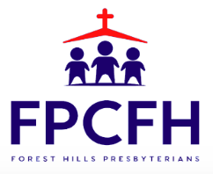

Building a Community of Faith, Hope, and Love
PresbyFH.org

