October 11, 2026 20th Sunday after Pentecost 11 AM
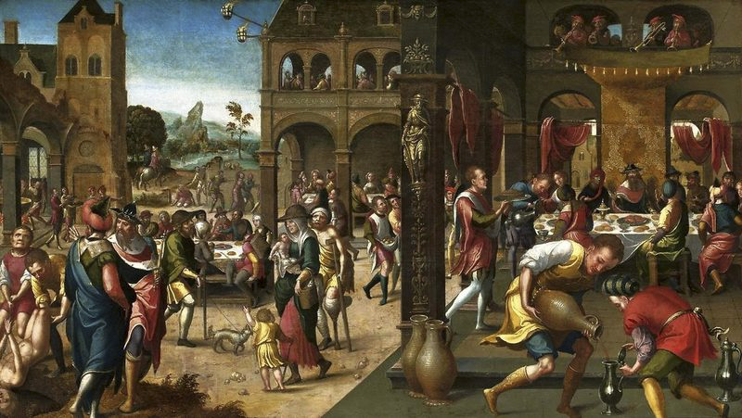
. Brunswick Monogrammist. Parable of the Great Banquet, ca. 1525,
from Art in the Christian Tradition, a project of the Vanderbilt University Divinity Library, Nashville, TN.

PRELUDE

WELCOME

CALL TO WORSHIP

HYMN #803 “My Shepherd Will Supply My Need”

1 My shepherd will supply my need; Jehovah is his name.
In pastures fresh he makes me feed, beside the living stream.
He brings my wandering spirit back when I forsake his ways,
and leads me, for his mercy's sake, in paths of truth and grace.

2 When I walk through the shades of death your presence is my stay;
one word of your supporting breath drives all my fears away.
Your hand, in sight of all my foes, does still my table spread;
my cup with blessings overflows; your oil anoints my head.

3 The sure provisions of my God attend me all my days;
O may your house be my abode, and all my work be praise.
There would I find a settled rest, while others go and come;
no more a stranger, or a guest, but like a child at home.

CALL TO CONFESSION

PRAYER OF CONFESSION

ASSURANCE OF GOD’S LOVE

RESPONSE: HYMN #582 “Glory to God”
1 Glory to God, whose goodness shines on me,
and to the Son, whose grace has pardoned me,
and to the Spirit, whose love has set me free.
As it was in the beginning, is now and ever shall be. Amen.

2 World without end, without end. Amen.
World without end, without end. Amen
World without end, without end. Amen.
As it was in the beginning, is now and ever shall be. Amen.

PEACE
Let there be peace on earth.
And let it begin with me.
The peace of Christ be with you.
And also with you.

RESPONSIVE READING Psalm 23 (KJV)
The Lord is my shepherd; I shall not want.
He maketh me to lie down in green pastures:
he leadeth me beside the still waters.
He restoreth my soul: he leadeth me in the paths of righteousness
for his name's sake.
Yea, though I walk through the valley of the shadow of death, I will fear no
evil: for thou art with me; thy rod and thy staff they comfort me.
Thou preparest a table before me in the presence of mine enemies:
thou anointest my head with oil; my cup runneth over.
Surely goodness and mercy shall follow me all the days of my life:
and I will dwell in the house of the Lord for ever.

FIRST READING Isaiah 25:6-9 (NRSVUE)
⁶ On this mountain the Lord of hosts will make for all peoples a feast of rich food, a feast of well-aged wines, of rich food filled with marrow, of well-aged wines strained clear. ⁷ And he will destroy on this mountain the shroud that is cast over all peoples, the covering that is spread over all nations; ⁸ he will swallow up death forever. Then the Lord God will wipe away the tears from all faces, and the disgrace of his people he will take away from all the earth, for the Lord has spoken.
⁹ It will be said on that day, “See, this is our God; we have waited for him, so that he might save us. This is the Lord for whom we have waited; let us be glad and rejoice in his salvation.”

SECOND READING Matthew 22:1-14 (NRSVUE)
¹ Once more Jesus spoke to them in parables, saying: ² “The kingdom of heaven may be compared to a king who gave a wedding banquet for his son. ³ He sent his slaves to call those who had been invited to the wedding banquet, but they would not come. ⁴ Again he sent other slaves, saying, ‘Tell those who have been invited: Look, I have prepared my dinner, my oxen and my fat calves have been slaughtered, and everything is ready; come to the wedding banquet.’ ⁵ But they made light of it and went away, one to his farm, another to his business, ⁶ while the rest seized his slaves, mistreated them, and killed them. ⁷ The king was enraged. He sent his troops, destroyed those murderers, and burned their city. ⁸ Then he said to his slaves, ‘The wedding is ready, but those invited were not worthy. ⁹ Go therefore into the main streets, and invite everyone you find to the wedding banquet.’ ¹⁰ Those slaves went out into the streets and gathered all whom they found, both good and bad, so the wedding hall was filled with guests.

¹¹ “But when the king came in to see the guests, he noticed a man there who was not wearing a wedding robe, ¹² and he said to him, ‘Friend, how did you get in here without a wedding robe?’ And he was speechless. ¹³ Then the king said to the attendants, ‘Bind him hand and foot, and throw him into the outer darkness, where there will be weeping and gnashing of teeth.’ ¹⁴ For many are called, but few are chosen.”

SERMON “Homecoming” Jeff Courter

HYMN#770 “I’m Gonna Eat at the Welcome Table”

1 I'm gonna eat at the welcome table; I'm gonna eat at the welcome table, Alleluia.
I'm gonna eat at the welcome table; I'm gonna eat at the welcome table, Alleluia.

2 I'm gonna eat and drink with my Jesus; I'm gonna eat and drink with my Jesus,
Alleluia.
I'm gonna eat and drink with my Jesus; I'm gonna eat and drink with my Jesus,
Alleluia.

3 I'm gonna join with sisters, brothers; I'm gonna join with sisters, brothers, Alleluia.
I'm gonna join with sisters, brothers; I'm gonna join with sisters, brothers, Alleluia.

4 Here all the world will find a welcome; here all the world will find a welcome,
Alleluia.
Here all the world will find a welcome; here all the world will find a welcome,
Alleluia.

5 We're gonna feast on milk and honey; we're gonna feast on milk and honey,
Alleluia.
We're gonna feast on milk and honey; we're gonna feast on milk and honey,
Alleluia.

PROFESSION OF FAITH THE APOSTLES’ CREED
I Believe in God the Father Almighty, Maker of heaven and earth; and in Jesus Christ, His Only Son, our Lord, who was conceived by the Holy Spirit, born of the Virgin Mary, suffered under Pontius Pilate, was crucified, dead, and buried. He descended into hell; the third day He rose again from the dead. He ascended into heaven, and sitteth at the right hand of God the Father Almighty, from thence He shall come to judge the quick and the dead.
I believe in the Holy Spirit, the holy catholic church, the communion of saints, the forgiveness of sins, the resurrection of the body, and the life everlasting. Amen.

PRAYERS OF THE PEOPLE

OFFERING/OFFERTORY

OFFERING SONG #328 “Praise God, All You Nations” (DaNase)
Praise God, all you nations. People of God, sing praise!
Praise God, all you nations. People of God, sing praise:
God’s love is great and endures forever.
Praise God, all you nations. People of God, sing praise!

PRAYER OF DEDICATION/THE LORD’S PRAYER

ANNOUNCEMENTS

CLOSING HYMN#384 “Soon and Very Soon” Andraé Crouch

1 Soon and very soon, we are going to see the King,
Soon and very soon, we are going to see the King.
Soon and very soon, we are going to see the King,
Hallelujah, hallelujah, we are going to see the King.

2 No more crying there, we are going to see the King,
No more crying there, we are going to see the King.
No more crying there, we are going to see the King,
Hallelujah, hallelujah, we are going to see the King.

3 No more dying there, we are going to see the King,
No more dying there, we are going to see the King.
No more dying there, we are going to see the King,
Hallelujah, hallelujah, we are going to see the King.

4 Soon and very soon, we are going to see the King,
Soon and very soon, we are going to see the King.
Soon and very soon, we are going to see the King,
Hallelujah, hallelujah, we are going to see the King.

BENEDICTION

POSTLUDE
___________________________________________________________________

UPCOMING CALENDAR

REMINDER – Please keep in mind that the worship is now at 11:00 AM through the Fall and Winter; Sunday School and Adult Bible Study starts at 10:00 AM.

REMINDER: We are still looking for volunteers for worship readers and/or juice/coffee hour. There is a 3-month sign-up sheet posted just outside the office.
If you have any questions, please contact the Office.

First Presbyterian Church of Forest Hills
70-35 112th St., Forest Hills, NY 11375 presbyfh.org
David Barnett, Admin.718-268-4036 Jeff Courter, Pastor,
FirstPresFHNY@gmail.com; rev.jeffrey.courter@gmail.com
Rafael Reyes-Quiroz, Clerk of Session

Please note: we now have a public WiFi for the church, though it may only be available in the church hall for now.
Name: CHURCH GUEST
Password: welcome1

For offerings/donations:

- Use Zelle to make Online donations from your bank account. Use this phone number to transfer to the church:
929-418-0958 (please note: this is a new number)
- Make checks payable to First Presbyterian Church of Forest Hills and mail check to the church office
- Go to our church website: presbyfh.org and click on the “Give Now” icon to set up a donation; or click on the QR code above
- The web address of your donation form has now been changed to: https://secure.myvanco.com/L-ZBFD
- Set up a “Bill pay” from your bank.

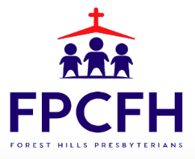

Building a Community of Faith, Hope, and Love
PresbyFH.org

