November 1, 2026 23rd Sunday after Pentecost 11 AM
ALL SAINTS’ DAY

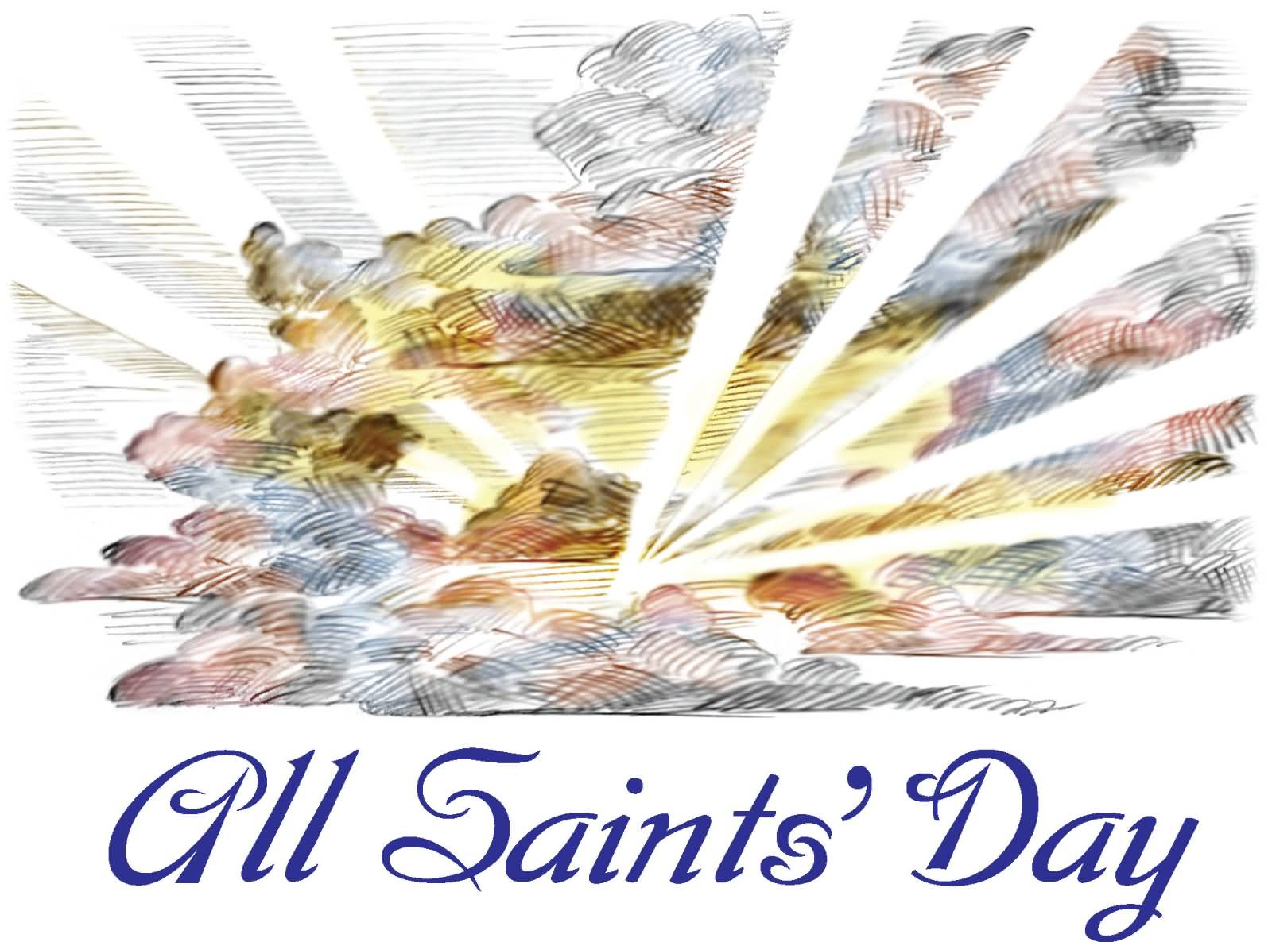
^{Clipart Library}

PRELUDE “Father, Whose Almighty Power, His Glory to Raise, G. Handel
His Salvation to His Holy Land”

WELCOME

CALL TO WORSHIP
Our help is in the name of the Lord,
Who made heaven and earth.
In life and in death
We belong to God.
Baptized into Christ’s death
We live unto Him.
Come, let us Worship God!
OPENING PRAYER
Eternal God, you have knit your people of all times and places into one communion in the mystical body of our Lord Jesus Christ. Grant us your Holy Spirit of encouragement and strength so we may persevere in our leg of the relay race of faith until such time as we join the great cloud of witnesses who cheer us on the Way. Keep us one with all who proclaim your gospel until such time as we finish our race, collapsing into your arms where you wait for us at the finish of your new creation begun in Christ, the pacesetter and perfecter of the way, the truth, and life everlasting. Amen.

HYMN #275 (vv. 1, 2) “A Mighty Fortress Is Our God”

1 A mighty fortress is our God, a bulwark never failing.
Our helper he, amid the flood of mortal ills prevailing.
For still our ancient foe doth seek to work us woe.
His craft and power are great, and armed with cruel hate, on earth is not his equal.

2 Did we in our own strength confide, our striving would be losing,
were not the right man on our side, the man of God's own choosing.
Dost ask who that may be? Christ Jesus, it is he.
Lord Sabaoth his name, from age to age the same, and he must win the battle.

CALL TO CONFESSION

PRAYER OF CONFESSION
Eternal God,
in every age you have raised up men and women to live and die in faith.
We confess that we are indifferent to your will. You call us to proclaim your name, but we are silent.
You call us to do what is just, but we remain idle. You call us to live faithfully, but we are afraid. In your mercy, forgive us.
Give us courage to follow in your way, that joined with those from ages past, who have served you with faith, hope, and love,
we may inherit the kingdom you promised in Jesus Christ.

ASSURANCE OF GOD’S LOVE
Hear the good news: We do not live to ourselves, and we do not die to ourselves.
If we live, we live to the Lord, and if we die, we die to the Lord; so then, whether
we live or die, we are the Lord’s. For to this end Christ died and lived again, so
that he might be Lord of both the living and the dead.
When we were baptized in Christ Jesus, we were baptized into his death. We were
buried so that as Christ was raised from the dead by the glory of God, we too might walk in newness of life. Friends, believe the good news:
In Jesus Christ we are forgiven!
Let us give thanks to the Lord; God’s steadfast love endures forever.

RESPONSE: HYMN #581 “Gloria Patri”
Glory be the Father, and to the Son and to the Holy Ghost,
As it was in the beginning, is now, and ever shall be,
World without end. Amen. Amen.

PEACE
Let there be peace on earth.
And let it begin with me.
The peace of Christ be with you.
And also with you.

RESPONSIVE READING Psalm 34:1-10,22 (NRSVUE)
I will bless the Lord at all times; his praise shall continually be in my mouth.
My soul makes its boast in the Lord; let the humble hear and be glad.
O magnify the Lord with me, and let us exalt his name together.
I sought the Lord, and he answered me and delivered me from all my fears.
Look to him, and be radiant, so your faces shall never be ashamed.
This poor soul cried and was heard by the Lord
and was saved from every trouble.
The angel of the Lord encamps around those who fear him and delivers them.
O taste and see that the Lord is good;
happy are those who take refuge in him.
O fear the Lord, you his holy ones, for those who fear him have no want.
The young lions suffer want and hunger,
but those who seek the Lord lack no good thing.
The Lord redeems the life of his servants;
none of those who take refuge in him will be condemned.

FIRST READING Revelations 7:9-17 (NRSVUE)
⁹ After this I looked, and there was a great multitude that no one could count, from every nation, from all tribes and peoples and languages, standing before the throne and before the Lamb, robed in white, with palm branches in their hands. ¹⁰ They cried out in a loud voice, saying, “Salvation belongs to our God who is seated on the throne and to the Lamb!” ¹¹ And all the angels stood around the throne and around the elders and the four living creatures, and they fell on their faces before the throne and worshiped God, ¹² singing, “Amen! Blessing and glory and wisdom
and thanksgiving and honor and power and might be to our God forever and ever! Amen.” ¹³ Then one of the elders addressed me, saying, “Who are these, robed in white, and where have they come from?” ¹⁴ I said to him, “Sir, you are the one who knows.” Then he said to me, “These are they who have come out of the great ordeal; they have washed their robes and made them white in the blood of the Lamb. ¹⁵ For this reason they are before the throne of God and worship him day and night within his temple, and the one who is seated on the throne will shelter them. ¹⁶ They will hunger no more and thirst no more; the sun will not strike them,
nor any scorching heat, ¹⁷ for the Lamb at the center of the throne will be their shepherd, and he will guide them to springs of the water of life, and God will wipe away every tear from their eyes.”

CHILDREN’S SERMON

SECOND READING Matthew 5:1-12 (NRSVUE)
¹ When Jesus saw the crowds, he went up the mountain, and after he sat down, his disciples came to him. ² And he began to speak and taught them, saying:
³ “Blessed are the poor in spirit, for theirs is the kingdom of heaven.
⁴ “Blessed are those who mourn, for they will be comforted.
⁵ “Blessed are the meek, for they will inherit the earth.
⁶ “Blessed are those who hunger and thirst for righteousness, for they will be filled.
⁷ “Blessed are the merciful, for they will receive mercy.
⁸ “Blessed are the pure in heart, for they will see God.
⁹ “Blessed are the peacemakers, for they will be called children of God.
¹⁰ “Blessed are those who are persecuted for the sake of righteousness, for theirs is the kingdom of heaven.
¹¹ “Blessed are you when people revile you and persecute you and utter all kinds of evil against you falsely on my account. ¹² Rejoice and be glad, for your reward is great in heaven, for in the same way they persecuted the prophets who were before you.

SERMON “For All the Saints” Jeff Courter

HYMN #326 (vv. 1, 3, 5) “For All the Saints”

1 For all the saints who from their labors rest,
who thee by faith before the world confessed,
thy name, O Jesus, be forever blest. Alleluia! Alleluia!

3 O blest communion, fellowship divine!
We feebly struggle; they in glory shine;
yet all are one in thee, for all are thine. Alleluia! Alleluia!

5 From earth's wide bounds, from ocean's farthest coast,
through gates of pearl streams in the countless host,
singing to Father, Son, and Holy Ghost, Alleluia! Alleluia!

READING from John Donne
“The church is catholic, universal, so are all her actions; all that she does belongs to all. When she baptizes a child, that action concerns me; for that child is thereby connected to that body which is my head too and ingrafted into that body whereof I am a member. And when [the church] buries a person, that action concerns me. All [of humanity] is of one author, and is one volume; when one [person] dies, one chapter is not torn out of the book, but translated into a better language; and every
chapter must be so translated. God employs several translators; some pieces are translated by age, some by sickness, some by war, some by justice; but [the Lord’s] hand is in every translation, and [God’s] hand shall bind up all our scattered leaves again for that library where every book shall lie open to one another. As therefore the bell that rings to a sermon calls not upon the preacher only but upon the congregation to come, so this bell calls us all. . .
No [one] is an island entire of itself; every[one] is a piece of the continent, a part of the main. If a clod be washed away by the sea, Europe is the less, as well as if a promontory were, as well as if a manor of thy friend’s or of thine own were. Any[one’s] death diminishes me, because I am involved in [hu]mankind, and therefore never send to know for whom the bell tolls; it tolls for thee.”
[from John Donne’s Meditation XVII of Devotions upon Emergent Occasions]

NAMING OF THE SAINTS

PROFESSION OF FAITH THE NICENE CREED
We believe in one God, the Father, the Almighty, maker of heaven and earth, of all that is, seen and unseen. We believe in one Lord, Jesus Christ, the only Son of God, eternally begotten of the Father, God from God, Light from Light, true God from true God, begotten, not made, of one Being with the Father; through him all things were made. For us and for our salvation he came down from heaven, was incarnate of the Holy Spirit and the Virgin Mary and became truly human. For our sake he was crucified under Pontius Pilate; he suffered death and was buried. On the third day he rose again in accordance with the Scriptures; he ascended into heaven and is seated at the right hand of the Father. He will come again in glory to judge the living and the dead, and his kingdom will have no end. We believe in the Holy Spirit, the Lord, the giver of life, who proceeds from the Father and the Son, who with the Father and the Son is worshiped and glorified, who has spoken through the prophets. We believe in one holy catholic and apostolic Church. We acknowledge one baptism for the forgiveness of sins. We look for the resurrection of the dead, and the life of the world to come. Amen.

PRAYERS OF THE PEOPLE

OFFERING/OFFERTORY “Cast Thy Burden Upon the Lord, F. Kühmstedt
and He Shall Sustain Thee. Let None Be Made
Ashamed That Wait Upon Thee”

OFFERING SONG #606 Doxology
Praise God, from whom all blessings flow,
Praise God, all creatures here below,
Praise God above, ye heavenly host,
Praise Father, Son and Holy Ghost. Amen.

PRAYER OF DEDICATION

PRAYER OF GREAT THANKSGIVING

The Lord be with you.
And also with you.
Lift up your hearts.
We lift them to the Lord.
Let us give thanks to the Lord our God.
It is right to give our thanks and praise.

It is truly right and our greatest joy to give you thanks and praise, O Lord our God, creator and ruler of the universe.

You established your people to be a light for the nations,
and called us to walk in your paths and follow your ways.
Even now, you are coming to bring justice and peace to the world.
You have been our shepherd and savior in every generation.
Though we turned away from you, you were always faithful.
In the fullness of time, you sent your only Son to be our Immanuel.

Therefore we praise you, joining our voices with choirs of angels with prophets, apostles, and martyrs, and with all the faithful of every time and place who forever sing to the glory of your name:

Holy, holy, holy Lord, God of power and might, heaven and earth are full of your glory. Hosanna in the highest. Blessed is he who comes in the name of the Lord. Hosanna in the highest.

Blessed are you, most gracious God, for the gift of your child, our brother, Jesus Christ, who lived in accord with your will to the point of laying down his life for the good news he preached and passed on to us.
On the night of his arrest, he taught us how to serve one another in love with a ritual of table fellowship enjoyed by Christians of all times and places. And so, in remembrance of our Lord Jesus Christ, we offer ourselves with thanksgiving as a living sacrifice. In union with Christ’s offering for us, we live out the mystery of the faith we proclaim:

Christ has died. Christ has risen. Christ will come again.

Gracious God, pour out your Holy Spirit upon us and upon these your gifts of bread and wine, that the bread we break and the cup we bless may be the communion of the body and blood of Christ.
Spirit of the living God, make us one as we partake of these your gifts to us, so we might be in communion with you and one another. As we break bread together, may our eyes be opened to see your glory. As we lift the cup of salvation, may we be strengthened to follow your Way. Until Christ comes in final victory and we feast together with all the saints at God’s great family reunion, keep your church one in service to the world here and now.
Work within us, that our lives may participate in the same unending song of the universe raised by all the saints.
Through Christ with Christ, in Christ, in the unity of the Holy Spirit, all glory and honor and praise are yours almighty God, now and forevermore. Amen.

THE LORD’S PRAYER

COMMUNION OF THE PEOPLE “Lamb of God, Who Takes Away W.A. Mozart
the Sins of the World, Have Mercy on Us”

ANNOUNCEMENTS

CLOSING HYMN #730 “I Sing a Song of the Saints of God”
1 I sing a song of the saints of God, patient and brave and true,
who toiled and fought and lived and died for the Lord they loved and knew.
And one was a doctor, and one was a queen, and one was a shepherdess on the green: they were all of them saints of God, and I mean, God helping, to be one too.

2 They loved their Lord so dear, so dear, and God’s love made them strong;
and they followed the right, for Jesus’ sake, the whole of their good lives long.
And one was a soldier, and one was a priest, and one was slain by a fierce wild beast: and there’s not any reason, no, not the least, why I shouldn’t be one too.

3 They lived not only in ages past; there are hundreds of thousands still;
the world is bright with the joyous saints who love to do Jesus’ will.
You can meet them in school, or in lanes, or at sea, in church, or in trains, or in shops, or at tea; for the saints of God are just folk like me, and I mean to be one too.

BENEDICTION

POSTLUDE “Shout for Joy to the Lord” Benedetto Marcello
(Psalm 100)
___________________________________________________________________

UPCOMING CALENDAR

REMINDER – Please keep in mind that the worship is now at 11:00 AM through the Fall and Winter; Sunday School and Adult Bible Study starts at 10:00 AM.

REMINDER: We are still looking for volunteers for worship readers and/or juice/coffee hour. There is a 3-month sign-up sheet posted just outside the office.
If you have any questions, please contact the Office.

First Presbyterian Church of Forest Hills
70-35 112th St., Forest Hills, NY 11375 presbyfh.org
David Barnett, Admin.718-268-4036 Jeff Courter, Pastor,
FirstPresFHNY@gmail.com; rev.jeffrey.courter@gmail.com
Rafael Reyes-Quiroz, Clerk of Session Hannah Lin, Guest Organist

Please note: we now have a public WiFi for the church, though it may only be available in the church hall for now.
Name: CHURCH GUEST
Password: welcome1

For offerings/donations:

- Use Zelle to make Online donations from your bank account. Use this phone number to transfer to the church:
929-418-0958 (please note: this is a new number)
- Make checks payable to First Presbyterian Church of Forest Hills and mail check to the church office
- Go to our church website: presbyfh.org and click on the “Give Now” icon to set up a donation; or click on the QR code above
- The web address of your donation form has now been changed to: https://secure.myvanco.com/L-ZBFD
- Set up a “Bill pay” from your bank.

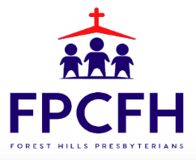

Building a Community of Faith, Hope, and Love
PresbyFH.org

