August 30, 2026 14th Sunday after Pentecost 11 AM

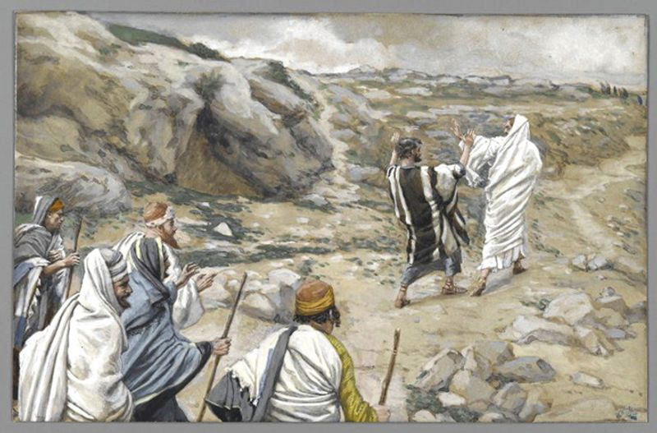
Tissot, James, 1836-1902. Get Thee Behind Me, Satan!, (1886-1894), from Art in the Christian Tradition, a project of the Vanderbilt University Divinity Library, Nashville, TN.

PRELUDE

WELCOME

CALL TO WORSHIP

HYMN #726 (vv. 1, 2, 5) “The Summons””

- “Will you come and follow me if I but call your name?
Will you go where you don’t know and never be the same?
Will you let my love be shown; Will you let my name be known;
will you let my life be grown in you and you in me?”

- “Will you leave yourself behind if I but call your name?
Will you care for cruel and kind and never be the same?
Will you risk the hostile stare should your life attract or scare?
Will you let me answer prayer in you and you in me?”

- “Lord, your summons echoes true when you but call my name.
Let me turn and follow you and never be the same.
In Your company I’ll go where your love and footsteps show.
Thus I’ll move and live and grow in you and you in me.”

CALL TO CONFESSION

PRAYER OF CONFESSION

ASSURANCE OF GOD’S LOVE

RESPONSE: HYMN #582 “Glory to God”
1 Glory to God, whose goodness shines on me,
and to the Son, whose grace has pardoned me,
and to the Spirit, whose love has set me free.
As it was in the beginning, is now and ever shall be. Amen.

2 World without end, without end. Amen.
World without end, without end. Amen
World without end, without end. Amen.
As it was in the beginning, is now and ever shall be. Amen.

PEACE
Let there be peace on earth.
And let it begin with me.
The peace of Christ be with you.
And also with you.

RESPONSIVE READING Psalm 26:1-8 (NRSVUE)
Vindicate me, O Lord, for I have walked in my integrity,
and I have trusted in the Lord without wavering.
Prove me, O Lord, and try me; test my heart and mind.
For your steadfast love is before my eyes, and I walk in faithfulness to you.
I do not sit with the worthless, nor do I consort with hypocrites;
I hate the company of evildoers and will not sit with the wicked.
I wash my hands in innocence and go around your altar, O Lord,
singing aloud a song of thanksgiving and telling all your wondrous deeds.
O Lord, I love the house in which you dwell and the place where your glory abides.

FIRST READING Jeremiah 15:15-21 (NRSVUE)
¹⁵ O Lord, you know; remember me and visit me, and bring down retribution for me on my persecutors. In your forbearance do not take me away; know that on your account I suffer insult. ¹⁶ Your words were found, and I ate them, and your words became to me a joy and the delight of my heart, for I am called by your name, O Lord, God of hosts. ¹⁷ I did not sit in the company of merrymakers, nor did I rejoice; under the weight of your hand I sat alone, for you had filled me with indignation. ¹⁸ Why is my pain unceasing, my wound incurable, refusing to be healed? Truly, you are to me like a deceitful brook, like waters that fail.

¹⁹ Therefore thus says the Lord: If you turn back, I will take you back, and you shall stand before me. If you utter what is precious and not what is worthless, you shall serve as my mouth. It is they who will turn to you, not you who will turn to them. ²⁰ And I will make you to this people a fortified wall of bronze; they will fight against you, but they shall not prevail over you, for I am with you to save you and deliver you, says the Lord. ²¹ I will deliver you out of the hand of the wicked and redeem you from the grasp of the ruthless.

CHILDREN’S SERMON

SECOND READING Matthew 16:21-28 (NRSVUE)
²¹ From that time on, Jesus began to show his disciples that he must go to Jerusalem and undergo great suffering at the hands of the elders and chief priests and scribes and be killed and on the third day be raised. ²² And Peter took him aside and began to rebuke him, saying, “God forbid it, Lord! This must never happen to you.” ²³ But he turned and said to Peter, “Get behind me, Satan! You are a hindrance to me, for you are setting your mind not on divine things but on human things.”

²⁴ Then Jesus told his disciples, “If any wish to come after me, let them deny themselves and take up their cross and follow me. ²⁵ For those who want to save their life will lose it, and those who lose their life for my sake will find it. ²⁶ For what will it profit them if they gain the whole world but forfeit their life? Or what will they give in return for their life?

²⁷ “For the Son of Man is to come with his angels in the glory of his Father, and then he will repay everyone for what has been done. ²⁸ Truly I tell you, there are some standing here who will not taste death before they see the Son of Man coming in his kingdom.”

SERMON “Satan Is Calling” Jeff Courter

HYMN #718 “Take Up Your Cross, the Savior Said”

1 Take up your cross, the Savior said, if you would my disciple be;
take up your cross with willing heart, and humbly follow after me.

2 Take up your cross; let not its weight fill your weak spirit with alarm;
Christ's strength shall bear your spirit up and brace your heart and nerve your arm.

3 Take up your cross; heed not the shame, and let your foolish pride be still;
the Lord for you accepted death upon a cross, on Calvary's hill.

4 Take up your cross, then, in Christ's strength, and calmly every danger brave:
it guides you to abundant life and leads to victory o'er the grave.

PROFESSION OF FAITH THE APOSTLES’ CREED
I Believe in God the Father Almighty, Maker of heaven and earth; and in Jesus Christ, His Only Son, our Lord, who was conceived by the Holy Spirit, born of the Virgin Mary, suffered under Pontius Pilate, was crucified, dead, and buried. He descended into hell; the third day He rose again from the dead. He ascended into heaven, and sitteth at the right hand of God the Father Almighty, from thence He shall come to judge the quick and the dead.
I believe in the Holy Spirit, the holy catholic church, the communion of saints, the forgiveness of sins, the resurrection of the body, and the life everlasting. Amen.

PRAYERS OF THE PEOPLE

OFFERING/OFFERTORY

OFFERING SONG #328 “Praise God, All You Nations” (DaNase)
Praise God, all you nations. People of God, sing praise!
Praise God, all you nations. People of God, sing praise:
God’s love is great and endures forever.
Praise God, all you nations. People of God, sing praise!

PRAYER OF DEDICATION/THE LORD’S PRAYER

ANNOUNCEMENTS

CLOSING HYMN #724 “O Jesus, I Have Promised”

1 O Jesus, I have promised to serve thee to the end;
be thou forever near me, my Master and my friend;
I shall not fear the battle if thou art by my side,
nor wander from the pathway if thou wilt be my guide.

2 O let me feel thee near me! The world is ever near:
I see the sights that dazzle; the tempting sounds I hear.
My foes are ever near me, around me and within;
but, Jesus, draw thou nearer and shield my soul from sin.
3 O let me hear thee speaking in accents clear and still,
above the storms of passion, the murmurs of self-will;
O speak to reassure me, to hasten or control;
O speak, and make me listen, thou guardian of my soul.

4 O Jesus, thou hast promised to all who follow thee
that where thou art in glory there shall thy servant be.
And, Jesus, I have promised to serve thee to the end;
O give me grace to follow, my Master and my friend.

BENEDICTION

POSTLUDE
___________________________________________________________________

UPCOMING CALENDAR

SUNDAY, SEPT. 6th - REMINDER – Please keep in mind that starting next Sunday, worship begins at 11:00 AM! And Sunday School begins at 10:00 AM with Karen Wood and Pat Young. Adult Bible Study will begin on Sept. 13th at 10:00 AM (we will be studying the book of Mark).

SUNDAY, SEPT. 6th AFTER WORSHIP - please come join us for a picnic after the worship service to celebrate Labor Day weekend! If possible, please bring a favorite dish you’d like to share! Hamburgers and hot dogs will be provided.

WORLD COMMUNION OFFERING - September 6 - October 4, 2026
All of God's people gather around the Table to celebrate the life, death and resurrection of Jesus Christ. Part of the atonement that happens around this Table is reconciliation, which is the focus of the World Communion Offering. Experience the grace that comes from reconciling all peoples from all nations around the corner and around the globe through the ministry of this offering.
(Formally Peace and Global Witness)

REMINDER: We are still looking for volunteers for worship readers and/or juice/coffee hour. There is a 3-month sign-up sheet posted just outside the office.
If you have any questions, please contact the Office.

First Presbyterian Church of Forest Hills
70-35 112th St., Forest Hills, NY 11375 presbyfh.org
David Barnett, Admin.718-268-4036 Jeff Courter, Pastor,
FirstPresFHNY@gmail.com; rev.jeffrey.courter@gmail.com
Rafael Reyes-Quiroz, Clerk of Session

Please note: we now have a public WiFi for the church, though it may only be available in the church hall for now.
Name: CHURCH GUEST
Password: welcome1

For offerings/donations:

- Use Zelle to make Online donations from your bank account. Use this phone number to transfer to the church:
929-418-0958 (please note: this is a new number)
- Make checks payable to First Presbyterian Church of Forest Hills and mail check to the church office
- Go to our church website: presbyfh.org and click on the “Give Now” icon to set up a donation; or click on the QR code above
- The web address of your donation form has now been changed to: https://secure.myvanco.com/L-ZBFD
- Set up a “Bill pay” from your bank.

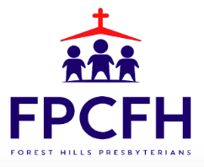

Building a Community of Faith, Hope, and Love
PresbyFH.org

