September 6, 2026 15th Sunday after Pentecost 11 AM
Labor Day Weekend

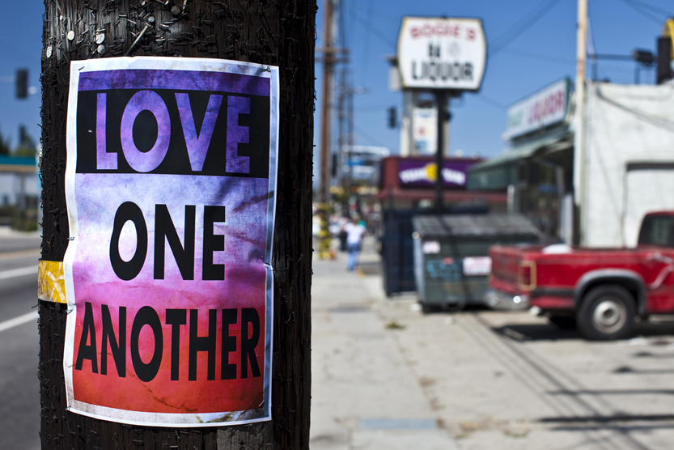
"Love One Another", (2011) from Art in the Christian Tradition,
a project of the Vanderbilt University Divinity Library, Nashville, TN.

PRELUDE “Fantasy No. 1” W.A. Mozart
(KV. 394, written in 1782)

WELCOME

CALL TO WORSHIP

HYMN #351 “All Who Love and Serve Your City”

1 All who love and serve your city, all who bear its daily stress,
all who cry for peace and justice, all who curse and all who bless:

2 In your day of wealth and plenty, wasted work and wasted play,
call to mind the word of Jesus, "You must work while it is day."

3 For all days are days of judgment, and the Lord is waiting still,
drawing near a world that spurns him, offering peace from Calvary's hill.

4 Risen Lord, shall yet the city be the city of despair?
Come today, our judge, our glory. Be its name “The Lord is there!"

CALL TO CONFESSION

PRAYER OF CONFESSION

ASSURANCE OF GOD’S LOVE

RESPONSE: HYMN #581 “Gloria Patri”
Glory be the Father, and to the Son and to the Holy Ghost,
As it was in the beginning, is now, and ever shall be,
World without end. Amen. Amen.

PEACE
Let there be peace on earth.
And let it begin with me.
The peace of Christ be with you.
And also with you.

RESPONSIVE READING Psalm 119:33-40 (NRSVUE)
Teach me, O Lord, the way of your statutes, and I will observe it to the end.
Give me understanding, that I may keep your law
and observe it with my whole heart.
Lead me in the path of your commandments, for I delight in it.
Turn my heart to your decrees and not to selfish gain.
Turn my eyes from looking at vanities; be gracious to me according to your word.
Confirm to your servant your promise, which is for those who fear you.
Turn away the disgrace that I dread, for your ordinances are good.
See, I have longed for your precepts;
in your righteousness be gracious to me.

FIRST READING Ezekial 33:7-11 (NRSVUE)
⁷ So you, mortal, I have made a sentinel for the house of Israel; whenever you hear a word from my mouth, you shall give them warning from me. ⁸ If I say to the wicked, “O wicked ones, you shall surely die,” and you do not speak to warn the wicked to turn from their ways, the wicked shall die in their iniquity, but their blood I will require at your hand. ⁹ But if you warn the wicked to turn from their ways and they do not turn from their ways, the wicked shall die in their iniquity, but you will have saved your life.

¹⁰ Now you, mortal, say to the house of Israel: Thus you have said: “Our transgressions and our sins weigh upon us, and we waste away because of them; how then can we live?” ¹¹ Say to them: As I live, says the Lord God, I have no pleasure in the death of the wicked but that the wicked turn from their ways and live; turn back, turn back from your evil ways, for why will you die, O house of Israel?

CHILDREN’S SERMON

SECOND READING Matthew 18:15-20 (NRSVUE)
¹⁵ “If your brother or sister sins against you, go and point out the fault when the two of you are alone. If you are listened to, you have regained that one. ¹⁶ But if you are not listened to, take one or two others along with you, so that every word may be confirmed by the evidence of two or three witnesses. ¹⁷ If that person refuses to listen to them, tell it to the church, and if the offender refuses to listen even to the church, let such a one be to you as a gentile and a tax collector. ¹⁸ Truly I tell you, whatever you bind on earth will be bound in heaven, and whatever you loose on earth will be loosed in heaven. ¹⁹ Again, truly I tell you, if two of you agree on earth about anything you ask, it will be done for you by my Father in heaven. ²⁰ For where two or three are gathered in my name, I am there among them.”
SERMON “God’s Work” Jeff Courter

HYMN #529 “Draw Us in the Spirit’s Tether”

1 Draw us in the Spirit's tether, for when humbly in your name,
two or three are met together, you are in the midst of them;
Alleluia, Alleluia! Here we touch your garment's hem.

2 As disciples used to gather in the name of Christ to sup,
then with thanks to God the giver break the bread and bless the cup,
Alleluia, Alleluia! so now bind our friendship up.

3 All our meals and all our living make as sacraments of you,
that by caring, helping, giving, we may be disciples true.
Alleluia, Alleluia! We will serve with faith anew.

PROFESSION OF FAITH THE NICENE CREED
We believe in one God, the Father, the Almighty, maker of heaven and earth, of all that is, seen and unseen. We believe in one Lord, Jesus Christ, the only Son of God, eternally begotten of the Father, God from God, Light from Light, true God from true God, begotten, not made, of one Being with the Father; through him all things were made. For us and for our salvation he came down from heaven, was incarnate of the Holy Spirit and the Virgin Mary and became truly human. For our sake he was crucified under Pontius Pilate; he suffered death and was buried. On the third day he rose again in accordance with the Scriptures; he ascended into heaven and is seated at the right hand of the Father. He will come again in glory to judge the living and the dead, and his kingdom will have no end. We believe in the Holy Spirit, the Lord, the giver of life, who proceeds from the Father and the Son, who with the Father and the Son is worshiped and glorified, who has spoken through the prophets. We believe in one holy catholic and apostolic Church. We acknowledge one baptism for the forgiveness of sins. We look for the resurrection of the dead, and the life of the world to come. Amen.

PRAYERS OF THE PEOPLE

OFFERING/OFFERTORY “O Lord, your name and renown John White
are the desire of our hearts” (Isaiah 26:8)

OFFERING SONG #606 Doxology
Praise God, from whom all blessings flow,
Praise God, all creatures here below,
Praise God above, ye heavenly host,
Praise Father, Son and Holy Ghost. Amen.

PRAYER OF DEDICATION

PRAYER OF GREAT THANKSGIVING (SACRAMENT OF COMMUNION)
Friends, this is the joyful feast of the people of God!
People will come from east and west, and from north and south, to sit at table in the kingdom of God. This is the Lord’s table. Our Savior invites those who trust him to share the feast he has prepared.

The Lord be with you.
And also with you.
Lift up your hearts.
We lift them to the Lord.
Let us give thanks to the Lord, our God.
It is right to give our thanks and praise.

It is truly right and our greatest joy to to give you thanks and praise, eternal God, our Creator. You formed the universe in your wisdom and created all things by your power. You made us in your image to love and serve you, but we turned from you and abandoned your ways. Yet you did not reject us. You claimed us as your people and sent prophets to call us back to your way.

Therefore, we praise you, joining our voices with choirs of angels, with prophets, apostles, and martyrs, and with all the faithful of every time and place, who forever sing to the glory of your name:

Holy, holy, holy Lord, God of power and might. Heaven and earth are
full of your glory. Hosanna in the highest! Blessed is he who comes in
the name of the Lord. Hosanna in the highest!

You are holy, O God of majesty, and blessed is Jesus Christ, your Son, our Lord.
Born of Mary, he came to dwell among us, full of grace and truth.
He forgave our failures, healed our hurts, and gave himself in utter sacrifice for those he loved. By his death on the cross, he overcame death. Rising from the tomb, he gave us everlasting life.

With thanksgiving, we take this bread and this cup and proclaim the mystery of faith:
Christ has died, Christ is risen, Christ will come again.

Gracious God, pour out your Holy Spirit on us, and upon these your gifts of bread and wine, that the bread we break and the cup we bless may be the communion of the body and blood of Christ. By your Spirit, make us one with Christ and with all who share this feast, united in ministry in every place.
As this bread is Christ’s body for us, send us out to be the body of Christ in the world.
Through Christ, in Christ, and with Christ, in the unity of the Holy Spirit,
all glory and honor belong to you, almighty God, now and forever.

THE LORD’S PRAYER

COMMUNION OF THE PEOPLE “Jesu, Grant Me This I Pray” C.H.Kitson

ANNOUNCEMENTS

CLOSING HYMN #767 “Together We Serve”

1 Together we serve, united by love,
inviting God's world to the glorious feast.
We work and we pray through sorrow and joy,
extending God's love to the last and the least.

2 We seek to become a beacon of hope,
a lamp for the heart and a light for the feet.
We learn, year by year, to let love shine through
until we see Christ in each person we meet.

3 We welcome the scarred, the wealthy, the poor,
the busy, the lonely, and all who need care.
We offer a home to those who will come,
our hands quick to help, our hearts ready to dare.

4 Together, by grace, we witness and work,
remembering Jesus, in whom we grow strong.
Together we serve in Spirit and truth,
remembering love is the strength of our song.

BENEDICTION

POSTLUDE “Chorale in D Major” Cesar Franck
(2nd Movement Maestos)

____________________________________________________________________________________________________________________________________________________________________________________________-_

UPCOMING CALENDAR

TODAY AFTER THE WORSHIP SERVICE – PICNIC – please come join us for a picnic to celebrate Labor Day weekend!

WORLD COMMUNION OFFERING - September 6 - October 4, 2026
All of God's people gather around the Table to celebrate the life, death and resurrection of Jesus Christ. Part of the atonement that happens around this Table is reconciliation, which is the focus of the World Communion Offering. Experience the grace that comes from reconciling all peoples from all nations around the corner and around the globe through the ministry of this offering.
(Formally Peace and Global Witness)

REMINDER – Please keep in mind that the worship is now at 11:00 AM through the Fall and Winter; Sunday School also starts today, and Adult Bible Study starts next Sunday at 10:00 AM. David will be back in the office on Wednesday.

REMINDER: We are still looking for volunteers for worship readers and/or juice/coffee hour. There is a 3-month sign-up sheet posted just outside the office.
If you have any questions, please contact the Office.
First Presbyterian Church of Forest Hills
70-35 112th St., Forest Hills, NY 11375 presbyfh.org
David Barnett, Admin.718-268-4036 Jeff Courter, Pastor,
FirstPresFHNY@gmail.com; rev.jeffrey.courter@gmail.com
Rafael Reyes-Quiroz, Clerk of Session Hannah Lin, Guest Organist

Please note: we now have a public WiFi for the church, though it may only be available in the church hall for now.
Name: CHURCH GUEST
Password: welcome1

For offerings/donations:

- Use Zelle to make Online donations from your bank account. Use this phone number to transfer to the church:
929-418-0958 (please note: this is a new number)
- Make checks payable to First Presbyterian Church of Forest Hills and mail check to the church office
- Go to our church website: presbyfh.org and click on the “Give Now” icon to set up a donation; or click on the QR code above
- The web address of your donation form has now been changed to: https://secure.myvanco.com/L-ZBFD
- Set up a “Bill pay” from your bank.

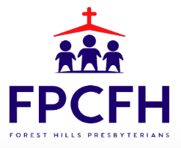

Building a Community of Faith, Hope, and Love
PresbyFH.org

