June 14, 2026 3rd Sunday after Pentecost 11 AM
PRIDE month

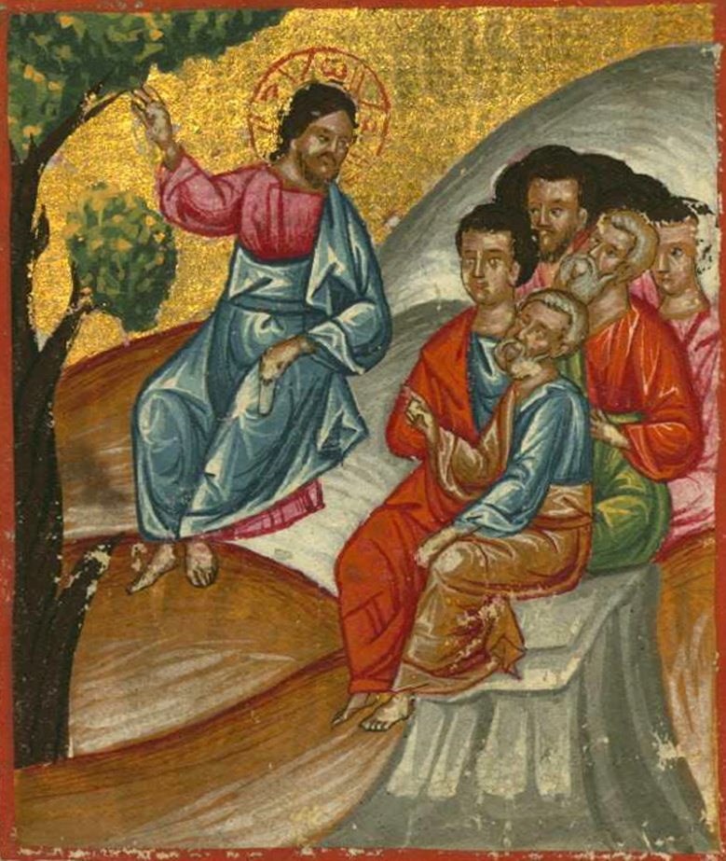
Bazzi Rahib, Ilyas Basim Khuri. Christ Teaching the Disciples, (1684)
from Art in the Christian Tradition, a project of the Vanderbilt Divinity Library, Nashville, TN.

PRELUDE

WELCOME

CALL TO WORSHIP

HYMN #343 (vv. 1, 2, 4, 5) “Where Cross the Crowded Ways of Life”

1 Where cross the crowded ways of life,
where sound the cries of race and clan,
above the noise of selfish strife,
we hear your voice, O Son of Man.

2 In haunts of wretchedness and need,
on shadowed thresholds fraught with fears,
from paths where hide the lures of greed,
we catch the vision of your tears.

4 The cup of water given for you
still holds the freshness of your grace;
yet long these multitudes to view
the sweet compassion of your face.

5 O Master, from the mountainside,
make haste to heal these hearts of pain;
among these restless throngs abide;
O tread the city's streets again;

CALL TO CONFESSION

PRAYER OF CONFESSION

ASSURANCE OF GOD’S LOVE

RESPONSE: HYMN #582 “Glory to God”
1 Glory to God, whose goodness shines on me,
and to the Son, whose grace has pardoned me,
and to the Spirit, whose love has set me free.
As it was in the beginning, is now and ever shall be. Amen.

2 World without end, without end. Amen.
World without end, without end. Amen
World without end, without end. Amen.
As it was in the beginning, is now and ever shall be. Amen.
PEACE
Let there be peace on earth.
And let it begin with me.
The peace of Christ be with you.

RESPONSIVE READING Psalm 100 (NRSVUE)
Make a joyful noise to the Lord, all the earth.
Serve the Lord with gladness; come into his presence with singing.
Know that the Lord is God. It is he who made us, and we are his;
we are his people and the sheep of his pasture.
Enter his gates with thanksgiving and his courts with praise.
Give thanks to him; bless his name.
For the Lord is good; his steadfast love endures forever
and his faithfulness to all generations.

FIRST READING Exodus 19:2-8a (NRSVUE)
² They journeyed from Rephidim, entered the wilderness of Sinai, and camped in the wilderness; Israel camped there in front of the mountain. ³ Then Moses went up to God; the Lord called to him from the mountain, “Thus you shall say to the house of Jacob and tell the Israelites: ⁴ ‘You have seen what I did to the Egyptians and how I bore you on eagles’ wings and brought you to myself. ⁵ Now, therefore, if you obey my voice and keep my covenant, you shall be my treasured possession out of all the peoples. Indeed, the whole earth is mine, ⁶ but you shall be for me a priestly kingdom and a holy nation.’ These are the words that you shall speak to the Israelites.”
⁷ So Moses went, summoned the elders of the people, and set before them all these words that the Lord had commanded him. ⁸ The people all answered as one, “Everything that the Lord has spoken we will do.”

SECOND READING Matthew 9:35-10:8 (NRSVUE)
³⁵ Then Jesus went about all the cities and villages, teaching in their synagogues and proclaiming the good news of the kingdom and curing every disease and every sickness. ³⁶ When he saw the crowds, he had compassion for them because they were harassed and helpless, like sheep without a shepherd. ³⁷ Then he said to his disciples, “The harvest is plentiful, but the laborers are few; ³⁸ therefore ask the Lord of the harvest to send out laborers into his harvest.”

¹ Then Jesus summoned his twelve disciples and gave them authority over unclean spirits, to cast them out, and to cure every disease and every sickness. ² These are the names of the twelve apostles: first, Simon, also known as Peter, and his brother Andrew; James son of Zebedee and his brother John; ³ Philip and Bartholomew; Thomas and Matthew the tax collector; James son of Alphaeus and Thaddaeus; ⁴ Simon the Cananaean and Judas Iscariot, the one who betrayed him.

⁵ These twelve Jesus sent out with the following instructions: “Do not take a road leading to gentiles, and do not enter a Samaritan town, ⁶ but go rather to the lost sheep of the house of Israel. ⁷ As you go, proclaim the good news, ‘The kingdom of heaven has come near.’ ⁸ Cure the sick; raise the dead; cleanse those with a skin disease; cast out demons. You received without payment; give without payment.

SERMON God’s People, Sent by God Jeff Courter

PRESENTATION OF CONFIRMATION CLASS

Statements from the Confirmation Class’s statements of faith:
I believe in God, maker of everything.
I see God as my father. Because of this I know I am loved and valued by him.
The Bible also reminds me that God has a plan for my life even when I don not understand everything that happens. It gives me hope during difficult times and encourages me to keep trusting Him.
To me, the Bible is a guide. If I ever feel stuck in life I can always rely on the Bible, Jesus and God. Reading the Bible helps me understand how God reminds me I’m never alone.
The Bible…is a guide that helps me stay connected to God and reminds me of his promises. (It) teaches me forgiveness, patience and honesty.
Jesus is my brother, showing how much he cares for us by dying on the cross, sacrificing his life for our sins.
Jesus is (God’s) son born of the virgin Mary and the Holy Spirit. He was convicted by the Romans, crucified but rose again on the third day and shall come again one day to judge the living and the dead.
I want to be part of this church…
This church is…where I feel closer to God and where I can pray and worship, (where) everyone is welcome and encouraged…at the end of the day we are all brothers, sisters and family.
When I think of church I think of family…everyone knows everyone belongs.

HYMN #69 “Here I Am, Lord”

- I, the Lord of sea and sky, I have heard my people cry.
All who dwell in dark and sin my hand will save.
I, who made the stars of night, I will make their darkness bright.
Who will bear my light to them? Whom shall I send?

[Refrain] Here I am, Lord. Is it I, Lord? I have heard You calling in the night.
I will go, Lord, If You lead me. I will hold Your people in my heart.

- I, the Lord of snow and rain, I have borne my people’s pain.
I have wept for love of them. They turn away.
I will break their hearts of stone, give them hearts for love alone.
I will speak my word to them. Whom shall I send? [Refrain]

- I, the Lord of wind and flame, I will tend the poor and lame.
I will set a feast for them. My hand will save.
Finest bread I will provide ‘til their hearts be satisfied.
I will give my life to them. Whom shall I send? [Refrain]

PROFESSION OF FAITH THE NICENE CREED
We believe in one God, the Father, the Almighty, maker of heaven and earth, of all that is, seen and unseen. We believe in one Lord, Jesus Christ, the only Son of God, eternally begotten of the Father, God from God, Light from Light, true God from true God, begotten, not made, of one Being with the Father; through him all things were made. For us and for our salvation he came down from heaven, was incarnate of the Holy Spirit and the Virgin Mary and became truly human. For our sake he was crucified under Pontius Pilate; he suffered death and was buried. On the third day he rose again in accordance with the Scriptures; he ascended into heaven and is seated at the right hand of the Father. He will come again in glory to judge the living and the dead, and his kingdom will have no end. We believe in the Holy Spirit, the Lord, the giver of life, who proceeds from the Father and the Son, who with the Father and the Son is worshiped and glorified, who has spoken through the prophets. We believe in one holy catholic and apostolic Church. We acknowledge one baptism for the forgiveness of sins. We look for the resurrection of the dead, and the life of the world to come. Amen.

PRAYERS OF THE PEOPLE

OFFERING/OFFERTORY

OFFERING SONG #328 “Praise God, All You Nations” (DaNase)
Praise God, all you nations. People of God, sing praise!
Praise God, all you nations. People of God, sing praise:
God’s love is great and endures forever.
Praise God, all you nations. People of God, sing praise!

PRAYER OF DEDICATION

PRAYER OF GREAT THANKSGIVING (SACRAMENT OF COMMUNION)
Friends, this is the joyful feast of the people of God!
People will come from east and west, and from north and south, to sit at table in the kingdom of God. This is the Lord’s table. Our Savior invites those who trust him to share the feast he has prepared.

The Lord be with you.
And also with you.
Lift up your hearts.
We lift them to the Lord.
Let us give thanks to the Lord, our God.
It is right to give our thanks and praise.

It is truly right and our greatest joy to give you thanks and praise, eternal God, our Creator. You formed the universe in your wisdom and created all things by your power. You made us in your image to love and serve you, but we turned from you and abandoned your ways. Yet you did not reject us. You claimed us as your people and sent prophets to call us back to your way.

Therefore, we praise you, joining our voices with choirs of angels, with prophets, apostles, and martyrs, and with all the faithful of every time and place, who forever sing to the glory of your name:

Holy, holy, holy Lord, God of power and might. Heaven and earth are
full of your glory. Hosanna in the highest! Blessed is he who comes in
the name of the Lord. Hosanna in the highest!

You are holy, O God of majesty, and blessed is Jesus Christ, your Son, our Lord.
Born of Mary, he came to dwell among us, full of grace and truth.
He forgave our failures, healed our hurts, and gave himself in utter sacrifice for those he loved. By his death on the cross, he overcame death. Rising from the tomb, he gave us everlasting life.

With thanksgiving, we take this bread and this cup and proclaim the mystery of faith:
Christ has died, Christ is risen, Christ will come again.

Gracious God, pour out your Holy Spirit on us, and upon these your gifts of bread and wine, that the bread we break and the cup we bless may be the communion of the body and blood of Christ. By your Spirit, make us one with Christ and with all who share this feast, united in ministry in every place.
As this bread is Christ’s body for us, send us out to be the body of Christ in the world.
Through Christ, in Christ, and with Christ, in the unity of the Holy Spirit,
all glory and honor belong to you, almighty God, now and forever.

THE LORD’S PRAYER

WORDS OF INSTITUTION

SACRAMENT OF THE LORD’S SUPPER

ANNOUNCEMENTS

HYMN #724 (vv.1,4) “O Jesus, I Have Promised”

1 O Jesus, I have promised to serve thee to the end;
be thou forever near me, my Master and my friend;
I shall not fear the battle if thou art by my side,
nor wander from the pathway if thou wilt be my guide.

4 O Jesus, thou hast promised to all who follow thee
that where thou art in glory there shall thy servant be.
And, Jesus, I have promised to serve thee to the end;
O give me grace to follow, my Master and my friend.

BENEDICTION

POSTLUDE

UPCOMING CALENDAR

WEDNESDAY, 7:00 PM - we have started our book discussion group on the book The Cost of Discipleship by Dietrich Bonhoeffer. We will be on the church Zoom at 7:00 PM.

SUNDAY, JUNE 21st, Father’s Day - Starting on this date, worship will move to 10:00 AM for the Summer months ending last Sunday of August.

REMINDER: We are still looking for volunteers for worship readers and/or juice/coffee hour. There is a 3-month sign-up sheet posted just outside the office.
If you have any questions, please contact the Office.

First Presbyterian Church of Forest Hills
70-35 112th St., Forest Hills, NY 11375 presbyfh.org
David Barnett, Admin.718-268-4036 Jeff Courter, Pastor,
FirstPresFHNY@gmail.com; rev.jeffrey.courter@gmail.com
Rafael Reyes-Quiroz, Clerk of Session

Please note: we now have a public WiFi for the church, though it may only be available in the church hall for now.
Name: CHURCH GUEST
Password: welcome1

For offerings/donations:

- Use Zelle to make Online donations from your bank account. Use this phone number to transfer to the church:
929-418-0958 (please note: this is a new number)
- Make checks payable to First Presbyterian Church of Forest Hills and mail check to the church office
- Go to our church website: presbyfh.org and click on the “Give Now” icon to set up a donation; or click on the qr code above
- The web address of your donation form has now been changed to: https://secure.myvanco.com/L-ZBFD
- Set up a “Bill pay” from your bank.

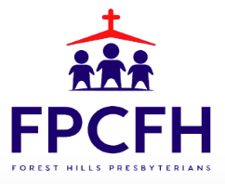

Building a Community of Faith, Hope, and Love
PresbyFH.org

