September 20, 2026 17th Sunday after Pentecost 11 AM

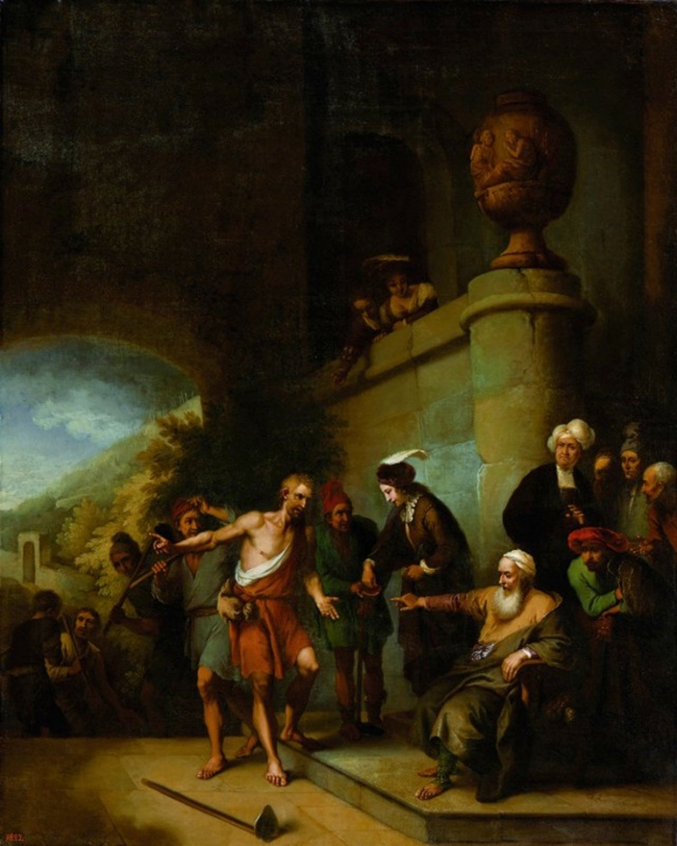
Dietrich, Christian Wilhelm Ernst, 1712-1774. Parable of the Workers in the Vineyard, (circa 1752),
from Art in the Christian Tradition, a project of the Vanderbilt University Divinity Library, Nashville, TN.

PRELUDE Chorale Prelude on “Lord Jesus Christ, Be Present Now” Max Reger

WELCOME

MINUTE FOR MISSION

CALL TO WORSHIP

HYMN #36 “For the Fruit of All Creation”

1 For the fruit of all creation, thanks be to God.
For the gifts to every nation, thanks be to God.
For the plowing, sowing, reaping, silent growth while we are sleeping,
future needs in earth's safekeeping, thanks be to God.

2 In the just reward of labor, God's will be done.
In the help we give our neighbor, God's will be done.
In our worldwide task of caring for the hungry and despairing,
in the harvests we are sharing, God's will be done.

3 For the harvests of the Spirit, thanks be to God.
For the good we all inherit, thanks be to God.
For the wonders that astound us, for the truths that still confound us,
most of all that love has found us, thanks be to God.

CALL TO CONFESSION

PRAYER OF CONFESSION

ASSURANCE OF GOD’S LOVE

RESPONSE: HYMN #581 “Gloria Patri”
Glory be the Father, and to the Son and to the Holy Ghost,
As it was in the beginning, is now, and ever shall be,
World without end. Amen. Amen.

PEACE
Let there be peace on earth.
And let it begin with me.
The peace of Christ be with you.
And also with you.

RESPONSIVE READING Psalm 145:1-8 (NRSVUE)
I will extol you, my God and King, and bless your name forever and ever.
Every day I will bless you and praise your name forever and ever.
Great is the Lord and greatly to be praised; his greatness is unsearchable.
One generation shall extol your works to another
and shall declare your mighty acts.
They will recount the glorious splendor of your majesty,
and on your wondrous works I will meditate.
They will proclaim the might of your awesome deeds,
and I will declare your greatness.
They shall celebrate the fame of your abundant goodness
and shall sing aloud of your righteousness.
The Lord is gracious and merciful,
slow to anger and abounding in steadfast love.

FIRST READING Jonah 3:10-4:11 (NRSVUE)
¹⁰ When God saw what they did, how they turned from their evil ways, God changed his mind about the calamity that he had said he would bring upon them, and he did not do it.

¹ But this was very displeasing to Jonah, and he became angry. ² He prayed to the Lord and said, “O Lord! Is not this what I said while I was still in my own country? That is why I fled to Tarshish at the beginning, for I knew that you are a gracious and merciful God, slow to anger, abounding in steadfast love, and relenting from punishment. ³ And now, O Lord, please take my life from me, for it is better for me to die than to live.” ⁴ And the Lord said, “Is it right for you to be angry?” ⁵ Then Jonah went out of the city and sat down east of the city and made a booth for himself there. He sat under it in the shade, waiting to see what would become of the city.
⁶ The Lord God appointed a bush and made it come up over Jonah, to give shade over his head, to save him from his discomfort, so Jonah was very happy about the bush. ⁷ But when dawn came up the next day, God appointed a worm that attacked the bush, so that it withered. ⁸ When the sun rose, God prepared a sultry east wind, and the sun beat down on the head of Jonah so that he was faint and asked that he might die. He said, “It is better for me to die than to live.”

⁹ But God said to Jonah, “Is it right for you to be angry about the bush?” And he said, “Yes, angry enough to die.” ¹⁰ Then the Lord said, “You are concerned about the bush, for which you did not labor and which you did not grow; it came into being in a night and perished in a night. ¹¹ And should I not be concerned about Nineveh, that great city, in which there are more than a hundred and twenty thousand persons who do not know their right hand from their left and also many animals?”

CHILDREN’S SERMON

SECOND READING Matthew 20:1-16 (NRSVUE)
¹ “For the kingdom of heaven is like a landowner who went out early in the morning to hire laborers for his vineyard. ² After agreeing with the laborers for a denarius for the day, he sent them into his vineyard. ³ When he went out about nine o’clock, he saw others standing idle in the marketplace, ⁴ and he said to them, ‘You also go into the vineyard, and I will pay you whatever is right.’ So they went. ⁵ When he went out again about noon and about three o’clock, he did the same. ⁶ And about five o’clock he went out and found others standing around, and he said to them, ‘Why are you standing here idle all day?’ ⁷ They said to him, ‘Because no one has hired us.’ He said to them, ‘You also go into the vineyard.’ ⁸ When evening came, the owner of the vineyard said to his manager, ‘Call the laborers and give them their pay, beginning with the last and then going to the first.’ ⁹ When those hired about five o’clock came, each of them received a denarius. ¹⁰ Now when the first came, they thought they would receive more; but each of them also received a denarius. ¹¹ And when they received it, they grumbled against the landowner, ¹² saying, ‘These last worked only one hour, and you have made them equal to us who have borne the burden of the day and the scorching heat.’ ¹³ But he replied to one of them, ‘Friend, I am doing you no wrong; did you not agree with me for a denarius? ¹⁴ Take what belongs to you and go; I choose to give to this last the same as I give to you. ¹⁵ Am I not allowed to do what I choose with what belongs to me? Or are you envious because I am generous?’ ¹⁶ So the last will be first, and the first will be last.”

SERMON “First and Last” Jeff Courter
HYMN #751 (vv. 1-3) “We Will Rise Up and Follow”

1 From the nets of our labors, through the noise and confusion,
from the city or seashore, Jesus summons us all.
Refrain: We will rise up and follow, Christ before and beside us,
loving pattern to guide us, as we answer the call.

2 When we faint and grow weary from the bearing of burdens,
with a message of comfort, Jesus summons us all. [Refrain]

3 In the eyes of the stranger—tearful, joyous, or frightened—
in the face of each neighbor, Jesus summons us all. [Refrain]

PROFESSION OF FAITH THE APOSTLES’ CREED
I Believe in God the Father Almighty, Maker of heaven and earth; and in Jesus Christ, His Only Son, our Lord, who was conceived by the Holy Spirit, born of the Virgin Mary, suffered under Pontius Pilate, was crucified, dead, and buried. He descended into hell; the third day He rose again from the dead. He ascended into heaven, and sitteth at the right hand of God the Father Almighty, from thence He shall come to judge the quick and the dead.
I believe in the Holy Spirit, the holy catholic church, the communion of saints, the forgiveness of sins, the resurrection of the body, and the life everlasting. Amen.

PRAYERS OF THE PEOPLE

OFFERING/OFFERTORY Aria from “Idylle” W. Henry Maxfield
(My Help Comes from the Lord)

OFFERING SONG #606 Doxology
Praise God, from whom all blessings flow,
Praise God, all creatures here below,
Praise God above, ye heavenly host,
Praise Father, Son and Holy Ghost. Amen.

PRAYER OF DEDICATION/ THE LORD’S PRAYER

ANNOUNCEMENTS

CLOSING HYMN #634 “To God Be the Glory”

1 To God be the glory; great things he has done!
So loved he the world that he gave us his Son,
who yielded his life an atonement for sin,
and opened the life-gate that all may go in.
Refrain:
Praise the Lord, praise the Lord; let the earth hear his voice!
Praise the Lord, praise the Lord; let the people rejoice!
O come to the Father through Jesus the Son,
and give him the glory: great things he has done!

2 Great things he has taught us; great things he has done,
and great our rejoicing through Jesus the Son;
but purer and higher and greater will be
our wonder, our transport, when Jesus we see. [Refrain]

BENEDICTION

POSTLUDE “Fantasia on the Triumph of Jesus Christ” L.N. Porter
___________________________________________________________________

UPCOMING CALENDAR

WORLD COMMUNION OFFERING - September 6 - October 4, 2026
All of God's people gather around the Table to celebrate the life, death and resurrection of Jesus Christ. Part of the atonement that happens around this Table is reconciliation, which is the focus of the World Communion Offering. Experience the grace that comes from reconciling all peoples from all nations around the corner and around the globe through the ministry of this offering.
(Formally Peace and Global Witness)

REMINDER – Please keep in mind that the worship is now at 11:00 AM through the Fall and Winter; Sunday School and Adult Bible Study starts at 10:00 AM.

REMINDER: We are still looking for volunteers for worship readers and/or juice/coffee hour. There is a 3-month sign-up sheet posted just outside the office.
If you have any questions, please contact the Office.

First Presbyterian Church of Forest Hills
70-35 112th St., Forest Hills, NY 11375 presbyfh.org
David Barnett, Admin.718-268-4036 Jeff Courter, Pastor,
FirstPresFHNY@gmail.com; rev.jeffrey.courter@gmail.com
Rafael Reyes-Quiroz, Clerk of Session Hannah Lin, Guest Organist

Please note: we now have a public WiFi for the church, though it may only be available in the church hall for now.
Name: CHURCH GUEST
Password: welcome1

For offerings/donations:

- Use Zelle to make Online donations from your bank account. Use this phone number to transfer to the church:
929-418-0958 (please note: this is a new number)
- Make checks payable to First Presbyterian Church of Forest Hills and mail check to the church office
- Go to our church website: presbyfh.org and click on the “Give Now” icon to set up a donation; or click on the QR code above
- The web address of your donation form has now been changed to: https://secure.myvanco.com/L-ZBFD
- Set up a “Bill pay” from your bank.



Building a Community of Faith, Hope, and Love
PresbyFH.org

