August 16, 2026 12th Sunday after Pentecost 11 AM

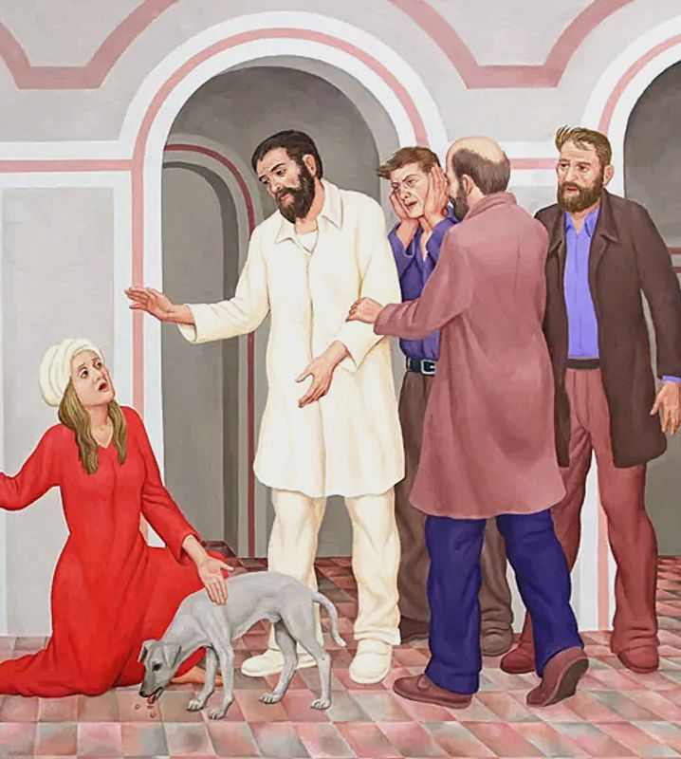
Koenig, Peter. The Daughter of the Canaanite Woman, (2016) from
Art in the Christian Tradition, a project of the Vanderbilt University Divinity Library, Nashville, TN.

PRELUDE Evocation: “ The Lord said ‘How long will those people
refuse to believe in me, in spite of all the miraculous
signs I’ve performed among them?’” (Numbers 14:11) Gilbert Martin

WELCOME

CALL TO WORSHIP

HYMN #314 “Christ, Be Our Light”

- Longing for light, we wait in darkness. Longing for truth, we turn to you.
Make us your own, your holy people, light for the world to see.

Refrain: Christ, be our light! Shine in our hearts. Shine through the darkness.
Christ, be our light! Shine in your church gathered today.

2. Longing for peace, our world is troubled. Longing for hope, many despair.
Your word alone has pow’r to save us. Make us your living voice. [Refrain]

3. Longing for food, many are hungry. Longing for water, many still thirst.
Make us your bread, broken for others, shared until all are fed. [Refrain]

4. Longing for shelter, many are homeless. Longing for warmth, many are cold.
Make us your building, sheltering others, walls made of living stone. [Refrain]

5. Many the gifts, many the people, many the hearts that yearn to belong.
Let us be servants to one another, making your kingdom come. [Refrain]

CALL TO CONFESSION

PRAYER OF CONFESSION

ASSURANCE OF GOD’S LOVE

RESPONSE: HYMN #581 “Gloria Patri”
Glory be the Father, and to the Son and to the Holy Ghost,
As it was in the beginning, is now, and ever shall be,
World without end. Amen. Amen.

PEACE
Let there be peace on earth.
And let it begin with me.
The peace of Christ be with you.
And also with you.

RESPONSIVE READING Psalm 67 (NRSVUE)
May God be gracious to us and bless us
and make his face to shine upon us, Selah
that your way may be known upon earth,
your saving power among all nations.
Let the peoples praise you, O God; let all the peoples praise you.
Let the nations be glad and sing for joy, for you judge the peoples with equity
and guide the nations upon earth. Selah
Let the peoples praise you, O God; let all the peoples praise you.
The earth has yielded its increase; God, our God, has blessed us.
May God continue to bless us; let all the ends of the earth revere him.

FIRST READING Isaiah 56:1;6-8 (NRSVUE)
¹ Thus says the Lord: Maintain justice, and do what is right, for soon my salvation will come and my deliverance be revealed.

⁶ And the foreigners who join themselves to the Lord, to minister to him, to love the name of the Lord, and to be his servants, all who keep the Sabbath and do not profane it and hold fast my covenant—⁷ these I will bring to my holy mountain
and make them joyful in my house of prayer; their burnt offerings and their sacrifices will be accepted on my altar, for my house shall be called a house of prayer for all peoples. ⁸ Thus says the Lord God, who gathers the outcasts of Israel:
I will gather others to them besides those already gathered.

CHILDREN’S SERMON

SECOND READING Matthew 15:21-28 (NRSVUE)
²¹ Jesus left that place and went away to the district of Tyre and Sidon. ²² Just then a Canaanite woman from that region came out and started shouting, “Have mercy on me, Lord, Son of David; my daughter is tormented by a demon.” ²³ But he did not answer her at all. And his disciples came and urged him, saying, “Send her away, for she keeps shouting after us.” ²⁴ He answered, “I was sent only to the lost sheep of the house of Israel.” ²⁵ But she came and knelt before him, saying, “Lord, help me.” ²⁶ He answered, “It is not fair to take the children’s food and throw it to the dogs.” ²⁷ She said, “Yes, Lord, yet even the dogs eat the crumbs that fall from their masters’ table.” ²⁸ Then Jesus answered her, “Woman, great is your faith! Let it be done for you as you wish.” And her daughter was healed from that moment.

SERMON “Belonging“ Jeff Courter

HYMN #301 “All Are Welcome”

- Let us build a house where love can dwell and all can safely live,
a place where saints and children tell how hearts learn to forgive.
Built of hopes and dreams and visions, rock of faith and vault of grace;
here the love of Christ shall end divisions:
All are welcome, all are welcome; all are welcome in this place.

- Let us build a house where prophets speak, and words are strong and true,
where all God’s children dare to seek to dream God’s reign anew.
Here the cross shall stand as witness and as symbol of God’s grace;
here as one we claim the faith of Jesus.
All are welcome, all are welcome; all are welcome in this place.

- Let us build a house where love is found in water, wine, and wheat;
a banquet hall on holy ground where peace and justice meet.
Here the love of God, through Jesus is revealed in time and space;
as we share in Christ the feast that frees us:
All are welcome, all are welcome; all are welcome in this place.

- Let us build a house where hands will reach beyond the wood and stone
to heal and strengthen, serve and teach, and live the Word they’ve known.
Here the outcast and the stranger bear the image of God’s face;
let us bring an end to fear and danger.
All are welcome, all are welcome; all are welcome in this place.

- Let us build a house where all are named, their songs and visions heard
and loved and treasured, taught and claimed as words within the Word.
Built of tears and cries and laughter, prayers of faith and songs of grace;
let this house proclaim from floor to rafter:
All are welcome, all are welcome; all are welcome in this place.

PROFESSION OF FAITH THE APOSTLES’ CREED
I Believe in God the Father Almighty, Maker of heaven and earth; and in Jesus Christ, His Only Son, our Lord, who was conceived by the Holy Spirit, born of the Virgin Mary, suffered under Pontius Pilate, was crucified, dead, and buried. He descended into hell; the third day He rose again from the dead. He ascended into heaven, and sitteth at the right hand of God the Father Almighty, from thence He shall come to judge the quick and the dead.
I believe in the Holy Spirit, the holy catholic church, the communion of saints, the forgiveness of sins, the resurrection of the body, and the life everlasting. Amen.

PRAYERS OF THE PEOPLE

OFFERING/OFFERTORY “The Lord Is My Shepherd” Philip Hayes
(from an organ concerto)

OFFERING SONG #606 Doxology
Praise God, from whom all blessings flow,
Praise God, all creatures here below,
Praise God above, ye heavenly host,
Praise Father, Son and Holy Ghost. Amen.

PRAYER OF DEDICATION/THE LORD’S PRAYER

ANNOUNCEMENTS

CLOSING HYMN #300 “We Are One in the Spirit”

- We are one in the Spirit, we are one in the Lord;
We are one in the Spirit, we are one in the Lord;
And we pray that all unity will one day be restored.
Refrain: And they'll know we are Christians by our love, by our love,
yes, they'll know we are Christians by our love.

- We will walk with each other, we will walk hand in hand;
We will walk with each other, we will walk hand in hand;
And together we'll spread the news that God is in our land. [Refrain]
- We Will work with each other, we will work side by side;
We will work with each other, we will work side by side;
And we'll guard each man's dignity and save each man's pride. [Refrain]

- All praise to the Father, from whom all things come;
And all praise to Christ Jesus, His only Son.
And all praise to the Spirit who makes us one. [Refrain]

BENEDICTION

POSTLUDE Trumpet Movement: Allegro William Goodwin
___________________________________________________________________

UPCOMING CALENDAR

WEDNESDAY, 7:00 PM - Book Discussion Group on the book The Cost of Discipleship by Dietrich Bonhoeffer. We will be on the church Zoom at 7:00 PM.

REMINDER – Please keep in mind that worship is now at 10:00 AM for the Summer months ending last Sunday of August.

WORLD COMMUNION OFFERING - September 6 - October 4, 2026
All of God's people gather around the Table to celebrate the life, death and resurrection of Jesus Christ. Part of the atonement that happens around this Table is reconciliation, which is the focus of the World Communion Offering. Experience the grace that comes from reconciling all peoples from all nations around the corner and around the globe through the ministry of this offering.
(Formally Peace and Global Witness)

REMINDER: We are still looking for volunteers for worship readers and/or juice/coffee hour. There is a 3-month sign-up sheet posted just outside the office.
If you have any questions, please contact the Office.

First Presbyterian Church of Forest Hills
70-35 112th St., Forest Hills, NY 11375 presbyfh.org
David Barnett, Admin.718-268-4036 Jeff Courter, Pastor,
FirstPresFHNY@gmail.com; rev.jeffrey.courter@gmail.com
Rafael Reyes-Quiroz, Clerk of Session Hannah Lin, Guest Organist

Please note: we now have a public WiFi for the church, though it may only be available in the church hall for now.
Name: CHURCH GUEST
Password: welcome1

For offerings/donations:

- Use Zelle to make Online donations from your bank account. Use this phone number to transfer to the church:
929-418-0958 (please note: this is a new number)
- Make checks payable to First Presbyterian Church of Forest Hills and mail check to the church office
- Go to our church website: presbyfh.org and click on the “Give Now” icon to set up a donation; or click on the QR code above
- The web address of your donation form has now been changed to: https://secure.myvanco.com/L-ZBFD
- Set up a “Bill pay” from your bank.

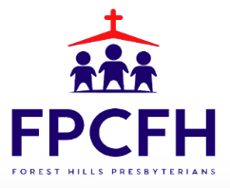

Building a Community of Faith, Hope, and Love
PresbyFH.org

