July 19, 2026 8th Sunday after Pentecost 11 AM

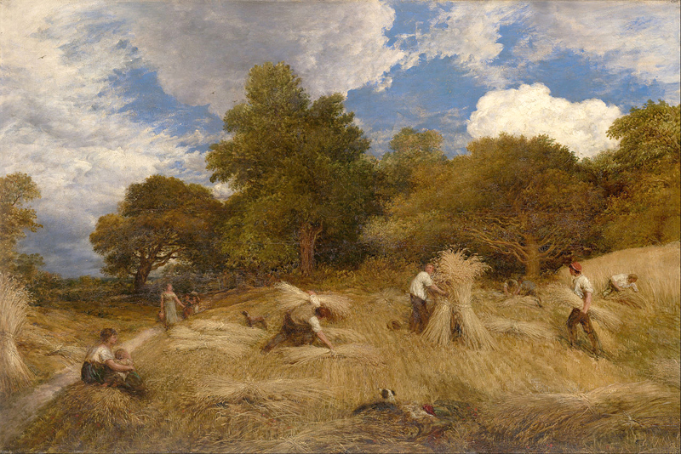
Linnell, John, 1792-1882. Wheat, (1860)
from Art in the Christian Tradition, a project of the Vanderbilt Divinity Library, Nashville, TN.

PRELUDE Chorale Var. on “Jesu, Truest Friend to Me, Johann Pachelbel
Source of Purest Pleasure” (var. 1,2,5)

WELCOME

CALL TO WORSHIP

HYMN #714 “God of the Fertile Fields”

1 God of the fertile fields, shaper of earth that yields
our daily bread: forth from your bounteous hand
come gifts your love has planned, that all in every land be clothed and fed.

2 We would be stewards true, holding in trust from you
all that you give; help us in love to share,
teach us like you to care for people everywhere, that all may live.

3 As grows the hidden seed to fruit that serves our need,
so your reign grows. Let all our toil be used,
no gift of yours abused, no humble task refused your love bestows.

4 God of the countryside, dear to the Christ who died
to make us one: we pledge our lives anew
in faithful love to you. Guide all we say and do. Your will be done.

CALL TO CONFESSION

PRAYER OF CONFESSION

ASSURANCE OF GOD’S LOVE

RESPONSE: HYMN #581 “Gloria Patri”
Glory be the Father, and to the Son and to the Holy Ghost,
As it was in the beginning, is now, and ever shall be,
World without end. Amen. Amen.

PEACE
Let there be peace on earth.
And let it begin with me.
The peace of Christ be with you.
And also with you.

RESPONSIVE READING Psalm 86:11-17 (NRSVUE)
Teach me your way, O Lord, that I may walk in your truth;
give me an undivided heart to revere your name.
I give thanks to you, O Lord my God, with my whole heart,
and I will glorify your name forever.
For great is your steadfast love toward me;
you have delivered my soul from the depths of Sheol.
O God, the insolent rise up against me; a band of ruffians seeks my life,
and they do not set you before them.
But you, O Lord, are a God merciful and gracious,
slow to anger and abounding in steadfast love and faithfulness.
Turn to me and be gracious to me; give your strength to your servant;
save the child of your maidservant.
Show me a sign of your favor, so that those who hate me may see it and be put to
shame, because you, Lord, have helped me and comforted me.

FIRST READING Isaiah 44:6-8 (NRSVUE)
⁶ Thus says the Lord, the King of Israel, and his Redeemer, the Lord of hosts:
I am the first, and I am the last; besides me there is no god. ⁷ Who is like me? Let them proclaim it; let them declare and set it forth before me. Who has announced from of old the things to come? Let them tell us what is yet to be. ⁸ Do not fear or be afraid; have I not told you from of old and declared it? You are my witnesses! Is there any god besides me? There is no other rock; I know not one.

CHILDREN’S SERMON

SECOND READING Matthew 13:24-30,36-43 (NRSVUE)
²⁴ He put before them another parable: “The kingdom of heaven may be compared to someone who sowed good seed in his field, ²⁵ but while everybody was asleep an enemy came and sowed weeds among the wheat and then went away. ²⁶ So when the plants came up and bore grain, then the weeds appeared as well. ²⁷ And the slaves of the householder came and said to him, ‘Master, did you not sow good seed in your field? Where, then, did these weeds come from?’ ²⁸ He answered, ‘An enemy has done this.’ The slaves said to him, ‘Then do you want us to go and
gather them?’ ²⁹ But he replied, ‘No, for in gathering the weeds you would uproot the wheat along with them. ³⁰ Let both of them grow together until the harvest, and at harvest time I will tell the reapers, Collect the weeds first and bind them in bundles to be burned, but gather the wheat into my barn.’ ”

³⁶ Then he left the crowds and went into the house. And his disciples approached him, saying, “Explain to us the parable of the weeds of the field.” ³⁷ He answered, “The one who sows the good seed is the Son of Man; ³⁸ the field is the world, and the good seed are the children of the kingdom; the weeds are the children of the evil one, ³⁹ and the enemy who sowed them is the devil; the harvest is the end of the age, and the reapers are angels. ⁴⁰ Just as the weeds are collected and burned up with fire, so will it be at the end of the age. ⁴¹ The Son of Man will send his angels, and they will collect out of his kingdom all causes of sin and all evildoers, ⁴² and they will throw them into the furnace of fire, where there will be weeping and gnashing of teeth. ⁴³ Then the righteous will shine like the sun in the kingdom of their Father. Let anyone with ears listen!

SERMON “Hellfire and Brimstone” Jeff Courter

HYMN #367 “Come, Ye Thankful People, Come”

1 Come, ye thankful people, come; raise the song of harvest home.
All is safely gathered in, ere the winter storms begin.
God, our Maker, doth provide for our wants to be supplied.
Come to God's own temple, come; raise the song of harvest home.

2 All the world is God's own field, fruit in thankful praise to yield,
wheat and tares together sown, unto joy or sorrow grown.
First the blade, and then the ear, then the full corn shall appear.
Lord of harvest, grant that we wholesome grain and pure may be.

3 For the Lord our God shall come, and shall take the harvest home;
from each field shall in that day all offenses purge away;
give the angels charge at last in the fire the tares to cast,
but the fruitful ears to store in God's garner evermore.
4 Even so, Lord, quickly come to thy final harvest home.
Gather thou thy people in, free from sorrow, free from sin,
there forever purified, in thy presence to abide:
come, with all thine angels, come; raise the glorious harvest home!

PROFESSION OF FAITH THE APOSTLES’ CREED
I Believe in God the Father Almighty, Maker of heaven and earth; and in Jesus Christ, His Only Son, our Lord, who was conceived by the Holy Spirit, born of the Virgin Mary, suffered under Pontius Pilate, was crucified, dead, and buried. He descended into hell; the third day He rose again from the dead. He ascended into heaven, and sitteth at the right hand of God the Father Almighty, from thence He shall come to judge the quick and the dead.
I believe in the Holy Spirit, the holy catholic church, the communion of saints, the forgiveness of sins, the resurrection of the body, and the life everlasting. Amen.

PRAYERS OF THE PEOPLE

OFFERING/OFFERTORY “Lord, Our Heart Inclined Unto Thee, Abide with Us”
Gustave Merkel
OFFERING SONG #606 Doxology
Praise God, from whom all blessings flow,
Praise God, all creatures here below,
Praise God above, ye heavenly host,
Praise Father, Son and Holy Ghost. Amen.

PRAYER OF DEDICATION/THE LORD’S PRAYER

ANNOUNCEMENTS

HYMN #750 “Goodness Is Stronger than Evil”
Goodness is stronger than evil; love is stronger than hate;
Light is stronger than darkness; life is stronger than death.
Victory is ours; victory is ours through God who loves us.
Victory is ours; victory is ours through God who loves us.
BENEDICTION

POSTLUDE______”The Lord Is Close to the Broken-Hearted Gustave Merkel
and Saves Those Who Are Crushed in the Spirit”
(Psalm 33:18)
___________________________________________________________________

UPCOMING CALENDAR

WEDNESDAY, 7:00 PM - Book Discussion Group on the book The Cost of Discipleship by Dietrich Bonhoeffer. We will be on the church Zoom at 7:00 PM.

REMINDER – Please keep in mind that worship is now at 10:00 AM for the Summer months ending last Sunday of August.

REMINDER: We are still looking for volunteers for worship readers and/or juice/coffee hour. There is a 3-month sign-up sheet posted just outside the office.
If you have any questions, please contact the Office.

First Presbyterian Church of Forest Hills
70-35 112th St., Forest Hills, NY 11375 presbyfh.org
David Barnett, Admin.718-268-4036 Jeff Courter, Pastor,
FirstPresFHNY@gmail.com; rev.jeffrey.courter@gmail.com
Rafael Reyes-Quiroz, Clerk of Session Hannah Lin, Guest Organist

Please note: we now have a public WiFi for the church, though it may only be available in the church hall for now.
Name: CHURCH GUEST
Password: welcome1

For offerings/donations:

- Use Zelle to make Online donations from your bank account. Use this phone number to transfer to the church:
929-418-0958 (please note: this is a new number)
- Make checks payable to First Presbyterian Church of Forest Hills and mail check to the church office
- Go to our church website: presbyfh.org and click on the “Give Now” icon to set up a donation; or click on the qr code above
- The web address of your donation form has now been changed to: https://secure.myvanco.com/L-ZBFD
- Set up a “Bill pay” from your bank.

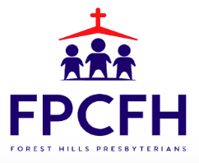

Building a Community of Faith, Hope, and Love
PresbyFH.org

