January 18, 2026 2nd Sunday after Epiphany 11 AM

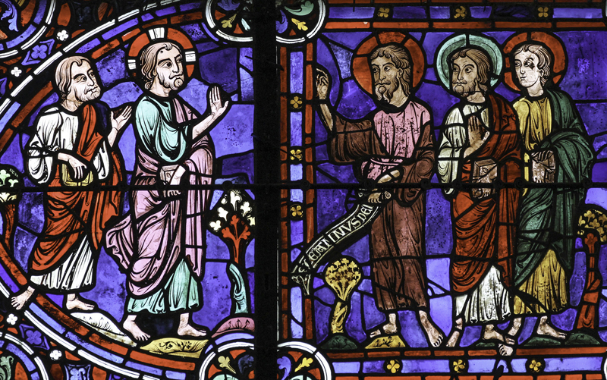
John and disciples acknowledge Jesus as the Lamb of God, (1205-1235),
from Art in the Christian Tradition, a project of the Vanderbilt Divinity Library, Nashville, TN.

PRELUDE “In Thee is Content” J.S. Bach

WELCOME

CALL TO WORSHIP

HYMN #475 “Come, Thou Fount of Every Blessing”

1 Come, thou Fount of every blessing; tune my heart to sing thy grace;
streams of mercy, never ceasing,call for songs of loudest praise.
Teach me some melodious sonnet, sung by flaming tongues above;
praise the mount! I’m fixed upon it, mount of God’s unchanging love!

2 Here I raise my Ebenezer; hither by thy help I’m come;
and I hope, by thy good pleasure, safely to arrive at home.
Jesus sought me when a stranger, wandering from the fold of God;
he, to rescue me from danger, interposed his precious blood.

3 O to grace how great a debtor daily I’m constrained to be!
Let that grace now, like a fetter, bind my wandering heart to thee.
Prone to wander, Lord, I feel it, prone to leave the God I love;
here’s my heart; O take and seal it; seal it for thy courts above.

CALL TO CONFESSION

ASSURANCE OF GOD’S LOVE

RESPONSE: HYMN #581 “Gloria Patri”
Glory be the Father, and to the Son and to the Holy Ghost,
As it was in the beginning, is now, and ever shall be,
World without end. Amen. Amen.

PEACE
Let there be peace on earth.
And let it begin with me.
The peace of Christ be with you.
And also with you.

RESPONSIVE READING Psalm 40:1-11 (NRSVUE)
I waited patiently for the Lord; he inclined to me and heard my cry.
He drew me up from the desolate pit, out of the miry bog,
and set my feet upon a rock, making my steps secure.
He put a new song in my mouth, a song of praise to our God.
Many will see and fear and put their trust in the Lord.
Happy are those who make the Lord their trust,
who do not turn to the proud, to those who go astray after false gods.
You have multiplied, O Lord my God, your wondrous deeds and your thoughts
toward us; none can compare with you. Were I to proclaim and tell of them, they
would be more than can be counted.
Sacrifice and offering you do not desire, but you have given me an open ear.
Burnt offering and sin offering you have not required.
Then I said, “Here I am; in the scroll of the book it is written of me.
I delight to do your will, O my God; your law is within my heart.”
I have told the glad news of deliverance in the great congregation; see, I have not
restrained my lips, as you know, O Lord.
I have not hidden your saving help within my heart;
I have spoken of your faithfulness and your salvation;
I have not concealed your steadfast love and your faithfulness
from the great congregation.
Do not, O Lord, withhold your mercy from me; let your steadfast love and your
faithfulness keep me safe forever.

FIRST READING Isaiah 49:1-7 (NRSVUE)
¹ Listen to me, O coastlands; pay attention, you peoples from far away! The Lord called me before I was born; while I was in my mother’s womb he named me. ² He made my mouth like a sharp sword; in the shadow of his hand he hid me;
he made me a polished arrow; in his quiver he hid me away. ³ And he said to me, “You are my servant, Israel, in whom I will be glorified.” ⁴ But I said, “I have labored in vain; I have spent my strength for nothing and vanity; yet surely my cause is with the Lord and my reward with my God.”
⁵ And now the Lord says, who formed me in the womb to be his servant, to bring Jacob back to him, and that Israel might be gathered to him, for I am honored in the sight of the Lord, and my God has become my strength — ⁶ he says, “It is too light a thing that you should be my servant to raise up the tribes of Jacob and to restore the survivors of Israel; I will give you as a light to the nations, that my salvation may reach to the end of the earth.”
⁷ Thus says the Lord, the Redeemer of Israel and his Holy One, to one deeply despised, abhorred by the nations, the slave of rulers, “Kings shall see and stand up; princes, and they shall prostrate themselves, because of the Lord, who is faithful, the Holy One of Israel, who has chosen you.”

CHILDREN’S SERMON

SECOND READING John 1:29-42 (NRSVUE)
²⁹ The next day he saw Jesus coming toward him and declared, “Here is the Lamb of God who takes away the sin of the world! ³⁰ This is he of whom I said, ‘After me comes a man who ranks ahead of me because he was before me.’ ³¹ I myself did not know him, but I came baptizing with water for this reason, that he might be revealed to Israel.” ³² And John testified, “I saw the Spirit descending from heaven like a dove, and it remained on him. ³³ I myself did not know him, but the one who sent me to baptize with water said to me, ‘He on whom you see the Spirit descend and remain is the one who baptizes with the Holy Spirit.’ ³⁴ And I myself have seen and have testified that this is the Chosen One.”

³⁵ The next day John again was standing with two of his disciples, ³⁶ and as he watched Jesus walk by he exclaimed, “Look, here is the Lamb of God!” ³⁷ The two disciples heard him say this, and they followed Jesus. ³⁸ When Jesus turned and saw them following, he said to them, “What are you looking for?” They said to him, “Rabbi” (which translated means Teacher), “where are you staying?” ³⁹ He said to them, “Come and see.” They came and saw where he was staying, and they remained with him that day. It was about four o’clock in the afternoon. ⁴⁰ One of the two who heard John speak and followed him was Andrew, Simon Peter’s brother. ⁴¹ He first found his brother Simon and said to him, “We have found the Messiah” (which is translated Anointed). ⁴² He brought Simon to Jesus, who looked at him and said, “You are Simon son of John. You are to be called Cephas” (which is translated Peter).

SERMON “Anointed” Jeff Courter

HYMN #829 “My Faith Looks Up to Thee”

1 My faith looks up to thee, thou Lamb of Calvary, Savior divine!
Now hear me while I pray; take all my guilt away;
O let me from this day be wholly thine!

2 May thy rich grace impart strength to my fainting heart,
my zeal inspire; as thou hast died for me,
O may my love to thee pure, warm, and changeless be, a living fire!

3 While life's dark maze I tread and griefs around me spread, be thou my guide;
bid darkness turn to day; wipe sorrow's tears away;
nor let me ever stray from thee aside.

4 When ends life's transient dream, when death's cold, sullen stream
shall o'er me roll; blest Savior, then, in love, fear and distrust remove;
O bear me safe above, a ransomed soul!

PROFESSION OF FAITH THE APOSTLES CREED
I Believe in God the Father Almighty, Maker of heaven and earth; and in Jesus Christ, His Only Son, our Lord, who was conceived by the Holy Spirit, born of the Virgin Mary, suffered under Pontius Pilate, was crucified, dead, and buried. He descended into hell; the third day He rose again from the dead. He ascended into heaven, and sitteth at the right hand of God the Father Almighty, from thence He shall come to judge the quick and the dead.
I believe in the Holy Spirit, the holy catholic church, the communion of saints,
the forgiveness of sins, the resurrection of the body, and the life everlasting.

RECEPTION OF NEW MEMBERS – Olivia Hernandez, Diana Paley

PRAYERS OF THE PEOPLE

OFFERING/OFFERTORY “Zion, Tune Your Harps to Songs of Praise” G. Handel

OFFERING SONG #606 Doxology
Praise God, from whom all blessings flow,
Praise God, all creatures here below,
Praise God above, ye heavenly host,
Praise Father, Son and Holy Ghost. Amen.
PRAYER OF DEDICATION/THE LORD’S PRAYER

ANNOUNCEMENTS

CLOSING HYMN #450 “Be Thou My Vision”

- Be thou my vision, O Lord of my heart;
naught be all else to me, save that thou art;
thou my best thought, by day or by night,
waking or sleeping, thy presence my light.

- Be thou my wisdom, and thou my true Word;
I ever with thee and thou with me, Lord;
thou my soul’s shelter, and thou my high tower;
raise thou me heavenward, O Power of my power.

- Riches I heed not, nor vain, empty praise;
thou, mine inheritance, now and always;
thou and thou only, first in my heart,
High King of Heaven, my treasure thou art.

- High King of Heaven, my victory won,
may I reach heaven’s joys, O bright heaven’s Sun!
Heart of my own heart, whatever befall,
still be my vision, O Ruler of all.

BENEDICTION

POSTLUDE “Father of Heaven from Thy eternal throne George Handel
look with an eye of blessing down”

UPCOMING CALENDAR

ADULT BIBLE STUDY – Sunday 10:00 AM – we are currently starting Delivered into Covenant (Pivotal Moments in the Book of Exodus) by Walter Brueggemann
If you are interested, please contact David in the office.

ANNUAL MEETING – We will have our congregational Annual Meeting on Sunday, January 25 in the sanctuary immediately after the worship service. At the annual meeting we will review the budget approved by the session and vote for elders and deacons for the new year. All church members are urged to attend. The meeting will be hybrid, in person and on Zoom.

REMINDER: We are still looking for volunteers for worship readers and/or juice/coffee hour. There is a 3-month sign-up sheet posted just outside the office.
If you have any questions, please contact the Office.

First Presbyterian Church of Forest Hills
70-35 112th St., Forest Hills, NY 11375 presbyfh.org
David Barnett, Admin.718-268-4036 Jeff Courter, Pastor,
FirstPresFHNY@gmail.com; rev.jeffrey.courter@gmail.com
Nadina Grants, Clerk of Session Hannah Lin, Guest Organist

Please note: we now have a public WiFi for the church, though it may only be available in the church hall for now.
Name: CHURCH GUEST
Password: welcome1

For offerings/donations:

- Use Zelle to make Online donations from your bank account. Use this phone number to transfer to the church:
929-418-0958 (please note: this is a new number)
- Make checks payable to First Presbyterian Church of Forest Hills and mail check to the church office
- Go to our church website: presbyfh.org and click on the “Give Now” icon to set up a donation; or click on the qr code above
- Set up a “Bill pay” from your bank.

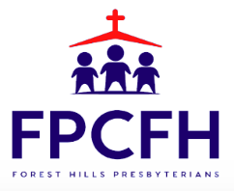

Building a Community of Faith, Hope, and Love
PresbyFH.org

