March 8, 2026 3rd Sunday in Lent 11 AM

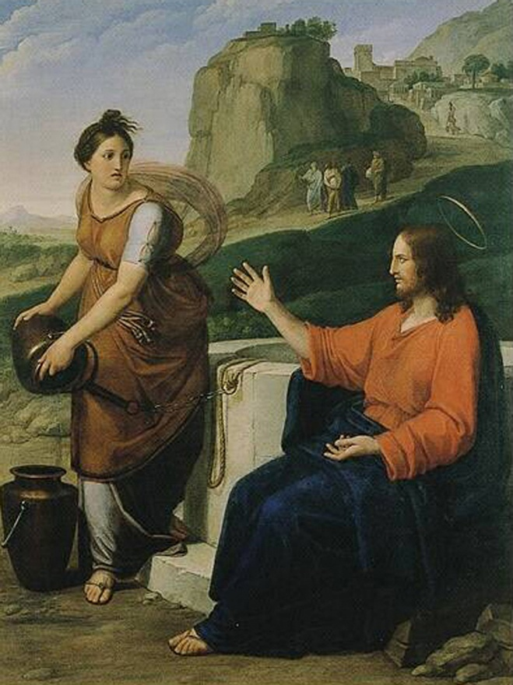
Benvenuti, Pietro, 1769-1844. Christ and the Samaritan Woman,
from Art in the Christian Tradition, a project of the Vanderbilt Divinity Library, Nashville, TN.

PRELUDE

WELCOME

CALL TO WORSHIP

HYMN#626 “As the Deer”
As the deer pants for the water, So my soul longs after You.
You alone are my heart's desire, And I long to worship You.
You alone are my strengh, my shield; To You alone may my spirit yield.
You alone are my heart's desire, And I long to worship You.

CALL TO CONFESSION

ASSURANCE OF GOD’S LOVE

RESPONSE: HYMN #582 “Glory to God”
1 Glory to God, whose goodness shines on me,
and to the Son, whose grace has pardoned me,
and to the Spirit, whose love has set me free.
As it was in the beginning, is now and ever shall be. Amen.
2 World without end, without end. Amen.
World without end, without end. Amen
World without end, without end. Amen.
As it was in the beginning, is now and ever shall be. Amen.

PEACE
Let there be peace on earth.
And let it begin with me.
The peace of Christ be with you.
And also with you.

RESPONSIVE READING Psalm 95 (NRSVUE)
O come, let us sing to the Lord;
let us make a joyful noise to the rock of our salvation!
Let us come into his presence with thanksgiving;
let us make a joyful noise to him with songs of praise!
For the Lord is a great God and a great King above all gods.
In his hand are the depths of the earth;
the heights of the mountains are his also.
The sea is his, for he made it, and the dry land, which his hands have formed.
O come, let us worship and bow down;
let us kneel before the Lord, our Maker!
For he is our God, and we are the people of his pasture and the sheep of his hand.
O that today you would listen to his voice!
Do not harden your hearts, as at Meribah,
as on the day at Massah in the wilderness,
when your ancestors tested me
and put me to the proof, though they had seen my work.
For forty years I loathed that generation and said, “They are a people whose
hearts go astray, and they do not regard my ways.”
Therefore in my anger I swore, “They shall not enter my rest.”

FIRST READING Exodus 17:1-7 (NRSVUE)
¹ From the wilderness of Sin the whole congregation of the Israelites journeyed by stages, as the Lord commanded. They camped at Rephidim, but there was no water for the people to drink. ² The people quarreled with Moses and said, “Give us water to drink.” Moses said to them, “Why do you quarrel with me? Why do you test the Lord?” ³ But the people thirsted there for water, and the people complained against Moses and said, “Why did you bring us out of Egypt, to kill us and our children and livestock with thirst?” ⁴ So Moses cried out to the Lord, “What shall I do for this people? They are almost ready to stone me.” ⁵ The Lord said to Moses, “Go on ahead of the people and take some of the elders of Israel with you; take in your hand the staff with which you struck the Nile and go. ⁶ I will be standing there in front of you on the rock at Horeb. Strike the rock, and water will come out of it, so that the people may drink.” Moses did so, in the sight of the elders of Israel. ⁷ He called the place Massah and Meribah, because the Israelites quarreled and tested the Lord, saying, “Is the Lord among us or not?”

CHILDREN’S SERMON

SECOND READING John 4:5-42 (NRSVUE)
⁵ So he came to a Samaritan city called Sychar, near the plot of ground that Jacob had given to his son Joseph. ⁶ Jacob’s well was there, and Jesus, tired out by his journey, was sitting by the well. It was about noon.

⁷ A Samaritan woman came to draw water, and Jesus said to her, “Give me a drink.” ⁸ (His disciples had gone to the city to buy food.) ⁹ The Samaritan woman said to him, “How is it that you, a Jew, ask a drink of me, a woman of Samaria?” (Jews do not share things in common with Samaritans.) ¹⁰ Jesus answered her, “If you knew the gift of God and who it is that is saying to you, ‘Give me a drink,’ you would have asked him, and he would have given you living water.” ¹¹ The woman said to him, “Sir, you have no bucket, and the well is deep. Where do you get that living water? ¹² Are you greater than our ancestor Jacob, who gave us the well and with his sons and his flocks drank from it?” ¹³ Jesus said to her, “Everyone who drinks of this water will be thirsty again, ¹⁴ but those who drink of the water that I will give them will never be thirsty. The water that I will give will become in them a spring of water gushing up to eternal life.” ¹⁵ The woman said to him, “Sir, give me this water, so that I may never be thirsty or have to keep coming here to draw water.”

¹⁶ Jesus said to her, “Go, call your husband, and come back.” ¹⁷ The woman answered him, “I have no husband.” Jesus said to her, “You are right in saying, ‘I have no husband,’ ¹⁸ for you have had five husbands, and the one you have now is not your husband. What you have said is true!” ¹⁹ The woman said to him, “Sir, I see that you are a prophet. ²⁰ Our ancestors worshiped on this mountain, but you say that the place where people must worship is in Jerusalem.” ²¹ Jesus said to her, “Woman, believe me, the hour is coming when you will worship the Father neither on this mountain nor in Jerusalem. ²² You worship what you do not know; we worship what we know, for salvation is from the Jews. ²³ But the hour is coming and is now here when the true worshipers will worship the Father in spirit and truth, for the Father seeks such as these to worship him. ²⁴ God is spirit, and those who worship him must worship in spirit and truth.” ²⁵ The woman said to him, “I know that Messiah is coming” (who is called Christ). “When he comes, he will proclaim all things to us.” ²⁶ Jesus said to her, “I am he, the one who is speaking to you.”

²⁷ Just then his disciples came. They were astonished that he was speaking with a woman, but no one said, “What do you want?” or, “Why are you speaking with her?” ²⁸ Then the woman left her water jar and went back to the city. She said to the people, ²⁹ “Come and see a man who told me everything I have ever done! He cannot be the Messiah, can he?” ³⁰ They left the city and were on their way to him.

³¹ Meanwhile the disciples were urging him, “Rabbi, eat something.” ³² But he said to them, “I have food to eat that you do not know about.” ³³ So the disciples said to one another, “Surely no one has brought him something to eat?” ³⁴ Jesus said to them, “My food is to do the will of him who sent me and to complete his work. ³⁵ Do you not say, ‘Four months more, then comes the harvest’? But I tell you, look around you, and see how the fields are ripe for harvesting. ³⁶ The reaper is already receiving wages and is gathering fruit for eternal life, so that sower and reaper may rejoice together. ³⁷ For here the saying holds true, ‘One sows and another reaps.’ ³⁸ I sent you to reap that for which you did not labor. Others have labored, and you have entered into their labor.”

³⁹ Many Samaritans from that city believed in him because of the woman’s testimony, “He told me everything I have ever done.” ⁴⁰ So when the Samaritans came to him, they asked him to stay with them, and he stayed there two days. ⁴¹ And many more believed because of his word. ⁴² They said to the woman, “It is no longer because of what you said that we believe, for we have heard for ourselves, and we know that this is truly the Savior of the world.”

SERMON “Living Water” Jeff Courter

HYMN #479 “Ho, All Who Thirst”
Refrain:
Ho, all who thirst, come now to the water, and all whose souls are parched
and weary, come and drink! Ho, all who thirst, come now to the water,
and from your heart will flow a never-failing spring!

1 Why forsake the Lord, the fount of living water,
choosing broken cups that cannot be filled? [Refrain]

2 For the Lamb will be our shepherd and will guide us
to the well-springs of the water of life. [Refrain]

3 All who come may take this gift of living water.
They will thirst no more, for they shall be filled. [Refrain]

PROFESSION OF FAITH THE NICENE CREED
We believe in one God, the Father, the Almighty, maker of heaven and earth, of all that is, seen and unseen. We believe in one Lord, Jesus Christ, the only Son of God, eternally begotten of the Father, God from God, Light from Light, true God from true God, begotten, not made, of one Being with the Father; through him all things were made. For us and for our salvation he came down from heaven, was incarnate of the Holy Spirit and the Virgin Mary and became truly human. For our sake he was crucified under Pontius Pilate; he suffered death and was buried. On the third day he rose again in accordance with the Scriptures; he ascended into heaven and is seated at the right hand of the Father. He will come again in glory to judge the living and the dead, and his kingdom will have no end. We believe in the Holy Spirit, the Lord, the giver of life, who proceeds from the Father and the Son, who with the Father and the Son is worshiped and glorified, who has spoken through the prophets. We believe in one holy catholic and apostolic Church. We acknowledge one baptism for the forgiveness of sins. We look for the resurrection of the dead, and the life of the world to come. Amen.

PRAYERS OF THE PEOPLE
OFFERING/OFFERTORY

OFFERING SONG #328 “Praise God, All You Nations” (DaNase)
Praise God, all you nations. People of God, sing praise!
Praise God, all you nations. People of God, sing praise:
God’s love is great and endures forever.
Praise God, all you nations. People of God, sing praise!

PRAYER OF DEDICATION/THE LORD’S PRAYER

ANNOUNCEMENTS

HYMN #314 (vv.1,2,5) “Christ, Be Our Light”

- Longing for light, we wait in darkness. Longing for truth, we turn to you.
Make us your own, your holy people, light for the world to see.

Refrain: Christ, be our light! Shine in our hearts. Shine through the darkness.
Christ, be our light! Shine in your church gathered today.

2. Longing for peace, our world is troubled. Longing for hope, many despair.
Your word alone has pow’r to save us. Make us your living voice. [Refrain]

5. Many the gifts, many the people, many the hearts that yearn to belong.
Let us be servants to one another, making your kingdom come. [Refrain]

BENEDICTION

POSTLUDE

UPCOMING CALENDAR

ADULT BIBLE STUDY – Sunday 10:00 AM – we are currently reading Delivered into Covenant (Pivotal Moments in the Book of Exodus) by Walter Brueggemann
If you are interested, please contact David in the office.

WEDNESDAY, MARCH 11th – Lenten Study, 7:00 PM on Zoom
We are continuing our Lenten study by reading Pastor Brian Zahnd's book, The Wood Between the Worlds:A Poetic Theology of the Cross (InterVarsity Press, 2024) until Holy Week. We have copies of the book available who are in the study - if you want a copy, please contact the office or stop by and get a copy.

REMINDER: We are still looking for volunteers for worship readers and/or juice/coffee hour. There is a 3-month sign-up sheet posted just outside the office.
If you have any questions, please contact the Office.

First Presbyterian Church of Forest Hills
70-35 112th St., Forest Hills, NY 11375 presbyfh.org
David Barnett, Admin.718-268-4036 Jeff Courter, Pastor,
FirstPresFHNY@gmail.com; rev.jeffrey.courter@gmail.com
Rafael Reyes-Quiroz, Clerk of Session

Please note: we now have a public WiFi for the church, though it may only be available in the church hall for now. Name: CHURCH GUEST Password: welcome1

For offerings/donations:

- Use Zelle to make Online donations from your bank account. Use this phone number to transfer to the church:
929-418-0958 (please note: this is a new number)
- Make checks payable to First Presbyterian Church of Forest Hills and mail check to the church office
- Go to our church website: presbyfh.org and click on the “Give Now” icon to set up a donation; or click on the qr code above
- Set up a “Bill pay” from your bank.

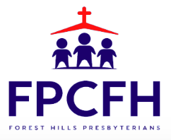

Building a Community of Faith, Hope, and Love
PresbyFH.org

