November 9, 2025 22nd Sunday After Pentecost 11 AM

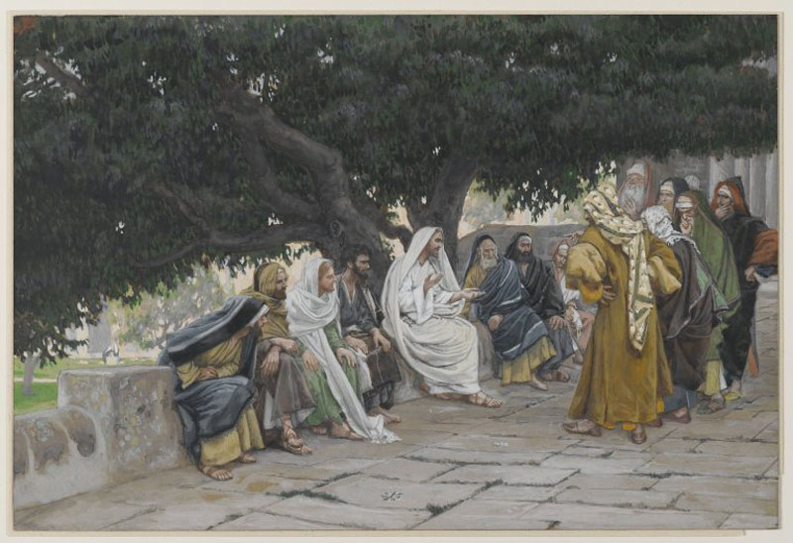
Tissot, James, 1836-1902. The Pharisees and the Sadducees Come to Tempt Jesus (1886-1894),
from Art in the Christian Tradition, a project of the Vanderbilt Divinity Library, Nashville, TN.

PRELUDE

WELCOME

CALL TO WORSHIP

OPENING PRAYER

HYMN # “We Are Restoring the House of God” Jeff Courter

Chorus:
We are restoring the house of God, We are renewing the Body of Christ,
We are creating a world of shalom, God is transforming and making us right!

Sisters and brothers who care for each other,
Love for our neighbor and love for the world;
Sharing ourselves creates new life together,
Healing and strength in the name of the Lord! (Chorus)

Living community, love overflowing, Being together intentionally;
Giving each other the gift of acceptance, Share the new vision of reality! (Chorus)

Giving attention to each precious person,
Giving our time to let love have its way;
Building relationships, moment by moment,
Making us one as we work and we play. (Chorus)

Now we invite you to please come and join us!
Lift up your voice as we sing a new song!
Bound to each other like muscle to sinew;
Christ’s holy Body to right what is wrong. (Chorus)

CALL TO CONFESSION

PRAYER OF CONFESSION

ASSURANCE OF GOD’S LOVE

RESPONSE: HYMN #582 “Glory to God”
1 Glory to God, whose goodness shines on me,
and to the Son, whose grace has pardoned me,
and to the Spirit, whose love has set me free.
As it was in the beginning, is now and ever shall be. Amen.
2 World without end, without end. Amen.
World without end, without end. Amen
World without end, without end. Amen.
As it was in the beginning, is now and ever shall be. Amen.

PEACE
Let there be peace on earth.
And let it begin with me.
The peace of Christ be with you.
And also with you.

RESPONSIVE READING Psalm 17:1-9 (NRSVUE)
Hear a just cause, O Lord; attend to my cry;
give ear to my prayer from lips free of deceit.
From you let my vindication come; let your eyes see the right.
If you try my heart, if you visit me by night, if you test me, you will find no
wickedness in me; my mouth does not transgress.
As for what others do, by the word of your lips
I have avoided the ways of the violent.
My steps have held fast to your paths; my feet have not slipped.
I call upon you, for you will answer me, O God;
incline your ear to me; hear my words.
Wondrously show your steadfast love, O savior of those who seek refuge
from their adversaries at your right hand.
Guard me as the apple of the eye; hide me in the shadow of your wings,
from the wicked who despoil me, my deadly enemies who surround me.

FIRST READING Job 19:23-27a (NRSVUE)
²³ “O that my words were written down! O that they were inscribed in a book!
²⁴ O that with an iron pen and with lead they were engraved on a rock forever!
²⁵ For I know that my vindicator lives and that in the end he will stand upon the earth; ²⁶ and after my skin has been destroyed, then in my flesh I shall see God,
²⁷ whom I shall see on my side, and my eyes shall behold, and not another.

CHILDREN’S SERMON
SECOND READING Luke 20:27-38 (NRSVUE)
²⁷ Some Sadducees, those who say there is no resurrection, came to him ²⁸ and asked him a question: “Teacher, Moses wrote for us that if a man’s brother dies leaving a wife but no children, the man shall marry the widow and raise up children for his brother. ²⁹ Now there were seven brothers; the first married a woman and died childless; ³⁰ then the second ³¹ and the third married her, and so in the same way all seven died childless. ³² Finally the woman also died. ³³ In the resurrection, therefore, whose wife will the woman be? For the seven had married her.”
³⁴ Jesus said to them, “Those who belong to this age marry and are given in marriage, ³⁵ but those who are considered worthy of a place in that age and in the resurrection from the dead neither marry nor are given in marriage. ³⁶ Indeed, they cannot die anymore, because they are like angels and are children of God, being children of the resurrection. ³⁷ And the fact that the dead are raised Moses himself showed, in the story about the bush, where he speaks of the Lord as the God of Abraham, the God of Isaac, and the God of Jacob. ³⁸ Now he is God not of the dead but of the living, for to him all of them are alive.”

SERMON “The Bride of Christ” Jeff Courter

HYMN #634 “To God Be the Glory”

1 To God be the glory; great things he has done!
So loved he the world that he gave us his Son,
who yielded his life an atonement for sin,
and opened the life-gate that all may go in.
Refrain:
Praise the Lord, praise the Lord; let the earth hear his voice!
Praise the Lord, praise the Lord; let the people rejoice!
O come to the Father through Jesus the Son,
and give him the glory: great things he has done!

2 Great things he has taught us; great things he has done,
and great our rejoicing through Jesus the Son;
but purer and higher and greater will be
our wonder, our transport, when Jesus we see. [Refrain]

PROFESSION OF FAITH THE APOSTLES CREED
I Believe in God the Father Almighty, Maker of heaven and earth; and in
Jesus Christ, His Only Son, our Lord, who was conceived by the Holy Spirit, born of the Virgin Mary, suffered under Pontius Pilate, was crucified, dead, and buried. He descended into hell; the third day He rose again from the dead. He ascended into heaven, and sitteth at the right hand of God the Father Almighty, from thence He shall come to judge the quick and the dead.
I believe in the Holy Spirit, the holy catholic church, the communion of saints,
the forgiveness of sins, the resurrection of the body, and the life everlasting.
Amen.

PRAYERS OF THE PEOPLE

OFFERING/OFFERTORY

OFFERING SONG #328 “Praise God, All You Nations” (DaNase)
Praise God, all you nations. People of God, sing praise!
Praise God, all you nations. People of God, sing praise:
God’s love is great and endures forever.
Praise God, all you nations. People of God, sing praise!

PRAYER OF DEDICATION/THE LORD’S PRAYER

ANNOUNCEMENTS

CLOSING HYMN #654 “In the Lord I’ll Be Ever Thankful”

In the Lord I'll be ever thankful,
In the Lord I will rejoice!
Look to God, do not be afraid.
Lift up your voices, the Lord is near.
Lift up your voices the Lord is near.

BENEDICTION

POSTLUDE

UPCOMING CALENDAR

SUNDAY, NOV. 16, 10:00 AM – ADULT BIBLE STUDY - we are using the book Delivered Out of Empire (Part 1) by Walter Brueggemann. Please read
Chapter 8 Multitude without Pedigree or Genealogy (Exodus 12:38).

WEDNESDAY, NOV. 12, 7:00 PM ZOOM – ADVENT STUDY – we are using Dr. Kelley Nikondeha's recent book, The First Advent in Palestine. This book will explore the theme of incarnation through the lens of Luke and Matthew's gospels. Please see David in the office.

NEXT SUNDAY, NOV. 16, 1:00 – 4:00 PM – SENIOR RESOURCE FAIR – Church Hall Please come join us for a free community event for seniors and caregivers, and for those who are “planning ahead”!

REMINDER: We are still looking for volunteers for worship readers and/or juice/coffee hour. There is a 3-month sign-up sheet posted just outside the office.
If you have any questions, please contact the Office.

First Presbyterian Church of Forest Hills
70-35 112th St., Forest Hills, NY 11375 presbyfh.org
David Barnett, Admin.718-268-4036 Jeff Courter, Pastor,
FirstPresFHNY@gmail.com; rev.jeffrey.courter@gmail.com
Nadina Grants, Clerk of Session

Please note: we now have a public WiFi for the church, though it may only be available in the church hall for now.
Name: CHURCH GUEST
Password: welcome1

For offerings/donations:

- Use Zelle to make Online donations from your bank account. Use this phone number to transfer to the church:
929-418-0958 (please note: this is a new number)
- Make checks payable to First Presbyterian Church of Forest Hills and mail check to the church office
- Go to our church website: presbyfh.org and click on the “Give Now” icon to set up a donation; or click on the qr code above
- Set up a “Bill pay” from your bank.

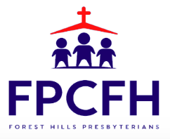

Building a Community of Faith, Hope, and Love
PresbyFH.org

