March 29, 2026 Palm/Passion Sunday 11 AM

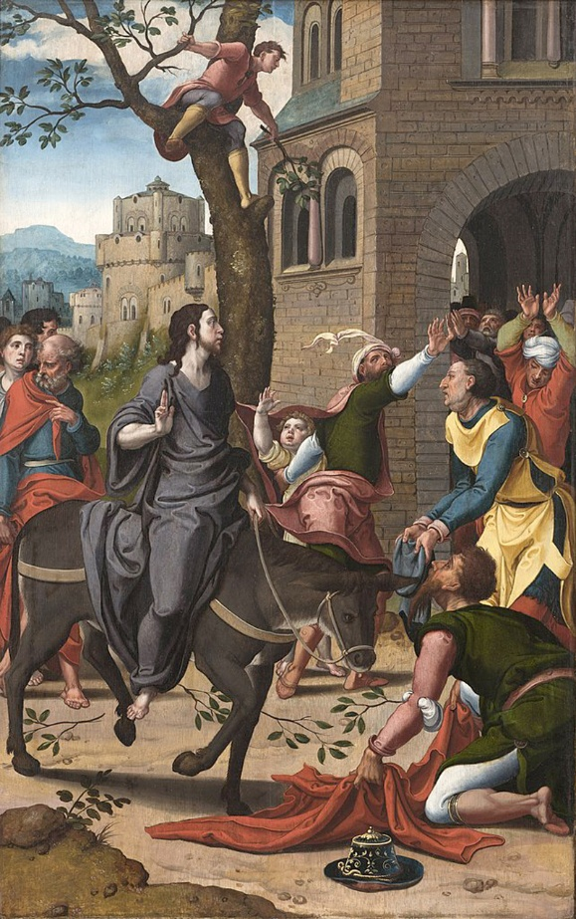
Coecke van Aelst, Pieter, 1502-1550. Entry into Jerusalem,(1530)
from Art in the Christian Tradition, a project of the Vanderbilt Divinity Library, Nashville, TN.

PRELUDE

WELCOME

CALL TO WORSHIP

HYMN #199 “Filled with Excitement”

- Filled with excitement, all the happy throng spread cloaks and branches on the city streets. There in the distance they begin to see, there on a donkey comes the Savior Christ.
Refrain: From every corner a thousand voices sing praise to the One who comes in the name of God. Our acclamation breaks forth in shouts of praise, our triumphant song of joy: “Hosanna, hosanna to Christ! Hosanna, hosanna to Christ!”

- As in that entrance to Jerusalem, hosannas we will sing to Jesus Christ, to our Redeemer who still calls today, asks us to follow with our love and faith.
Refrain: From every corner a thousand voices sing praise to the One who comes in the name of God. Our acclamation breaks forth in shouts of praise, our triumphant song of joy: “Hosanna, hosanna to Christ! Hosanna, hosanna to Christ!”

CALL TO CONFESSION

ASSURANCE OF GOD’S LOVE

RESPONSE: HYMN #582 “Glory to God”
1 Glory to God, whose goodness shines on me,
and to the Son, whose grace has pardoned me,
and to the Spirit, whose love has set me free.
As it was in the beginning, is now and ever shall be. Amen.

2 World without end, without end. Amen.
World without end, without end. Amen
World without end, without end. Amen.
As it was in the beginning, is now and ever shall be. Amen.

PEACE
Let there be peace on earth.
And let it begin with me.
The peace of Christ be with you.
And also with you.
RESPONSIVE READING Psalm 118:1-2,19-29 (NRSVUE)
O give thanks to the Lord, for he is good; his steadfast love endures forever!
Let Israel say, “His steadfast love endures forever.”

Open to me the gates of righteousness, that I may enter through them
and give thanks to the Lord.
This is the gate of the Lord; the righteous shall enter through it.
I thank you that you have answered me and have become my salvation.
The stone that the builders rejected has become the chief cornerstone.
This is the Lord’s doing; it is marvelous in our eyes.
This is the day that the Lord has made; let us rejoice and be glad in it.
Save us, we beseech you, O Lord! O Lord, we beseech you, give us success!
Blessed is the one who comes in the name of the Lord.
We bless you from the house of the Lord.
The Lord is God, and he has given us light. Bind the festal procession with
branches, up to the horns of the altar.
You are my God, and I will give thanks to you;
you are my God; I will extol you.
O give thanks to the Lord, for he is good, for his steadfast love endures forever.

FIRST READING Matthew 21:1-11 (NRSVUE)
¹ When they had come near Jerusalem and had reached Bethphage, at the Mount of Olives, Jesus sent two disciples, ² saying to them, “Go into the village ahead of you, and immediately you will find a donkey tied and a colt with her; untie them and bring them to me. ³ If anyone says anything to you, just say this, ‘The Lord needs them.’ And he will send them immediately.” ⁴ This took place to fulfill what had been spoken through the prophet:
⁵ “Tell the daughter of Zion, Look, your king is coming to you,
humble and mounted on a donkey, and on a colt, the foal of a donkey.”
⁶ The disciples went and did as Jesus had directed them; ⁷ they brought the donkey and the colt and put their cloaks on them, and he sat on them. ⁸ A very large crowd[b] spread their cloaks on the road, and others cut branches from the trees and spread them on the road. ⁹ The crowds that went ahead of him and that followed were shouting,
“Hosanna to the Son of David!
Blessed is the one who comes in the name of the Lord!
Hosanna in the highest heaven!”
¹⁰ When he entered Jerusalem, the whole city was in turmoil, asking, “Who is this?” ¹¹ The crowds were saying, “This is the prophet Jesus from Nazareth in Galilee.”

SPECIAL MUSIC “The Palms” J. Faure
Performed by Jeff Courter

CHILDREN’S SERMON

SECOND READING Matthew 27:24-37 (NRSVUE)
24 So when Pilate saw that he could do nothing but rather that a riot was beginning, he took some water and washed his hands before the crowd, saying, “I am innocent of this man’s blood;[v] see to it yourselves.” 25 Then the people as a whole answered, “His blood be on us and on our children!” 26 So he released Barabbas for them, and after flogging Jesus he handed him over to be crucified.
The Soldiers Mock Jesus
27 Then the soldiers of the governor took Jesus into the governor’s headquarters,[w] and they gathered the whole cohort around him. 28 They stripped him and put a scarlet robe on him, 29 and after twisting some thorns into a crown they put it on his head. They put a reed in his right hand and knelt before him and mocked him, saying, “Hail, King of the Jews!” 30 They spat on him and took the reed and struck him on the head. 31 After mocking him, they stripped him of the robe and put his own clothes on him. Then they led him away to crucify him.
The Crucifixion of Jesus
32 As they went out, they came upon a man from Cyrene named Simon; they compelled this man to carry his cross. 33 And when they came to a place called Golgotha (which means Place of a Skull), 34 they offered him wine to drink, mixed with gall, but when he tasted it, he would not drink it. 35 And when they had crucified him, they divided his clothes among themselves by casting lots; 36 then they sat down there and kept watch over him. 37 Over his head they put the charge against him, which read, “This is Jesus, the King of the Jews.”

SERMON “King of Kings” Jeff Courter
HYMN #198 “Ride On! Ride On in Majesty!”

1 Ride on! ride on in majesty! Hark! all the tribes hosanna cry;
thy humble beast pursues its road with palms and scattered garments strowed.

2 Ride on! ride on in majesty! In lowly pomp ride on to die;
O Christ, thy triumphs now begin o'er captive death and conquered sin.

3 Ride on! ride on in majesty! The hosts of angels in the sky
look down with sad and wondering eyes to see the approaching sacrifice.

4 Ride on! ride on in majesty! In lowly pomp ride on to die;
bow thy meek head to mortal pain; then take, O God, thy power, and reign.

PROFESSION OF FAITH THE APOSTLES’ CREED
I Believe in God the Father Almighty, Maker of heaven and earth; and in Jesus Christ, His Only Son, our Lord, who was conceived by the Holy Spirit, born of the Virgin Mary, suffered under Pontius Pilate, was crucified, dead, and buried. He descended into hell; the third day He rose again from the dead. He ascended into heaven, and sitteth at the right hand of God the Father Almighty, from thence He shall come to judge the quick and the dead. I believe in the Holy Spirit, the holy catholic church, the communion of saints, the forgiveness of sins, the resurrection of the body, and the life everlasting. Amen.

PRAYERS OF THE PEOPLE

OFFERING/OFFERTORY

OFFERING SONG #328 “Praise God, All You Nations” (DaNase)
Praise God, all you nations. People of God, sing praise!
Praise God, all you nations. People of God, sing praise:
God’s love is great and endures forever.
Praise God, all you nations. People of God, sing praise!

PRAYER OF DEDICATION/THE LORD’S PRAYER

ANNOUNCEMENTS

CLOSING HYMN #216 “Beneath the Cross of Jesus”

1 Beneath the cross of Jesus I fain would take my stand,
the shadow of a mighty rock within a weary land;
a home within the wilderness, a rest upon the way,
from the burning of the noontide heat, and the burden of the day.

2 Upon the cross of Jesus mine eye at times can see
the very dying form of One who suffered there for me;
and from my stricken heart with tears two wonders I confess:
the wonders of redeeming love and my unworthiness.

3 I take, O cross, thy shadow for my abiding place;
I ask no other sunshine than the sunshine of his face;
content to let the world go by, to know no gain or loss,
my sinful self my only shame, my glory all the cross.

BENEDICTION

POSTLUDE

UPCOMING CALENDAR

ADULT BIBLE STUDY – Postponed until after Easter; starts up again on April 12th.

WEDNESDAY, APRIL 1st – Lenten Study, 7:00 PM on Zoom – last session
We are continuing our Lenten study by reading Pastor Brian Zahnd's book, The Wood Between the Worlds:A Poetic Theology of the Cross (InterVarsity Press, 2024) until Holy Week. We have copies of the book available who are in the study - if you want a copy, please contact the office or stop by and get a copy.

MAUNDY THURSDAY, CHURCH HALL - 6:00 PM/7:00 PM – Pot luck dinner (please bring something to share!), followed by worship service at 7.

GOOD FRIDAY AT CHURCH IN THE GARDENS – 7:00 PM
Please join us for worship at Church in the Gardens on Friday evening.

EASTER EGG HUNT – 1:00 PM – CHURCH PARKING LOT/LAWN – family event! – You are invited to join us to hunt for eggs and participate in activities! We look forward to seeing you there!

REMINDER: We are still looking for volunteers for worship readers and/or juice/coffee hour. There is a 3-month sign-up sheet posted just outside the office.
If you have any questions, please contact the Office.

First Presbyterian Church of Forest Hills
70-35 112th St., Forest Hills, NY 11375 presbyfh.org
David Barnett, Admin.718-268-4036 Jeff Courter, Pastor
FirstPresFHNY@gmail.com; rev.jeffrey.courter@gmail.com
Rafael Reyes-Quiroz, Clerk of Session

Please note: we now have a public WiFi for the church, though it may only be available in the church hall for now. Name: CHURCH GUEST Password: welcome1

For offerings/donations:

- Use Zelle to make Online donations from your bank account. Use this phone number to transfer to the church:
929-418-0958 (please note: this is a new number)
- Make checks payable to First Presbyterian Church of Forest Hills and mail check to the church office
- Go to our church website: presbyfh.org and click on the “Give Now” icon to set up a donation; or click on the qr code above
- Set up a “Bill pay” from your bank.

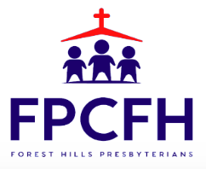

Building a Community of Faith, Hope, and Love
PresbyFH.org

