January 11, 2026 Baptism of the Lord 11 AM

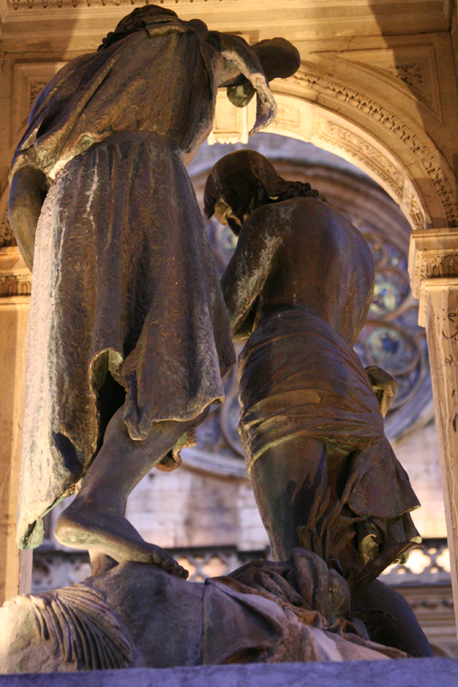
The Baptism of Christ, from Art in the Christian Tradition,
a project of the Vanderbilt Divinity Library, Nashville, TN.

PRELUDE

WELCOME

CALL TO WORSHIP

HYMN #479 “Come Now to the Water”
Refrain:
Ho, all who thirst, come now to the water, and all whose souls are parched
and weary, come and drink! Ho, all who thirst, come now to the water,
and from your heart will flow a never-failing spring!

1 Why forsake the Lord, the fount of living water,
choosing broken cups that cannot be filled? [Refrain]

2 For the Lamb will be our shepherd and will guide us
to the well-springs of the water of life. [Refrain]

3 All who come may take this gift of living water.
They will thirst no more, for they shall be filled. [Refrain]

CALL TO CONFESSION

ASSURANCE OF GOD’S LOVE

RESPONSE: HYMN #582 “Glory to God”
1 Glory to God, whose goodness shines on me,
and to the Son, whose grace has pardoned me,
and to the Spirit, whose love has set me free.
As it was in the beginning, is now and ever shall be. Amen.
2 World without end, without end. Amen.
World without end, without end. Amen
World without end, without end. Amen.
As it was in the beginning, is now and ever shall be. Amen.

PEACE
Let there be peace on earth.
And let it begin with me.
The peace of Christ be with you.
And also with you.

RESPONSIVE READING Psalm 29 (NRSVUE)
Ascribe to the Lord, O heavenly beings, ascribe to the Lord glory and strength.
Ascribe to the Lord the glory of his name; worship the Lord in holy splendor.
The voice of the Lord is over the waters; the God of glory thunders,
the Lord, over mighty waters.
The voice of the Lord is powerful; the voice of the Lord is full of majesty.
The voice of the Lord breaks the cedars; the Lord breaks the cedars of Lebanon.
He makes Lebanon skip like a calf and Sirion like a young wild ox.
The voice of the Lord flashes forth flames of fire.
The voice of the Lord shakes the wilderness;
the Lord shakes the wilderness of Kadesh.
The voice of the Lord causes the oaks to whirl and strips the forest bare,
and in his temple all say, “Glory!”
The Lord sits enthroned over the flood;
the Lord sits enthroned as king forever.
May the Lord give strength to his people! May the Lord bless his people with peace!

FIRST READING Isaiah 42:1-9 (NRSVUE)
¹ Here is my servant, whom I uphold, my chosen, in whom my soul delights;
I have put my spirit upon him; he will bring forth justice to the nations.
² He will not cry out or lift up his voice or make it heard in the street; ³ a bruised reed he will not break, and a dimly burning wick he will not quench; he will faithfully bring forth justice. ⁴ He will not grow faint or be crushed until he has established justice in the earth, and the coastlands wait for his teaching. ⁵ Thus says God, the Lord, who created the heavens and stretched them out, who spread out the earth and what comes from it, who gives breath to the people upon it and spirit to those who walk in it: ⁶ I am the Lord; I have called you in righteousness; I have taken you by the hand and kept you; I have given you as a covenant to the people, a light to the nations, ⁷ to open the eyes that are blind, to bring out the prisoners from the dungeon, from the prison those who sit in darkness. ⁸ I am the Lord; that is my name; my glory I give to no other, nor my praise to idols. ⁹ See, the former things have come to pass, and new things I now declare; before they spring forth, I tell you of them.

CHILDREN’S SERMON

SECOND READING Matthew 3:13-17 (NRSVUE)
¹³ Then Jesus came from Galilee to John at the Jordan, to be baptized by him. ¹⁴ John would have prevented him, saying, “I need to be baptized by you, and do you come to me?” ¹⁵ But Jesus answered him, “Let it be so now, for it is proper for us in this way to fulfill all righteousness.” Then he consented. ¹⁶ And when Jesus had been baptized, just as he came up from the water, suddenly the heavens were opened to him and he saw God’s Spirit descending like a dove and alighting on him. ¹⁷ And a voice from the heavens said, “This is my Son, the Beloved, with whom I am well pleased.”

SERMON “Baptized into New Life” Jeff Courter

HYMN #482 “Baptized in Water”

1 Baptized in water, sealed by the Spirit,
cleansed by the blood of Christ our King; heirs of salvation,
trusting the promise, faithfully now God's praises we sing.

2 Baptized in water, sealed by the Spirit,
dead in the tomb with Christ our King; one with his rising,
freed and forgiven, thankfully now God's praises we sing.

3 Baptized in water, sealed by the Spirit,
marked with the sign of Christ our King; born of the Spirit,
we are God's children; joyfully now God's praises we sing.

PROFESSION OF FAITH THE APOSTLES CREED
I Believe in God the Father Almighty, Maker of heaven and earth; and in Jesus Christ, His Only Son, our Lord, who was conceived by the Holy Spirit, born of the Virgin Mary, suffered under Pontius Pilate, was crucified, dead, and buried. He descended into hell; the third day He rose again from the dead. He ascended into heaven, and sitteth at the right hand of God the Father Almighty, from thence He shall come to judge the quick and the dead.
I believe in the Holy Spirit, the holy catholic church, the communion of saints,
the forgiveness of sins, the resurrection of the body, and the life everlasting.

PRAYERS OF THE PEOPLE

OFFERING/OFFERTORY

OFFERING SONG #328 “Praise God, All You Nations” (DaNase)
Praise God, all you nations. People of God, sing praise!
Praise God, all you nations. People of God, sing praise:
God’s love is great and endures forever.
Praise God, all you nations. People of God, sing praise!

PRAYER OF DEDICATION/THE LORD’S PRAYER

ANNOUNCEMENTS

CLOSING HYMN #192 “Shine, Jesus, Shine”

1 Lord, the light of your love is shining, In the midst of the darkness, shining;
Jesus, Light of the world, shine upon us; Set us free by the truth you now bring us.
Shine on me; shine on me.
[Refrain] : Shine, Jesus, shine; Fill this land with the Father's glory.
Blaze, Spirit, blaze; Set our hearts on fire.
Flow, river, flow; Flood the nations with grace and mercy.
Send forth your word, Lord, and let there be light.

2 Lord, I come to your awesome presence, From the shadows into your radiance;
By the blood I may enter your brightness. Search me, try me, consume all my darkness. Shine on me, shine on me. [Refrain]

3 As we gaze on your kingly brightness, So our faces display your likeness;
Ever changing from glory to glory, Mirrored here may our lives tell your story.
Shine on me, shine on me. [Refrain]

BENEDICTION

POSTLUDE

UPCOMING CALENDAR

TODAY – SESSION MEETING after the worship service.

ADULT BIBLE STUDY – We will begin Part 2 – Delivered into Covenant (Pivotal Moments in the Book of Exodus) by Walter Brueggemann next Sunday, January 18th, at 10:00 AM. Books for this study are available in the church office. Please see David.

ANNUAL MEETING – We will have our congregational Annual Meeting on Sunday, January 25 in the sanctuary immediately after the worship service. At the annual meeting we will review the budget approved by the session and vote for elders and deacons for the new year. All church members are urged to attend. The meeting will be hybrid, in person and on Zoom.

REMINDER: We are still looking for volunteers for worship readers and/or juice/coffee hour. There is a 3-month sign-up sheet posted just outside the office.
If you have any questions, please contact the Office.

First Presbyterian Church of Forest Hills
70-35 112th St., Forest Hills, NY 11375 presbyfh.org
David Barnett, Admin.718-268-4036 Jeff Courter, Pastor,
FirstPresFHNY@gmail.com; rev.jeffrey.courter@gmail.com
Nadina Grants, Clerk of Session

Please note: we now have a public WiFi for the church, though it may only be available in the church hall for now.
Name: CHURCH GUEST
Password: welcome1

For offerings/donations:

- Use Zelle to make Online donations from your bank account. Use this phone number to transfer to the church:
929-418-0958 (please note: this is a new number)
- Make checks payable to First Presbyterian Church of Forest Hills and mail check to the church office
- Go to our church website: presbyfh.org and click on the “Give Now” icon to set up a donation; or click on the qr code above
- Set up a “Bill pay” from your bank.

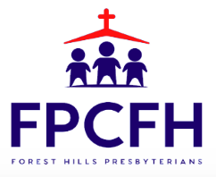

Building a Community of Faith, Hope, and Love
PresbyFH.org

