November 16, 2025 23rd Sunday After Pentecost 11 AM

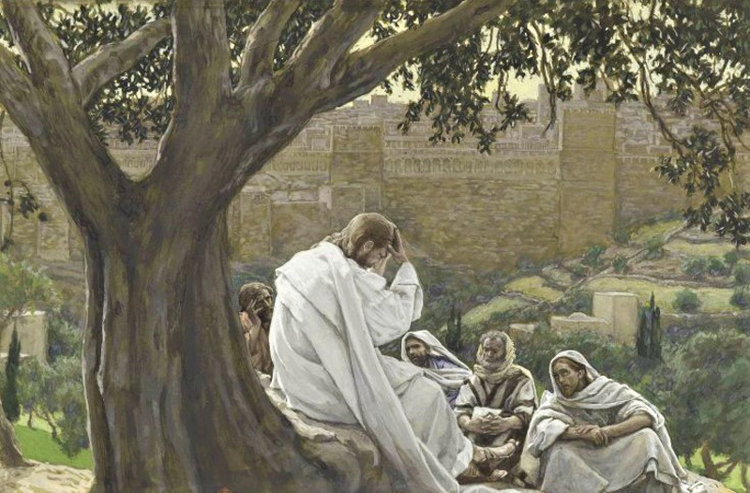
Tissot, James, 1836-1902. Prophecy of the Destruction of the Temple (1886-1894),
from Art in the Christian Tradition, a project of the Vanderbilt Divinity Library, Nashville, TN.

PRELUDE “Father, Whose Almighty Power, George Handel
His Glory to Raise, His Salvation to His Holy Land.”
(from Judas Maccabaeus Oratorio #7)

WELCOME

CALL TO WORSHIP

OPENING PRAYER

HYMN #348 “Lo, He Comes with Clouds Descending”

1 Lo, he comes with clouds descending, once for our salvation slain;
thousand, thousand saints attending join to sing the glad refrain:
Alleluia, alleluia, alleluia! Christ the Lord returns to reign.

2 Now redemption, long expected, comes in solemn splendor near;
all the saints this world rejected thrill the trumpet sound to hear:
Alleluia, alleluia, alleluia! See the day of God appear!

3 Yea, amen, let all adore thee, high on thine eternal throne;
Savior, take the power and glory; claim the kingdom as thine own.
Come, Lord Jesus; come, Lord Jesus; come, Lord Jesus.
Thou shalt reign, and thou alone!

CALL TO CONFESSION

PRAYER OF CONFESSION

ASSURANCE OF GOD’S LOVE

RESPONSE: HYMN #581 “Gloria Patri”
Glory be the Father, and to the Son and to the Holy Ghost,
As it was in the beginning, is now, and ever shall be,
World without end. Amen. Amen.

PEACE
Let there be peace on earth.
And let it begin with me.
The peace of Christ be with you.
And also with you.

RESPONSIVE READING Psalm 98 (NRSVUE)
O sing to the Lord a new song, for he has done marvelous things.
His right hand and his holy arm have gotten him victory.
The Lord has made known his victory;
he has revealed his vindication in the sight of the nations.
He has remembered his steadfast love and faithfulness to the house of Israel.
All the ends of the earth have seen the victory of our God.
Make a joyful noise to the Lord, all the earth;
break forth into joyous song and sing praises.
Sing praises to the Lord with the lyre, with the lyre and the sound of melody.
With trumpets and the sound of the horn
make a joyful noise before the King, the Lord.
Let the sea roar and all that fills it, the world and those who live in it.
Let the floods clap their hands; let the hills sing together for joy
at the presence of the Lord, for he is coming to judge the earth.
He will judge the world with righteousness and the peoples with equity.

FIRST READING Malachi 4:1-2a (NRSVUE)
¹ See, the day is coming, burning like an oven, when all the arrogant and all evildoers will be stubble; the day that comes shall burn them up, says the Lord of hosts, so that it will leave them neither root nor branch. ² But for you who revere my name the sun of righteousness shall rise, with healing in its wings.

CHILDREN’S SERMON

SECOND READING Luke 21:5-19 (NRSVUE)
⁵ When some were speaking about the temple, how it was adorned with beautiful stones and gifts dedicated to God, he said, ⁶ “As for these things that you see, the days will come when not one stone will be left upon another; all will be thrown down.”

⁷ They asked him, “Teacher, when will this be, and what will be the sign that this is about to take place?” ⁸ And he said, “Beware that you are not led astray, for many will come in my name and say, ‘I am he!’ and, ‘The time is near!’ Do not go after them.

⁹ “When you hear of wars and insurrections, do not be terrified, for these things must take place first, but the end will not follow immediately.” ¹⁰ Then he said to them, “Nation will rise against nation and kingdom against kingdom; ¹¹ there will be great earthquakes and in various places famines and plagues, and there will be dreadful portents and great signs from heaven.

¹² “But before all this occurs, they will arrest you and persecute you; they will hand you over to synagogues and prisons, and you will be brought before kings and governors because of my name. ¹³ This will give you an opportunity to testify. ¹⁴ So make up your minds not to prepare your defense in advance, ¹⁵ for I will give you words and a wisdom that none of your opponents will be able to withstand or contradict. ¹⁶ You will be betrayed even by parents and siblings, by relatives and friends, and they will put some of you to death. ¹⁷ You will be hated by all because of my name. ¹⁸ But not a hair of your head will perish. ¹⁹ By your endurance you will gain your souls.

SERMON “Jesus’ Return” Jeff Courter

HYMN #357 “The Days Are Surely Coming”

1. The days are surely coming, says God to all the earth,
When you will see my promise; salvation come to birth.
My righteousness and justce will spread throughout the land
and you will be delivered by my almighty hand.

2. The days are surely coming, says Christ, the promised one,
When you will read my warning in moon and stars and sun.
Though earth and heaven tremble, stand up and do not fear,
for I am your redeemer, and I am drawing near.

3. The days are surely coming when we will know at last
the fullness of God’s presence, God’s promise, come to pass.
Then righteousness and justice will spread throughout the land
and we will be delivered by God’s almighty hand.

PROFESSION OF FAITH THE APOSTLES CREED
I Believe in God the Father Almighty, Maker of heaven and earth; and in
Jesus Christ, His Only Son, our Lord, who was conceived by the Holy Spirit, born of the Virgin Mary, suffered under Pontius Pilate, was crucified, dead, and buried. He descended into hell; the third day He rose again from the dead. He ascended into heaven, and sitteth at the right hand of God the Father Almighty, from thence He shall come to judge the quick and the dead.
I believe in the Holy Spirit, the holy catholic church, the communion of saints,
the forgiveness of sins, the resurrection of the body, and the life everlasting.
Amen.

PRAYERS OF THE PEOPLE

OFFERING/OFFERTORY “See the Conquering Hero Comes, George Handel
Sound the Trumpets, Beat the Drums; Songs of Triumph
to the Lord Our God and Sing.”
(from Judas Maccabaeus Oratorio #56)

OFFERING SONG #606 Doxology
Praise God, from whom all blessings flow,
Praise God, all creatures here below,
Praise God above, ye heavenly host,
Praise Father, Son and Holy Ghost. Amen.

PRAYER OF DEDICATION/THE LORD’S PRAYER

ANNOUNCEMENTS

CLOSING HYMN #463 (vv. 1, 2, 5) “How Firm a Foundation”

1 How firm a foundation, ye saints of the Lord,
is laid for your faith in God's excellent Word!
What more can be said than to you God hath said,
to you who for refuge to Jesus have fled?

2 "Fear not, I am with thee, O be not dismayed,
for I am thy God, and will still give thee aid;
I'll strengthen thee, help thee, and cause thee to stand,
upheld by my righteous, omnipotent hand.

5 "The soul that on Jesus hath leaned for repose,
I will not, I will not desert to its foes;
that soul, though all hell should endeavor to shake,
I'll never, no, never, no, never forsake."

BENEDICTION
POSTLUDE “O God Our Help in Ages Past, George Handel
Our Hope for Years to Come”
(from Judas Maccabaeus Oratorio #56)

UPCOMING CALENDAR

TODAY, 1:00 – 4:00 PM – SENIOR RESOURCE FAIR – Church Hall Please come join us for a free community event for seniors and caregivers, and for those who are “planning ahead”!

SUNDAY, NOV. 23, 10:00 AM – ADULT BIBLE STUDY - we are using the book Delivered Out of Empire (Part 1) by Walter Brueggemann. Please read
Chapter 9 Fear Outflanked by Holy Resolve (Exodus 14:13-14).
Please note: there will not be a study next Sunday, Nov. 30th; the last study of this book will be on Sunday, December 7th. We will then take a short break till after the holidays, then start Part 2 of the study in January. Books for this study will be ordered, and we’ll let you know when they’ve arrived.

SUNDAY NOVEMBER 23th - we will have a Thanksgiving meal after our worship service, featuring turkey and dressing and dishes from our community (that's where YOU come in – please bring pot-luck dishes!), and invite your neighbors and family to join us!

WEDNESDAY, NOV. 19, 7:00 PM ZOOM – ADVENT STUDY – we are using Dr. Kelley Nikondeha's recent book, The First Advent in Palestine. This book will explore the theme of incarnation through the lens of Luke and Matthew's gospels. Please see David in the office.

REMINDER: We are still looking for volunteers for worship readers and/or juice/coffee hour. There is a 3-month sign-up sheet posted just outside the office.
If you have any questions, please contact the Office.

First Presbyterian Church of Forest Hills
70-35 112th St., Forest Hills, NY 11375 presbyfh.org
David Barnett, Admin.718-268-4036 Jeff Courter, Pastor,
FirstPresFHNY@gmail.com; rev.jeffrey.courter@gmail.com
Nadina Grants, Clerk of Session Hannah Lin, Guest Organist

Please note: we now have a public WiFi for the church, though it may only be available in the church hall for now.
Name: CHURCH GUEST
Password: welcome1

For offerings/donations:

- Use Zelle to make Online donations from your bank account. Use this phone number to transfer to the church:
929-418-0958 (please note: this is a new number)
- Make checks payable to First Presbyterian Church of Forest Hills and mail check to the church office
- Go to our church website: presbyfh.org and click on the “Give Now” icon to set up a donation; or click on the qr code above
- Set up a “Bill pay” from your bank.

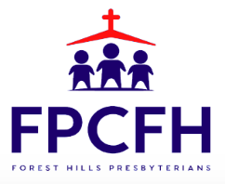

Building a Community of Faith, Hope, and Love
PresbyFH.org

