August 9, 2026 11th Sunday after Pentecost 11 AM

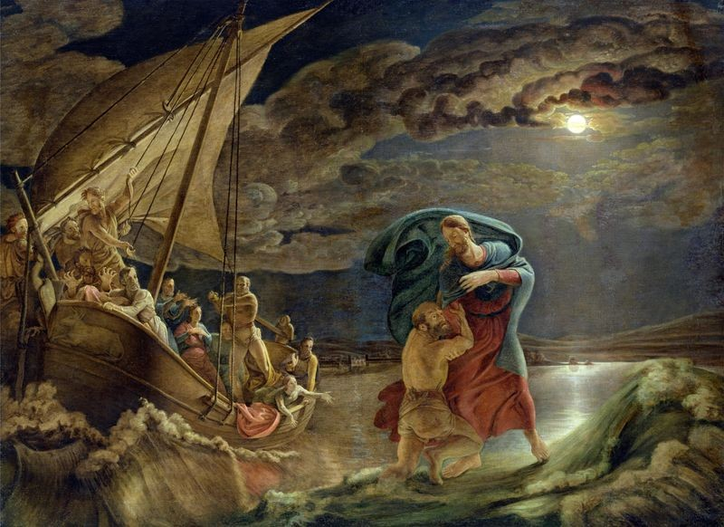
Runge, Philipp Otto, 1777-1810. Christ Walking on the Water, (1806-1807)
from Art in the Christian Tradition, a project of the Vanderbilt University Divinity Library, Nashville, TN.

PRELUDE

WELCOME

CALL TO WORSHIP

HYMN #410 “God Is Calling”

- God is calling through the whisper of the Spirit’s deepest sighs,
through the thrill of sudden beauties that can catch us by surprise.
Flash of lightning, crash of thunder; hush of stillness, rush of wonder:
God is calling – can you hear? God is calling – can you hear?

- God is calling through the voices of our neighbors’ urgent prayers,
through their longing for redemption and for rescue from despair.
Place of hurt or face of needing; strident cry or silent pleading:
God is calling – can you hear? God is calling – can you hear?

- God is calling through the music of sublime and human arts,
through the hymns of earth and angels, and the carols of our hearts.
Lift of joy and gift of singing; days and nights our praises bringing:
God is calling – and we hear! God is calling – and we hear!

CALL TO CONFESSION

PRAYER OF CONFESSION

ASSURANCE OF GOD’S LOVE

RESPONSE: HYMN #582 “Glory to God”
1 Glory to God, whose goodness shines on me,
and to the Son, whose grace has pardoned me,
and to the Spirit, whose love has set me free.
As it was in the beginning, is now and ever shall be. Amen.

2 World without end, without end. Amen.
World without end, without end. Amen
World without end, without end. Amen.
As it was in the beginning, is now and ever shall be. Amen.

PEACE
Let there be peace on earth.
And let it begin with me.
The peace of Christ be with you.
And also with you.

RESPONSIVE READING Psalm 85:8-13 (NRSVUE)
Let me hear what God the Lord will speak, for he will speak peace to his people,
to his faithful, to those who turn to him in their hearts.
Surely his salvation is at hand for those who fear him,
that his glory may dwell in our land.
Steadfast love and faithfulness will meet;
righteousness and peace will kiss each other.
Faithfulness will spring up from the ground,
and righteousness will look down from the sky.
The Lord will give what is good,
and our land will yield its increase.
Righteousness will go before him
and will make a path for his steps.

FIRST READING 1 Kings 19:9-18 (NRSVUE)
⁹ At that place he came to a cave and spent the night there.
Then the word of the Lord came to him, saying, “What are you doing here, Elijah?” ¹⁰ He answered, “I have been very zealous for the Lord, the God of hosts, for the Israelites have forsaken your covenant, thrown down your altars, and killed your prophets with the sword. I alone am left, and they are seeking my life, to take it away.”

11 He said, “Go out and stand on the mountain before the Lord, for the Lord is about to pass by.” Now there was a great wind, so strong that it was splitting mountains and breaking rocks in pieces before the Lord, but the Lord was not in the wind, and after the wind an earthquake, but the Lord was not in the earthquake, ¹² and after the earthquake a fire, but the Lord was not in the fire, and after the fire a sound of sheer silence. ¹³ When Elijah heard it, he wrapped his face in his mantle and went out and stood at the entrance of the cave. Then there came a voice to him that said, “What are you doing here, Elijah?” ¹⁴ He answered, “I have been very zealous for the Lord, the God of hosts, for the Israelites have forsaken your covenant, thrown down your altars, and killed your prophets with the sword. I alone am left, and they are seeking my life, to take it away.” ¹⁵ Then the Lord said to him, “Go, return on your way to the wilderness of Damascus; when you arrive, you shall anoint Hazael as king over Aram. ¹⁶ Also you shall anoint Jehu son of Nimshi as king over Israel, and you shall anoint Elisha son of Shaphat of Abel-meholah as prophet in your place. ¹⁷ Whoever escapes from the sword of Hazael, Jehu shall kill, and whoever escapes from the sword of Jehu, Elisha shall kill. ¹⁸ Yet I will leave seven thousand in Israel, all the knees that have not bowed to Baal, and every mouth that has not kissed him.”

CHILDREN’S SERMON

SECOND READING Matthew 14:22-33 (NRSVUE)
²² Immediately he made the disciples get into a boat and go on ahead to the other side, while he dismissed the crowds. ²³ And after he had dismissed the crowds, he went up the mountain by himself to pray. When evening came, he was there alone, ²⁴ but by this time the boat, battered by the waves, was far from the land, for the wind was against them. ²⁵ And early in the morning he came walking toward them on the sea. ²⁶ But when the disciples saw him walking on the sea, they were terrified, saying, “It is a ghost!” And they cried out in fear. ²⁷ But immediately Jesus spoke to them and said, “Take heart, it is I; do not be afraid.”

²⁸ Peter answered him, “Lord, if it is you, command me to come to you on the water.” ²⁹ He said, “Come.” So Peter got out of the boat, started walking on the water, and came toward Jesus. ³⁰ But when he noticed the strong wind, he became frightened, and, beginning to sink, he cried out, “Lord, save me!” ³¹ Jesus immediately reached out his hand and caught him, saying to him, “You of little faith, why did you doubt?” ³² When they got into the boat, the wind ceased. ³³ And those in the boat worshiped him, saying, “Truly you are the Son of God.”

SERMON “Walking by Faith” Jeff Courter

HYMN #656 (Sing 3 times) “We’ve Come This Far by Faith”

We've come this far by faith, leaning on the Lord,
trusting in the holy word; God’s never failed us yet.
O, can't turn around, we've come this far by faith. We've come this far by faith.

PROFESSION OF FAITH THE NICENE CREED
We believe in one God, the Father, the Almighty, maker of heaven and earth, of all that is, seen and unseen. We believe in one Lord, Jesus Christ, the only Son of God, eternally begotten of the Father, God from God, Light from Light, true God from true God, begotten, not made, of one Being with the Father; through him all things were made. For us and for our salvation he came down from heaven, was incarnate of the Holy Spirit and the Virgin Mary and became truly human. For our sake he was crucified under Pontius Pilate; he suffered death and was buried. On the third day he rose again in accordance with the Scriptures; he ascended into heaven and is seated at the right hand of the Father. He will come again in glory to judge the living and the dead, and his kingdom will have no end. We believe in the Holy Spirit, the Lord, the giver of life, who proceeds from the Father and the Son, who with the Father and the Son is worshiped and glorified, who has spoken through the prophets. We believe in one holy catholic and apostolic Church. We acknowledge one baptism for the forgiveness of sins. We look for the resurrection of the dead, and the life of the world to come. Amen.

PRAYERS OF THE PEOPLE

OFFERING/OFFERTORY

OFFERING SONG #328 “Praise God, All You Nations” (DaNase)
Praise God, all you nations. People of God, sing praise!
Praise God, all you nations. People of God, sing praise:
God’s love is great and endures forever.
Praise God, all you nations. People of God, sing praise!

PRAYER OF DEDICATION

PRAYER OF GREAT THANKSGIVING (SACRAMENT OF COMMUNION)
Friends, this is the joyful feast of the people of God!
People will come from east and west, and from north and south, to sit at table in the kingdom of God. This is the Lord’s table. Our Savior invites those who trust him to share the feast he has prepared.

The Lord be with you.
And also with you.
Lift up your hearts.
We lift them to the Lord.
Let us give thanks to the Lord, our God.
It is right to give our thanks and praise.

It is truly right and our greatest joy to to give you thanks and praise, eternal God, our Creator. You formed the universe in your wisdom and created all things by your power. You made us in your image to love and serve you, but we turned from you and abandoned your ways. Yet you did not reject us. You claimed us as your people and sent prophets to call us back to your way.

Therefore, we praise you, joining our voices with choirs of angels, with prophets, apostles, and martyrs, and with all the faithful of every time and place, who forever sing to the glory of your name:

Holy, holy, holy Lord, God of power and might. Heaven and earth are
full of your glory. Hosanna in the highest! Blessed is he who comes in
the name of the Lord. Hosanna in the highest!

You are holy, O God of majesty, and blessed is Jesus Christ, your Son, our Lord.
Born of Mary, he came to dwell among us, full of grace and truth.
He forgave our failures, healed our hurts, and gave himself in utter sacrifice for those he loved. By his death on the cross, he overcame death. Rising from the tomb, he gave us everlasting life.

With thanksgiving, we take this bread and this cup and proclaim the mystery of faith:
Christ has died, Christ is risen, Christ will come again.

Gracious God, pour out your Holy Spirit on us, and upon these your gifts of bread and wine, that the bread we break and the cup we bless may be the communion of the body and blood of Christ. By your Spirit, make us one with Christ and with all who share this feast, united in ministry in every place.
As this bread is Christ’s body for us, send us out to be the body of Christ in the world.
Through Christ, in Christ, and with Christ, in the unity of the Holy Spirit,
all glory and honor belong to you, almighty God, now and forever.

THE LORD’S PRAYER

ANNOUNCEMENTS

CLOSING HYMN #519 (Sing twice) “You Are My All in All”

You are my strength when I am weak; You are the treasure that I seek;
You are my all in all.
When I fall down, You pick me up; When I am dry, You fill my cup;
You are my all in all.

Jesus, Lamb of God, worthy is Your name!
Jesus, Lamb of God, worthy is Your name!
BENEDICTION

POSTLUDE
___________________________________________________________________
UPCOMING CALENDAR

WEDNESDAY, 7:00 PM - Book Discussion Group on the book The Cost of Discipleship by Dietrich Bonhoeffer. We will be on the church Zoom at 7:00 PM.

REMINDER – Please keep in mind that worship is now at 10:00 AM for the Summer months ending last Sunday of August.

REMINDER: We are still looking for volunteers for worship readers and/or juice/coffee hour. There is a 3-month sign-up sheet posted just outside the office.
If you have any questions, please contact the Office.
First Presbyterian Church of Forest Hills
70-35 112th St., Forest Hills, NY 11375 presbyfh.org
David Barnett, Admin.718-268-4036 Jeff Courter, Pastor,
FirstPresFHNY@gmail.com; rev.jeffrey.courter@gmail.com
Rafael Reyes-Quiroz, Clerk of Session

Please note: we now have a public WiFi for the church, though it may only be available in the church hall for now.
Name: CHURCH GUEST
Password: welcome1

For offerings/donations:

- Use Zelle to make Online donations from your bank account. Use this phone number to transfer to the church:
929-418-0958 (please note: this is a new number)
- Make checks payable to First Presbyterian Church of Forest Hills and mail check to the church office
- Go to our church website: presbyfh.org and click on the “Give Now” icon to set up a donation; or click on the QR code above
- The web address of your donation form has now been changed to: https://secure.myvanco.com/L-ZBFD
- Set up a “Bill pay” from your bank.

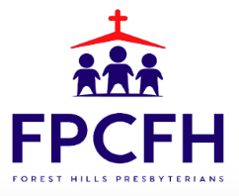

Building a Community of Faith, Hope, and Love
PresbyFH.org

