May 3, 2026 5th Sunday of Easter 11 AM

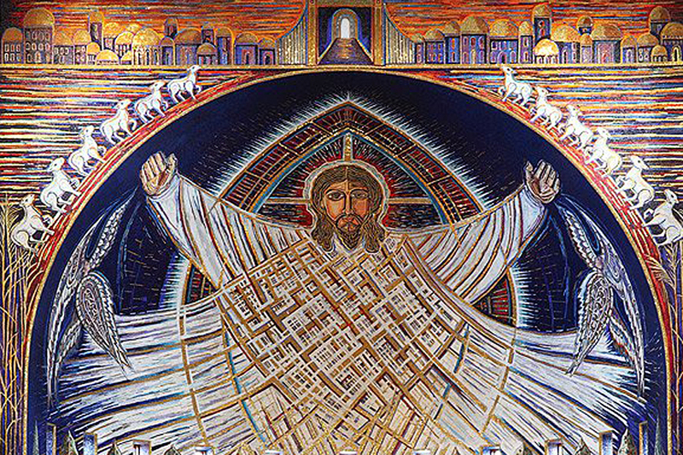
McLean, Helen, Christ in Glory, (2000-2010)
from Art in the Christian Tradition, a project of the Vanderbilt Divinity Library, Nashville, TN.

PRELUDE Fantasie and Fuge in C minor Carl Philipp Emanuel Bach

WELCOME

CALL TO WORSHIP

HYMN #311 “Here, O Lord, Your Servants Gather”

- Here, O Lord, your servants gather, hand we link with hand;
looking toward our Savior’s cross, joined in love we stand.
As we seek the realm of God, we unite to pray:
Jesus, Savior, guide our steps, for you are the Way.

- Many are the tongues we speak, scattered are the lands,
Yet our hearts are one in God, one in love’s demands.
While in darkness hope appears, calling age and youth:
Jesus, teacher, dwell with us, for You are the Truth.

- Nature’s secrets open wide, changes never cease;
where, O where, can weary souls find the source of peace?
Unto all those sore distressed, torn by endless strife:
Jesus, healer, bring your balm, For You are the Life.

- Grant, O God, an age renewed, filled with deathless love;
help us as we work and pray; send us from above
Truth and courage, faith and power needed in our strife:
Jesus, Savior, be our Way, Be our Truth, our Life.

CALL TO CONFESSION

PRAYER OF CONFESSION

ASSURANCE OF GOD’S LOVE

RESPONSE: HYMN #581 “Gloria Patri”
Glory be the Father, and to the Son and to the Holy Ghost,
As it was in the beginning, is now, and ever shall be,
World without end. Amen. Amen.

PEACE
Let there be peace on earth.
And let it begin with me.
The peace of Christ be with you.
And also with you.
RESPONSIVE READING Psalm 119:9-32 (NRSVUE)
How can young people keep their way pure?
By guarding it according to your word.
With my whole heart I seek you;
do not let me stray from your commandments.
I treasure your word in my heart, so that I may not sin against you.
Blessed are you, O Lord; teach me your statutes.
With my lips I declare all the ordinances of your mouth.
I delight in the way of your decrees as much as in all riches.
I will meditate on your precepts and fix my eyes on your ways.
I will delight in your statutes; I will not forget your word.
Deal bountifully with your servant, so that I may live and observe your word.
Open my eyes, so that I may behold wondrous things out of your law.
I live as an alien in the land; do not hide your commandments from me.
My soul is consumed with longing for your ordinances at all times.
You rebuke the insolent, accursed ones, who wander from your commandments;
take away from me their scorn and contempt, for I have kept your decrees.
Even though princes sit plotting against me,
your servant will meditate on your statutes.
Your decrees are my delight; they are my counselors.
My soul clings to the dust; revive me according to your word.
When I told of my ways, you answered me; teach me your statutes.
Make me understand the way of your precepts,
and I will meditate on your wondrous works.
My soul melts away for sorrow; strengthen me according to your word.
Put false ways far from me, and graciously teach me your law.
I have chosen the way of faithfulness; I set your ordinances before me.
I cling to your decrees, O Lord; let me not be put to shame.
I run the way of your commandments, for you enlarge my understanding.

FIRST READING Proverbs 4:10-18 (NRSVUE)
¹⁰ Hear, my child, and accept my words, that the years of your life may be many.
¹¹ I have taught you the way of wisdom; I have led you in the paths of uprightness.
¹² When you walk, your step will not be hampered, and if you run, you will not stumble. ¹³ Keep hold of instruction; do not let go; guard her, for she is your life.
¹⁴ Do not enter the path of the wicked, and do not walk in the way of evildoers.
¹⁵ Avoid it; do not go on it; turn away from it and pass on. ¹⁶ For they cannot sleep unless they have done wrong; they are robbed of sleep unless they have made someone stumble. ¹⁷ For they eat the bread of wickedness and drink the wine of violence. ¹⁸ But the path of the righteous is like the light of dawn, which shines brighter and brighter until full day.

CHILDREN’S SERMON

SECOND READING John 14:1-14 (NRSVUE)
¹ “Do not let your hearts be troubled. Believe in God; believe also in me. ² In my Father’s house there are many dwelling places. If it were not so, would I have told you that I go to prepare a place for you? ³ And if I go and prepare a place for you, I will come again and will take you to myself, so that where I am, there you may be also. ⁴ And you know the way to the place where I am going.” ⁵ Thomas said to him, “Lord, we do not know where you are going. How can we know the way?” ⁶ Jesus said to him, “I am the way and the truth and the life. No one comes to the Father except through me. ⁷ If you know me, you will know my Father also. From now on you do know him and have seen him.”

⁸ Philip said to him, “Lord, show us the Father, and we will be satisfied.” ⁹ Jesus said to him, “Have I been with you all this time, Philip, and you still do not know me? Whoever has seen me has seen the Father. How can you say, ‘Show us the Father’? ¹⁰ Do you not believe that I am in the Father and the Father is in me? The words that I say to you I do not speak on my own, but the Father who dwells in me does his works. ¹¹ Believe me that I am in the Father and the Father is in me, but if you do not, then believe because of the works themselves. ¹² Very truly, I tell you, the one who believes in me will also do the works that I do and, in fact, will do greater works than these, because I am going to the Father. ¹³ I will do whatever you ask in my name, so that the Father may be glorified in the Son. ¹⁴ If in my name you ask me for anything, I will do it.

GUEST SPEAKER Irene Stolarz
HYMN #494 (vv. 1,2,3) “Jesus, Thou Joy of Loving Hearts”

1 Jesus, thou joy of loving hearts, thou fount of life, thou light of all,
from the best bliss that earth imparts we turn, unfilled, to heed thy call.

2 Thy truth unchanged hath ever stood; thou savest those that on thee call;
to them that seek thee thou art good, to them that find thee, all in all.

3 We taste thee, O thou living bread, and long to feast upon thee still;
we drink of thee, the fountainhead, and thirst our souls from thee to fill.

PROFESSION OF FAITH THE NICENE CREED
We believe in one God, the Father, the Almighty, maker of heaven and earth, of all that is, seen and unseen. We believe in one Lord, Jesus Christ, the only Son of God, eternally begotten of the Father, God from God, Light from Light, true God from true God, begotten, not made, of one Being with the Father; through him all things were made. For us and for our salvation he came down from heaven, was incarnate of the Holy Spirit and the Virgin Mary and became truly human. For our sake he was crucified under Pontius Pilate; he suffered death and was buried. On the third day he rose again in accordance with the Scriptures; he ascended into heaven and is seated at the right hand of the Father. He will come again in glory to judge the living and the dead, and his kingdom will have no end. We believe in the Holy Spirit, the Lord, the giver of life, who proceeds from the Father and the Son, who with the Father and the Son is worshiped and glorified, who has spoken through the prophets. We believe in one holy catholic and apostolic Church. We acknowledge one baptism for the forgiveness of sins. We look for the resurrection of the dead, and the life of the world to come. Amen.

PRAYERS OF THE PEOPLE

OFFERING/OFFERTORY Devotional Meditation Gustav Merkel

OFFERING SONG #606 Doxology
Praise God, from whom all blessings flow,
Praise God, all creatures here below,
Praise God above, ye heavenly host,
Praise Father, Son and Holy Ghost. Amen.

PRAYER OF DEDICATION/

PRAYER OF GREAT THANKSGIVING (SACRAMENT OF COMMUNION)
Friends, this is the joyful feast of the people of God!
People will come from east and west, and from north and south, to sit at table in the kingdom of God. This is the Lord’s table. Our Savior invites those who trust him to share the feast he has prepared.

The Lord be with you.
And also with you.
Lift up your hearts.
We lift them to the Lord.
Let us give thanks to the Lord, our God.
It is right to give our thanks and praise.

It is truly right and our greatest joy to to give you thanks and praise, eternal God, our Creator. You formed the universe in your wisdom and created all things by your power. You made us in your image to love and serve you, but we turned from you and abandoned your ways. Yet you did not reject us. You claimed us as your people and sent prophets to call us back to your way.

Therefore, we praise you, joining our voices with choirs of angels, with prophets, apostles, and martyrs, and with all the faithful of every time and place, who forever sing to the glory of your name:

Holy, holy, holy Lord, God of power and might. Heaven and earth are
full of your glory. Hosanna in the highest! Blessed is he who comes in
the name of the Lord. Hosanna in the highest!

You are holy, O God of majesty, and blessed is Jesus Christ, your Son, our Lord.
Born of Mary, he came to dwell among us, full of grace and truth.
He forgave our failures, healed our hurts, and gave himself in utter sacrifice for those he loved. By his death on the cross, he overcame death. Rising from the tomb, he gave us everlasting life.

With thanksgiving, we take this bread and this cup and proclaim the mystery of faith:
Christ has died, Christ is risen, Christ will come again.

Gracious God, pour out your Holy Spirit on us, and upon these your gifts of bread and wine, that the bread we break and the cup we bless may be the communion of the body and blood of Christ. By your Spirit, make us one with Christ and with all who share this feast, united in ministry in every place.
As this bread is Christ’s body for us, send us out to be the body of Christ in the world.
Through Christ, in Christ, and with Christ, in the unity of the Holy Spirit,
all glory and honor belong to you, almighty God, now and forever.

THE LORD’S PRAYER

COMMUNION OF THE PEOPLE “O Ye People”: Is it nothing to you, all you who pass by? Look around and see. Is any suffering like my suffering that was inflicted on me, that the Lord brought on me in the day of his fierce anger? O ye people, is it nothing to you all you who pass by?
(Lamentations 1:12) Pablo Casals

ANNOUNCEMENTS

CLOSING HYMN #725 “O Jesus, I Have Promised”

1 O Jesus, I have promised to serve you to the end;
be now and always near me, my Master and my friend;
I shall not fear the battle if you are by my side,
nor wander from the pathway if you will be my guide.

2 O let me feel you near me! The world is ever near:
I see the sights that dazzle; the tempting sounds I hear.
My foes are ever near me, around me and within;
but, Jesus, draw still nearer and shield my soul from sin.

3 O let me hear you speaking in accents clear and still,
above the storms of passion, the murmurs of self-will;
O speak to reassure me, to hasten or control;
O speak, and make me listen, true guardian of my soul.

4 O Jesus, you have promised to all who follow you
that where you are in glory your servant shall be too.
And, Jesus, I have promised to serve you to the end;
now give me grace to follow, my Master and my friend.

BENEDICTION

POSTLUDE “Fugue in C Minor” C. Geissier
(op. 90, No. 13)

UPCOMING CALENDAR

TODAY, 2:00 PM – FOREST VIEW NURSING HOME – SONGFEST –
Please come join us to help celebrate Spring with the residents….we will practice after worship, then go to see them.

SUNDAY, ADULT BIBLE STUDY – 10:00 AM – We are studying the Bible book of Ephesians in case you would like to join us. There are only six chapters in the book, so that it will not take us long to finish. If you are interested, please see David in the office.

REMINDER: We are still looking for volunteers for worship readers and/or juice/coffee hour. There is a 3-month sign-up sheet posted just outside the office.
If you have any questions, please contact the Office.

First Presbyterian Church of Forest Hills
70-35 112th St., Forest Hills, NY 11375 presbyfh.org
David Barnett, Admin.718-268-4036 Jeff Courter, Pastor,
FirstPresFHNY@gmail.com; rev.jeffrey.courter@gmail.com
Nadina Grants, Clerk of Session Hannah Lin, Guest Organist

Please note: we now have a public WiFi for the church, though it may only be available in the church hall for now.
Name: CHURCH GUEST
Password: welcome1

For offerings/donations:

- Use Zelle to make Online donations from your bank account. Use this phone number to transfer to the church:
929-418-0958 (please note: this is a new number)
- Make checks payable to First Presbyterian Church of Forest Hills and mail check to the church office
- Go to our church website: presbyfh.org and click on the “Give Now” icon to set up a donation; or click on the qr code above
- The web address of your donation form has now been changed to: https://secure.myvanco.com/L-ZBFD
- Set up a “Bill pay” from your bank.

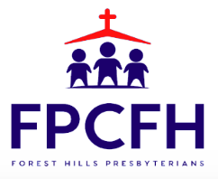

Building a Community of Faith, Hope, and Love
PresbyFH.org

