April 28, 2024 5th Sunday of Easter 11 AM

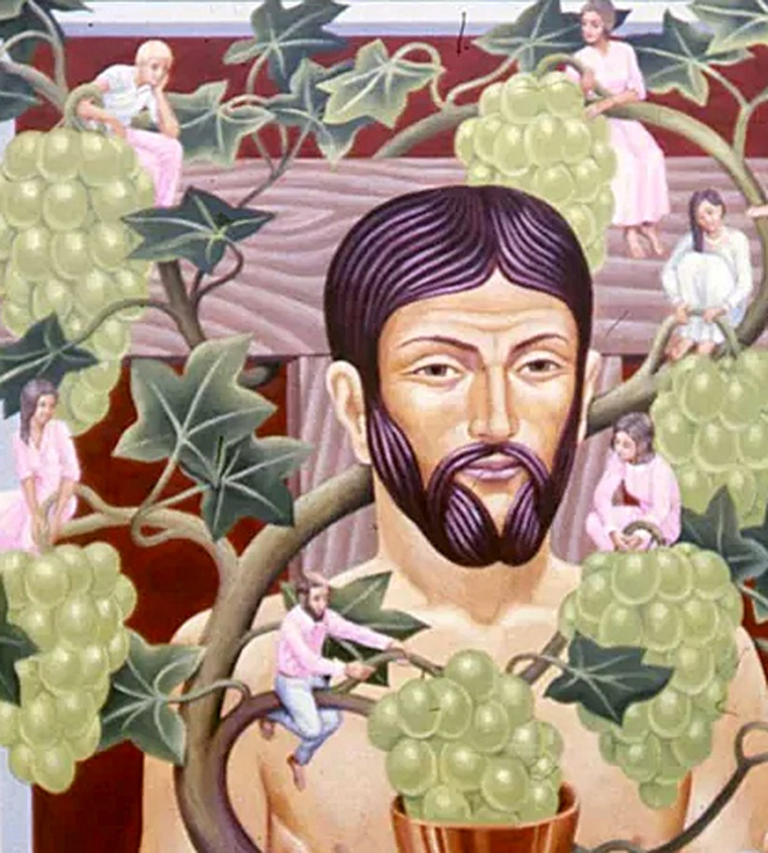
Koenig, Peter. Christ the Vine, 20th century
from Art in the Christian Tradition, a project of the Vanderbilt Divinity Library, Nashville, TN.

PRELUDE

WELCOME

CALL TO WORSHIP

HYMN #157 “I Danced in the Morning”

1 I danced in the morning when the world was begun,
and I danced in the moon and the stars and the sun,
and I came down from heaven and I danced on the earth.
At Bethlehem I had my birth.
Refrain: Dance, then, wherever you may be; I am the Lord of the Dance, said he,
and I'll lead you all, wherever you may be, and I'll lead you all in the dance, said he.

2 I danced for the scribe and the Pharisee,
but they would not dance and they would not follow me.
I danced for the fishermen, for James and John.
They came with me and the dance went on. [Refrain]

3 I danced on the Sabbath and I cured the lame.
The holy people said it was a shame.
They whipped and they stripped and they hung me high,
and left me there on a cross to die. [Refrain]

4 I danced on a Friday when the sky turned black.
It's hard to dance with the devil on your back.
They buried my body and they thought I'd gone,
but I am the dance and I still go on. [Refrain]

5 They cut me down and I leapt up high.
I am the life that will never, never die.
I'll live in you if you'll live in me,
I am the Lord of the Dance, said he. [Refrain]

CALL TO CONFESSION

PRAYER OF CONFESSION

ASSURANCE OF GOD’S LOVE

RESPONSE: HYMN #582 “Glory to God”
1 Glory to God, whose goodness shines on me,
and to the Son, whose grace has pardoned me,
and to the Spirit, whose love has set me free.
As it was in the beginning, is now and ever shall be. Amen.
2 World without end, without end. Amen.
World without end, without end. Amen
World without end, without end. Amen.
As it was in the beginning, is now and ever shall be. Amen.

PEACE
Let there be peace on earth.
And let it begin with me.
The peace of Christ be with you.
And also with you.

RESPONSIVE READING Psalm 118:19-25 (NRSVUE)
Open to me the gates of righteousness,
that I may enter through them and give thanks to the Lord.
This is the gate of the Lord; the righteous shall enter through it.
I thank you that you have answered me and have become my salvation.
The stone that the builders rejected has become the chief cornerstone.
This is the Lord’s doing; it is marvelous in our eyes.
This is the day that the Lord has made; let us rejoice and be glad in it.
Save us, we beseech you, O Lord! O Lord, we beseech you, give us success!

FIRST READING 1 John 4:7-21 (NRSVUE)
⁷ Beloved, let us love one another, because love is from God; everyone who loves is born of God and knows God. ⁸ Whoever does not love does not know God, for God is love. ⁹ God’s love was revealed among us in this way: God sent his only Son into the world so that we might live through him. ¹⁰ In this is love, not that we loved God but that he loved us and sent his Son to be the atoning sacrifice for our sins. ¹¹ Beloved, since God loved us so much, we also ought to love one another. ¹² No one has ever seen God; if we love one another, God abides in us, and his love is perfected in us.

¹³ By this we know that we abide in him and he in us, because he has given us of his Spirit. ¹⁴ And we have seen and do testify that the Father has sent his Son as the Savior of the world. ¹⁵ God abides in those who confess that Jesus is the Son of God, and they abide in God. ¹⁶ So we have known and believe the love that God has for us.

God is love, and those who abide in love abide in God, and God abides in them. ¹⁷ Love has been perfected among us in this: that we may have boldness on the day of judgment, because as he is, so are we in this world. ¹⁸ There is no fear in love, but perfect love casts out fear; for fear has to do with punishment, and whoever fears has not reached perfection in love. ¹⁹ We love because he first loved us. ²⁰ Those who say, “I love God,” and hate a brother or sister are liars, for those who do not love a brother or sister, whom they have seen, cannot love God, whom they have not seen. ²¹ The commandment we have from him is this: those who love God must love their brothers and sisters also.

SECOND READING John 15:1-8 (NRSVUE)
¹ “I am the true vine, and my Father is the vinegrower. ² He removes every branch in me that bears no fruit. Every branch that bears fruit he prunes to make it bear more fruit. ³ You have already been cleansed by the word that I have spoken to you. ⁴ Abide in me as I abide in you. Just as the branch cannot bear fruit by itself unless it abides in the vine, neither can you unless you abide in me. ⁵ I am the vine; you are the branches. Those who abide in me and I in them bear much fruit, because apart from me you can do nothing. ⁶ Whoever does not abide in me is thrown away like a branch and withers; such branches are gathered, thrown into the fire, and burned. ⁷ If you abide in me and my words abide in you, ask for whatever you wish, and it will be done for you. ⁸ My Father is glorified by this, that you bear much fruit and become my disciples.

SERMON “The Spiritual Fruit of Love” Rev. Jeff Courter

HYMN #301 “ All Are Welcome”

- Let us build a house where love can dwell and all can safely live, A place where saints and children tell how hearts learn to forgive. Built of hopes and dreams and visions, rock of faith and vault of grace; here the love of Christ shall end divisions: All are welcome, all are welcome, all are welcome in this place.

- Let us build a house where prophets speak, and words are strong and true, where all God’s children dare to seek to dream God’s reign anew. Here the cross shall stand as witness and as symbol of God’s grace; here as one we claim the faith of Jesus: All are welcome, all are welcome, all are welcome in this place.

- Let us build a house where love is found in water, wine and wheat; a banquet
hall on holy ground, where peace and justice meet. Here the love of God,
through Jesus, is revealed in time and space; as we share in Christ the feast
that frees us: All are welcome, all are welcome, all are welcome in this place.

- Let us build a house where hands will reach beyond the wood and stone to heal
and strengthen, serve and teach, and live the Word they’ve known. Here the outcast and the stranger bear the image of God’s face; let us bring an end to fear and danger: All are welcome, all are welcome, all are welcome in this place.

- Let us build a house where all are named, their songs and visions heard and
loved and treasured, taught and claimed as words within the Word. Built of tears and cries and laughter, prayers of faith and songs of grace; let this house proclaim from floor to rafter: All are welcome, all are welcome, all are welcome in this place.

PROFESSION OF FAITH THE APOSTLES CREED
I Believe in God the Father Almighty, Maker of heaven and earth; and in Jesus Christ, His Only Son, our Lord, who was conceived by the Holy Spirit, born of the Virgin Mary, suffered under Pontius Pilate, was crucified, dead, and buried. He descended into hell; the third day He rose again from the dead. He ascended into heaven, and sitteth at the right hand of God the Father Almighty, from thence He shall come to judge the quick and the dead.
I believe in the Holy Spirit, the holy catholic church, the communion of saints, the forgiveness of sins, the resurrection of the body, and the life everlasting. Amen.

PRAYERS OF THE PEOPLE

OFFERING/OFFERTORY

OFFERING SONG #328 “Praise God, All You Nations” (DaNase)
Praise God, all you nations. People of God, sing praise!
Praise God, all you nations. People of God, sing praise:
God’s love is great and endures forever.
Praise God, all you nations. People of God, sing praise!

PRAYER OF DEDICATION/THE LORD’S PRAYER

ANNOUNCEMENTS

CLOSING HYMN #300 “They’ll Know We Are Christians By Our Love”

- We are one in the Spirit, we are one in the Lord,
We are one in the Spirit, we are one in the Lord,
And we pray that all unity may one day be restored:
Refrain: And they'll know we are Christians by our love, by our love,
Yes, they'll know we are Christians by our love.

- We will walk with each other, we will walk hand in hand,
We will walk with each other, we will walk hand in hand,
And together we'll spread the news that God is in our land: [Refrain]

- We will work with each other, we will work side by side,
We will work with each other, we will work side by side,
And we'll guard each man's dignity and save each man's pride: [Refrain]

- All praise to the Father, from whom all things come,
And all praise to Christ Jesus, God’s only Son,
And all praise to the Spirit, who makes us one: [Refrain]

BENEDICTION

POSTLUDE
_________________________________________________________________________________________________________

UPCOMING CALENDAR

TODAY, 1:00 PM – Romantic Spirits: works for clarinet & piano, featuring Medina and Margrit Zimmermann. Please join us!

MONDAY, 7:00 PM – Meditation & Prayer Group in the church sanctuary. No Zoom.

SUNDAY, 10:00 AM – Bible Study in Room 7. We are studying the book of James, and will finish by end May.

REMINDER: We are still looking for volunteers for worship readers and/or juice/coffee hour. There is a 3-month sign-up sheet posted just outside the office, and we would appreciate your help as we have been transitioning back to in-worship service. If you have any questions, please contact the Office.

The flowers today are given in loving memory of Jeanette DiIorio from her good friend, Marilyn Haas. Tomorrow is the one year anniversary of her passing.
First Presbyterian Church of Forest Hills
70-35 112th St., Forest Hills, NY 11375 presbyfh.org
David Barnett, Admin.718-268-4036 Jeff Courter, Pastor,
FirstPresFHNY@gmail.com; rev.jeffrey.courter@gmail.com
‘Cil Brewer, Clerk of Session

For offerings/donations:
- Use Zelle to make Online donations from your bank account. Use this phone number to transfer to the church: 929-418-0958 (please note: this is a new number)
- Make checks payable to First Presbyterian Church of Forest Hills and mail check to the church office
- Go to our church website: presbyfh.org and click on the “Give Now” icon to set up a donation; or click on the qr code above
- Set up a “Bill pay” from your bank

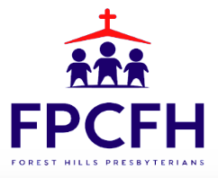

Building a Community of Faith, Hope, and Love

