April 21, 2024 4th Sunday of Easter 11 AM 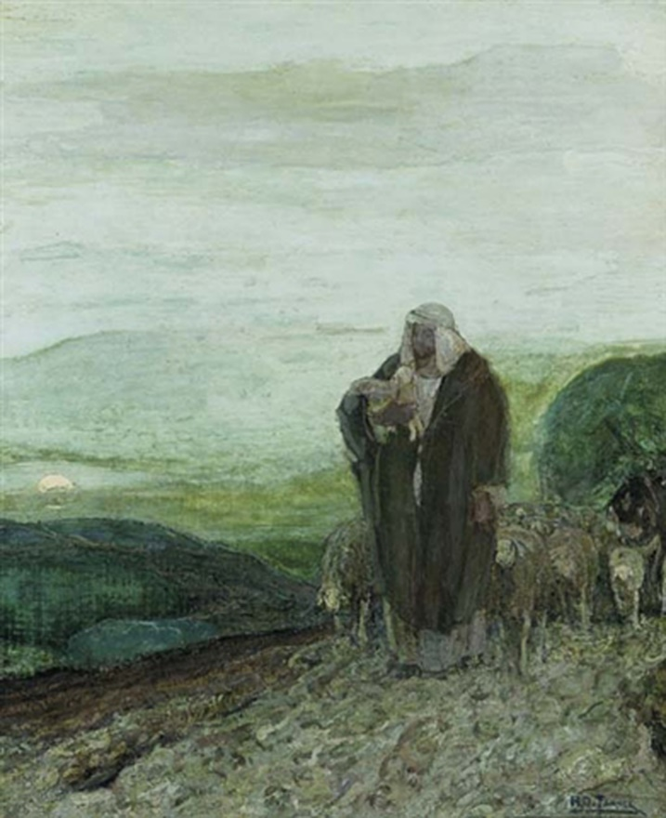
Tanner, Henry Ossawa, 1859-1937. Good Shepherd,
from Art in the Christian Tradition, a project of the Vanderbilt Divinity Library, Nashville, TN.

PRELUDE

WELCOME

CALL TO WORSHIP
Give ear, O Shepherd of Israel, you who lead Joseph like a flock!
You who are enthroned upon the cherubim, shine forth before Ephraim and Benjamin and Manasseh. Stir up your might, and come to save us!

HYMN #240 (vv.1,2) “Alleluia, Alleluia! Give Thanks”

Refrain: Alleluia, Alleluia, give thanks to the risen Lord,
Alleluia, alleluia, give praise to His name.

- Jesus is Lord of all the earth. He is the King of creation. [Refrain]

- Spread the good news o’er all the earth.
Jesus has died and has risen. [Refrain]

CALL TO CONFESSION
God’s love has been poured into our hearts
through the gift of the Holy Spirit.
The proof of God’s amazing love is this:
While we were sinners Christ died for us.
Because we have faith in him, we dare to approach God in confidence.
Confident in God’s grace, let us confess our sin before God and one another.

PRAYER OF CONFESSION
Merciful God,
we confess that we have sinned against you in thought, word, and deed,
by what we have done, and by what we have left undone.
We have not loved you with our whole heart and soul and mind and strength.
We have not loved our neighbors as ourselves.
In your mercy, forgive what we have been, help us amend what we are,
and direct what we shall be, so that we may delight in your will
and walk in your ways, to the glory of your holy name.

ASSURANCE OF GOD’S LOVE
Hear the good news!
Christ died for us, Christ rose for us,
Christ reigns in power for us, Christ prays for us.
Anyone who is in Christ is a new creation.
The old life has gone; a new life has begun.
Believe the good news of the gospel:
In Jesus Christ you are forgiven.
RESPONSE: HYMN #582 “Glory to God”
1 Glory to God, whose goodness shines on me,
and to the Son, whose grace has pardoned me,
and to the Spirit, whose love has set me free.
As it was in the beginning, is now and ever shall be. Amen.
2 World without end, without end. Amen.
World without end, without end. Amen
World without end, without end. Amen.
As it was in the beginning, is now and ever shall be. Amen.

PEACE
Let there be peace on earth.
And let it begin with me.
The peace of Christ be with you.
And also with you.

FIRST READING Acts 4:5-12 (NRSVUE)
⁵ The next day their rulers, elders, and scribes assembled in Jerusalem, ⁶ with Annas the high priest, Caiaphas, John, and Alexander, and all who were of the high-priestly family. ⁷ When they had made the prisoners stand in their midst, they inquired, “By what power or by what name did you do this?” ⁸ Then Peter, filled with the Holy Spirit, said to them, “Rulers of the people and elders, ⁹ if we are being questioned today because of a good deed done to someone who was sick and are being asked how this man has been healed, ¹⁰ let it be known to all of you, and to all the people of Israel, that this man is standing before you in good health by the name of Jesus Christ of Nazareth, whom you crucified, whom God raised from the dead. ¹¹ This Jesus is
‘the stone that was rejected by you, the builders
it has become the cornerstone.’
¹² “There is salvation in no one else, for there is no other name under heaven given among mortals by which we must be saved.”

SECOND READING Mark 4:1-9 (NRSVUE)
1 Again he began to teach beside the sea. Such a very large crowd gathered around him that he got into a boat on the sea and sat there, while the whole crowd was beside the sea on the land. 2 He began to teach them many things in parables, and in his teaching he said to them: 3 “Listen! A sower went out to sow. 4 And as he sowed, some seed fell on a path, and the birds came and ate it up. 5 Other seed fell on rocky ground, where it did not have much soil, and it sprang up quickly, since it had no depth of soil. 6 And when the sun rose, it was scorched, and since it had no root it withered away. 7 Other seed fell among thorns, and the thorns grew up and choked it, and it yielded no grain. 8 Other seed fell into good soil and brought forth grain, growing up and increasing and yielding thirty and sixty and a hundredfold.” 9 And he said, “If you have ears to hear, then hear!”

SERMON “Four Successes from Three Failures” Rev. Won Tae Cho

PROFESSION OF FAITH THE APOSTLES CREED
I Believe in God the Father Almighty, Maker of heaven and earth; and in Jesus Christ, His Only Son, our Lord, who was conceived by the Holy Spirit, born of the Virgin Mary, suffered under Pontius Pilate, was crucified, dead, and buried. He descended into hell; the third day He rose again from the dead. He ascended into heaven, and sitteth at the right hand of God the Father Almighty, from thence He shall come to judge the quick and the dead.
I believe in the Holy Spirit, the holy catholic church, the communion of saints, the forgiveness of sins, the resurrection of the body, and the life everlasting. Amen.

PRAYERS OF THE PEOPLE

OFFERING/OFFERTORY

OFFERING SONG #328 “Praise God, All You Nations” (DaNase)
Praise God, all you nations. People of God, sing praise!
Praise God, all you nations. People of God, sing praise:
God’s love is great and endures forever.
Praise God, all you nations. People of God, sing praise!
PRAYER OF DEDICATION/THE LORD’S PRAYER

ANNOUNCEMENTS

CLOSING HYMN #765 “May the God of Hope Go with Us”
May the God of hope go with us every day,
filling all our lives with love and joy and peace.
May the God of justice speed us on our way,
bringing light and hope to every land and race.
Refrain:
Praying, let us work for peace;
singing, share our joy with all;
working for a world that's new,
faithful when we hear Christ's call.

BENEDICTION

POSTLUDE
_________________________________________________________________________________________________________

UPCOMING CALENDAR

MONDAY, 7:00 PM – Meditation & Prayer Group in the church sanctuary. No Zoom.

SUNDAY, 10:00 AM – Bible Study in Room 7. We are studying the book of James, and will finish by end May.

SUNDAY, April 28th, 1:00 PM – Romantic Spirits: works for clarinet & piano, featuring Medina and Margrit Zimmermann. Please join us!

REMINDER: We are still looking for volunteers for worship readers and/or juice/coffee hour. There is a 3-month sign-up sheet posted just outside the office, and we would appreciate your help as we have been transitioning back to in-worship service. If you have any questions, please contact the Office.

First Presbyterian Church of Forest Hills
70-35 112th St., Forest Hills, NY 11375 presbyfh.org
David Barnett, Admin.718-268-4036 Jeff Courter, Pastor,
FirstPresFHNY@gmail.com; rev.jeffrey.courter@gmail.com
‘Cil Brewer, Clerk of Session

For offerings/donations:
- Use Zelle to make Online donations from your bank account. Use this phone number to transfer to the church: 929-418-0958 (please note: this is a new number)
- Make checks payable to First Presbyterian Church of Forest Hills and mail check to the church office
- Go to our church website: presbyfh.org and click on the “Give Now” icon to set up a donation; or click on the qr code above
- Set up a “Bill pay” from your bank

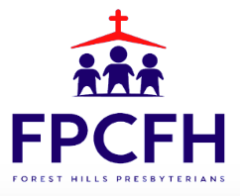

Building a Community of Faith, Hope, and Love

