April 26, 2026 4th Sunday of Easter 11 AM

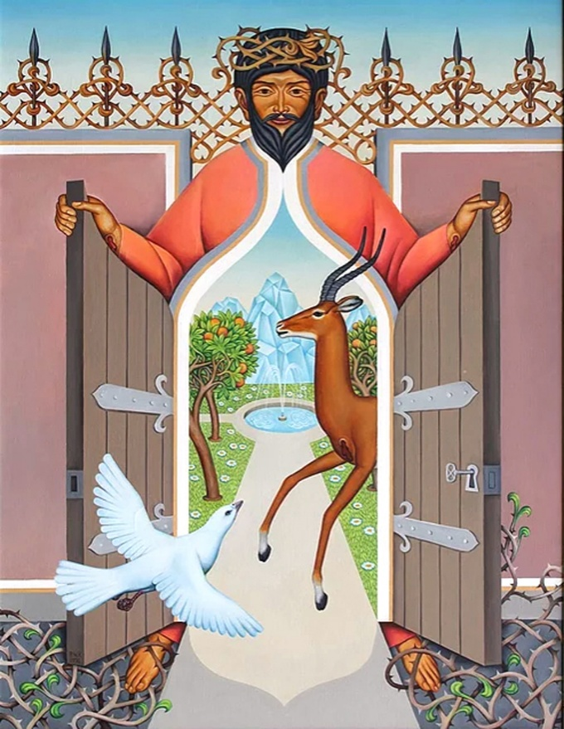
Koenig, Peter, I am the Gate, (20th century)
from Art in the Christian Tradition, a project of the Vanderbilt Divinity Library, Nashville, TN.

PRELUDE

WELCOME

CALL TO WORSHIP

HYMN #634 “To God Be the Glory”

1 To God be the glory; great things he has done!
So loved he the world that he gave us his Son,
who yielded his life an atonement for sin,
and opened the life-gate that all may go in.
Refrain:
Praise the Lord, praise the Lord; let the earth hear his voice!
Praise the Lord, praise the Lord; let the people rejoice!
O come to the Father through Jesus the Son,
and give him the glory: great things he has done!

2 Great things he has taught us; great things he has done,
and great our rejoicing through Jesus the Son;
but purer and higher and greater will be
our wonder, our transport, when Jesus we see. [Refrain]

CALL TO CONFESSION

PRAYER OF CONFESSION

ASSURANCE OF GOD’S LOVE

RESPONSE: HYMN #582 “Glory to God”
1 Glory to God, whose goodness shines on me,
and to the Son, whose grace has pardoned me,
and to the Spirit, whose love has set me free.
As it was in the beginning, is now and ever shall be. Amen.
2 World without end, without end. Amen.
World without end, without end. Amen
World without end, without end. Amen.
As it was in the beginning, is now and ever shall be. Amen.

PEACE
Let there be peace on earth.
And let it begin with me.
The peace of Christ be with you.
And also with you.

RESPONSIVE READING Psalm 100 (NRSVUE)
Make a joyful noise to the Lord, all the earth.
Serve the Lord with gladness; come into his presence with singing.
Know that the Lord is God. It is he who made us, and we are his;
we are his people and the sheep of his pasture.
Enter his gates with thanksgiving and his courts with praise.
Give thanks to him; bless his name.
For the Lord is good; his steadfast love endures forever
and his faithfulness to all generations.

FIRST READING 1 Peter 2:21-25 (NRSVUE)
²¹ For to this you have been called, because Christ also suffered for you, leaving you an example, so that you should follow in his steps.
²² “He committed no sin, and no deceit was found in his mouth.”
²³ When he was abused, he did not return abuse; when he suffered, he did not threaten, but he entrusted himself to the one who judges justly. ²⁴ He himself bore our sins in his body on the cross, so that, having died to sins, we might live for righteousness; by his wounds you have been healed. ²⁵ For you were going astray like sheep, but now you have returned to the shepherd and guardian of your souls.

CHILDREN’S SERMON

SECOND READING John 10:1-10 (NRSVUE)
¹ “Very truly, I tell you, anyone who does not enter the sheepfold by the gate but climbs in by another way is a thief and a bandit. ² The one who enters by the gate is the shepherd of the sheep. ³ The gatekeeper opens the gate for him, and the sheep hear his voice. He calls his own sheep by name and leads them out. ⁴ When he has brought out all his own, he goes ahead of them, and the sheep follow him because they know his voice. ⁵ They will not follow a stranger, but they will run from him because they do not know the voice of strangers.” ⁶ Jesus used this figure of speech with them, but they did not understand what he was saying to them.
⁷ So again Jesus said to them, “Very truly, I tell you, I am the gate for the sheep. ⁸ All who came before me are thieves and bandits, but the sheep did not listen to them. ⁹ I am the gate. Whoever enters by me will be saved and will come in and go out and find pasture. ¹⁰ The thief comes only to steal and kill and destroy. I came that they may have life and have it abundantly.

GUEST SPEAKER Chuck Park

HYMN #720 “Jesus Calls Us”

1 Jesus calls us: o'er the tumult of our life's wild, restless sea;
day by day his sweet voice soundeth saying, "Christian, follow me."

2 Jesus calls us from the worship of the vain world's golden store,
from each idol that would keep us, saying, "Christian, love me more."

3 In our joys and in our sorrows, days of toil and hours of ease,
still he calls, in cares and pleasures, "Christian, love me more than these."

4 Jesus calls us: by thy mercies, Savior, may we hear thy call,
give our hearts to thy obedience, serve and love thee best of all.

PROFESSION OF FAITH THE APOSTLES CREED
I Believe in God the Father Almighty, Maker of heaven and earth; and in Jesus Christ, His Only Son, our Lord, who was conceived by the Holy Spirit, born of the Virgin Mary, suffered under Pontius Pilate, was crucified, dead, and buried. He descended into hell; the third day He rose again from the dead. He ascended into heaven, and sitteth at the right hand of God the Father Almighty, from thence He shall come to judge the quick and the dead.
I believe in the Holy Spirit, the holy catholic church, the communion of saints,
the forgiveness of sins, the resurrection of the body, and the life everlasting.

PRAYERS OF THE PEOPLE

OFFERING/OFFERTORY
OFFERING SONG #328 “Praise God, All You Nations” (DaNase)
Praise God, all you nations. People of God, sing praise!
Praise God, all you nations. People of God, sing praise:
God’s love is great and endures forever.
Praise God, all you nations. People of God, sing praise!

PRAYER OF DEDICATION/THE LORD’S PRAYER

ANNOUNCEMENTS

HYMN #802 (vv. 1,4,6) “The King of Love My Shepherd Is”

1 The King of love my shepherd is, whose goodness faileth never;
I nothing lack if I am his and he is mine forever.

4 In death's dark vale I fear no ill with thee, dear Lord, beside me;
thy rod and staff my comfort still, thy cross before to guide me.

6 And so through all the length of days thy goodness faileth never;
Good Shepherd, may I sing thy praise within thy house forever.

BENEDICTION

POSTLUDE

UPCOMING CALENDAR

TODAY, 1:00 PM – Please come join us to help decorate and fill special treat bags for moms being helped by Safe Horizons. The bags will be distributed by Safe Horizons to their clients before Mother’s Day. (see flyer)

SUNDAY, ADULT BIBLE STUDY – 10:00 AM – We are studying the Bible book of Ephesians in case you would like to join us. There are only six chapters in the book, so that it will not take us long to finish. If you are interested, please see David in the office.

SUNDAY, MAY 3rd, 2:00 PM – FOREST VIEW NURSING HOME – SONGFEST –
Please come join us to help celebrate Spring with the residents….we will practice after worship, then go to see them.

REMINDER: We are still looking for volunteers for worship readers and/or juice/coffee hour. There is a 3-month sign-up sheet posted just outside the office.
If you have any questions, please contact the Office.

First Presbyterian Church of Forest Hills
70-35 112th St., Forest Hills, NY 11375 presbyfh.org
David Barnett, Admin.718-268-4036 Jeff Courter, Pastor,
FirstPresFHNY@gmail.com; rev.jeffrey.courter@gmail.com
Nadina Grants, Clerk of Session

Please note: we now have a public WiFi for the church, though it may only be available in the church hall for now.
Name: CHURCH GUEST
Password: welcome1

For offerings/donations:

- Use Zelle to make Online donations from your bank account. Use this phone number to transfer to the church:
929-418-0958 (please note: this is a new number)
- Make checks payable to First Presbyterian Church of Forest Hills and mail check to the church office
- Go to our church website: presbyfh.org and click on the “Give Now” icon to set up a donation; or click on the qr code above
- The web address of your donation form has now been changed to: https://secure.myvanco.com/L-ZBFD
- Set up a “Bill pay” from your bank.

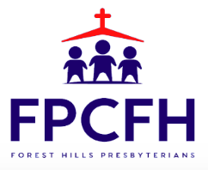

Building a Community of Faith, Hope, and Love
PresbyFH.org

