April 5, 2026 Resurrection of the Lord/Easter Day 11 AM

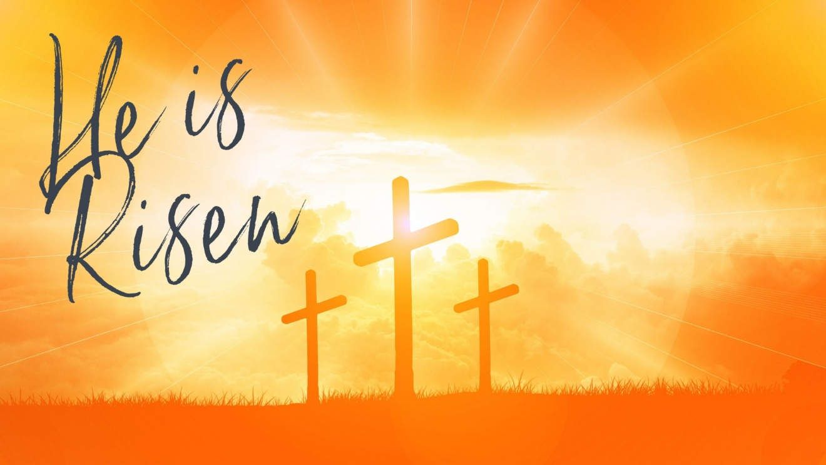
PublicDomainPictures.net

PRELUDE “The Trumpet Shall Sound: And the Dead Shall Be Raised G.F. Handel
Incorruptible. Death Is Swallowed Up in Victory.”
(from Messiah Oratorio #48, 1 Corinthians 15:52-53)

WELCOME

CALL TO WORSHIP
The Lord is risen!
He is risen indeed!
Let us worship God with joy!

HYMN #245 “ Christ the Lord Is Risen Today!”

1 "Christ the Lord is risen today!" Alleluia!
All creation, join to say: Alleluia!
Raise your joys and triumphs high, Alleluia!
Sing, O heavens, and earth reply, Alleluia!

2 Love’s redeeming work is done, Alleluia!
Fought the fight, the battle won, Alleluia!
Death in vain forbids him rise, Alleluia!
Christ has opened paradise. Alleluia!

3 Lives again our glorious King, Alleluia!
Where, O death, is now your sting? Alleluia!
Jesus died, our souls to save, Alleluia!
Where your victory, O grave? Alleluia!

4 Hail the Lord of earth and heaven! Alleluia!
Praise to you by both be given, Alleluia!
Every knee to you shall bow, Alleluia!
Risen Christ, triumphant now. Alleluia!

CALL TO CONFESSION

PRAYER OF CONFESSION
Almighty God, in raising Jesus from the grave, you shattered the power of sin and death. We confess that we remain captive to doubt and fear, bound by the ways that lead to death. We overlook the poor and the hungry and pass by those who mourn; we ignore the cries of the oppressed and are indifferent to calls for peace; we despise the weak and abuse the earth you made. Forgive us, God of mercy. Help us to trust your power to change our lives and make us new, that we may know the joy of life abundant given in Jesus Christ, the risen Lord.

ASSURANCE OF GOD’S LOVE
Hear the word of the Lord through the prophet Jeremiah:
Thus says the Lord:
I have loved you with an everlasting love;
therefore I have continued my faithfulness to you.
Again you shall adorn yourself with your tambourines
and go forth in the dance of the merrymakers.
Friends, hear and believe the good news of the gospel:
In the name of Jesus Christ, you are forgiven.
Thanks be to God!

RESPONSE: HYMN #581 “Gloria Patri”
Glory be the Father, and to the Son and to the Holy Ghost,
As it was in the beginning, is now, and ever shall be,
World without end. Amen. Amen.

PEACE
Let there be peace on earth.
And let it begin with me.
The peace of Christ be with you.
And also with you.

RESPONSIVE READING Psalm 118:14-24 (NRSVUE)
The Lord is my strength and my might; he has become my salvation.
There are glad songs of victory in the tents of the righteous:
“The right hand of the Lord does valiantly;
the right hand of the Lord is exalted; the right hand of the Lord does valiantly.”
I shall not die, but I shall live and recount the deeds of the Lord.
The Lord has punished me severely, but he did not give me over to death.
Open to me the gates of righteousness, that I may enter through them
and give thanks to the Lord.
This is the gate of the Lord; the righteous shall enter through it.
I thank you that you have answered me and have become my salvation.
The stone that the builders rejected has become the chief cornerstone.
This is the Lord’s doing; it is marvelous in our eyes.
This is the day that the Lord has made; let us rejoice and be glad in it.

SPECIAL MUSIC “Sound the Trumpet” Henry Purcell
You make the list’ning shores rebound,
all instruments of joy….to celebrate the glories of this day.
sung by Miangaly Razafindrakoto

FIRST READING Acts 10:34-43 (NRSVUE)
³⁴ Then Peter began to speak to them: “I truly understand that God shows no partiality, ³⁵ but in every people anyone who fears him and practices righteousness is acceptable to him. ³⁶ You know the message he sent to the people of Israel, preaching peace by Jesus Christ—he is Lord of all. ³⁷ That message spread throughout Judea, beginning in Galilee after the baptism that John announced: ³⁸ how God anointed Jesus of Nazareth with the Holy Spirit and with power; how he went about doing good and healing all who were oppressed by the devil, for God was with him. ³⁹ We are witnesses to all that he did both in Judea and in Jerusalem. They put him to death by hanging him on a tree, ⁴⁰ but God raised him on the third day and allowed him to appear, ⁴¹ not to all the people but to us who were chosen by God as witnesses and who ate and drank with him after he rose from the dead. ⁴² He commanded us to preach to the people and to testify that he is the one ordained by God as judge of the living and the dead. ⁴³ All the prophets testify about him that everyone who believes in him receives forgiveness of sins through his name.”

CHILDREN’S SERMON

SECOND READING Matthew 28:1-10 (NRSVUE)
¹ After the Sabbath, as the first day of the week was dawning, Mary Magdalene and the other Mary went to see the tomb. ² And suddenly there was a great earthquake, for an angel of the Lord, descending from heaven, came and rolled back the stone and sat on it. ³ His appearance was like lightning and his clothing white as snow. ⁴ For fear of him the guards shook and became like dead men. ⁵ But the angel said to the women, “Do not be afraid, for I know that you are looking for Jesus who was crucified. ⁶ He is not here, for he has been raised, as he said. Come, see the place where he lay. ⁷ Then go quickly and tell his disciples, ‘He has been raised from the dead, and indeed he is going ahead of you to Galilee; there you will see him.’ This is my message for you.” ⁸ So they left the tomb quickly with fear and great joy and ran to tell his disciples. ⁹ Suddenly Jesus met them and said, “Greetings!” And they came to him, took hold of his feet, and worshiped him. ¹⁰ Then Jesus said to them, “Do not be afraid; go and tell my brothers and sisters to go to Galilee; there they will see me.”

SERMON “Easter People” Jeff Courter

HYMN #236 “The Strife Is O’er”

Refrain: Alleluia, alleluia, alleluia!

1 The strife is o'er, the battle done; the victory of life is won;
the song of triumph has begun. Alleluia!

2 The powers of death have done their worst,
but Christ their legions hath dispersed:
let shouts of holy joy outburst. Alleluia!

3 The three sad days are quickly sped; Christ rises glorious from the dead:
all glory to our risen Head! Alleluia!

4 Lord, by the stripes which wounded thee,
from death’s dread sting thy servants free,
that we may live, and sing to thee: Alleluia! [Refrain]

PROFESSION OF FAITH THE NICENE CREED
We believe in one God, the Father, the Almighty, maker of heaven and earth, of all that is, seen and unseen. We believe in one Lord, Jesus Christ, the only Son of God, eternally begotten of the Father, God from God, Light from Light, true God from true God, begotten, not made, of one Being with the Father; through him all things were made. For us and for our salvation he came down from heaven, was incarnate of the Holy Spirit and the Virgin Mary and became truly human. For our sake he was crucified under Pontius Pilate; he suffered death and was buried. On the third day he rose again in accordance with the Scriptures; he ascended into heaven and is seated at the right hand of the Father. He will come again in glory to judge the living and the dead, and his kingdom will have no end. We believe in the Holy Spirit, the Lord, the giver of life, who proceeds from the Father and the Son, who with the Father and the Son is worshiped and glorified, who has spoken through the prophets. We believe in one holy catholic and apostolic Church. We acknowledge one baptism for the forgiveness of sins. We look for the resurrection of the dead, and the life of the world to come. Amen.

PRAYERS OF THE PEOPLE

OFFERING/OFFERTORY “It’s Christ that died, yea rather, G.F. Handel
that is risen again, who is at the right hand of God, who make intercession for us.”
(from Messiah Oratorio #50)

OFFERING SONG #606 Doxology
Praise God, from whom all blessings flow,
Praise God, all creatures here below,
Praise God above, ye heavenly host,
Praise Father, Son and Holy Ghost. Amen.

PRAYER OF DEDICATION

SACRAMENT OF THE LORD’S SUPPER
Let us pray: Be present, be present, Lord Jesus Christ, our risen high priest; make yourself known in the breaking of bread. Amen.

PRAYER OF GREAT THANKSGIVING
The Lord be with you. And also with you.
Lift up your hearts. We lift them to the Lord.
Let us give thanks to the Lord our God. It is right to give thanks and praise.
It is indeed right, our duty and our joy, always and everywhere to give you thanks, almighty and eternal Father, and to celebrate with joyful hearts the memory of your wonderful works. For by the mystery of his passion Jesus Christ, your risen Son, has conquered the powers of death and hell. and restored in men and women the image of your glory. He has placed them once more in paradise and opened to them the gate of life eternal. And so, in the joy of this Passover, earth and heaven resound with gladness, while angels and archangels and the powers of all creation sing forever the hymn of your glory:
Holy, holy, holy Lord, God of power and might. Heaven and earth are full of your glory. Hosanna in the highest. Blessed is he who comes in the name of the Lord. Hosanna in the highest.
Lord, you are holy indeed, the source of all holiness; grant that by the power of your Holy Spirit, and according to your holy will, these gifts of bread and wine may be to us the body and blood of our Lord Jesus Christ; who, in the same night that he was betrayed, took bread and gave you thanks; he broke it and gave it to his disciples, saying: Take, eat; this is my body which is given for you; do this in remembrance of me. In the same way, after supper he took the cup and gave you thanks; he gave it to them, saying: Drink this, all of you; this is my blood of the new covenant, which is shed for you and for many for the forgiveness of sins. Do this, as often as you drink it, in remembrance of me.
Great is the mystery of faith:
Christ has died: Christ is risen: Christ will come again.
And so, Father, calling to mind his death on the cross, his perfect sacrifice made once for the sins of the whole world; rejoicing in his mighty resurrection and glorious ascension, and looking for his coming in glory, we celebrate this memorial of our redemption. As we offer you this our sacrifice of praise and thanksgiving, we share this bread and this cup and thank you for counting us worthy to stand in your presence and serve you. Send your Holy Spirit on your people and gather into one in your kingdom all who share this bread and cup, so that we may praise and glorify you forever, through Jesus Christ our Lord; by whom, and with whom, and in whom, in the unity of the Holy Spirit, all honor and glory be yours, almighty Father, for ever and ever. Amen.
Rejoicing in God’s new creation, let us pray with confidence as our Saviour has taught us:
Our Father, who art in heaven, hallowed be thy name; thy kingdom come; thy will be done on earth as it is in heaven. Give us this day our daily bread. And forgive us our debts as we forgive our debtors. And lead us not into temptation but deliver us from evil. For thine is the kingdom, the power, and the glory forever. Amen.
Jesus says, I am the bread of life, whoever eats this bread will live forever.

COMMUNION

COMMUNION OF THE PEOPLE “Stabat Mater” John White
A 13th century Christian Hymn to Mary which portrays her suffering as Jesus’ Mother during His crucifixion. The song it seems gently to touch the meeting place of human who implore the help of Holy Spirit for consolation and a glance.

PRAYER AFTER COMMUNION
Let us pray: God of life, who for our redemption gave your only-begotten Son to the death of the cross, and by his glorious resurrection have delivered us from the power of our enemy: grant us so to die daily to sin, that we may evermore live with him in the joy of his risen life; through Jesus Christ our Lord. Amen.

ANNOUNCEMENTS

CLOSING HYMN #239 “Good Christians All, Rejoice and Sing!”

1 Good Christians all, rejoice and sing! Now is the triumph of our King!
To all the world glad news we bring: Alleluia! Alleluia! Alleluia!

2 The Lord of life is risen today! Death’s mighty stone is rolled away.
Let all the earth rejoice and say: Alleluia! Alleluia! Alleluia!

3 Praise we in songs of victory that love, that life which cannot die,
and sing with hearts uplifted high: Alleluia! Alleluia! Alleluia!

4 Your name we bless, O risen Lord, and sing today with one accord
the life laid down, the life restored: Alleluia! Alleluia! Alleluia!

BENEDICTION

POSTLUDE “But thanks, thanks, thanks. G.F. Handel
Thanks be to God, who giveth us the victory through our Lord Jesus Christ.”
(from Messiah Oratorio #49)

UPCOMING CALENDAR

ONE GREAT HOUR OF SHARING (Feb 18 – April 5) – Ends today. This year’s theme is REPAIRING THE BREACH. It is a time of providing relief from natural disasters, food for the hungry, and support for the poor and oppressed.

SUNDAY, APRIL 19th , 12:30 PM – EMBRACING COMPASSION. Please come join us in the church hall to hear Dr. Rikki Asher.

REMINDER: We are still looking for volunteers for worship readers and/or juice/coffee hour. There is a 3-month sign-up sheet posted just outside the office.
If you have any questions, please contact the Office.


EASTER LILY DEDICATIONS:
In Loving Memory of Ruth Stanton, Marilyn Haas, and Robert Courter
In Grateful Memory of my husband, Uga, and
for the love we shared for almost 50 years
Nadina Grants

Glory to God! Christ is Risen! Allelujah!
Tiana Andriananjason

First Presbyterian Church of Forest Hills
70-35 112th St., Forest Hills, NY 11375 presbyfh.org
David Barnett, Admin.718-268-4036 Jeff Courter, Pastor,
FirstPresFHNY@gmail.com; rev.jeffrey.courter@gmail.com
Nadina Grants, Clerk of Session Hannah Lin, Guest Organist

Please note: we now have a public WiFi for the church, though it may only be available in the church hall for now.
Name: CHURCH GUEST
Password: welcome1

For offerings/donations:

- Use Zelle to make Online donations from your bank account. Use this phone number to transfer to the church:
929-418-0958 (please note: this is a new number)
- Make checks payable to First Presbyterian Church of Forest Hills and mail check to the church office
- Go to our church website: presbyfh.org and click on the “Give Now” icon to set up a donation; or click on the qr code above
- Set up a “Bill pay” from your bank.



Building a Community of Faith, Hope, and Love
PresbyFH.org

