July 12, 2026 7th Sunday after Pentecost 11 AM

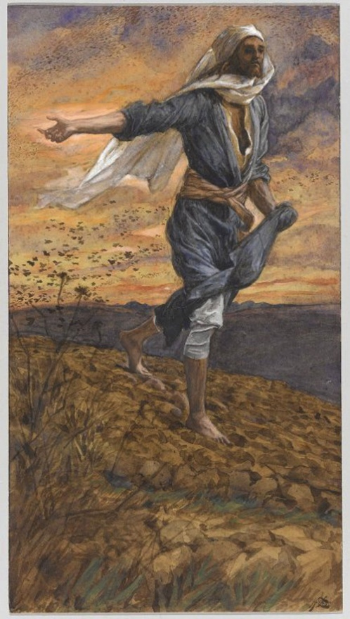
Tissot, James, 1836-1902. Sower, (1886-1894)
from Art in the Christian Tradition, a project of the Vanderbilt Divinity Library, Nashville, TN.

PRELUDE

WELCOME

CALL TO WORSHIP

HYMN #54 “Make a Joyful Noise to God!”

1 Make a joyful noise to God! All creation sings your praise!
Great your wonders here displayed, unexcelled throughout our days.
Glorious is your sacred name, ages old, yet still the same.

2 Come and see what God has done, great the blessings to the just:
walked the chosen through the sea, brought their enemies to dust.
Let us lift a thankful voice for God's mercies, and rejoice!

3 Bless the Lord, our refuge sure; let our songs of praise be heard!
By whose justice, we are tried; by whose grace, our guilt deferred.
When our life's sure end shall come, bring us to your heavenly home.

CALL TO CONFESSION

PRAYER OF CONFESSION

ASSURANCE OF GOD’S LOVE

RESPONSE: HYMN #582 “Glory to God”
1 Glory to God, whose goodness shines on me,
and to the Son, whose grace has pardoned me,
and to the Spirit, whose love has set me free.
As it was in the beginning, is now and ever shall be. Amen.

2 World without end, without end. Amen.
World without end, without end. Amen
World without end, without end. Amen.
As it was in the beginning, is now and ever shall be. Amen.

PEACE
Let there be peace on earth.
And let it begin with me.
The peace of Christ be with you.

RESPONSIVE READING Psalm 65:9-13 (NRSVUE)
You visit the earth and water it; you greatly enrich it; the river of God is full of water;
you provide the people with grain, for so you have prepared it.
You water its furrows abundantly, settling its ridges, softening it with
showers, and blessing its growth.
You crown the year with your bounty; your wagon tracks overflow with richness.
The pastures of the wilderness overflow; the hills gird themselves with joy;
the meadows clothe themselves with flocks; the valleys deck themselves with grain;
they shout and sing together for joy.

FIRST READING Isaiah 55:10-13 (NRSVUE)
¹⁰ For as the rain and the snow come down from heaven and do not return there until they have watered the earth, making it bring forth and sprout, giving seed to the sower and bread to the eater, ¹¹ so shall my word be that goes out from my mouth; it shall not return to me empty, but it shall accomplish that which I purpose
and succeed in the thing for which I sent it. ¹² For you shall go out in joy and be led back in peace; the mountains and the hills before you shall burst into song, and all the trees of the field shall clap their hands. ¹³ Instead of the thorn shall come up the cypress; instead of the brier shall come up the myrtle, and it shall be to the Lord for a memorial, for an everlasting sign that shall not be cut off.

CHILDREN’S SERMON

SECOND READING Matthew 13:1-9,18-23 (NRSVUE)
¹ That same day Jesus went out of the house and sat beside the sea. ² Such great crowds gathered around him that he got into a boat and sat there, while the whole crowd stood on the beach. ³ And he told them many things in parables, saying: “Listen! A sower went out to sow. ⁴ And as he sowed, some seeds fell on a path, and the birds came and ate them up. ⁵ Other seeds fell on rocky ground, where they did not have much soil, and they sprang up quickly, since they had no depth of soil. ⁶ But when the sun rose, they were scorched, and since they had no root, they withered away. ⁷ Other seeds fell among thorns, and the thorns grew up and choked them. ⁸ Other seeds fell on good soil and brought forth grain, some a hundredfold, some sixty, some thirty. ⁹ If you have ears, hear!”

¹⁸ “Hear, then, the parable of the sower. ¹⁹ When anyone hears the word of the kingdom and does not understand it, the evil one comes and snatches away what is sown in the heart; this is what was sown on the path. ²⁰ As for what was sown on rocky ground, this is the one who hears the word and immediately receives it with joy, ²¹ yet such a person has no root but endures only for a while, and when trouble or persecution arises on account of the word, that person immediately falls away. ²² As for what was sown among thorns, this is the one who hears the word, but the cares of this age and the lure of wealth choke the word, and it yields nothing. ²³ But as for what was sown on good soil, this is the one who hears the word and understands it, who indeed bears fruit and yields in one case a hundredfold, in another sixty, and in another thirty.”

SERMON “The Good Earth” Jeff Courter

HYMN #171 “A Sower Came from Ancient Hills”

1. A Sower came from ancient hills and cast good seed abroad;
his field, ten thousand human hearts; his seed, the word of God.
And some who listened would not hear. and some who heard forgot.
But some received in fertile soil the truth the Sower taught.

2. A Sower walked throughout the land and, everywhere he trod,
He sowed his life because he was himself the Seed of God.
But then, atop a barren hill, beneath a darkening sky,
they threw God’s Seed on stony ground and left it there to die.

3. The Seed was buried deep in death beneath a blood-red sky,
and deeper still was buried hope for those who watched him die.
But then, in Joseph’s garden fair, as dawn broke o’er the land,
the Seed, from three days’ silent sleep, awoke at God’s command!

4. O Christ, you come among us still, the Sower and the Seed.
As once you sowed the truth of God in glowing word and deed,
implant your Word in waiting hearts, and let it there take hold,
until it bears in fruitful lives a harvest hundredfold.

PROFESSION OF FAITH THE APOSTLES’ CREED
I Believe in God the Father Almighty, Maker of heaven and earth; and in Jesus Christ, His Only Son, our Lord, who was conceived by the Holy Spirit, born of the Virgin Mary, suffered under Pontius Pilate, was crucified, dead, and buried. He descended into hell; the third day He rose again from the dead. He ascended into heaven, and sitteth at the right hand of God the Father Almighty, from thence He shall come to judge the quick and the dead.
I believe in the Holy Spirit, the holy catholic church, the communion of saints, the forgiveness of sins, the resurrection of the body, and the life everlasting. Amen.

PRAYERS OF THE PEOPLE

OFFERING/OFFERTORY

OFFERING SONG #328 “Praise God, All You Nations” (DaNase)
Praise God, all you nations. People of God, sing praise!
Praise God, all you nations. People of God, sing praise:
God’s love is great and endures forever.
Praise God, all you nations. People of God, sing praise!

PRAYER OF DEDICATION/THE LORD’S PRAYER

ANNOUNCEMENTS

HYMN #745 “Now Go in Joy”

Now go in joy to spread the Word till all people have heard:
God embraces all! Follow, then, the disciples’ call:
tend your neighbors with loving care in daily work and prayer.
God’s own grace empower your spirit. Amen!

BENEDICTION

POSTLUDE_________________________________________________________

UPCOMING CALENDAR

WEDNESDAY, 7:00 PM - Book Discussion Group on the book The Cost of Discipleship by Dietrich Bonhoeffer. We will be on the church Zoom at 7:00 PM.

REMINDER – Please keep in mind that worship is now at 10:00 AM for the Summer months ending last Sunday of August.

REMINDER: We are still looking for volunteers for worship readers and/or juice/coffee hour. There is a 3-month sign-up sheet posted just outside the office.
If you have any questions, please contact the Office.

First Presbyterian Church of Forest Hills
70-35 112th St., Forest Hills, NY 11375 presbyfh.org
David Barnett, Admin.718-268-4036 Jeff Courter, Pastor,
FirstPresFHNY@gmail.com; rev.jeffrey.courter@gmail.com
Rafael Reyes-Quiroz, Clerk of Session

Please note: we now have a public WiFi for the church, though it may only be available in the church hall for now.
Name: CHURCH GUEST
Password: welcome1

For offerings/donations:

- Use Zelle to make Online donations from your bank account. Use this phone number to transfer to the church:
929-418-0958 (please note: this is a new number)
- Make checks payable to First Presbyterian Church of Forest Hills and mail check to the church office
- Go to our church website: presbyfh.org and click on the “Give Now” icon to set up a donation; or click on the qr code above
- The web address of your donation form has now been changed to: https://secure.myvanco.com/L-ZBFD
- Set up a “Bill pay” from your bank.

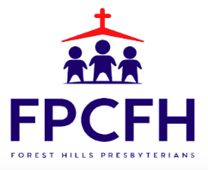

Building a Community of Faith, Hope, and Love
PresbyFH.org

