September 13, 2026 16th Sunday after Pentecost 11 AM

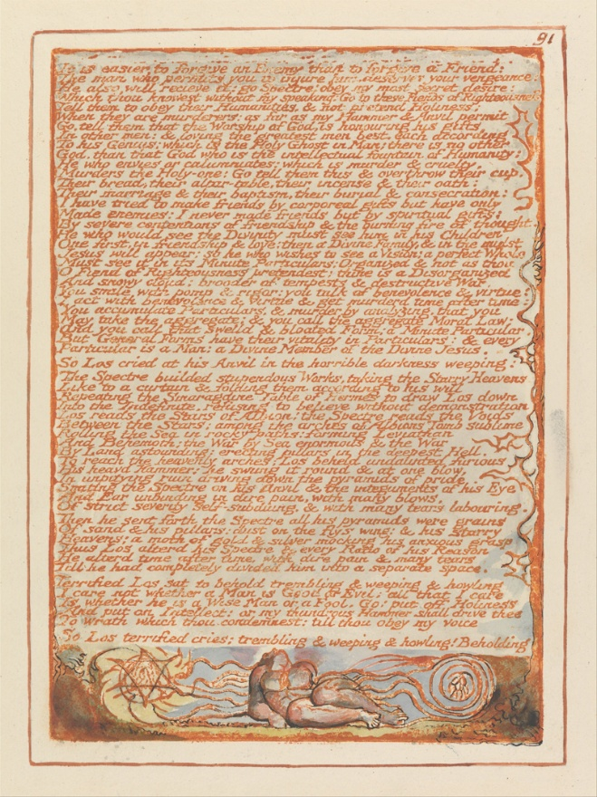
Blake, William, 1757-1827. "It is easier to forgive an enemy than to forgive a friend…",
from Art in the Christian Tradition, a project of the Vanderbilt University Divinity Library, Nashville, TN.

PRELUDE

WELCOME

MINUTE FOR MISSION

CALL TO WORSHIP

HYMN #733 “We All Are One in Mission”

1 We all are one in mission; we all are one in call,
our varied gifts united by Christ, the Lord of all.
A single, great commission compels us from above
to plan and work together that all may know Christ's love.

2 We all are called for service to witness in God's name.
Our ministries are different; our purpose is the same:
to touch the lives of others by God's surprising grace,
so every folk and nation may feel God's warm embrace.

3 Now let us be united and let our song be heard.
Now let us be a vessel for God's redeeming word.
We all are one in mission; we all are one in call,
our varied gifts united by Christ, the Lord of all.

CALL TO CONFESSION

PRAYER OF CONFESSION

ASSURANCE OF GOD’S LOVE

RESPONSE: HYMN #582 “Glory to God”
1 Glory to God, whose goodness shines on me,
and to the Son, whose grace has pardoned me,
and to the Spirit, whose love has set me free.
As it was in the beginning, is now and ever shall be. Amen.

2 World without end, without end. Amen.
World without end, without end. Amen
World without end, without end. Amen.
As it was in the beginning, is now and ever shall be. Amen.

PEACE
Let there be peace on earth.
And let it begin with me.
The peace of Christ be with you.
And also with you.

RESPONSIVE READING Psalm 103:8-13 (NRSVUE)
The Lord is merciful and gracious, slow to anger and abounding in steadfast love.
He will not always accuse, nor will he keep his anger forever.
He does not deal with us according to our sins
nor repay us according to our iniquities.
For as the heavens are high above the earth,
so great is his steadfast love toward those who fear him;
as far as the east is from the west,
so far he removes our transgressions from us.
As a father has compassion for his children,
so the Lord has compassion for those who fear him.

FIRST READING Genesis 50:15-21 (NRSVUE)
¹⁵ Realizing that their father was dead, Joseph’s brothers said, “What if Joseph still bears a grudge against us and pays us back in full for all the wrong that we did to him?” ¹⁶ So they approached Joseph, saying, “Your father gave this instruction before he died, ¹⁷ ‘Say to Joseph: I beg you, forgive the crime of your brothers and the wrong they did in harming you.’ Now therefore please forgive the crime of the servants of the God of your father.” Joseph wept when they spoke to him. ¹⁸ Then his brothers also wept, fell down before him, and said, “We are here as your slaves.” ¹⁹ But Joseph said to them, “Do not be afraid! Am I in the place of God? ²⁰ Even though you intended to do harm to me, God intended it for good, in order to preserve a numerous people, as he is doing today. ²¹ So have no fear; I myself will provide for you and your little ones.” In this way he reassured them, speaking kindly to them.

CHILDREN’S SERMON

SECOND READING Matthew 18:21-35 (NRSVUE)
²¹ Then Peter came and said to him, “Lord, if my brother or sister sins against me, how often should I forgive? As many as seven times?” ²² Jesus said to him, “Not seven times, but, I tell you, seventy-seven times.

²³ “For this reason the kingdom of heaven may be compared to a king who wished to settle accounts with his slaves. ²⁴ When he began the reckoning, one who owed him ten thousand talents was brought to him, ²⁵ and, as he could not pay, the lord ordered him to be sold, together with his wife and children and all his possessions and payment to be made. ²⁶ So the slave fell on his knees before him, saying, ‘Have patience with me, and I will pay you everything.’ ²⁷ And out of pity for him, the lord of that slave released him and forgave him the debt. ²⁸ But that same slave, as he went out, came upon one of his fellow slaves who owed him a hundred denarii, and seizing him by the throat he said, ‘Pay what you owe.’ ²⁹ Then his fellow slave fell down and pleaded with him, ‘Have patience with me, and I will pay you.’ ³⁰ But he refused; then he went and threw him into prison until he would pay the debt. ³¹ When his fellow slaves saw what had happened, they were greatly distressed, and they went and reported to their lord all that had taken place. ³² Then his lord summoned him and said to him, ‘You wicked slave! I forgave you all that debt because you pleaded with me. ³³ Should you not have had mercy on your fellow slave, as I had mercy on you?’ ³⁴ And in anger his lord handed him over to be tortured until he would pay his entire debt. ³⁵ So my heavenly Father will also do to every one of you, if you do not forgive your brother or sister from your heart.”

SERMON “How to Build a Better World” Jeff Courter

HYMN #445 “God, How Can We Forgive”

- God, how can we forgive when bonds of love are torn?
How can we rise and start anew, our trust reborn?
When human loving fails and every hope is gone,
your love gives strength beyond our own to face the dawn.

- When we have missed the mark, and tears of anguish flow,
how can you still release our guilt, the debt we owe?
The ocean depth of grace surpasses all our needs.
A priest who shares our human pain, Christ intercedes.

- Who dares to throw the stone to damn another's sin,
when you, while knowing all our past, forgive again?
No more we play the judge, for by your grace we live.
As you, O God, forgive our sin, may we forgive.

PROFESSION OF FAITH THE APOSTLES’ CREED
I Believe in God the Father Almighty, Maker of heaven and earth; and in Jesus Christ, His Only Son, our Lord, who was conceived by the Holy Spirit, born of the Virgin Mary, suffered under Pontius Pilate, was crucified, dead, and buried. He descended into hell; the third day He rose again from the dead. He ascended into heaven, and sitteth at the right hand of God the Father Almighty, from thence He shall come to judge the quick and the dead.
I believe in the Holy Spirit, the holy catholic church, the communion of saints, the forgiveness of sins, the resurrection of the body, and the life everlasting. Amen.

PRAYERS OF THE PEOPLE

OFFERING/OFFERTORY

OFFERING SONG #328 “Praise God, All You Nations” (DaNase)
Praise God, all you nations. People of God, sing praise!
Praise God, all you nations. People of God, sing praise:
God’s love is great and endures forever.
Praise God, all you nations. People of God, sing praise!

PRAYER OF DEDICATION/ THE LORD’S PRAYER

ANNOUNCEMENTS

CLOSING HYMN#730 “I Sing a Song of the Saints of God”

1 I sing a song of the saints of God, patient and brave and true,
who toiled and fought and lived and died for the Lord they loved and knew.
And one was a doctor, and one was a queen, and one was a shepherdess on the green: they were all of them saints of God, and I mean, God helping, to be one too.

2 They loved their Lord so dear, so dear, and God’s love made them strong;
and they followed the right, for Jesus’ sake, the whole of their good lives long.
And one was a soldier, and one was a priest, and one was slain by a fierce wild beast: and there’s not any reason, no, not the least, why I shouldn’t be one too.

3 They lived not only in ages past; there are hundreds of thousands still;
the world is bright with the joyous saints who love to do Jesus’ will.
You can meet them in school, or in lanes, or at sea, in church, or in trains, or in shops, or at tea; for the saints of God are just folk like me, and I mean to be one too.

BENEDICTION

POSTLUDE
___________________________________________________________________

UPCOMING CALENDAR

WORLD COMMUNION OFFERING - September 6 - October 4, 2026
All of God's people gather around the Table to celebrate the life, death and resurrection of Jesus Christ. Part of the atonement that happens around this Table is reconciliation, which is the focus of the World Communion Offering. Experience the grace that comes from reconciling all peoples from all nations around the corner and around the globe through the ministry of this offering.
(Formally Peace and Global Witness)

REMINDER – Please keep in mind that the worship is now at 11:00 AM through the Fall and Winter; Sunday School and Adult Bible Study starts at 10:00 AM.

REMINDER: We are still looking for volunteers for worship readers and/or juice/coffee hour. There is a 3-month sign-up sheet posted just outside the office.
If you have any questions, please contact the Office.

First Presbyterian Church of Forest Hills
70-35 112th St., Forest Hills, NY 11375 presbyfh.org
David Barnett, Admin.718-268-4036 Jeff Courter, Pastor,
FirstPresFHNY@gmail.com; rev.jeffrey.courter@gmail.com
Rafael Reyes-Quiroz, Clerk of Session

Please note: we now have a public WiFi for the church, though it may only be available in the church hall for now.
Name: CHURCH GUEST
Password: welcome1

For offerings/donations:

- Use Zelle to make Online donations from your bank account. Use this phone number to transfer to the church:
929-418-0958 (please note: this is a new number)
- Make checks payable to First Presbyterian Church of Forest Hills and mail check to the church office
- Go to our church website: presbyfh.org and click on the “Give Now” icon to set up a donation; or click on the QR code above
- The web address of your donation form has now been changed to: https://secure.myvanco.com/L-ZBFD
- Set up a “Bill pay” from your bank.

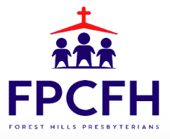

Building a Community of Faith, Hope, and Love
PresbyFH.org

