February 22, 2026 1st Sunday in Lent 11 AM
Black History Month

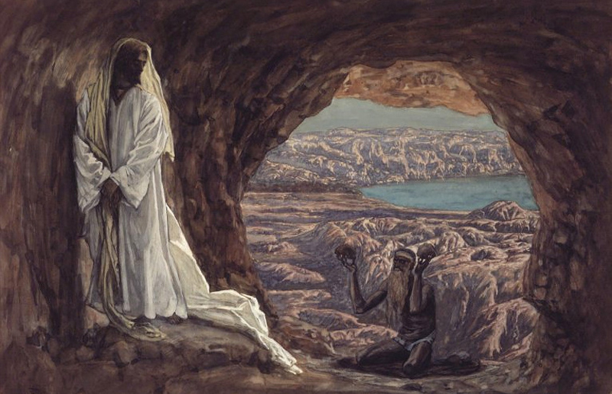
Tissot, James, 1836-1902. Temptation in the Desert, (between 1886 & 1894)
from Art in the Christian Tradition, a project of the Vanderbilt Divinity Library, Nashville, TN.

PRELUDE

WELCOME

CALL TO WORSHIP

HYMN #166 “Lord, Who throughout These Forty Days”

1 Lord, who throughout these forty days for us did fast and pray,
teach us with you to mourn our sins and close by you to stay.

2 As you with Satan did contend and did the victory win,
O give us strength to persevere, in you to conquer sin.

3 And through these days of penitence, and through this Passiontide,
yes, evermore, in life and death, O Lord, with us abide.

4 Abide with us, till when this life of suffering shall be past,
an Easter of unending joy we may attain at last.

CALL TO CONFESSION

ASSURANCE OF GOD’S LOVE

RESPONSE: HYMN #582 “Glory to God”
1 Glory to God, whose goodness shines on me,
and to the Son, whose grace has pardoned me,
and to the Spirit, whose love has set me free.
As it was in the beginning, is now and ever shall be. Amen.

2 World without end, without end. Amen.
World without end, without end. Amen
World without end, without end. Amen.
As it was in the beginning, is now and ever shall be. Amen.

PEACE
Let there be peace on earth.
And let it begin with me.
The peace of Christ be with you.
And also with you.

SPECIAL MUSIC “Spirit of Gentleness” Helen and Lily Potter

RESPONSIVE READING Psalm 32 (NRSVUE)
Happy are those whose transgression is forgiven, whose sin is covered.
Happy are those to whom the Lord imputes no iniquity
and in whose spirit there is no deceit.
While I kept silent, my body wasted away through my groaning all day long.
For day and night your hand was heavy upon me;
my strength was dried up as by the heat of summer. Selah
Then I acknowledged my sin to you, and I did not hide my iniquity;
I said, “I will confess my transgressions to the Lord,”
and you forgave the guilt of my sin. Selah
Therefore let all who are faithful offer prayer to you;
at a time of distress, the rush of mighty waters shall not reach them.
You are a hiding place for me; you preserve me from trouble;
you surround me with glad cries of deliverance. Selah
I will instruct you and teach you the way you should go;
I will counsel you with my eye upon you.
Do not be like a horse or a mule, without understanding,
whose temper must be curbed with bit and bridle, else it will not stay near you.
Many are the torments of the wicked,
but steadfast love surrounds those who trust in the Lord.
Be glad in the Lord and rejoice, O righteous,
and shout for joy, all you upright in heart.

FIRST READING Genesis 2:15-17; 3:1-7 (NRSVUE)
¹⁵ The Lord God took the man and put him in the garden of Eden to till it and keep it. ¹⁶ And the Lord God commanded the man, “You may freely eat of every tree of the garden, ¹⁷ but of the tree of the knowledge of good and evil you shall not eat, for in the day that you eat of it you shall die.”

¹ Now the serpent was more crafty than any other wild animal that the Lord God had made. He said to the woman, “Did God say, ‘You shall not eat from any tree in the garden’?” ² The woman said to the serpent, “We may eat of the fruit of the trees in the garden, ³ but God said, ‘You shall not eat of the fruit of the tree that is in the middle of the garden, nor shall you touch it, or you shall die.’ ” ⁴ But the serpent said to the woman, “You will not die, ⁵ for God knows that when you eat of it your eyes will be opened, and you will be like God, knowing good and evil.” ⁶ So when the woman saw that the tree was good for food and that it was a delight to the eyes and that the tree was to be desired to make one wise, she took of its fruit and ate, and she also gave some to her husband, who was with her, and he ate. ⁷ Then the eyes of both were opened, and they knew that they were naked, and they sewed fig leaves together and made loincloths for themselves.

CHILDREN’S SERMON

SECOND READING Matthew 4:1-11 (NRSVUE)
¹ Then Jesus was led up by the Spirit into the wilderness to be tested by the devil. ² He fasted forty days and forty nights, and afterward he was famished. ³ The tempter came and said to him, “If you are the Son of God, command these stones to become loaves of bread.” ⁴ But he answered, “It is written, ‘One does not live by bread alone, but by every word that comes from the mouth of God.’ ” ⁵ Then the devil took him to the holy city and placed him on the pinnacle of the temple, ⁶ saying to him, “If you are the Son of God, throw yourself down, for it is written, ‘He will command his angels concerning you,’ and ‘On their hands they will bear you up,
so that you will not dash your foot against a stone.’ ” ⁷ Jesus said to him, “Again it is written, ‘Do not put the Lord your God to the test.’ ” ⁸ Again, the devil took him to a very high mountain and showed him all the kingdoms of the world and their glory, ⁹ and he said to him, “All these I will give you, if you will fall down and worship me.” ¹⁰ Then Jesus said to him, “Away with you, Satan! for it is written,
‘Worship the Lord your God, and serve only him.’ ” ¹¹ Then the devil left him, and suddenly angels came and waited on him.

SERMON “Tempted” Jeff Courter

HYMN #783 (vv. 1,2) “When We Are Tested”

1 When we are tested and wrestle alone,
famished for bread when the world offers stone,
nourish us, God, by your word and your way,
food that sustains us by night and by day.

2 When in the desert we cry for relief,
pleading for paths marked by certain belief,
lift us to love you beyond sign and test,
trusting your presence, our only true rest.

PROFESSION OF FAITH THE APOSTLES CREED
I Believe in God the Father Almighty, Maker of heaven and earth; and in Jesus Christ, His Only Son, our Lord, who was conceived by the Holy Spirit, born of the Virgin Mary, suffered under Pontius Pilate, was crucified, dead, and buried. He descended into hell; the third day He rose again from the dead. He ascended into heaven, and sitteth at the right hand of God the Father Almighty, from thence He shall come to judge the quick and the dead.
I believe in the Holy Spirit, the holy catholic church, the communion of saints,
the forgiveness of sins, the resurrection of the body, and the life everlasting.

PRAYERS OF THE PEOPLE

OFFERING/OFFERTORY

OFFERING SONG #328 “Praise God, All You Nations” (DaNase)
Praise God, all you nations. People of God, sing praise!
Praise God, all you nations. People of God, sing praise:
God’s love is great and endures forever.
Praise God, all you nations. People of God, sing praise!
PRAYER OF DEDICATION/THE LORD’S PRAYER

ANNOUNCEMENTS

CLOSING HYMN #175 “Seek Ye First”

1 Seek ye first the kingdom of God and His righteousness;
And all these things shall be added unto you. Allelu, alleluja!

2 Ask, and it shall be given unto you; seek, and you shall find.
Knock, and the door shall be opened unto you. Allelu, alleluja!

3 You shall not live by bread alone, but by every word
That proceeds from the mouth of God. Allelu, alleluja!

BENEDICTION

POSTLUDE

UPCOMING CALENDAR

ADULT BIBLE STUDY – Sunday 10:00 AM – we are currently reading Delivered into Covenant (Pivotal Moments in the Book of Exodus) by Walter Brueggemann
If you are interested, please contact David in the office.

WEDNESDAY, FEBRUARY 25th – Lenten Study, 7:00 PM on Zoom
We are continuing our Lenten study by reading Pastor Brian Zahnd's book, The Wood Between the Worlds:A Poetic Theology of the Cross (InterVarsity Press, 2024) until Holy Week. We have copies of the book available who are in the study - if you want a copy, please contact the office or stop by and get a copy.

REMINDER: We are still looking for volunteers for worship readers and/or juice/coffee hour. There is a 3-month sign-up sheet posted just outside the office.
If you have any questions, please contact the Office.

First Presbyterian Church of Forest Hills
70-35 112th St., Forest Hills, NY 11375 presbyfh.org
David Barnett, Admin.718-268-4036 Jeff Courter, Pastor,
FirstPresFHNY@gmail.com; rev.jeffrey.courter@gmail.com
Nadina Grants, Clerk of Session

Please note: we now have a public WiFi for the church, though it may only be available in the church hall for now.
Name: CHURCH GUEST
Password: welcome1

For offerings/donations:

- Use Zelle to make Online donations from your bank account. Use this phone number to transfer to the church:
929-418-0958 (please note: this is a new number)
- Make checks payable to First Presbyterian Church of Forest Hills and mail check to the church office
- Go to our church website: presbyfh.org and click on the “Give Now” icon to set up a donation; or click on the qr code above
- Set up a “Bill pay” from your bank.



Building a Community of Faith, Hope, and Love
PresbyFH.org

