November 30, 2025 1st Sunday of Advent 11 AM

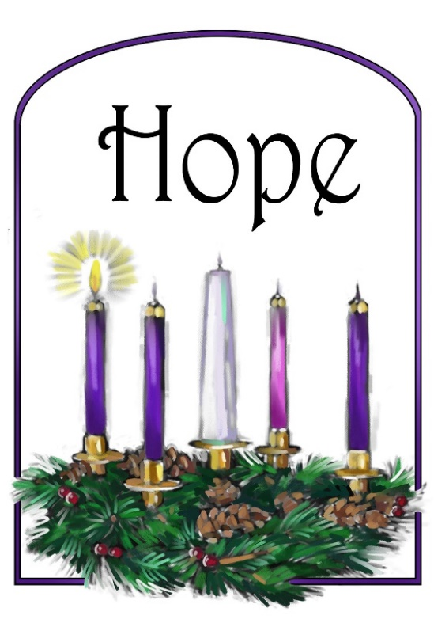
First Sunday of Advent – Clip Art Library

PRELUDE

WELCOME

MINUTE FOR STEWARDSHIP

CALL TO WORSHIP

HYMN #85 (v.1) “Light One Candle to Watch for Messiah”
Light one candle to watch for Messiah: let the light banish darkness,
He shall bring salvation to Israel, God fulfills the promise.

LIGHTING OF THE ADVENT CANDLE
Watch and wait for Christ’s coming!
Light candles of hope, peace, joy, and love,
remembering the promises of God with prayer.
We light this candle in hope. (Light the first candle.)
Hear God’s promise of hope from Isaiah 2:2-4:
In days to come the mountain of the Lord’s house shall be established as the highest of the mountains, and shall be raised above the hills; all the nations shall stream to it.
Many peoples shall come and say,
“Come, let us go up to the mountain of the LORD, to the house of the God of Jacob;
that he may teach us his ways and that we may walk in his paths.”
For out of Zion shall go forth instruction, and the word of the LORD from Jerusalem.
He shall judge between the nations, and shall arbitrate for many peoples;
they shall beat their swords into plowshares, and their spears into pruning hooks;
nation shall not lift up sword against nation, neither shall they learn war any more.
Let us pray:
Faithful God, out of war’s chaos, you bring the order of peace.
Renew us in hope, that we may work toward Christ’s advent of peace
among all nations.
God of promise, God of hope, into our darkness come.

OPENING PRAYER

HYMN #92 “While We Are Waiting, Come”
- While we are waiting come; while we are waiting come.
Jesus, our Lord, Emmanuel, while we are waiting come.

- With power and glory come; with power and glory come.
Jesus, our Lord, Emmanuel, while we are waiting come.

- Come, Savior, quickly come; come, Savior, quickly come.
Jesus, our Lord, Emmanuel, while we are waiting come.

CALL TO CONFESSION

PRAYER OF CONFESSION

ASSURANCE OF GOD’S LOVE

RESPONSE: HYMN #582 “Glory to God”
1 Glory to God, whose goodness shines on me,
and to the Son, whose grace has pardoned me,
and to the Spirit, whose love has set me free.
As it was in the beginning, is now and ever shall be. Amen.
2 World without end, without end. Amen.
World without end, without end. Amen
World without end, without end. Amen.
As it was in the beginning, is now and ever shall be. Amen.

PEACE
Let there be peace on earth.
And let it begin with me.
The peace of Christ be with you.
And also with you.

RESPONSIVE READING Psalm 122 (NRSVUE)
I was glad when they said to me, “Let us go to the house of the Lord!”
Our feet are standing within your gates, O Jerusalem.
Jerusalem—built as a city that is bound firmly together.
To it the tribes go up, the tribes of the Lord,
as was decreed for Israel, to give thanks to the name of the Lord.
For there the thrones for judgment were set up,
the thrones of the house of David.
Pray for the peace of Jerusalem: “May they prosper who love you.
Peace be within your walls and security within your towers.”
For the sake of my relatives and friends I will say, “Peace be within you.”
For the sake of the house of the Lord our God, I will seek your good.

FIRST READING Isaiah 2:1-5 (NRSVUE)
¹ The word that Isaiah son of Amoz saw concerning Judah and Jerusalem.
² In days to come the mountain of the Lord’s house shall be established as the highest of the mountains and shall be raised above the hills; all the nations shall stream to it. ³ Many peoples shall come and say, “Come, let us go up to the mountain of the Lord, to the house of the God of Jacob, that he may teach us his ways and that we may walk in his paths.” For out of Zion shall go forth instruction
and the word of the Lord from Jerusalem. ⁴ He shall judge between the nations
and shall arbitrate for many peoples; they shall beat their swords into plowshares
and their spears into pruning hooks; nation shall not lift up sword against nation;
neither shall they learn war any more. ⁵ O house of Jacob, come, let us walk in the light of the Lord!

CHILDREN’S SERMON

SECOND READING Matthew 24:36-44 (NRSVUE)
³⁶ “But about that day and hour no one knows, neither the angels of heaven, nor the Son, but only the Father. ³⁷ For as the days of Noah were, so will be the coming of the Son of Man. ³⁸ For as in the days before the flood they were eating and drinking, marrying and giving in marriage, until the day Noah entered the ark, ³⁹ and they knew nothing until the flood came and swept them all away, so, too, will be the coming of the Son of Man. ⁴⁰ Then two will be in the field; one will be taken, and one will be left. ⁴¹ Two women will be grinding meal together; one will be taken, and one will be left. ⁴² Keep awake, therefore, for you do not know on what day your Lord is coming. ⁴³ But understand this: if the owner of the house had known in what part of the night the thief was coming, he would have stayed awake and would not have let his house be broken into. ⁴⁴ Therefore you also must be ready, for the Son of Man is coming at an hour you do not expect.

SERMON What Kind of Kingdom?” Jeff Courter

HYMN #106 “Prepare the Way, O Zion”
1 Prepare the way, O Zion, your Christ is drawing near!
Let every hill and valley a level way appear.
Greet One who comes in glory, foretold in sacred story.
Refrain: O blest is Christ who came in God’s most holy name.

2 He brings God’s rule, O Zion; he comes from heaven above.
His rule is peace and freedom, and justice, truth, and love.
Lift high your praise resounding, for grace and joy abounding. [Refrain]

3 Fling wide your gates, O Zion; your Savior’s rule embrace,
and tidings of salvation proclaim in every place.
All lands will bow rejoicing, their adoration voicing. [Refrain]

PROFESSION OF FAITH THE APOSTLES CREED
I Believe in God the Father Almighty, Maker of heaven and earth; and in
Jesus Christ, His Only Son, our Lord, who was conceived by the Holy Spirit, born of the Virgin Mary, suffered under Pontius Pilate, was crucified, dead, and buried. He descended into hell; the third day He rose again from the dead. He ascended into heaven, and sitteth at the right hand of God the Father Almighty, from thence He shall come to judge the quick and the dead.
I believe in the Holy Spirit, the holy catholic church, the communion of saints,
the forgiveness of sins, the resurrection of the body, and the life everlasting.
Amen.

PRAYERS OF THE PEOPLE

OFFERING/OFFERTORY

OFFERING SONG #328 “Praise God, All You Nations” (DaNase)
Praise God, all you nations. People of God, sing praise!
Praise God, all you nations. People of God, sing praise:
God’s love is great and endures forever.
Praise God, all you nations. People of God, sing praise!

PRAYER OF DEDICATION/THE LORD’S PRAYER

ANNOUNCEMENTS

CLOSING HYMN #100 “Canticle of the Turning”

1 My soul cries out with a joyful shout that the God of my heart is great,
And my spirit sings of the wondrous things that you bring to the ones who wait.
You fixed your sight on your servant's plight, and my weakness you did not spurn,
So from east to west shall my name be blest. Could the world be about to turn?
[Refrain] My heart shall sing of the day you bring. Let the fires of your justice burn.
Wipe away all tears, for the dawn draws near, and the world is about to turn.

2 Though I am small, my God, my all, you work great things in me,
and your mercy will last from the depths of the past to the end of the age to be.
Your very name puts the proud to shame, and to those who would for you yearn,
You will show your might, put the strong to flight, for the world is about to turn. [Refrain]

3 From the halls of power to the fortress tower, not a stone will be left on stone.
Let the king beware for your justice tears every tyrant from his throne.
The hungry poor shall weep no more, for the food they can never earn;
there are tables spread, ev'ry mouth be fed, for the world is about to turn.
[Refrain]

4 Though the nations rage from age to age, we remember who holds us fast:
God's mercy must deliver us from the conqueror's crushing grasp.
This saving word that our forebears heard is the promise which holds us bound,
'Til the spear and rod can be crushed by God, who is turning the world around.
[Refrain]

BENEDICTION

POSTLUDE

UPCOMING CALENDAR

WEDNESDAY, DEC. 3, 7:00 PM ZOOM – ADVENT STUDY – we are using Dr. Kelley Nikondeha's recent book, The First Advent in Palestine. This book will explore the theme of incarnation through the lens of Luke and Matthew's gospels. Please see David in the office.

SUNDAY, DEC. 7, 10:00 AM – ADULT BIBLE STUDY – We are using the book Delivered Out of Empire (Part 1) by Walter Brueggemann, and will finish up Part 1 by reading Chapter 10 Enthroned in Jerusalem (Exodus 15:18).
We will then take a short break till after the holidays, then start Part 2 of the study in January. Books for this study will be ordered, and we’ll let you know when they’ve arrived.

SUNDAY, DEC. 7 - We will also be dedicating our pledges on December 7 for next year. Please be sure to fill out your pledge cards and bring them to worship that day!

SUNDAY, DEC. 7 - SONGFEST at FORESTVIEW – we will bring the gift of holiday music to the residents of Forest View Nursing and Rehab Center after worship on December 7. We will rehearse after coffee hour and walk to Forest View to sing – join us!

SUNDAY, DEC. 21 – HOLIDAY PARTY! We will have our annual Christmas party after our worship service in the church hall. Mark your calendars!

REMINDER: We are still looking for volunteers for worship readers and/or juice/coffee hour. There is a 3-month sign-up sheet posted just outside the office.
If you have any questions, please contact the Office.

First Presbyterian Church of Forest Hills
70-35 112th St., Forest Hills, NY 11375 presbyfh.org
David Barnett, Admin.718-268-4036 Jeff Courter, Pastor,
FirstPresFHNY@gmail.com; rev.jeffrey.courter@gmail.com
Nadina Grants, Clerk of Session

Please note: we now have a public WiFi for the church, though it may only be available in the church hall for now.
Name: CHURCH GUEST
Password: welcome1

For offerings/donations:

- Use Zelle to make Online donations from your bank account. Use this phone number to transfer to the church:
929-418-0958 (please note: this is a new number)
- Make checks payable to First Presbyterian Church of Forest Hills and mail check to the church office
- Go to our church website: presbyfh.org and click on the “Give Now” icon to set up a donation; or click on the qr code above
- Set up a “Bill pay” from your bank.

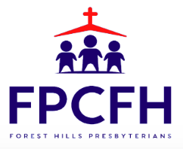

Building a Community of Faith, Hope, and Love
PresbyFH.org

